IT20476212

Dewmini P.W.K

**Information System for Covid-19 Quarantine Centers**

**(1)**

* A person has a NIC (unique), age, name, phone and an address. Name can be divided in to Fname, Mname and Lname.
* One person can have many phone numbers.
* Age is derived from date of birth and current date. Address can be divided into country, city and village.
* An employee is a person with the following attributes: Qualification, experience, salary and workplace.
* Doctor, Army Staff and Nurse are not only employees but also persons.
* Doctor has attributes named speciality and SD_ID. Visiting doctor overlaps permanent doctor and visiting doctor has one attribute named Hour.
* Army Staff also has an attribute “position” and Nurse has an attribute “Hours-worked”.
* Non-Employees are also persons with following attributes: Admit-date, DateOfBirth, Covid-19_Symptoms and Discharge date.
* There can be multiple covid-19 symptoms in one Non-Employee.
* Non-Employees are also persons and can be divided into three categories. They are Critically_ill_Patients, PCR_Positive_Patients and Quarantined Patients.
* Critically patients have an attribute Heart_beat.
* Doctor checks PCR Tests.
* The PCR Test has following attributes: PID, quarantine_start_date, pname and Temperature. Each test is done by one doctor for many patients.
* If PCR Test result become it gets covid-19 Positive Report.
* It will send to the PCR Test positive patients.
* One PCR Test can be gets one covid-19 Positive Report and Covid-19 Positive Report has following attributes: BloodGroup, Info symptoms, DID and RID (unique).
* There can be multiple information in one covid-19 Positive_Report of a PCR_Test_Positive_Patient.
* Covid-19 Positive Report is depend on PCR Test (weak entity). Covid-19 positive report can’t exist on its own.
* One Covid-19 Positive Report sent to a one PCR Test Positive Patient and system recorded the date that sent the Covid-19 Positive Report.
* And also doctors must check PCR Test Positive Patients for the treatments. Treatment entity has following attributes: Description, Result, Vaccine and PID (unique).
* One doctor is checking for PCR positive patients for many treatments.
* PCR positive patients must admit for the treatments and many patients admitted for one treatment.
* Doctors must work for one department. One doctor works for only one department.
* Department has Dep_ID, Dep_name, details and Location attributes.
* The Army_Staff facilitates rooms. Rooms have Floor, WID (unique), Type and Facility attributes.
* Many army staff facilitate many rooms assigned for the quarantined patients.
* There are two types of nurses. They are training and permanent.
* When PCR positive patient admitted for treatments, they must take care by nurses. In There many patients are taken care by one nurse.
* When patients are in critical condition doctors check them and give a critical condition report. One critical ill patient can receive only one critical condition report.
* Critical condition report has following attributes: CCID (unique), BloodGroup, Temperature and pname.
* When critical condition report received to a patient, he will transfer to a covid-19 treatment Hospital. Covid-19 treatment Hospital has Hcity, HID (unique), Hospital_name, Critically ill patient ID(CIP_ID) and H_Adress attributes.
* Many critical ill patients are transferred to one covid-19 treatment Hospital.
* When a patient’s PCR Test become positive, he will be known as PCR Test Positive patient. If test become positive the patient must admits for treatments. (Total participation)
* Many PCR Test Positive patients are admitted for one or many treatments.
* A quarantined patient not only a non-employee but also a person. He will quarantine in the quarantine center for 14 days.
* Even after the 14th day if he is not show any symptom of covid-19, he will discharge from the quarantine center for the Home_quarantine.
* Home_quarantine has Address, Duration, Pname, discharge_date and QID (unique) attributes.
* Many quarantined patients discharge to many home quarantines.
* All the data will be recorded in the system in covid-19 quarantine center.

**(2)** 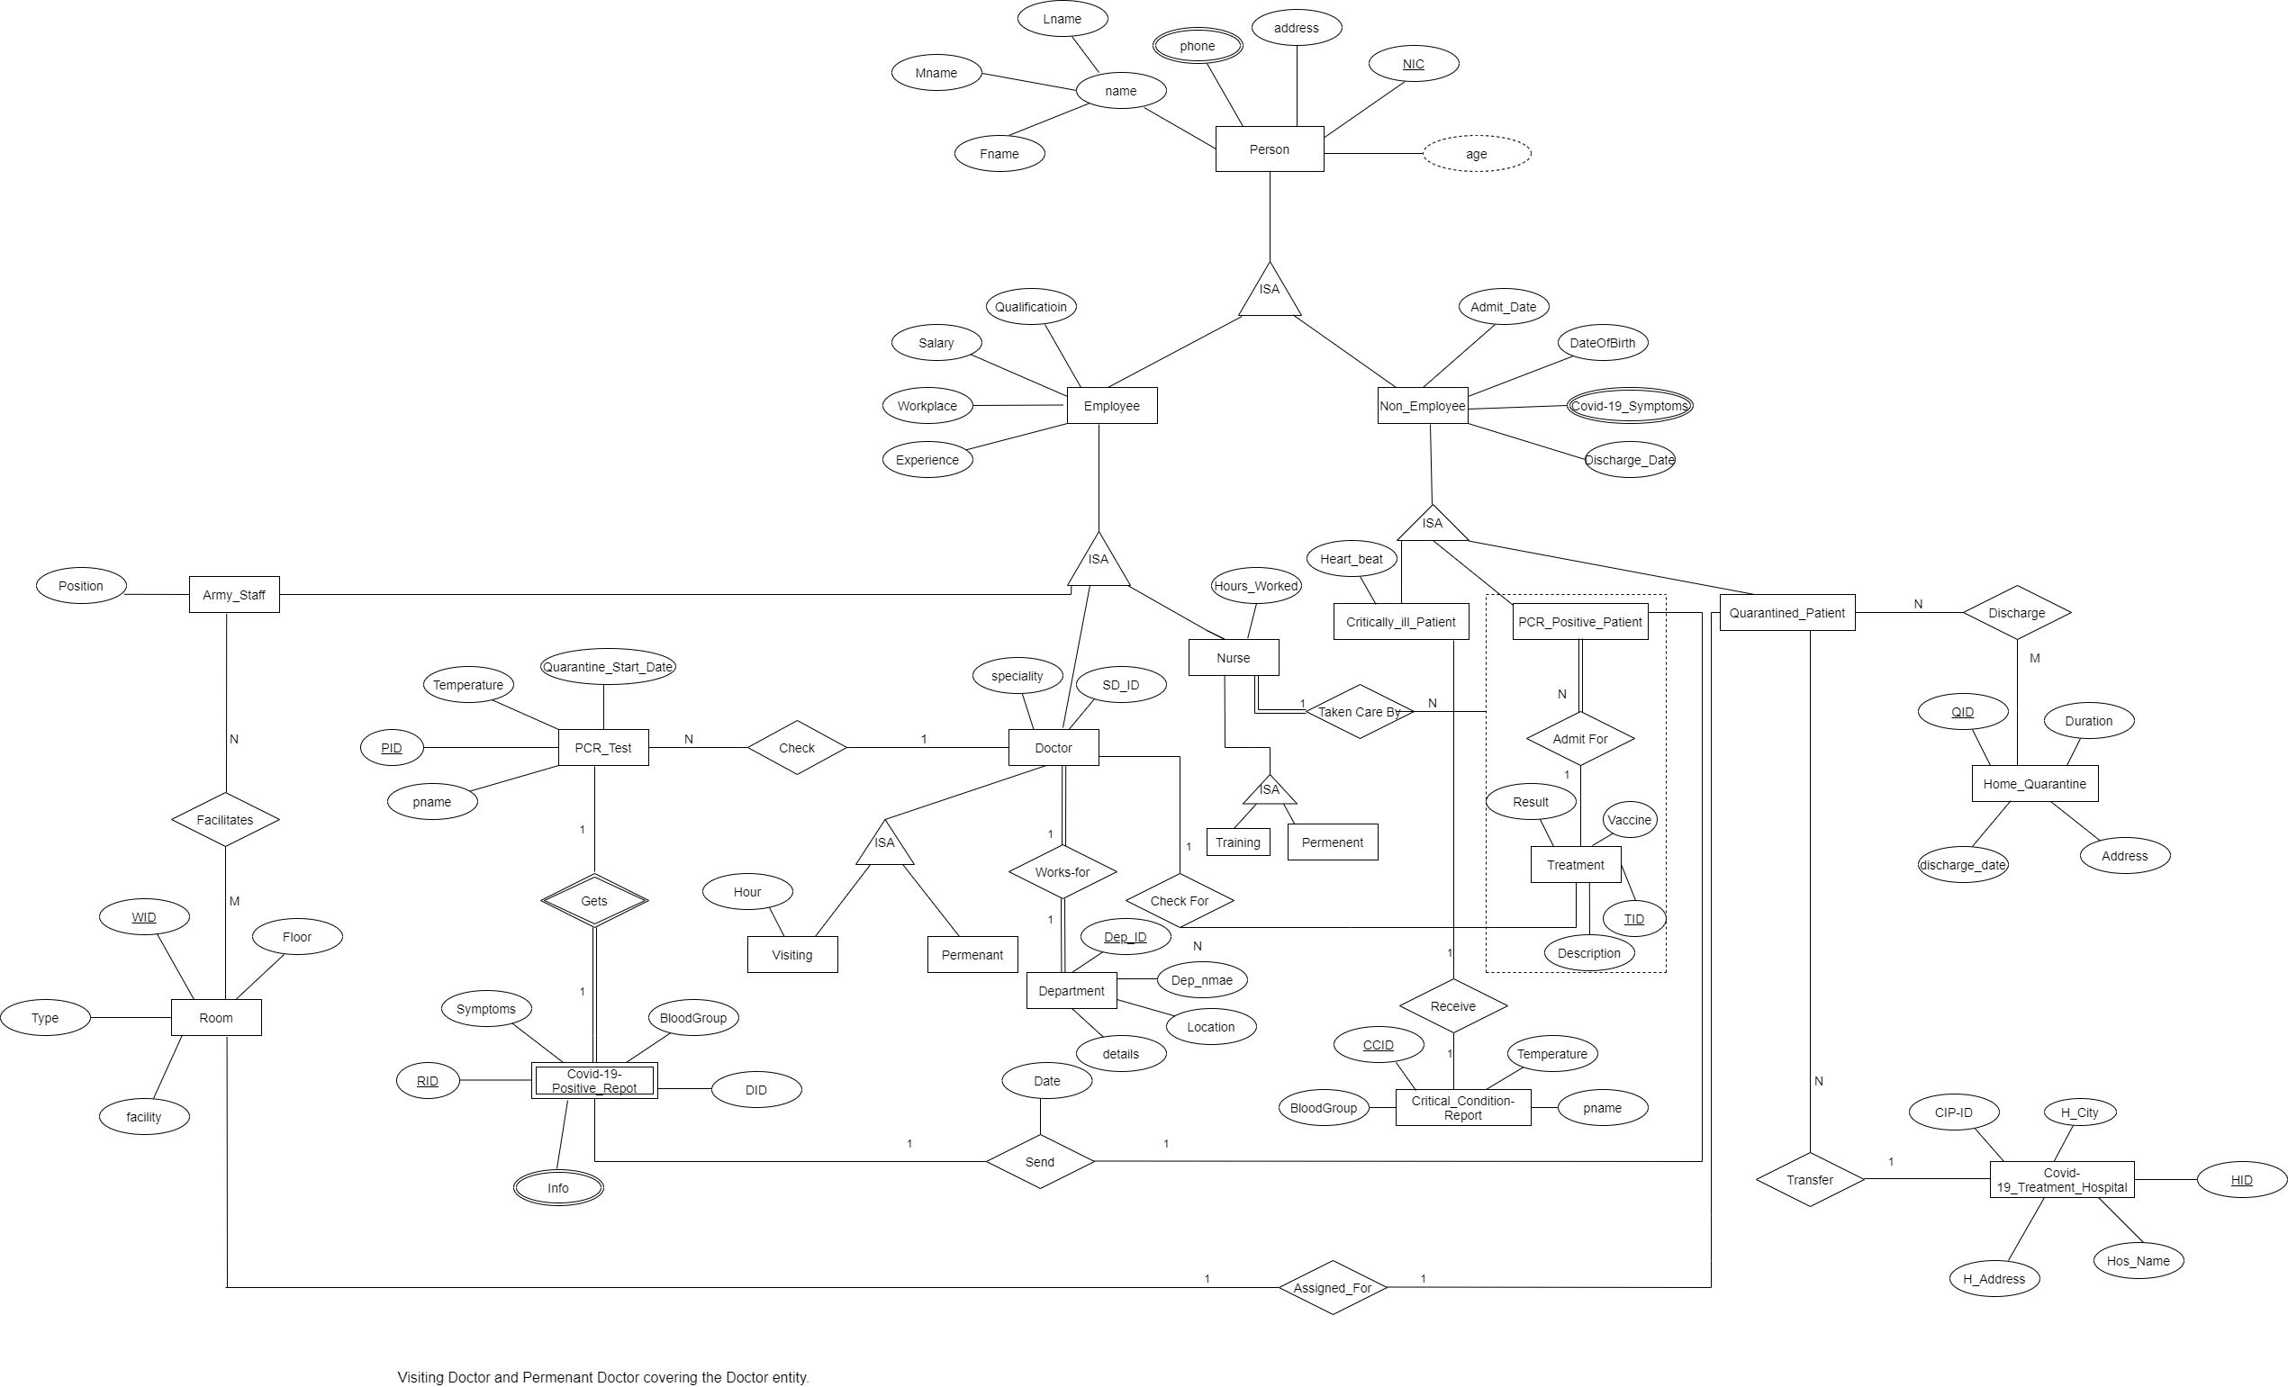

**(3)**

Person Person.phone

|  |  |  |  |  |  |
| --- | --- | --- | --- | --- | --- |
| NIC | Fname | Mname | Lname | age | address |

|  |  |
| --- | --- |
| NIC | phone |

Employee

|  |  |  |  |  |
| --- | --- | --- | --- | --- |
| E_NIC | Qualification | Experience | Salary | Workplace |

Non-Employee Non-Employee.Covid-19_Symptoms

|  |  |  |  |  |  |
| --- | --- | --- | --- | --- | --- |
| NE_NIC | Discharge_date | Admit_date | DateOfBirth | Heartbeat | type |

|  |  |
| --- | --- |
| NE_NIC | Covid-19_Symptoms |

Nurse

|  |  |
| --- | --- |
| N_NIC | Hours_Worked |

Doctor

|  |  |  |  |  |  |
| --- | --- | --- | --- | --- | --- |
| DOC_NIC | Speciality | Hour | SD_ID | Permanent | Visiting |

Army_Staff

|  |  |
| --- | --- |
| AR_NIC | position |

PCR_Positive_Patient

|  |  |  |  |
| --- | --- | --- | --- |
| P_NIC | DOC_NIC | TID | N_NIC |

FOREIGN KEY (TID) REFERENCES Treatment(TID)

FOREIGN KEY (N_NIC) REFERENCES Nurse(N_NIC)

Critically_ill_Patient

|  |  |  |
| --- | --- | --- |
| C_NIC | Heartbeat | HID |

FOREIGN KEY (HID) REFERENCES Covid-19_Treatment_Hospital(HID)

Quarantined_Patient

|  |
| --- |
| Q_NIC |

PCR_Test

|  |  |  |  |  |
| --- | --- | --- | --- | --- |
| PID | Quarantine_start_date | Temperature | pname | DOC_NIC |

FOREIGN KEY (DOC_NIC) REFERENCES Doctor(DOC_NIC)

Covid_19_Positive_Report Covid_19_Positive_Report.Info

|  |  |
| --- | --- |
| RID | Info |

|  |  |  |  |
| --- | --- | --- | --- |
| RID | BloodGroup | Symptoms | DID |

Check

|  |  |
| --- | --- |
| DOC_NIC | PID |

FOREIGN KEY (DOC_NIC) REFERENCES Doctor(DOC_NIC)

FOREIGN KEY (PID) REFERENCES PCR_Test(PID)

Department

|  |  |  |  |
| --- | --- | --- | --- |
| Dep-ID | Dep_name | details | Location |

Works-for

|  |  |
| --- | --- |
| Doc_NIC | Dep_ID |

FOREIGN KEY (DOC_NIC) REFERENCES Doctor(DOC_NIC)

FOREIGN KEY (Dep_ID) REFERENCES Department(Dep_ID)

Send

|  |  |  |
| --- | --- | --- |
| RID | P_NIC | Date |

FOREIGN KEY (RID) REFERENCES Covid_19_Positive_Report (RID)

FOREIGN KEY (P_NIC) REFERENCES PCR_Positive_Patient(P_NIC)

Critical_Condition_Report

|  |  |  |  |
| --- | --- | --- | --- |
| CCID | BloodGroup | pname | Temperature |

Receive

|  |  |
| --- | --- |
| C_NIC | CCID |

FOREIGN KEY (C_NIC) REFERENCES Critically_ill_Patient(C_NIC)

FOREIGN KEY (CCID) REFERENCES Critical_Condition_Report(CCID)

Covid-19_Treatment_Hospital

|  |  |  |  |  |
| --- | --- | --- | --- | --- |
| HID | H_City | Hos_Name | H_Address | CIP_ID |

Transfer

|  |  |
| --- | --- |
| C_NIC | HID |

FOREIGN KEY (C_NIC) REFERENCES Critically_ill_Patient(C_NIC)

FOREIGN KEY (HID) REFERENCES Covid-19_Treatment_Hospital(HID)

Treatment

|  |  |  |  |  |
| --- | --- | --- | --- | --- |
| TID | Vaccine | Result | Description | DOC_NIC |

FOREIGN KEY (DOC_NIC) REFERENCES Doctor(DOC_NIC)

Checks-For

|  |  |
| --- | --- |
| DOC_NIC | TID |

FOREIGN KEY (DOC_NIC) REFERENCES Doctor(DOC_NIC)

FOREIGN KEY (TID) REFERENCES Treatment(TID)

Admit-For

|  |  |
| --- | --- |
| P_NIC | TID |

FOREIGN KEY (P_NIC) REFERENCES PCR_Positive_Patient (P_NIC)

FOREIGN KEY (TID) REFERENCES Treatment(TID)

Room

|  |  |  |  |
| --- | --- | --- | --- |
| WID | Type | Floor | Facility |

Facilitate

|  |  |
| --- | --- |
| Ar_NIC | WID |

FOREIGN KEY (Ar_NIC) REFERENCES Army_Staff(Ar_NIC)

FOREIGN KEY (WID) REFERENCES Room(WID)

Home_Quarantine

|  |  |  |  |
| --- | --- | --- | --- |
| QID | Address | Duration | discharge_date |

Discharge

|  |  |
| --- | --- |
| Q_NIC | QID |

FOREIGN KEY (Q_NIC) REFERENCES Quarantined_Patient(Q_NIC)

FOREIGN KEY (QID) REFERENCES Home_Quarantine (QID)

Assigned

|  |  |
| --- | --- |
| Q_NIC | WID |

FOREIGN KEY (Q_NIC) REFERENCES Quarantined_Patient(Q_NIC)

FOREIGN KEY (WID) REFERENCES Room(WID)

c) Justification of ISA hierarchy mapping

* Option 4 is used to map Doctor and its sub-entities. A doctor who is not a visiting or a permanent (partial). Primary key of Doctor (superclass) becomes primary key of the relation. And also this has overlapping constraint. So, the best option to map this ISA hierarchy is option 4.
* Option 3 is used to map Non-Employee and its sub entities. It’s created a single relation including attributes of the Non-Employee (super class) as well as attributes of all sub classes. (Critically ill patient, PCR Positive Patient, Quarantined patient). And also these sub classes have few attributes and the relationship is disjoint. So the best option to map this ISA hierarchy is option 3.
* Option 2 is used to map Nurse and its sub entities. Permanent nurse entity has specific different relationship with PCR_Positive_Patient. So, the best option to map this ISA hierarchy is option 2.

**4) QUERIES**

a) Query 1:

1. Write a query to find Treatment ID and PCR TEST Count of each is done where the Doctor NIC is start in letter “M” and PCR TEST count is greater than 15.

|  |  |  |  |  |  |
| --- | --- | --- | --- | --- | --- |
| DOC_NIC | Speciality | Hour | SD_ID | Permanent | Visiting |

Doctor

|  |  |  |  |  |
| --- | --- | --- | --- | --- |
| TID | Vaccine | Result | Discription | DOC_NIC |

Treatment

|  |  |  |  |  |
| --- | --- | --- | --- | --- |
| PID | Quarantine_Start_Date | Temperature | Pname | DOC_NIC |

PCR_TEST

SELECT t.TID, Count (p.PID) AS ‘PCR Test Count’

FROM Doctor d, Treatment t, PCR_Test P

Where d.name LIKE (‘%M’) AND t.TID=d.SD_ID AND p.PID=d.DOC_NIC

Group By p.PID

Having COUNT (p.PID)>15.

1. Find the IDS of PCR Test and count of the covid-19 positive reports checks by the doctor (DOC_NIC=100520100V) which marked the the Temperature is above 38 0C

|  |  |  |  |  |  |
| --- | --- | --- | --- | --- | --- |
| DOC_NIC | Speciality | Hours | SD_ID | Permanent | Visiting |

Doctor

|  |  |  |  |  |
| --- | --- | --- | --- | --- |
| PID | Quarantine_Start_Date | Temperature | pname | DOC_NIC |

PCR_Test

|  |  |  |  |  |  |
| --- | --- | --- | --- | --- | --- |
| RID | BloodGroup | Symptoms | DID | Body_Heat | Info |

Covid-19_Positive_Report

SELECT P.PID, Count (r.RID)

FROM PCR_TEST p

JOIN PCR_TEST p ON P.PID=r.RID

JOIN Covid-19_Positive_Report r ON r. Body_Heat=p.Temperature

JOIN Doctor d ON d.DOC_NIC=r.DID

Where d.DOC_NIC= ‘100520100V’

Group by r.RID

Having p. Temperature >38

b) Query 2: Write a query to find the NIC and patient name in critically ill patient who was transferred to “IDH Hospital”

|  |  |  |
| --- | --- | --- |
| C_NIC | Heartbeat | HID |

Criticallly_ ill_ patient

|  |  |  |  |  |
| --- | --- | --- | --- | --- |
| HID | H_City | Hos_Name | H_Adress | CIP_ID |

Covid-19_Treatment_Hospital

SELECT c.name, c.C_NIC

FROM Critically_ill_Patient c, Covid-19 _Treatment_Hospital h

Where c.C_NIC=h.CIP_ID AND c.HID IN

(SELECT h.HID

FROM Covid-19 _Treatment_Hospital

WHERE h.HOS_name= ‘IDH’)

**5) Procedure**

Create a procedure that give output specialist doctor name and salary in given department.

CREATE PROCEDIURE ds_getnameSalary (@Dep_ID char(7), @name varchar(20) output, @salary real output)

AS

begin

Select @name=d.name, @salary= d.salary

From Doctor d, Department e

Where d.SD-ID =e.Dep_ID and d.Dep_ID=@Dep_ID

End

**6)Trigger**

Create a trigger to ensure that one doctor doesn’t works in more than 1 department.

CREATE TRIGGER CheckNumDepts

ON works_for

FOR INSERT,UPDATE

AS

Begin

declare @SD_ID int

declare @total int

select @SD_ID=SD_ID

from inserted

select@total=count(*)

from works_for

where SD_ID=@SD-ID

if @total>1

begin

print’Cannot work in more than 1 department’

rollback transaction

end

end