**SRI LANKA INSTITUTE OF INFORMATION TECHNOLOGY Malabe**



**Data Warehousing And Business Intelligence**

**IT 3021**

**Assignment 02**

**Name : Dewmini P.W.K**

**Student IT NO : IT 20476212**

# Data Source

For this purpose use Restaurant_DataWarehousing as Data warehouse which implemented in last Assignment.

The data set follows a Star Schema and following figure shows the created data source view.

## SSAS Cube

In here first create data source view using previous implemented data dimensions and fact table.

Then create Data Cube,

In here I choose Fact Price as measure group, dimDate, dimRestaurants, dimReview, dimMeal and dimAddress as dimensions.

After that configure all the dimension with proper way.

* DimDate

* Dim Restaurants

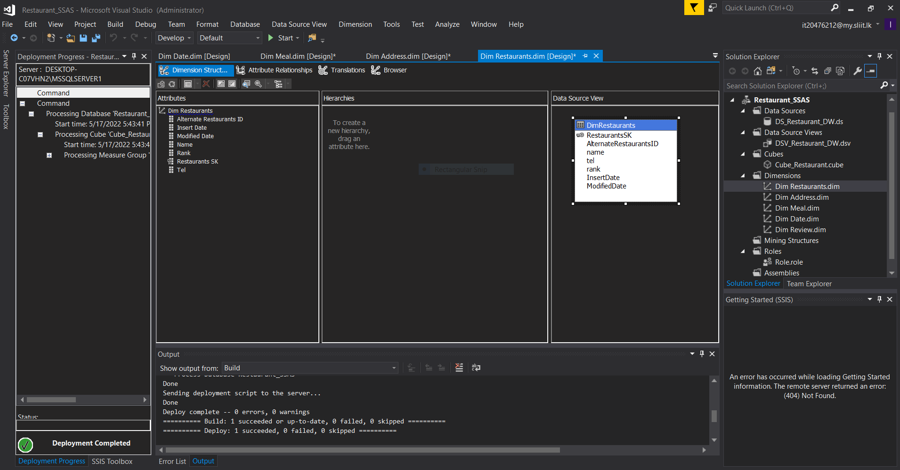

* Dim MealA screenshot of a computer

  Description automatically generated with medium confidence
* Dim Address

* Dim Review

Then Deploy the Cube.

**Create KPI**

KPI Use for monitoring measures.

KPI to find out the Price is greater than 50,000

Created KPIs were demonstrated below.

After deploying of this Cube look like this,

Browsed Cube data of KPI Price

• Browsed

# OLAP Operation

Using Excel 2016 Power Pivot we can do all OLAP operation

The SSAS cube “Restaurant_SSAS” which was created in the above step was then connected to the Excel using the MDX query.

## • Roll Up

The roll-up operation performs aggregation on a data cube, either by climbing up a hierarchy or by climbing down a hierarchy

In roll up the location hierarchy (Country->City) was used to create the report. It is simply opposite to Drill-down.

• **Drill-Down**

The Drill down operation is the reverse of roll up. It navigates from less detailed data to more detailed data.

In this drill down the restaurant address(Country -> State-> City) was used with the measures of prices.

## • Slicing

Slice performs a selection on one dimension of the given cube, thus resulting in a sub cube.

In the slicer the measures of prices are sliced using the cities.

## • Dice

The dice operation defines a sub cube by performing a selection on two or more dimensions.

* Pivot

In pivot the data axes were rotated to provide alternative presentation to data.

**SSRS Reports**

First the data warehouse which was created in assignment 1 was used as the data source.

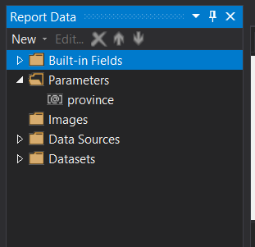

Then the dataset was created by executing a query as follows **.**

***select dm.primary_cuisiness , dm.cuisines ,***

***dr.AlternateRestaurantsID , dr.name ,***

***da.address , da.postalCode , da.city , da.province , da.country ,***

***fp.res_id , fp.Price , fp.discount***

***from FactPrice fp***

***inner join DimMeal dm on fp.MealKey = dm.MealSK***

***inner join DimRestaurants dr on fp.RestaurantsKey = dr.RestaurantsSK***

***inner join DimAddress da on fp.AddressKey = da.AddressSK***

**Report 1 - Creating a Matrix Report**

Report to display the restaurant name, located province and meal price in each month of different years.

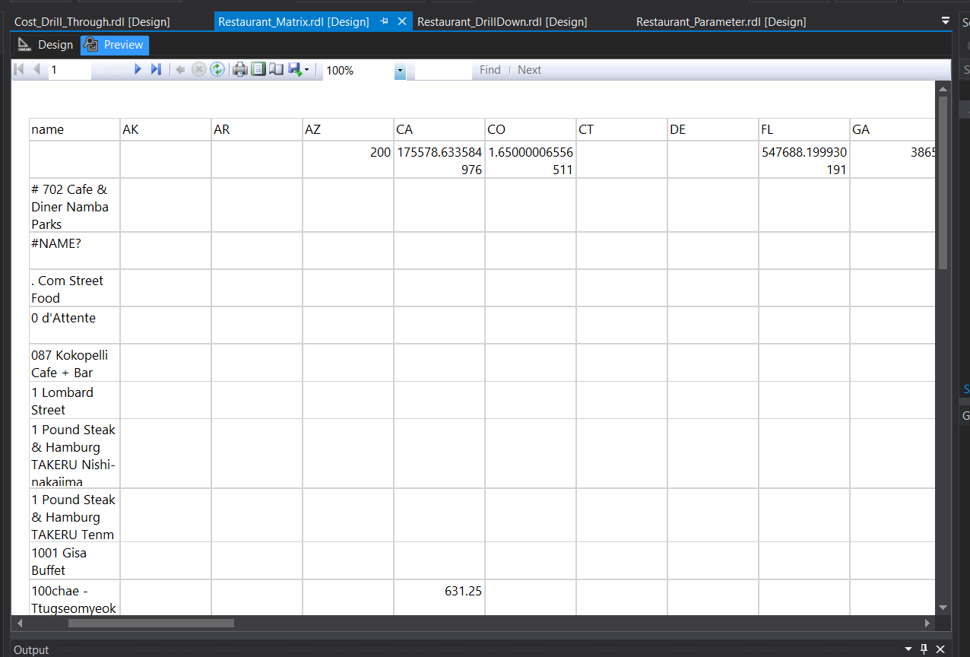

**Report 2 - Creating a Multi-Parameter Report**

Report displays the Restaurant city, country, postal code wise data. From the down the citywas selected and accordingly the postal code was selected. Postal code was selected according to the city.

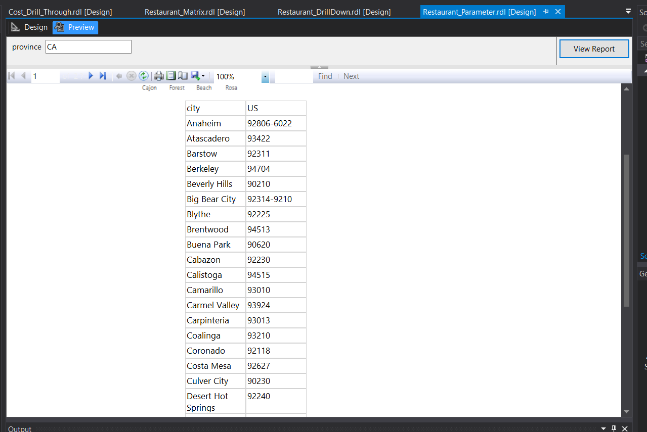

Then we can create a chart including those values.

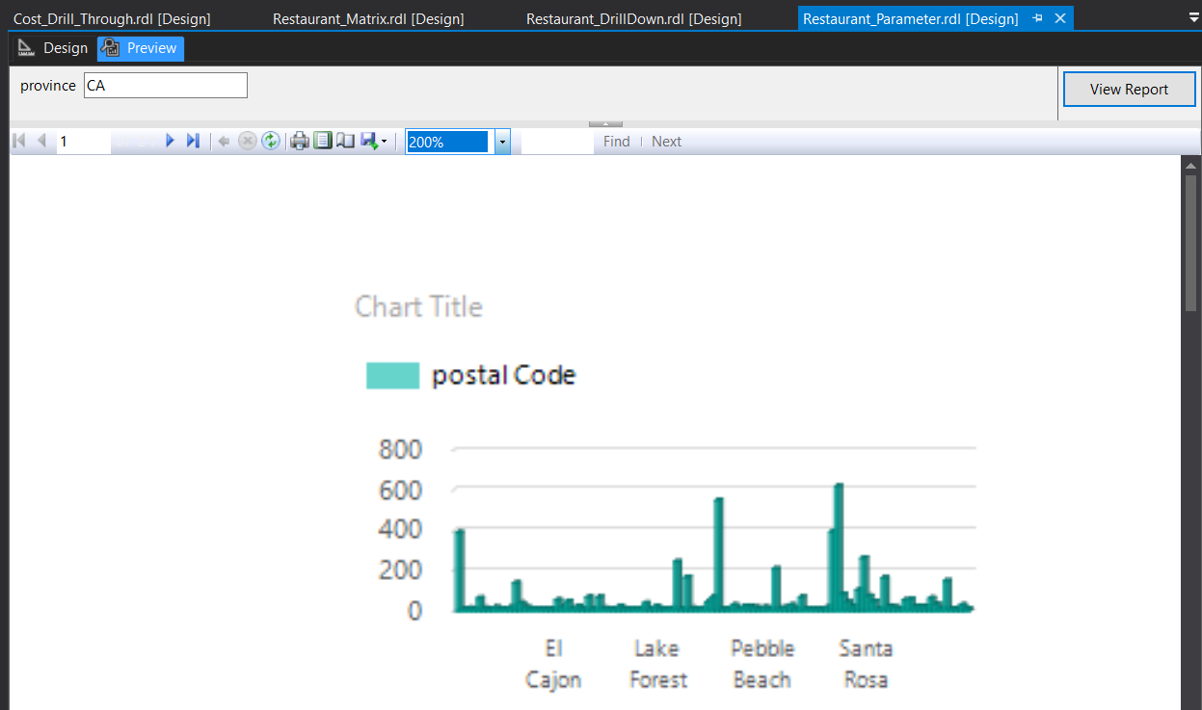

**Report 3 - Creating a Drill-Down Report**

Report to display the province, city, country, postal code total according to the restaurants’postal code ,city ,province and country.

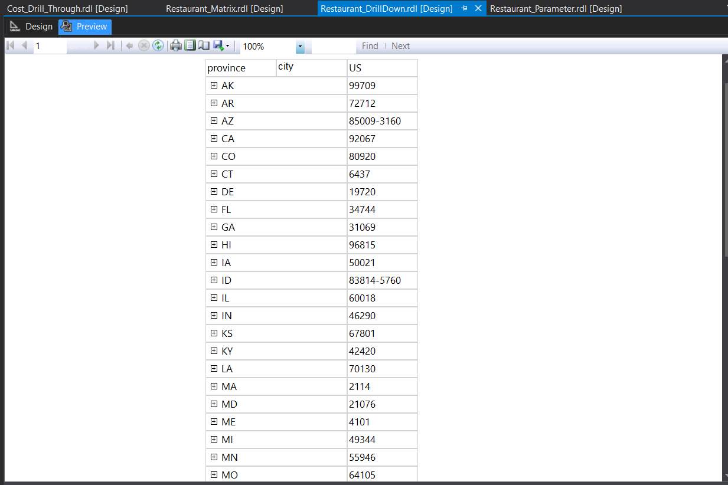

**Report 4 - Creating a Drill-Through Report**

A summarized report of prices of meals in each restaurant in each year was depicted below

