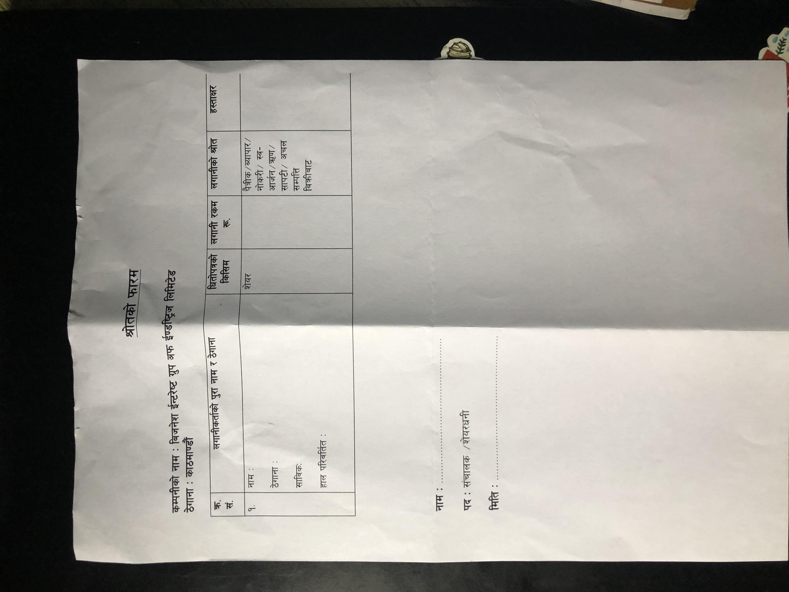

|  |  |  |  |  |  |  |  |
| --- | --- | --- | --- | --- | --- | --- | --- |
| **lit1049** |  | | | | | | |
| 4s1 k.ct3qAibl.4 |  | li  cv- | t rs | 1 |  |  | |
| 1-Pcb qA1144 |  | | | | | | |
| I 4" 1 | ..,4 | | | | | | |
|  |  | | ipal4 | |  | |  |
| Ig: If |  | | | | | | |