**Introduction of Data Structure**

Lets start with the introduction of the hype word Data Structure.

Let’s Break it first:-

Data + Structure

**What is Data?**

We really use this word in many places,in school data are the names, class, roll number of students, Faculties, etc. In office, as faculty names, products sales data, profit and loss data. All these facts concise in one word called Data.

In computers ,Data is an integral part of applications or programs.

Lets Talk what is a Program?

In view of expert(programmers), Program is a set of instructions which performs operations in the Data( the term which we discussed earlier) to get some results(or Information).

What that means? Without the Data, there is no use of instructions, or programs or even computers.

In the daily life, we hear a lot about this term DATA added to various other terms like, **Data Structures, Data Bases, Data Warehouse, Big Data**, etc.

Lets go more deep into it.

Structure means the arrangement or state.

So, **Data Structure** is an arrangement and also collection of datae, so that they and their operations can be utilized efficiently in the main memory (RAM) in computers.

So, that means, during the execution of program applications that runs in our computer mobile phones and performing those operations, that is game of data and its operation is Data Structure.

**In programming**, the term **data structure** refers to a scheme for organizing related pieces of information.

**Example:-**

How the program utilized data in main memory?

In computer, we have three basic components:- CPU, RAM, and Hard disk. In phone too, we have its processor, its RAM, and its ROM/Storage Capacity memory.

How does it all works?

Where are their Datae?

How any applications works in our PC and phones?

So, we know, in PC(windows), we have our OS installed in C drive of Hard Disk/SSD, similarly, we have android os installed in our root directory of phone’s storage. That’s the place our os and applications data( i.e. data files) reside.

When loading on our PC or phone, our OS is loaded in main memory(i.e. RAM), i.e. all the programs code/ instructions will processed and we get our os logo popping out.

Similar, goes with any applications like Chrome, Facebook, games,etc.

How these instructions are organized inside the main memory to work and execute those data operations is called as Data Structure.

**Data Bases :-** When an organization have large set of data like, banks, Multi-national Companies(MNC), or any other sectors, data should be organized with their relational data, stored in Disk. These data are stored in data relational tables. For the use of those data bases from data tables, for operations and execution, to memory, then we need some specific data structure. Hence, we know, arrangement of data structure is known as Data structure and stored data tables how, they are organized in storage devices in the form of tables is known as DataBase.

**Data WareHouse :-**  Big organizations performs huge amount of data transactions which they may not used for long term. So, data in those can be divided into two parts- operational and non-operational(legacy or old) data. This legacy or historical or old data or inactive data can be kept in array(which we will cover in sometime) of disks(multiple disk), that arranged data are Data Warehouse. Algorithms written for analying these data are Data mining Algorithms.

**Big Data :-** Internet is booming around the world since, years creating data accumulation every day. You post something in your social media account accumulates data too, millions of videos are created in youtube that creates accumulation too. Those data are of various things like, people, places, etc. By analysis of those data, lots of decisions can be taken, for management, for business analysis, for governance, etc.

Study of storing and utilizing those data is known as Big Data.

Lets go back to Data structure

Types of Data Structures

Data structure can be categorized into various types. Some of the division are as follows: -

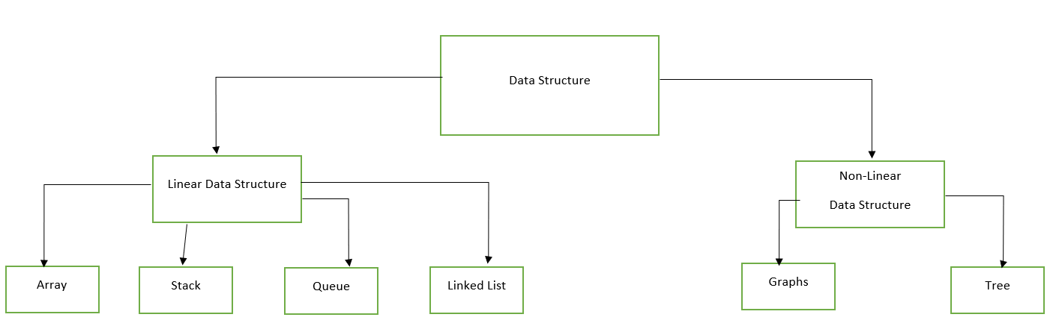

**Linear Data Structure:-**

Data are stored in linear or contiguous manner and are processed one by one is Linear data structure. Operations are performed in linear manner at one or both ends.

Example, Array, Stack, Queue, List.

**Non-linear Data Structure:**-

Data in non-linear data structure are not in sequence i.e. operations performed are irregular.

Example, Tree, Graph.

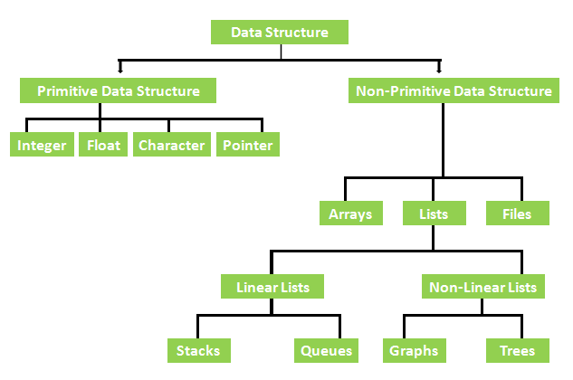

In above, we have primitive data and non-primitive data types of Data Structure. Above is the different Implementations for different types of Data

We will discuss more of it as by ADT.

Lets first understand what Data structure is. After all, we can conclude, Data structures is to store and manage data efficiently.

**Information**

Data having some meaning to it is an information. In computing, information is something stored in the memory. The basic unit we have in memory is a bits (Binary Digits) which have two values to it(o and 1 or on and off). N number of bits have 2^N possible instant. The content there arranged is the Information like we have morse code. 8-bit message can contain 1 bytes of information.

**Abstract DataType (ADT)**

Here, we will have concept ot ADT. Lets break the word again

Abstract + DataType

Lets Learn About DataType- It is defined as the representation and operations performed on data.

Example, we have interger (int) data types in C and C++, we have 2 bytes(16-bit) of memory as a single unit. Here, 1-bit is sign bit and other 15-bits consist of data or number. Operations performed in integer value are arithmetic operations.

This is Data type. In any programming language, we study about the data types and its possible operations and understand representations.

Now, lets go back to Abstract, Abstract is the hiding of internal details.

Example, above we have integer value and we can perform arithmetic operations in integer using various representative operators like +,-,/,*,%,etc. There, do we want to know how those operations in bit-level understanding for users? No, right. Without knowing them, we can use it.

So, we take here primitive data type(integer) and understand the abstract data type. This is related to OOP(Object Oriented Programming), as we can use their by making our know data types in class.

There are number of methods for specifying ADT. Lets see an example of ADT STACK.

Stack using array:-

Stack element: - 12 13 14 15 16 17 18

Index:- 0 1 2 3 4 5 6

Top in stack is at 6 index here.

/*operations*/

Push(x)

Pop(top)

Peek(top)

Traverse()

**Array**

Array is the collection of same type of variables under a common name and each elements are contiguous to each other. Array can be type of integers, character, floating, or user-defined too.

The common type of array is one dimensional array that can be represented either as a single column or as a single row.

**Initialization and Declaration of 1-D array**

Data_type array_name[size] = { ‘elements1’,’elements2’, ,,,,};

Here is a simple program to read n numbers and to find the sum and average of numbers stored in an array .

#include<stdio.h>

int main(){

int arr[100],n,add=0;

float average;

printf("Enter the number of elements in array: ");

scanf("%d",&n);

printf("Enter %d numbers: ", n);

for(int i=0; i<n; i++){

scanf("%d",&arr[i]);

add+=arr[i];

}

average=add/n;

printf("Total of numbers is %d\n Average is %f",add,average);

return 0;

}

**Structure**

Structure is the collection of variables of different types under common name. We can store multiple variables of different type under common name (user-defined). For example, in a department of institution, name of employee and student of different branch can be defined in a structure based program.

**Union**

As the name defined, Union is a special data type to store different data types in the same memory location.

The difference between Structure and union is as follows:-

