**МИНОБРНАУКИ РОССИИ**

**Санкт-Петербургский государственный**

**электротехнический университет**

**«ЛЭТИ» им. В.И. Ульянова (Ленина)**

**Кафедра Вычислительной техники**

**Курсовая работа**

**по дисциплине «Программирование»**

**Тема: Обработка текстовой информации**

|  |  |  |
| --- | --- | --- |
| Студент гр. 3312 |  | Шарапов И. Д. |
| Преподаватель |  | Аббас С. А. |

Санкт-Петербург

2023

**Содержание**

Цель работы 3

Задание (Вариант 51) 3

Постановка задачи и описание решения 3

Описание переменных 4

Схема алгоритма 4

Текст программы 5

Формат ввода 7

Контрольные примеры 7

Содержимое файлов 8

Примеры выполнения программы 10

Выводы 11

# Цель работы

Законченное поэтапное решение содержательной задачи (постановка задачи, спецификация, выбор структур данных и разработка алгоритма, программная реализация, тестирование).

# Задание (Вариант 51)

Ввести заданное количество ключевых слова и строку символов-разделителей. Затем вводится текст с неизвестным количеством строк. Ввод текста заканчивается, если после ввода строки в тексте окажется в любой последовательности все ключевые слова. Из строк введённого текста, в которых встречается хотя бы одно ключевое слово, удалить слово, имеющее минимальную длину. Вывести преобразованный текст.

# Постановка задачи и описание решения

# Структура вызова функций

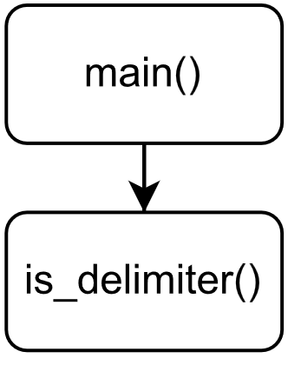

# Описание переменных

|  |  |  |  |
| --- | --- | --- | --- |
| Функция *int is_delimiter(char c, char *delimiters)* | | | |
| № | Имя переменной | Тип | Назначение |
| 1 | c | char | Проверяем: есть ли этот символ в массиве |
| 2 | delimiters | char* | Массив разделителей |
| 3 | x | char* | Указатель для перебора всех элементов |
| 4 | ans | int | Логическая переменная |
| Функция *int main()* | | | |
| № | Имя переменной | Тип | Назначение |
| 1 | r | int | Модуль хеширования |
| 2 | t | int | Первое основание хеша |
| 3 | b | int | Второе основание хеша |
| 4 | type_of_input | char | Символьная переменная для типа ввода |
| 5 | filename | char[] | Имя файла |
| 6 | f | file | Указатель на файл |
| 7 | cnt_of_keywords | int | Количество ключевых слов |
| 8 | keyword | char[] | Ключевое слово |
| 9 | x | char* | Указатель на символ |
| 10 | hash_of_word1 | long long | Первое значения хеша |
| 11 | hash_of_word2 | long long | Второе значения хеша |
| 12 | keysh | int[][] | Двумерный массив для хранения значений хеша и счетчиков |
| 13 | delimiters | char[] | Массив для хранения разделителей |
| 14 | flag | int | Флаг для ограничения ввода |
| 15 | lines | int | Количество строк |
| 16 | text | char[][] | Двумерный массив для хранения текста |
| 17 | start | char* | Указатель на начало слова |
| 18 | min_line | int | Минимальная длина слова в строке |
| 19 | cnt_words_bef | int | Количество найденных слов до этого момента |
| 20 | cnt_words_now | int | Количество найденных слов сейчас |
| 21 | min_word | char*[][] | Двумерный массив для хранения указателей на начало и конец минимального слова в каждой строке |
| 22 | type_of_output | char | Символьная переменная для типа вывода |

# **Схема алгоритма**

# Текст программы

|  |
| --- |
| **#include <stdio.h>  #define HASH_MOD 1000000009 */* Hash module */* #define HASH_B1 43 */* Hash base 1 */* #define HASH_B2 47 */* Hash base 2 */* #define MAXLEN_N 128 */* Max file name length */* #define MAXLEN_K 128 */* Max keyword length */* #define MAXKEYS 256 */* Max keywords count */* #define MAXLEN_D 64 */* Max delimiters length */* #define MAXLEN_S 512 */* Max text lines length */* #define MAXLINES 512 */* Max lines count */  /* The function checks if there is "c" in the array delimiters */* int is_delimiter(char c, char *delimiters);  int main() {  */* Block of variables */*  int r; */* Module of hash */*  int t; */* First hash base */*  int b; */* Second hash base */*  char type_of_input; */* Character variable for input type ('f' or 'c') */*  char filename[MAXLEN_N]; */* String of filename */*  FILE *f; */* File pointer */*  int cnt_of_keywords; */* Count of keywords */*  char keyword[MAXLEN_K]; */* String of keyword */*  char *x; */* Character pointer */*  long long hash_of_word1; */* Long integer for first hash value */*  long long hash_of_word2; */* Long integer for second hash value */*  int keysh[MAXKEYS][3]; */* 2D array for storing hash values and counts */*  char delimiters[MAXLEN_D]; */* Array to store delimiters */*  int flag; */* Flag for control input */*  int lines; */* Count of lines */*  char text[MAXLINES][MAXLEN_S]; */* 2D array to store text */*  char *start; */* Character pointer for the start of a word */*  int min_line; */* Minimum word length in line */*  int cnt_words_bef; */* Count of founded words before */*  int cnt_words_now; */* Count of founded words now */*  char *min_word[MAXLINES][2]; */* 2D array to store pointers to the beginning and end of the minimum word in each line */*  char type_of_output; */* Character variable for output type ('f' or 'c') */***  ***/* Block of initialization */* r = HASH_MOD;  t = HASH_B1;  b = HASH_B2;  flag = 1;  lines = 0;  cnt_words_bef = 0;   */* Info */* printf("Hello! The program removes the minimum words in the lines that contain keywords.\n");   */* Block of input */  /* Prompt the user for input type (file or console) */* printf("Input from file or console? (f/c)\n");  type_of_input = getchar();   */* Validate the input type; loop until a valid input is provided */* while (type_of_input != 'f' && type_of_input != 'c') {  printf("Something went wrong! Please enter \'f\' or \'c\':\n");  type_of_input = getchar();  }   */* Process based on the input type */* if (type_of_input == 'f') {  */* Prompt user for the file name and attempt to open the file */* printf("Please enter the file name (limit: %i chars):\n",  MAXLEN_N);  scanf("%s", filename);  f = fopen(filename, "r");   */* Continue prompting until a valid file is opened */* while (f == NULL) {  printf("Something went wrong! Perhaps such a file does not exist."  "\nPlease enter the file name again:\n");  scanf("%s", filename);  f = fopen(filename, "r");  }  } else {  */* If console input, set the file pointer to standard input */* f = stdin;  }   */* For console input, prompt for the count of keywords */* if (type_of_input == 'c')  printf("Please enter the count of keywords (limit: %i):\n",  MAXKEYS);  fscanf(f, "%i", &cnt_of_keywords);   */* For console input, prompt for each keyword and compute hash values */* if (type_of_input == 'c')  printf("Please enter the keywords (limit: %i chars):\n", MAXLEN_K);  for (int i = 0; i < cnt_of_keywords; ++i) {  fscanf(f, "%s", keyword);  x = keyword;  hash_of_word1 = 0;  hash_of_word2 = 0;   */* Compute double hash values for each character in the keyword */* while (*x != '\0') {  hash_of_word1 = (hash_of_word1 * t + (int) *x) % r;  hash_of_word2 = (hash_of_word2 * b + (int) *x) % r;  ++x;  }   */* Store the double hash values and initialize count in the keysh array */* keysh[i][0] = hash_of_word1;  keysh[i][1] = hash_of_word2;  keysh[i][2] = 0;  }   */* For console input, prompt for the line of delimiter characters */* if (type_of_input == 'c')  printf("Please enter the line of delimiter characters (limit: %i chars):\n",  MAXLEN_D);  fgets(delimiters, MAXLEN_D, f);  fgets(delimiters, MAXLEN_D, f);   */* For console input, prompt for the lines of text with specified limits */* if (type_of_input == 'c')  printf("Please enter the lines of text (limit of line\'s length: %i; limit\n"  "count of lines: %i):\n", MAXLEN_S, MAXLINES);    */* Block of main logic */  /* Loop through lines of text from the input file or console */* while (flag == 1 && fgets(text[lines], MAXLEN_S, f)) {  x = text[lines];  start = text[lines];  hash_of_word1 = 0;  hash_of_word2 = 0;  min_line = MAXLEN_S;   */* Iterate through characters in the current line */* while (*x != '\0') {  */* Check if the character is a delimiter */* if (is_delimiter(*x, delimiters) == 1) {  */* Process the word if hash values are not zero */* if (hash_of_word1 != 0 || hash_of_word2 != 0) {  */* Check if the word matches any keyword and update counts */* for (int i = 0; i < cnt_of_keywords; ++i) {  if (hash_of_word1 == keysh[i][0] &&  hash_of_word2 == keysh[i][1]) {  ++keysh[i][2];  }  }  */* Reset hash values for the next word */* hash_of_word1 = 0;  hash_of_word2 = 0;  }   */* Update minimum word information if conditions are met */* if (x - start != 0 && min_line > x - start) {  min_line = x - start;  min_word[lines][0] = start;  min_word[lines][1] = x;  }  start = x +  1; */* Move start pointer to the next character */* } else {  */* Update hash values for the current word */* hash_of_word1 = (hash_of_word1 * t + (int) *x) % r;  hash_of_word2 = (hash_of_word2 * b + (int) *x) % r;  }  ++x;  }   */* Update flag and word count information */* flag = 0;  cnt_words_now = 0;   */* Check if any keyword count is still zero, set the flag accordingly */* for (int i = 0; i < cnt_of_keywords; ++i) {  if (keysh[i][2] == 0) flag = 1;  cnt_words_now += keysh[i][2];  }   */* Update minimum word information if the current word count matches the previous one */* if (cnt_words_now == cnt_words_bef) {  min_word[lines][0] = text[lines];  min_word[lines][1] = text[lines];  }   cnt_words_bef = cnt_words_now; */* Update the previous word count */* lines++; */* Move to the next line in the text */* }   */* Close the file if input is from a file */* if (type_of_input == 'f') fclose(f);    */* Block of output */  /* Prompt the user for output type (file or console) */* printf("Output to file or console? (f/c)\n");   */* If the input was from a file, consume an extra newline character from the buffer */* if (type_of_input == 'f') getchar();   */* Get the user's choice for output type */* type_of_output = getchar();   */* Validate the output type; loop until a valid input is provided */* while (type_of_output != 'f' && type_of_output != 'c') {  printf("Something went wrong! Please enter \'f\' or \'c\':\n");  type_of_output = getchar();  }   */* Process based on the output type */* if (type_of_output == 'f') {  */* Prompt user for the file name and attempt to open the file for writing */* printf("Please enter the file name (limit: %i chars):\n",  MAXLEN_N);  scanf("%s", filename);  f = fopen(filename, "w");   */* Continue prompting until a valid file is opened */* while (f == NULL) {  printf("Something went wrong! Please enter the file name again:\n");  scanf("%s", filename);  f = fopen(filename, "w");  }  } else {  */* If console output, set the file pointer to standard output */* printf("Processed text:\n");  f = stdout;  }   */* Process and output each line of text, excluding the minimum words */* for (int i = 0; i < lines; ++i) {  x = text[i];  while (*x != '\0') {  */* Skip characters within the minimum words and update the pointer */* if (x == min_word[i][0]) {  x = min_word[i][1];  min_word[i][0] = NULL;  }  */* Output the character to the file or console */* fprintf(f, "%c", *x);  ++x;  }  }   */* If the output type is a file, display a completion message, close the file, and finalize */* if (type_of_output == 'f') {  printf("DONE");  fclose(f);  }   return 0; }  int is_delimiter(char c, char *delimiters) {  char *x;  int ans = 0;  x = delimiters;  while (*x != '\0') { */* Iterating until the end of delimiters */* if (c == *x) ans = 1;  ++x;  }  return ans; */* Return 1 if the element in the array 0 else */* }** |

# Контрольные примеры

|  |  |  |
| --- | --- | --- |
| № | Исходные данные | Результаты |
| 1 | f  input1.txt  f  output1.txt | DONE |
| 2 | f  input2.txt  c | Processed text:  Ryaba Hen  Once upon time there lived an old man and an  old woman. And they had hen, called Ryaba.  One day the hen laid an egg not a simple one,  but golden one. The old man hit it and hit it,  but couldn' break it. The old woman hit it and  hit it, but couldn't break it. A mouse was running  by, swang its tail, the egg fell and broke.  The old man crying, the old woman is crying,  but the hen is clucking, "Don' cry, grandpa, don't  cry, grandma. I'll lay you another egg, not a  golden one, but a simple one!" |
| 3 | c  4  are  simpler,  programmer  Java,    There are many other programming languages out there with  a host of cool features that make developing applications  relatively easy. You might have heard of some of these  languages like Python, Java, and JavaScript.  However, if you are new to programming and want a career  in it, you need to learn C++ first. This is because other  modern languages, while convenient and simpler, rob you of  the ability to learn important concepts that any successful  programmer should know.  f  output3.txt | DONE |

# Содержимое файлов

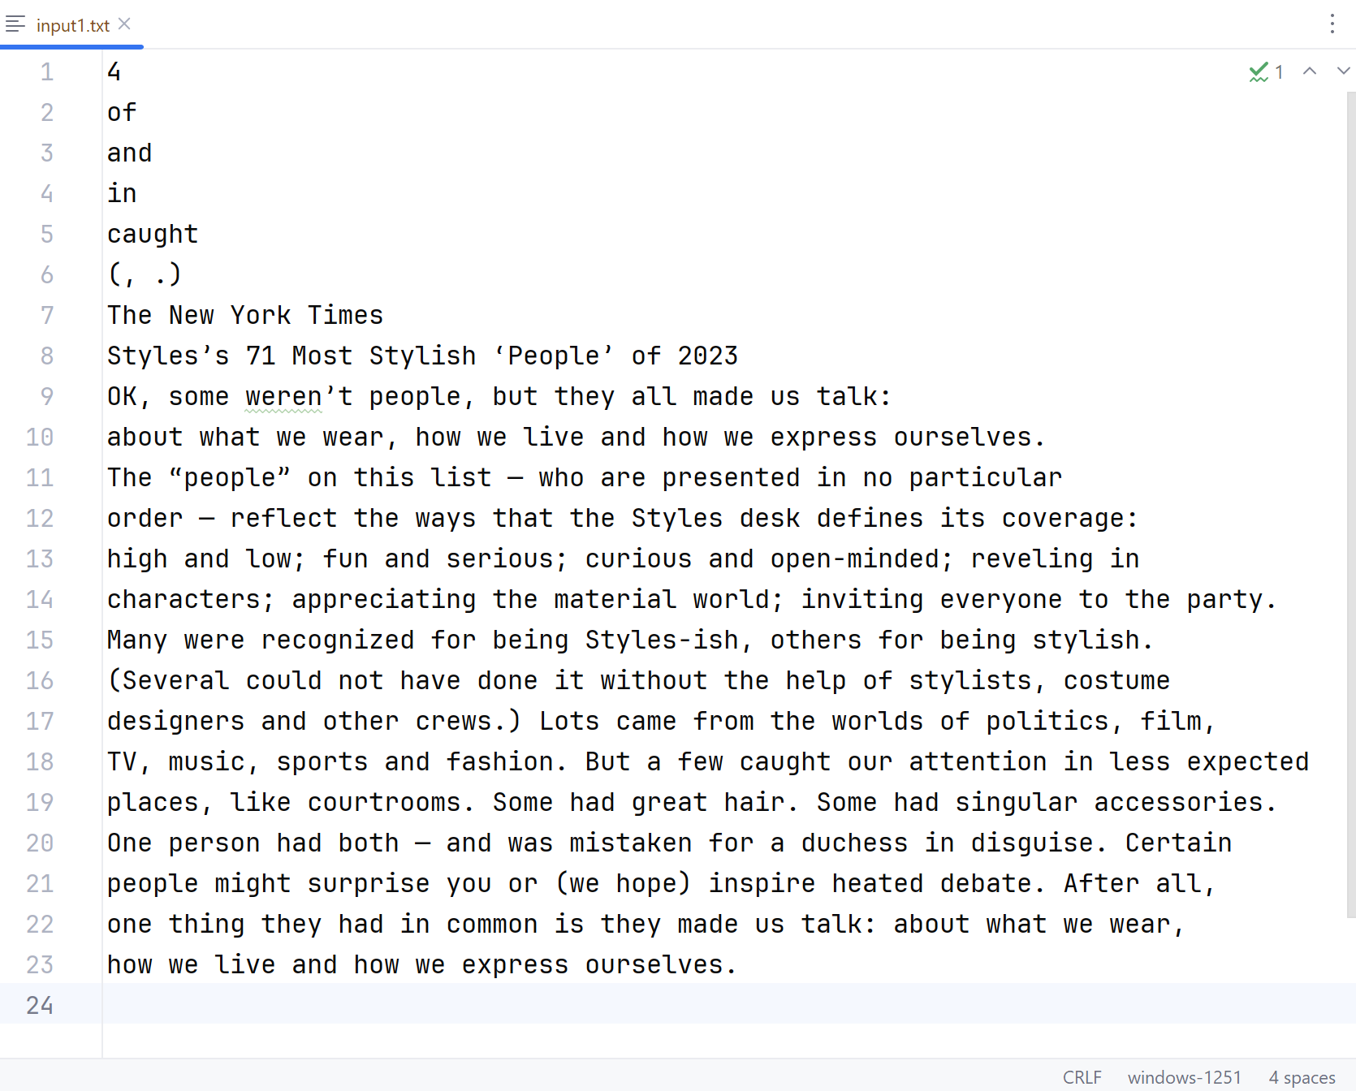

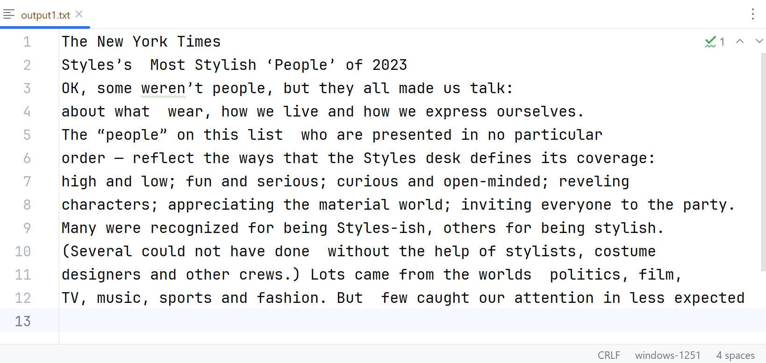

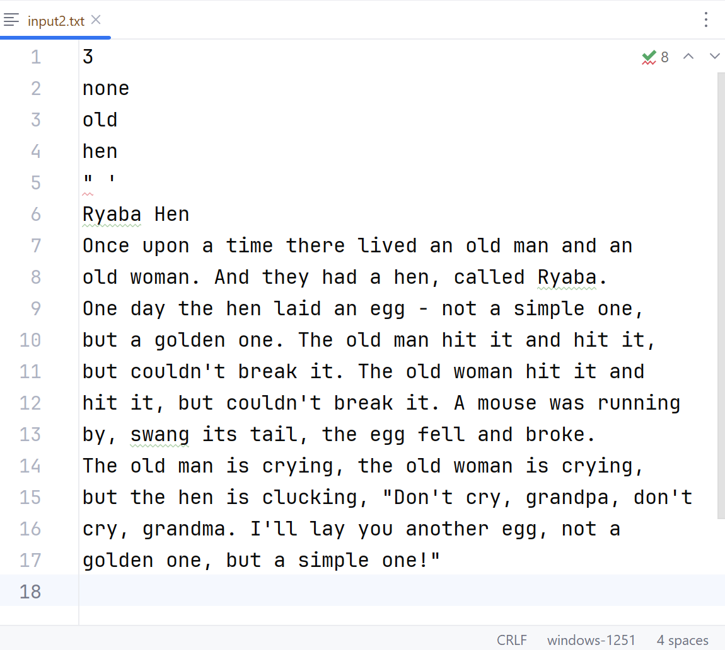

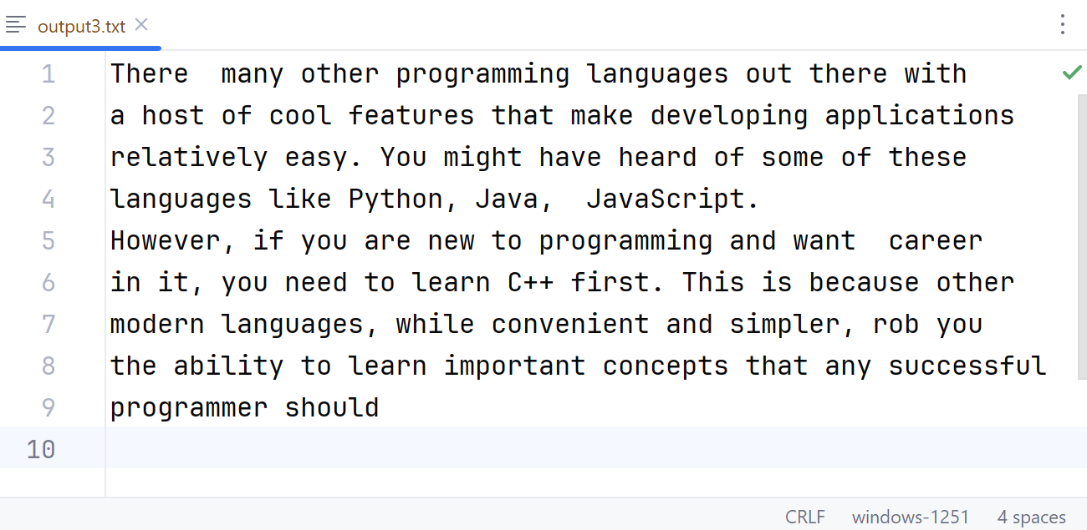

# Примеры выполнения программы

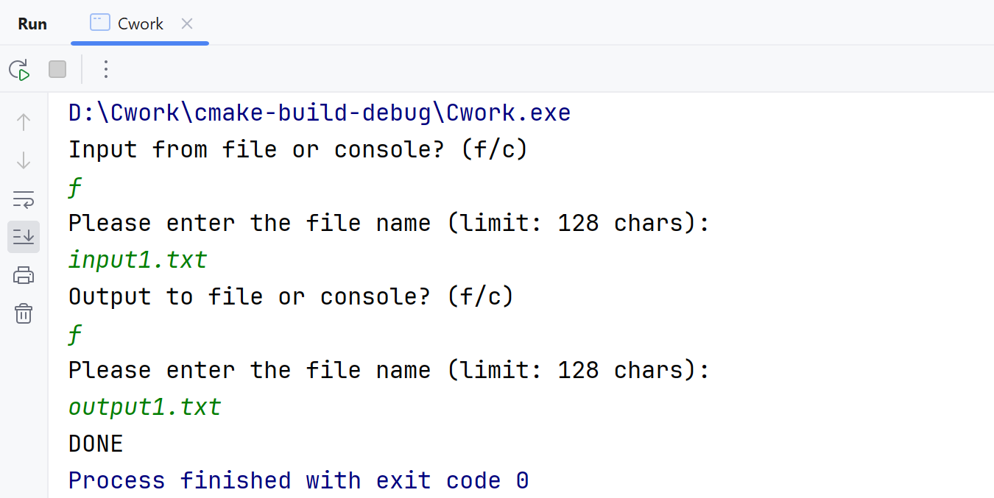

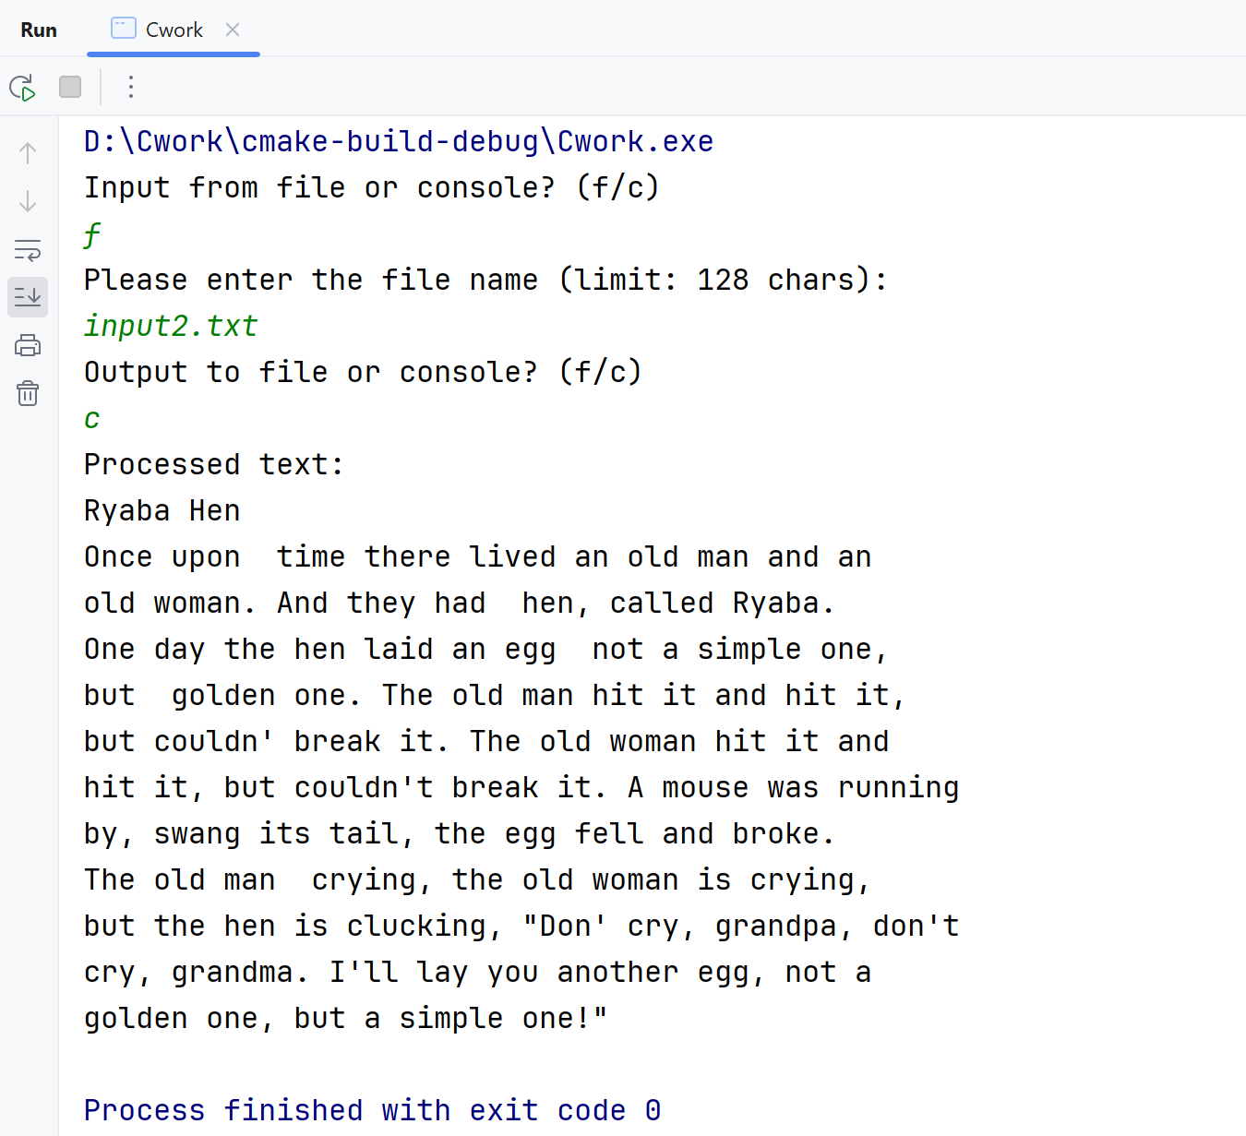

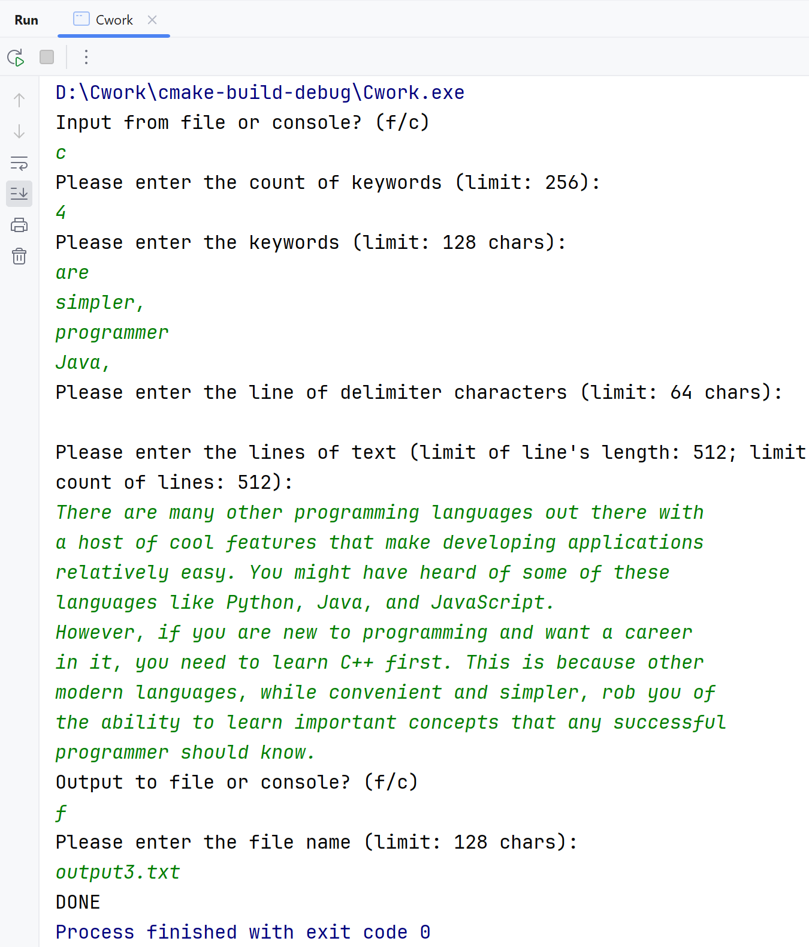

# Выводы

В работе использован только один заголовочный файл стандартной библиотеки. *<stdio.h>* используется для ввода и вывода из файла и консоли.