***“REDIRECT”***

IP DROPLET ARUBA: 80.211.234.218

***Register.it:***

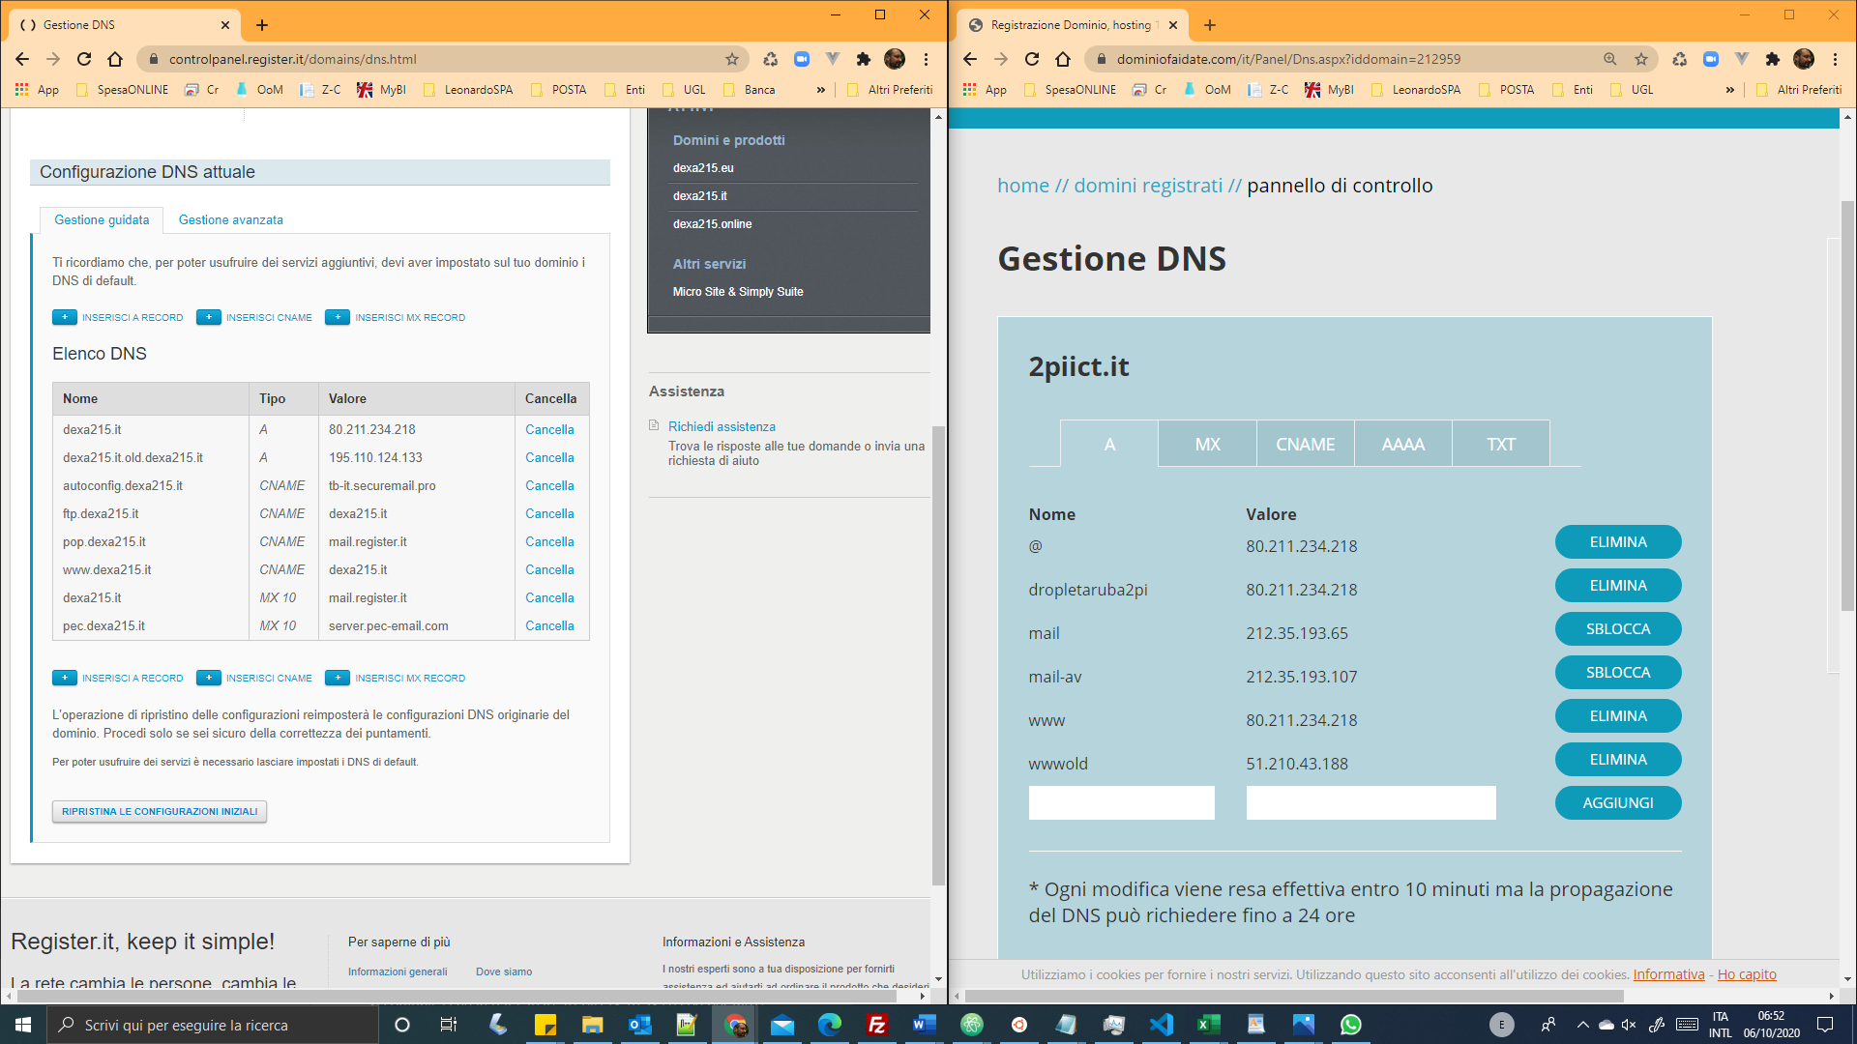

IP DEL DROPLET [ ARUBA ]

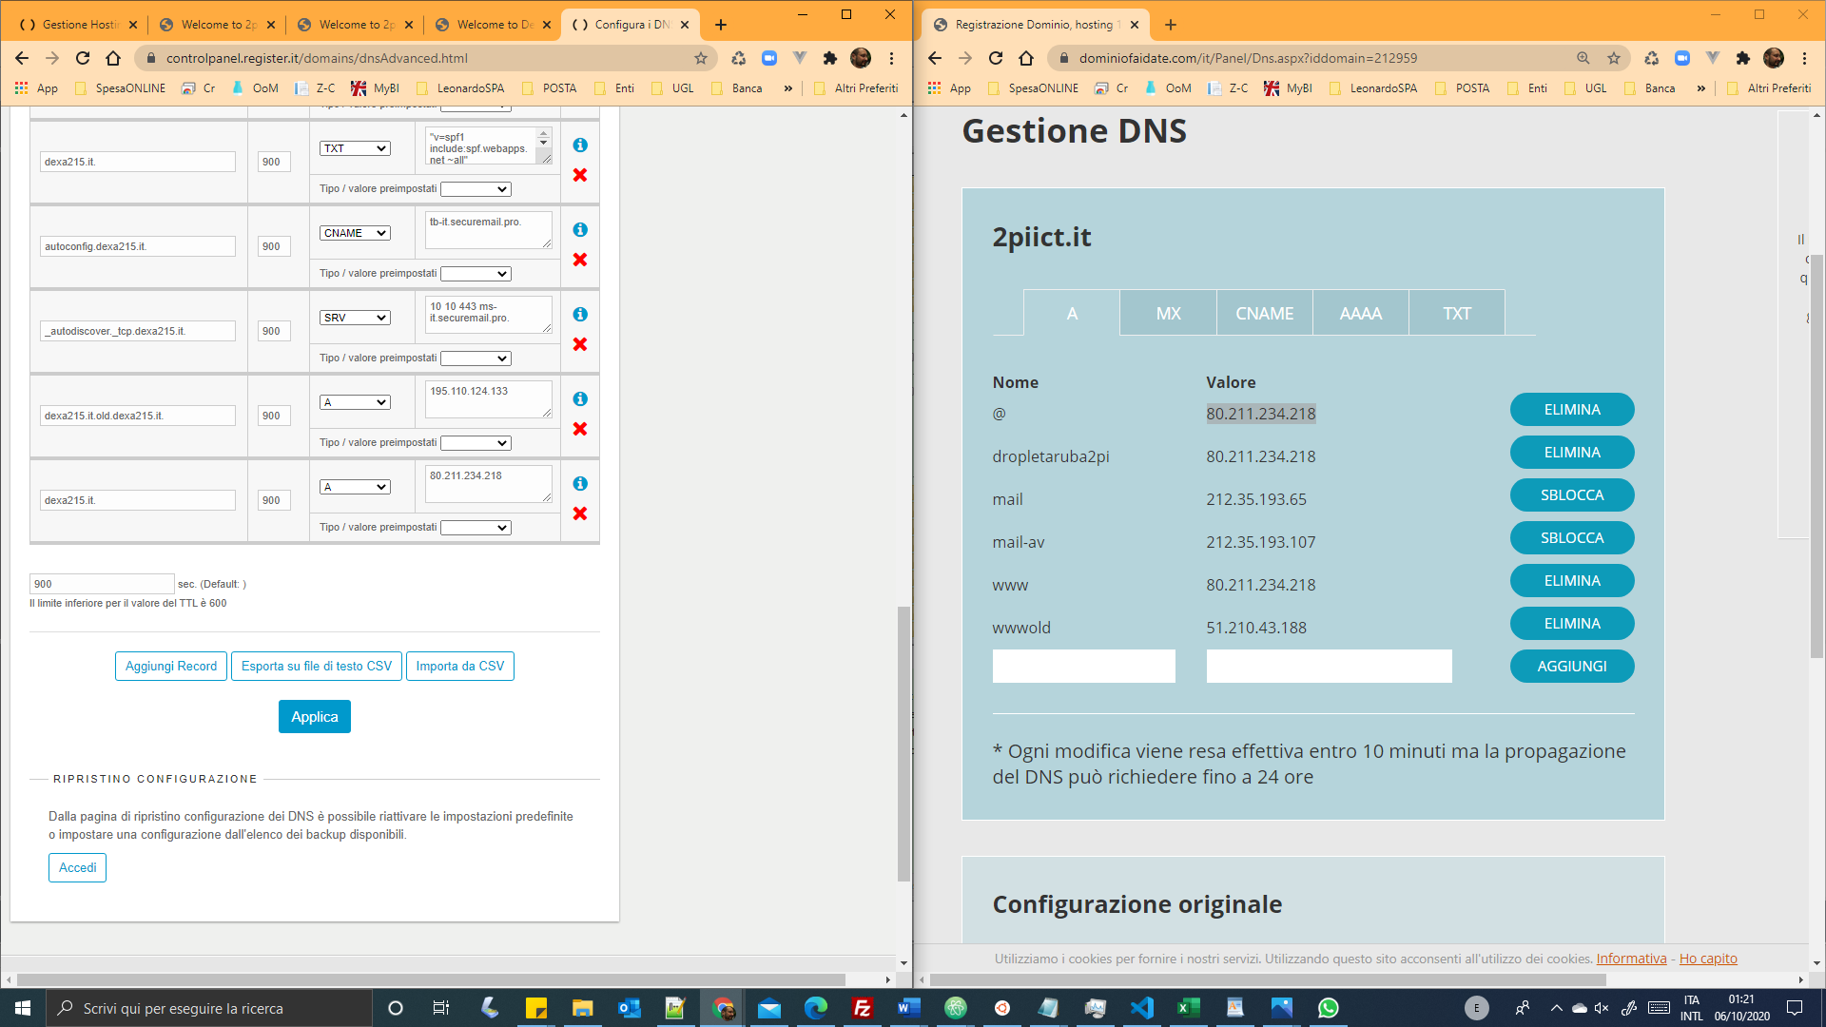

IP DEL DROPLET [ ARUBA ]  
80.211.234.218

***“REDIRECT”***

IP DROPLET ARUBA: 80.211.234.218

***DominioFaiDaTe.it:***

