
SULTANATE OF OMAN
MINISTRY OF HOUSING AND URBAN PLANNING
​
CONSTRUCTION, COMPLETION AND MAINTENANCE
OF (20 NOS.) HOUSING UNITS AND MAINTENANCE OF (32 NOS.)
HOUSING UNITS AT HALLANIYAT ISLAND
Wilayat Shaleem · Dhofar Governorate
​
PROJECT No. 023/2023
MONTHLY PROGRESS REPORT
JULY 2026
DATA DATE · 25 JULY 2026
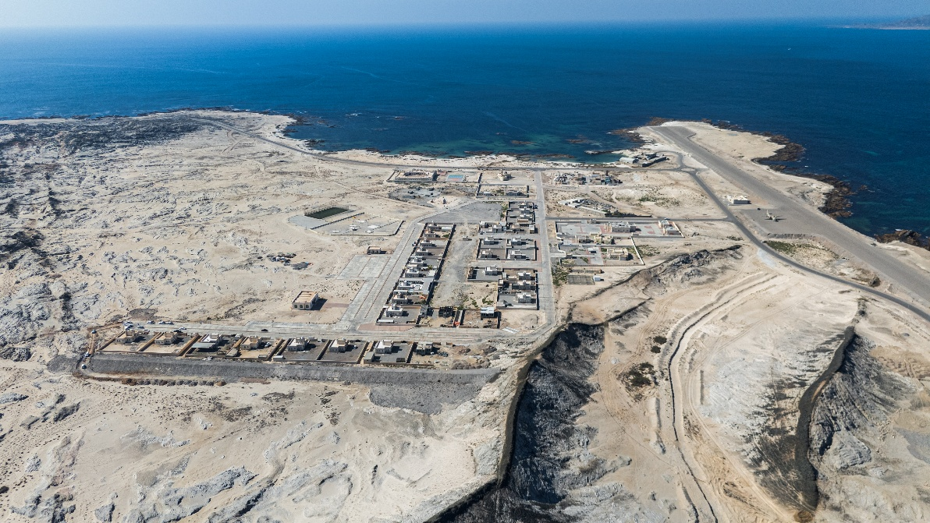
Aerial View of the Project
CLIENT    Ministry of Housing and  Urban Planning | CONSULTANT    Al Manarah Engineering  Consultancy | CONTRACTOR    East Waterfalls Trading and  Contracting Company
Salalah · Sultanate of Oman

Contents

Section | Description | Content | Page
01 | Executive Dashboard | Headline KPIs, planned vs. actual, schedule variance | 3
02 | Contract Particulars | Dates, durations, contract value and adjustment | 5
03 | Project Organisation | Organisation chart, allocated professionals, stakeholders | 6
04 | Progress by Work Breakdown Structure | Element-level planned vs. actual with variance | 9
05 | Critical Path Analysis | EWF-HI.3 trade breakdown and constraint identification | 11
06 | Financial Status | Payment register, certification curve, cash exposure | 13
07 | Resource Deployment | Labour histogram, plant and machinery deployment | 16
08 | Handover Milestones | Phase status and milestone timeline | 18
09 | Variations, Instructions and Challenges | Engineer's instructions and current issues | 19
10 | Fortnight Programme | Planned activities 25 July – 11 August 2026 | 20
11 | Outlook and Recommended Actions | Prioritised action register and run-rate analysis | 22
12 | Progress Picture Gallery | Site photographs at data date | 23
— | Annexures | A: Material Approval Status B: Shop Drawings Status | —
Click any row above to jump straight to that section · Open View ▸ Navigation Pane for the full document index
Basis of this report
Prepared by East Waterfalls Trading and Contracting Company from programme and commercial data as at the data date of 25 July 2026. Progress percentages are weighted against total contract scope. Financial percentages are expressed against the revised contract sum of OMR 4,251,632.747 as the primary basis, with the original contract sum of OMR 4,451,632.747 shown alongside; the payment register states both.

01 | Executive Dashboard | As of 25 July 2026,

PHYSICAL PROGRESS  78.87%  vs 84.99% planned · −6.12% | TIME ELAPSED  80.7%  662 of 820 days · 158 left | VALUE CERTIFIED  57.22%  OMR 2,432,697 · 54.65% orig | REVISED COMPLETION  29 Dec 2026  Original 30 Sep 2026 · +90 d EOT

Planned vs. Actual — Where the Project Stands
Physical progress, elapsed time and certified value on a common percentage scale.

Progress Composition
Achieved work, shortfall against baseline, and scope remaining.

Principal finding — a widening gap between work executed and value certified
Physical completion stands at 78.87% while cumulative certified value, including Bill No. 12, stands at 57.22% of the revised contract sum of OMR 4,251,632.747 (54.65% of the original sum). The 21.65-point spread represents approximately OMR 920,600 of executed work that has not yet converted into certified entitlement. This is the single largest commercial exposure on the project and should be addressed through an accelerated measurement and certification cycle with the Consultant.
All twelve certified bills have now been received, so no certified sum is currently outstanding; Bill No. 12, however, took 37 days from submission to certification against a project average of 10 days. Certification throughput, not measurement, appears to be the binding constraint on cash recovery.
Separately, time elapsed (80.7%) now exceeds physical progress (78.87%). With 158 days remaining, the required run-rate is 0.134% per day against a trailing performance of 0.119% per day. Section 07 shows why: labour on site is 19.5% below the revised requirement and plant deployment has halved from peak.

02 | Contract Particulars

Item | Particular | Item | Particular
Project Number | 023/2023 | Original Duration | 730 days
Mobilisation Start | 03 June 2024 | Revised Duration | 820 days
Project Commencement | 01 October 2024 | Days Elapsed | 662 days (80.7%)
Original Completion | 30 September 2026 | Original Contract Value | OMR 4,451,632.747
EOT Approved | 90 days | Revised Contract Value | OMR 4,251,632.747
Revised Completion | 29 December 2026 | Net Adjustment | − OMR 200,000.000

Contract value adjustment
The contract sum has been reduced by OMR 200,000.000 from OMR 4,451,632.747 to OMR 4,251,632.747, following removal of the provisional sum and substructure addition/omission adjustments. The Minutes of Meeting of 13 May 2026 record that the valuation basis under Clause 12.1 of the tender documents, and the consequential effect of the reduction on contractor margin, remain unresolved.

03 | Project Organisation | East Waterfalls Trading and Contracting Company

Organisation Structure
Reporting lines for the Hallaniyat Island project team.
​ |  |  |  |  |  | HEAD OF DEPARTMENT  Mr. Mohammad Hubais |  | ​
​ |  |  |  |  |  |  | ​
​ |  |  |  |  |  | PROJECT MANAGER  Mr. Muhammad Ahmed |  | ​
​ |  |  |  |  |  |  | ​
​ |  | ​ |  |  |  |  |  |  |  |  |  | ​
​ |  | ​ |  | ​ |  |  | ​ |  |  | ​ |  | ​
SITE ENGINEER  Eng. Vivek |  |  | QUANTITY SURVEYOR  Mr. Prasanth |  |  | ARCHITECT  Eng. Ahmed Hubais |  | MEP ENGINEER  Eng. Nasir Hubais |  |  | HSE OFFICER  Mr. Mohammad Talat
​ |  | ​
​ |  | ​ |  |  |  |  |  |  |  |  |  | ​
​ |  | ​ |  | ​ |  |  | ​ |  |  | ​ |  | ​
CIVIL ENGINEER  Eng. Nijas Umer |  |  | ​  ​ |  |  | CIVIL ENGINEER  Eng. Mohammad Zahid |  | ​  ​ |  |  | INVENTORY CONTROLLER  Mr. Abijit
​ |  |  |  |  |  |  | ​
​ |  |  | ​ |  |  |  |  |  |  |  | ​
​ |  |  | ​ |  |  |  | ​ |  |  |  | ​
​ | FOREMAN — EXTERNAL / PROTECTION WORKS |  |  |  | FOREMAN — DEMOLITION / NEW CONSTRUCTION |  |  |  | FOREMAN — MAINTENANCE |  |  |  | ​
Coordination with the Client and the Consultant is conducted by Mr. Mohammad Hubais, Head of Department, and Mr. Muhammad Ahmed, Project Manager. Eng. Vivek, Site Engineer, is the site focal person on behalf of East Waterfalls Trading and Contracting Company.

Allocated Professionals
Nine professionals allocated to the project, with combined relevant experience of 147.5 years.
S. No. | Name | Designation | Experience | Discipline
1 | Mohammad Hubais | Head of Department | 22 years | Management
2 | Muhammad Ahmed | Project Manager | 18.5 years | Management
3 | Prasanth | Quantity Surveyor | 32 years | Commercial
4 | Nijas Umer | Civil Engineer | 15 years | Civil
5 | Ahmed Hubais | Architect | 14 years | Architecture
6 | Mohammad Zahid | Civil Engineer | 13 years | Civil
7 | Vivek | Site Engineer | 12 years | Civil
8 | Nasir Hubais | MEP Engineer | 11 years | MEP
9 | Mohammad Talat | HSE Officer | 10 years | Safety
 | Total — 9 professionals | Combined experience |  | Avg 16.4 yrs

Stakeholder Representatives
Organisation | Representative | Role
Ministry of Housing and Urban Planning | Mr. Ahmed Al-Aamri | Director, Social Housing and Projects Department
 | Eng. Talal Habis | Section Head, Project Implementation and Follow-up
 | Mr. Said Al Shahri | Project Manager
 | Mr. Salim Al-Amri | Project Engineer
Al Manarah Engineering Consultancy | Mr. Ehab Mohammad | Project Manager
 | Mr. Ahmed Radhy | Resident Engineer
East Waterfalls Trading and Contracting Company | Mr. Mohammad Hubais | Head of Department
 | Mr. Muhammad Ahmed | Project Manager
 | Mr. Nijas Umer | Civil Engineer
 | Mr. Vivek | Site Engineer · Site Focal Person
 | Mr. Mohammad Zahid | Civil Engineer

04 | Progress by Work Breakdown Structure | Weighted % of total scope

Planned vs. Actual by Major WBS Element
Each element's weighted contribution to overall project completion.

WBS Element | Planned | Actual | Variance | Achieved | Status
EWF-HI.1 Preliminaries and Mobilisation | 5.11% | 5.11% | 0.00% | 100% | Complete
EWF-HI.2 Maintenance — Units 1–12/29 | 13.98% | 13.98% | 0.00% | 100% | Complete
EWF-HI.5 Maintenance — Units 13–20/29 | 7.90% | 7.90% | 0.00% | 100% | Complete
EWF-HI.8 Maintenance — Units 21–29/29 | 8.10% | 10.21% | +2.11% | 126% | Ahead
EWF-HI.4 Storm Water and Drainage | 4.56% | 5.35% | +0.79% | 117% | Ahead
EWF-HI.3 Construction — 23 Housing Units | 44.14% | 34.73% | −9.41% | 78.7% | Critical
EWF-HI.6 Project Handing Over | 0.28% | 0.47% | +0.19% | 168% | Ahead
EWF-HI.7 Demobilisation | 0.00% | 0.63% | +0.63% | — | Early
Project Total (as stated) | 84.99% | 78.87% | −6.12% | 92.8% | Behind

Every element except the 23 new housing units is at or ahead of baseline
Seven of the eight WBS elements are performing to or above plan, contributing a combined +3.72% of favourable variance. The entire −6.12% project shortfall, and more, originates in EWF-HI.3, Construction of 23 Housing Units.
Work stopped on 4 Units out of 20 Units, and 20% of the work is affected on the NHU Section from 23rd July 2023 Onwards
Additional Job of 2 rooms and a bathroom for 32 units started from 05 July 2026, House No. 98

05 | Critical Path Analysis — 23 Housing Units | EWF-HI.3

Structure vs. Finishes
Substructure is complete; superstructure trades are the constraint.

Substructure is 100% complete. Superstructure has achieved 11.75% against a planned 21.15% — a completion rate of just 55.6%.
Superstructure Trade Breakdown — Planned vs. Actual
Trade-level weighted progress. Services and joinery packages have barely commenced.

EWF-HI.3 Sub-Element Detail
Sub-Element | Planned | Actual | Variance | Achieved | Assessment
Completed Packages
3.1 Demolition Work | 1.43% | 1.43% | 0.00% | 100% | Complete
3.5.2 Sub-Structure Work | 21.55% | 21.55% | 0.00% | 100% | Complete
Superstructure — In Progress
3.5.1.3 Civil Work | 9.76% | 9.31% | −0.45% | 95.4% | On track
3.5.10 External Works | 0.78% | 0.48% | −0.30% | 61.5% | Lagging
3.5.1.2 Finishes Work | 5.58% | 2.12% | −3.46% | 38.0% | Critical
Superstructure — Not Substantially Commenced
3.5.1.4 Sanitaryware and Fittings | 0.96% | 0.16% | −0.80% | 16.7% | Critical
3.5.1.1 Doors and Windows | 3.17% | 0.13% | −3.04% | 4.1% | Critical
3.5.1.8 Electrical Work | 0.38% | 0.01% | −0.37% | 2.6% | Critical
3.5.1.9 TV | 0.29% | 0.01% | −0.28% | 3.4% | Critical
3.5.1.7 Air Conditioning and Mechanical | 0.62% | 0.00% | −0.62% | 0.0% | Not started
3.5.1.5 Water Supply and Drainage | 0.35% | 0.00% | −0.35% | 0.0% | Not started
3.5.1.6 Fire Fighting Installations | 0.05% | 0.00% | −0.05% | 0.0% | Not started
EWF-HI.3 Total | 44.14% | 34.73% | −9.41% | 78.7% | Critical

06 | Financial Status | Expenditure and payments

RECEIVED TO DATE  2,432,697  OMR · 57.22% revised · Bills 01–12 | CERTIFIED TOTAL  2,432,697  OMR · 57.22% rev · 54.65% orig | CERTIFIED, UNPAID  0.000  OMR · Bill 13 not yet submitted | EXECUTED, UNCERTIFIED  920,566  OMR · 21.65 pt gap on revised sum

Certification Curve — Cumulative Certified Value vs. Physical Progress

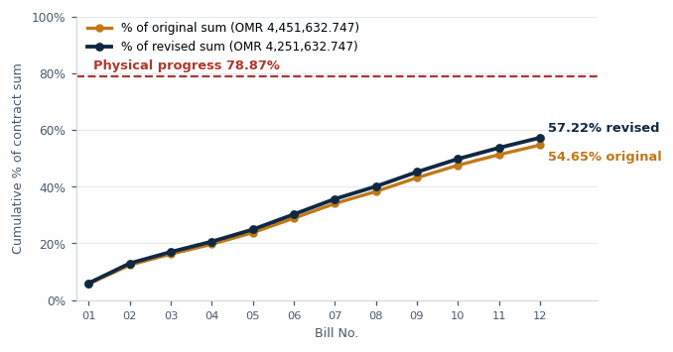
Cumulative certified value as a percentage of the revised contract sums of OMR 4,251,632.747. The dashed line marks physical progress at the data date.

Payment Register
Bill | Submitted | Claimed (OMR) | Certified | Certified (OMR) | % Original | % Revised | Status
01 | 13 Feb 2025 | 287,228.243 | 20 Feb 2025 | 252,002.034 | 5.661 | 5.927 | Received
02 | 10 Apr 2025 | 330,878.987 | 24 Apr 2025 | 296,979.015 | 6.671 | 6.985 | Received
03 | 21 May 2025 | 172,000.588 | 03 Jun 2025 | 170,905.497 | 3.839 | 4.020 | Received
04 | 03 Jul 2025 | 181,567.326 | 09 Jul 2025 | 155,378.068 | 3.490 | 3.655 | Received
05 | 25 Aug 2025 | 150,787.103 | 14 Sep 2025 | 181,709.374 | 4.082 | 4.274 | Received
06 | 16 Oct 2025 | 233,822.282 | 20 Oct 2025 | 226,822.282 | 5.095 | 5.335 | Received
07 | 10 Nov 2025 | 236,294.991 | 16 Nov 2025 | 230,273.410 | 5.173 | 5.416 | Received
08 | 16 Dec 2025 | 189,337.521 | 23 Dec 2025 | 188,303.868 | 4.230 | 4.429 | Received
09 | 29 Jan 2026 | 219,139.350 | 22 Feb 2026 | 216,791.900 | 4.870 | 5.099 | Received
10 | 03 Mar 2026 | 177,344.720 | 11 Mar 2026 | 195,681.250 | 4.396 | 4.602 | Received
11 | 26 Apr 2026 | 168,521.200 | 28 Apr 2026 | 166,605.080 | 3.743 | 3.919 | Received
12 | 23 May 2026 | 182,364.137 | 29 Jun 2026 | 151,245.342 | 3.398 | 3.557 | Received
 | Total Received (Bills 01–12) |  |  | 2,432,697.120 | 54.65 | 57.22 | Received in full
13
14
 | Total Certified (Bills 01–12) | 2,529,286.450 |  | 2,432,697.120 | 54.65 | 57.22

Claim vs. Certification Rate
Value certified as a proportion of value claimed, by bill.

Certification discipline
Cumulative claims total OMR 2,529,286.45 against certifications of OMR 2,432,697.12 — an aggregate certification rate of 96.2%, which is sound. On the revised contract sum, claims represent 59.49% and certifications 57.22%. Two bills were certified above the claimed sum (Bill 05 at 120.5% and Bill 10 at 110.3%), reflecting remeasurement of earlier under-claims.
Bill No. 12 is the outlier: certified at 82.9% of claim — the lowest rate on the project — and taking 37 days from submission to certification against a project average of 10 days. The reasons for the reduction should be obtained in writing and the balance re-presented if the deduction is not substantiated.

Basis of percentages and balance to certify
The payment register now states each bill on two bases: against the original contract sum of OMR 4,451,632.747 and against the revised contract sum of OMR 4,251,632.747. On the revised basis, cumulative certification stands at 57.22% and cumulative claims at 59.49%. The revised sum is the appropriate basis for all forward cash-flow, entitlement and margin analysis, and is used as the primary basis throughout this report.
Bills 01–12 are recorded as received, totalling OMR 2,432,697.120. The balance to certify against the revised contract sum is therefore OMR 1,818,935.627 — 42.78% of the revised value — to be measured and certified within the 158 days remaining. Of that balance, approximately OMR 920,600 relates to work already executed and awaiting certification; the remainder is scope yet to be constructed.

07 | Resource Deployment | Labour, plant and machinery

LABOUR ON SITE  91 men  vs 113 required · −22 | PEAK LABOUR  114 men  Achieved Feb-26 · now −20% | PLANT ON SITE  28 units  vs peak 59 · −53% | EQUIPMENT TYPES  26  Categories of plant deployed

Labour Histogram — Planned, Actual and Revised Requirement
Monthly manpower deployment from October 2024 to December 2026. Actual data ends at the data date.

Labour deployment is the physical cause of the schedule shortfall
At the data date the site carries 91 workers against a revised requirement of 113 — a shortfall of 22 men, or 19.5%. Manpower peaked at 114 in Feb-26 and has since fallen by 20%, at precisely the point in the programme where the revised plan calls for the highest sustained deployment of the project.
The revised programme requires labour to remain above 100 men through September 2026 before tapering. On the current trajectory that requirement will not be met, and the finishing and MEP trades identified in Section 05 cannot mobilise without it. Labour recovery is the precondition for schedule recovery.

Plant and Machinery — Peak vs. Current Deployment
Units of plant on site at the data date compared with peak deployment, by equipment type.

Plant deployment has more than halved from peak
Total plant on site stands at 28 units across 26 equipment categories, against a peak of 59 units — a reduction of 53%. The reduction is consistent with completion of the substructure and earthworks phases, which are plant-intensive.
The remaining programme is labour-intensive rather than plant-intensive, so the reduction is not in itself a concern. It does, however, confirm that the project has passed out of the phase where plant availability could constrain progress: the binding constraint is now manpower and subcontractor mobilisation.

08 | Handover Milestones and Phase Status

Maintenance Units — Phase Completion
Units handed over by phase against total scope.

Milestone Timeline
Date | Status | Milestone | Detail
28 May 2025 | ACHIEVED | Phase 1 — 9 Units Handed Over to Client | Partial Completion Certificate issued same date.
12 Dec 2025 | ACHIEVED | Phase 2 — 15/15 Units Complete | Taken over by EWF 12 Dec 2025; works accomplished 30 Dec 2025. Partial Completion Certificate issued 12 Dec 2025.
30 Mar 2026 | 90 DAYS LATE | Phase 3 — 5/5 Units Taken Over by EWF | Site access was contractually due 30 December 2025. The three-month delay in possession is the substantive basis of the prolongation claim. 2 of 5 units currently accomplished.
23 Jul 2026 | ACTIVE | Work Stopped on 4 New Housing Units | Suspension instruction currently in force. Time and cost impact to be quantified and notified.
29 Dec 2026 | TARGET | Revised Contract Completion | 158 days remaining from data date.

09 | Variations, Instructions and Current Challenges

Variations and Engineer's Instructions
Item | Date | Status
Work stopped on 4 new housing units | 23 Jul 2026 | Suspended
Additional 2 rooms and bathroom at first floor level | In progress | Ongoing
Storm water scope change (Consultant email) | 01 Jun 2025 | Survey stage
Provisional sum removed from contract | Recorded | Closed
Substructure addition/omission — 35% value reduction | Under Cl. 12.1 | Disputed

Current Challenges
Challenge | Description and Impact
Prolongation and delay entitlement | Planned versus actual handover dates across all three maintenance phases remain unresolved. A determination is required before a credible recovery programme can be proposed and agreed. This is the highest-priority commercial matter on the project.
Labour shortfall | Site carries 91 workers against a revised requirement of 113. Manpower has fallen 20% from its Feb-26 peak at the point of peak programme demand. See Section 07.
Storm water diversion channel | The change order of 01 June 2025 requires diverting flow toward the sea. Initial survey indicates the proposed alignment is technically challenging and may not be viable; alternative options are under investigation.
Weather disruption | Three days lost to adverse weather during the reporting period, recorded in the Daily Progress Reports.
Suspension of 4 new housing units | In force since 23 July 2026. Requires prompt notification of time and cost consequences to preserve entitlement.

Recovery planning is blocked pending a delay determination
A recovery programme cannot be meaningfully proposed until the prolongation entitlement is determined, because the target completion date against which recovery would be measured is itself in dispute. Resolution of this matter is the critical enabler for all other schedule mitigation and should be escalated as a matter of urgency.
Minutes of the meeting held 13 May 2026 have not yet been issued. Agenda items recorded include the 90/128-day prolongation and suspension delay claim, the tender document addition/omission under Clause 12.1, removal of the provisional sum, and the consequential effect of contract value reduction on contractor margin.

10 | Fortnight Programme | 25 July – 11 August 2026

S. No. | Plot | Activity Description | Trade
Structural and Finishing Works
1 | Plot 01 | Internal painting work | Finishes
2 | Plot 01 | Boundary wall foundation PCC work | Civil
3 | Plot 02 | External natural marble work | Finishes
4 | Plot 03 | Staircase step granite work | Finishes
5 | Plot 04 | External plaster work | Finishes
6 | Plot 06 | External design block work | Civil
7 | Plot 08 | First floor block work | Civil
8 | Plot 11 | Ground floor roof beam and slab formwork | Structure
9 | Plot 13 | First floor block work | Civil
10 | Plot 14 | GF kitchen and toilet wall tile fixing work | Finishes
11 | Plot 16 | GF kitchen and toilet floor tile laying work | Finishes
12 | Plot 91 | GF internal plaster work | Finishes
13 | Plot 91 | Compound wall gate column foundation reinforcement | Civil
14 | Plot 113 | Internal painting work | Finishes
15 | Plot 113 | Electrical and sanitary fixture installation work | MEP
Infrastructure Works and Snags
16 | Plot 93 | Preparation of drawings | Infrastructure
17 | Near Plot 91 | Slope cutting work — L-cut | Infrastructure

Programme Composition
Planned activities by trade over the fortnight.

Programme weighting does not match the critical path
Only one of the 17 planned activities addresses MEP works, yet MEP and joinery packages account for 4.71 of the 9.41 points of shortfall on EWF-HI.3. The fortnight programme is weighted toward finishes and civil work on plots already substantially advanced, rather than toward first-fix services on plots yet to commence.

11 | Outlook and Recommended Actions

# | Action | Rationale | Priority | Owner
1 | Escalate prolongation and delay determination | No credible recovery programme can be agreed while the target completion date remains in dispute. Blocks all other mitigation. | Critical | PM / Client
2 | Restore labour to the revised requirement | Site carries 91 men against 113 required — a 19% shortfall at peak programme demand. Without this, no other schedule action can succeed. | Critical | PM / HR
3 | Accelerate measurement and certification cycle | OMR ~0.92M of executed work is uncertified against the revised contract sum, and the balance to certify is OMR 1.82M. Bill No. 12 took 37 days to certify against a 10-day average. | Critical | QS / Consultant
4 | Mobilise doors, windows and MEP first-fix subcontractors | Six packages carrying 4.86% weighting have delivered 0.15%. Longest lead-time path with 158 days remaining. | Critical | MEP / Procurement
5 | Notify time and cost impact of the 23 July suspension | Four new housing units suspended. Entitlement must be preserved by prompt written notification. | High | PM / QS
6 | Rebalance the fortnight programme toward MEP | Only 1 of 17 planned activities addresses MEP, despite MEP being the dominant driver of the shortfall. | High | Planning
7 | Conclude storm water diversion feasibility | Change order dated 01 June 2025 remains at survey stage after 14 months. Initial findings indicate the proposed alignment may not be viable. | High | Engineering
8 | Request issue of Minutes of Meeting dated 13 May 2026 | Agreed positions on the prolongation claim and Clause 12.1 valuation remain unrecorded, weakening the contemporaneous record. | Medium | PM
9 | Complete remaining 3 of 5 Phase 3 maintenance units | 2 of 5 units accomplished since possession on 30 March 2026. Completion releases the final maintenance handover milestone. | Medium | Site

REQUIRED RUN-RATE  0.134 %/day  21.13% remaining ÷ 158 days | TRAILING RUN-RATE  0.119 %/day  78.87% achieved ÷ 662 days | PRODUCTIVITY UPLIFT NEEDED  +12.3%  To meet 29 Dec 2026 at current scope

12 | Progress Picture Gallery | Site photographs at 25 July 2026

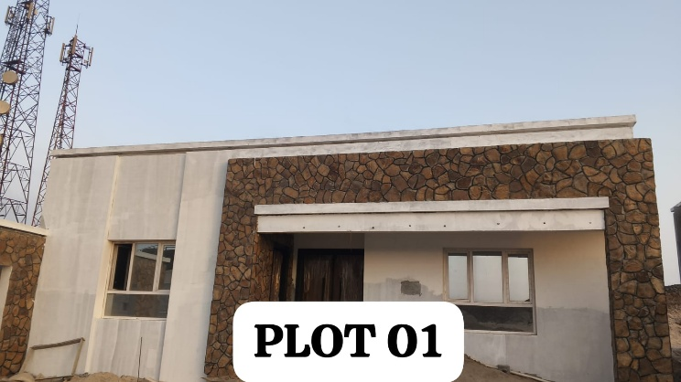  Plot 01 — external stone cladding and roof complete | 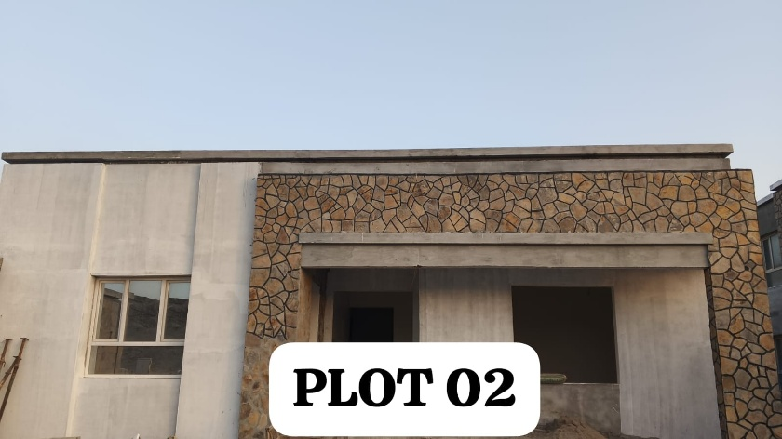  Plot 02 — external natural marble in progress
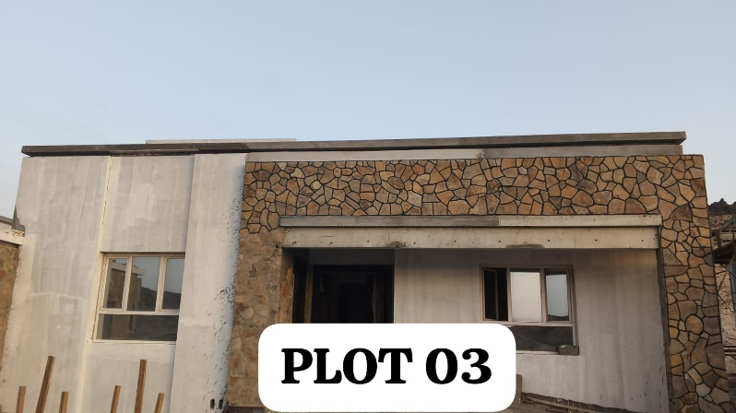  Plot 03 — external finishes advancing | 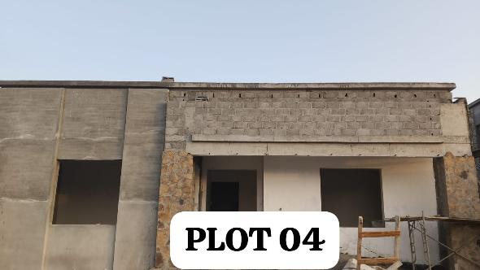  Plot 04 — external plaster stage
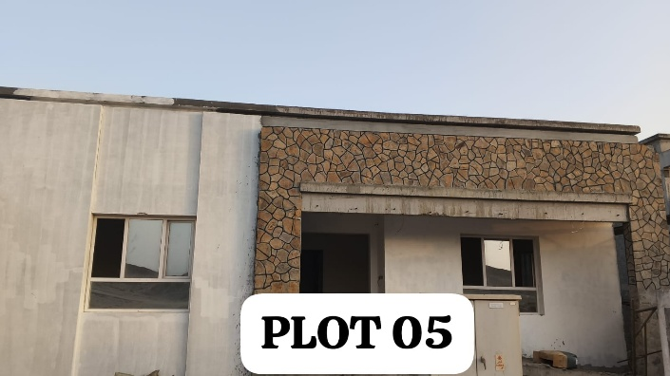  Plot 05 — stone cladding complete | 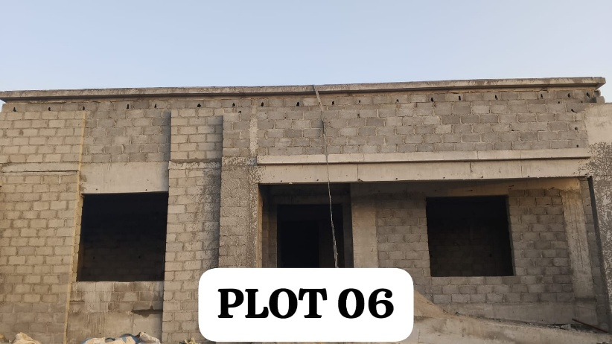  Plot 06 — blockwork and roof slab complete
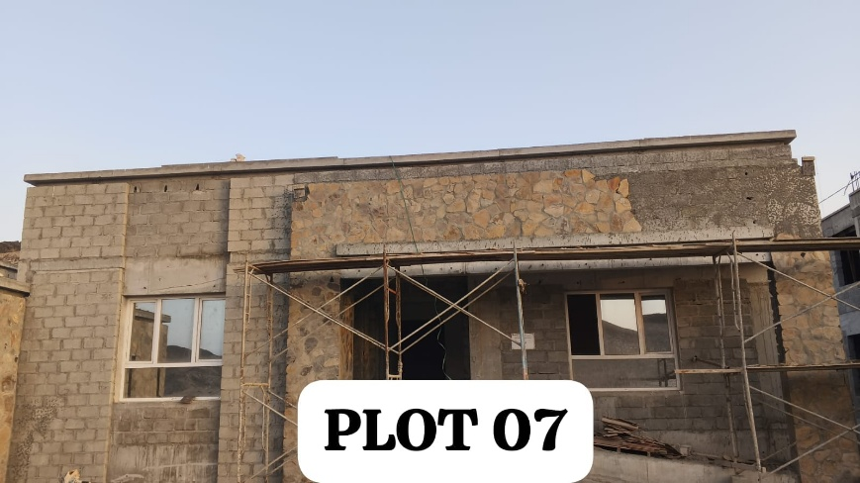  Plot 07 — scaffolding erected for stone cladding | 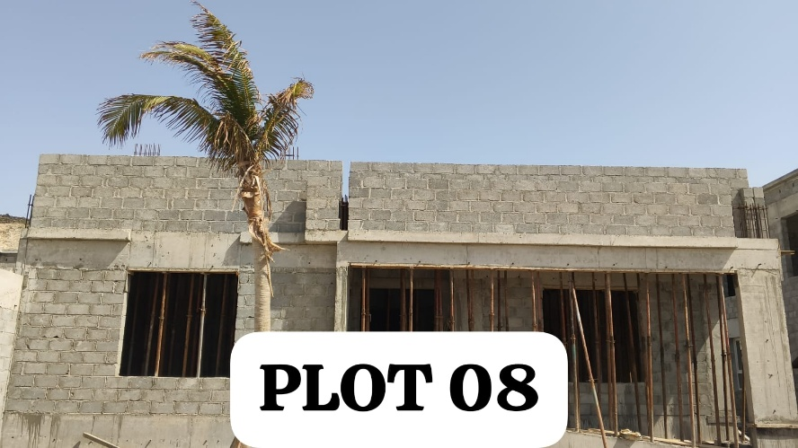  Plot 08 — first floor blockwork in progress
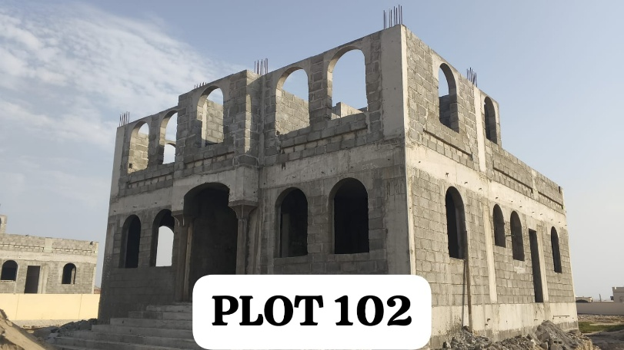  Plot 102 — two-storey unit, first floor blockwork | 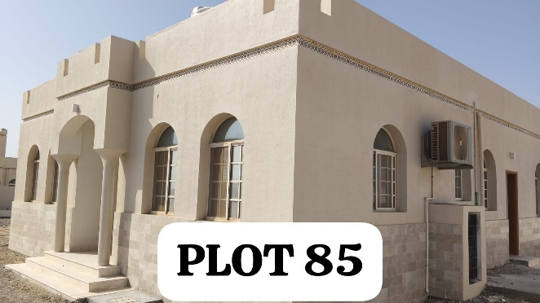  Plot 85 — maintenance unit completed and handed over
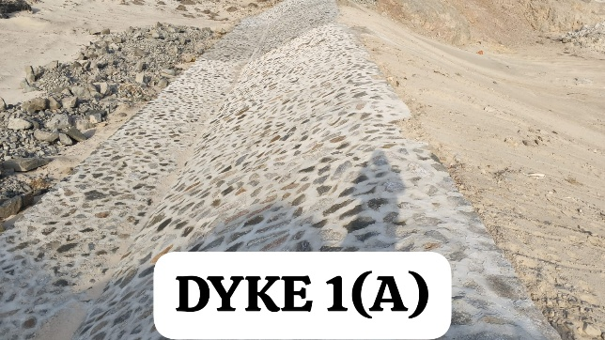  Dyke 1(A) — stone pitching complete | 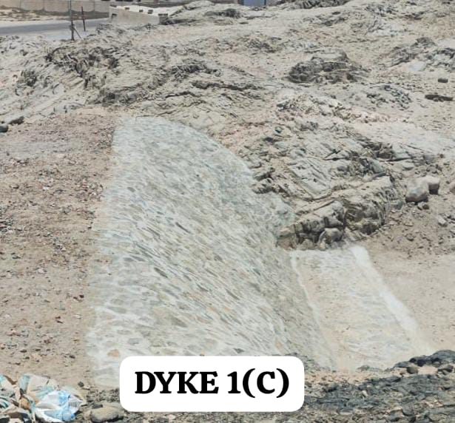  Dyke 1(C) — slope protection works
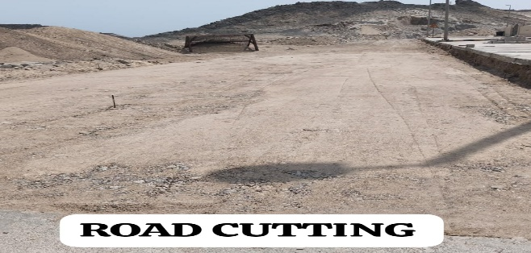
Sub-surface drainage — road cutting works

​
EAST WATERFALLS TRADING AND CONTRACTING COMPANY
Salalah · Sultanate of Oman
Prepared by · Muhammad Ahmed – Project Manager
​
MONTHLY PROGRESS REPORT — JULY 2026
Project No. 023/2023 · Date 25 July 2026
Annexure A — Material Approval Status · Annexure B — Shop Drawings Status
muhammed.ahmed@eastwaterfalls.com

