

**Project: Exploring Weather Trends**

**By Oyinloye Oluwasola Abdullahi**

**Date: 01/04/2022**

Q1. What tools did you use for each step? (SQL, Excel, Python etc)

These steps were use to extract dataset from the database using SQL queries.

Step 1: I used two SQL queries to extract my data.

* For Global Data;

SELECT *

FROM global_data

* For Local data (For Lagos);

SELECT year, city, avg_temp

FROM city_data

WHERE city = ‘lagos’

Step 2: I downloaded the data as CSV file using the “Download CSV” button and converted it to XSLX file via MS Excel.



Q2**.**  How did you calculate the moving average?

To calculate the moving average in MS Excel, I tried 7, 10, 20 year moving average to see which average is better to smooth out data. (as shown below)

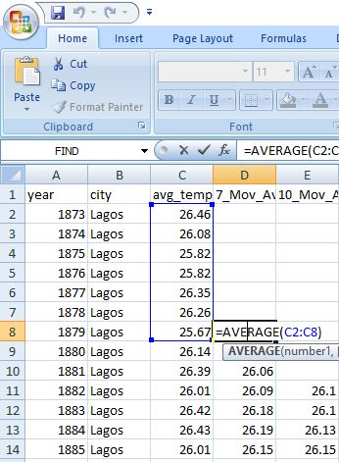

Fig: Local Average of 7 year.

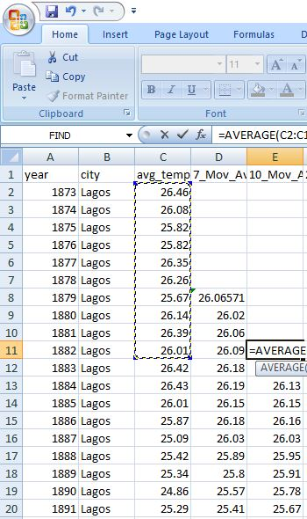

Fig: Local Average of 10 year.

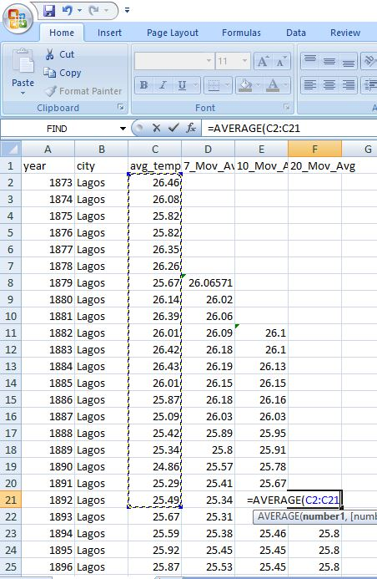

Fig: Local Average of 20 year.

Q3. What were your key considerations when deciding how to visualize the trends?

The key consideration was to determine the timeframe for data visualization. Looking at the local temperature data for Lagos, the data covers the period between 1873 to 2013, where in the global temperature data covers the period between 1750 to 2015. Therefore, the analysis was performed for the range between 1873 to 2013.

To make sure local and global temperature data is mapped correctly, we have to use VLOOKUP to retrieve the global temperature data worksheet into the local data worksheet.

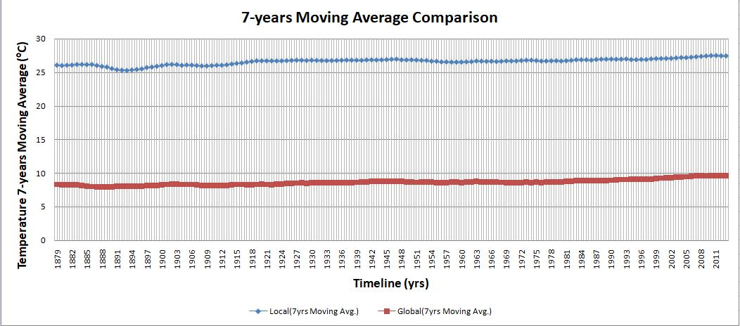

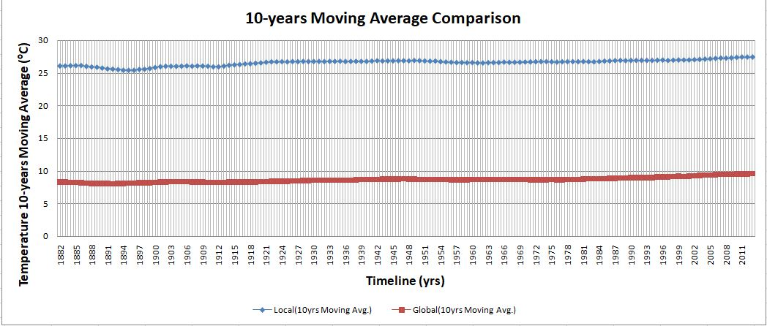

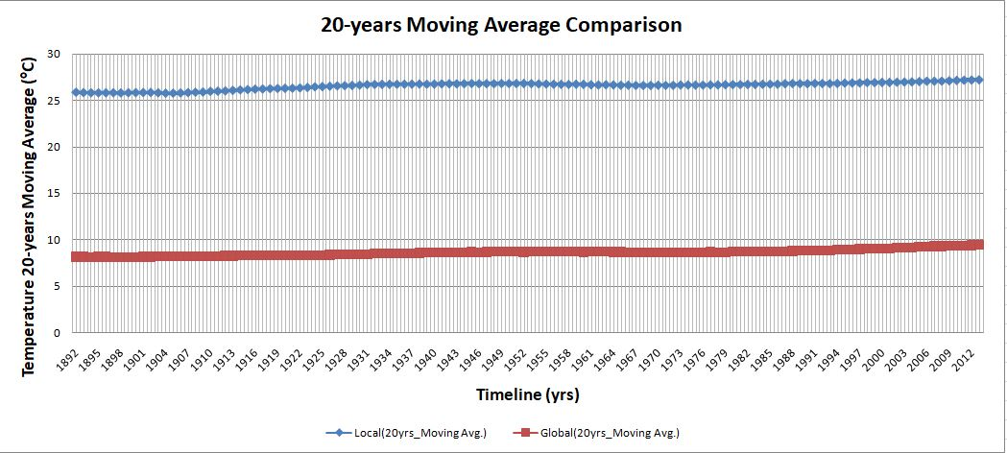

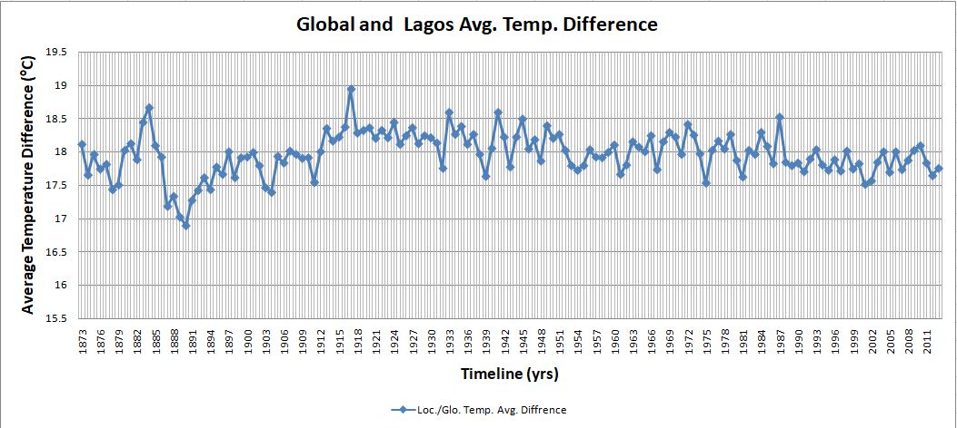

Observations:

According to the line charts the following observations may be deduced;

1. Lagos city average temperature for 7, 10, 20 years Moving Average varies between 25.8 ºC to 27.48 ºC, 25.45 ºC to 27.3 ºC, 25.75 ºC to 27.25 ºC respectively.
2. Global average temperature for 7, 10, 20 years Moving Average varies between 7.96 ºC to 9.57 ºC, 8.00 ºC to 9.56 ºC, 8.09 ºC to 9.44 ºC respectively.
3. Both global and local graphs shows increase in average temperature with time.
4. The highest difference between the local and global temperature is 18.94ºC and the lowest difference between the local and global temperature is 16.89ºC.

Conclusion:

These are evidence which suggests that the global temperature is raising over the years which support the case of of climate change.