Face Detection and Recognition

In order to detect faces on an image with sliding window technique I decided to use HOG (histogram of oriented gradients) method due to its simplicity and lower computational costs. First, I defined image_processing.py file which was responsible for operations with images specific to this project. The order of operations was as follows:
- reading input images and processing annotations.
- Resizing each bounding rectangle with face to the dimension of current sliding window used for detection
- Generating hog features for all positive examples (rectangles with faces)
- Adding extra padding to rectangles with faces for data augmentation
- For each image extracting random samples which did not overlap with bounding rectangles of faces and getting negative hog descriptors
- Saving these descriptors into a folder because processing input data each time and extracting them is a costly operation
In total I got around 12k positive hog descriptors and around 19k negative.
After getting hog descriptors it was necessary to train a classifier to distinguish positive and negative samples. I used svm with linear kernel which was performing decently.

In the main file RunProject.py I set different parameters such as threshold for detection, hog cell size, dimension of current sliding window, scale factors for image pyramid, paths to different directories etc. After multiple tests I noticed that hog cell with dimension (8, 8) outperforms the one with (6, 6). I decided to use multiple windows of different sizes since faces in train images had different sizes, some being small while others very big. After testing many of them I decided to use 6: face_windows = [(64, 64), (56,64), (48,56), (24, 24), (96, 96), (96, 104)]
In the main loop I iterate over test/validation images and detect faces using sliding window. In order to improve detection performance, I use image pyramid technique by repeatedly scaling down each region of image and testing my sliding windows on it. If model score for current region is greater than threshold a new face detection is identified. Threshold for sliding windows of smaller sizes was smaller since average model score for them was much lower than for models with higher window sizes. Since detections could overlap, non-maximal suppression was used to pick only the best detections with highest confidence score. Also, final non maximal suppression was used to get rid of overlaps from different windows. After playing with different parameters and window sizes, average precision score of around 0.73 was achieved.
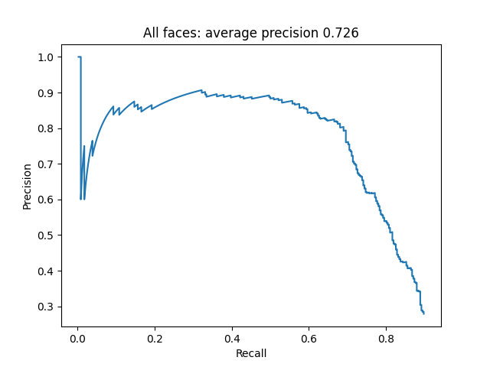
For face recognition I trained another LinearSVC model based on the same hog descriptors. This time instead of passing binary labels (0 negative, 1 positive), 4 labels were given for 4 different characters. For each final detection, the svm classifier model was deciding which character has this face. However, this classification did not produce satisfactory results with average AP score around characters just 0.28-0.29 on validation images. This demonstrated the weakness of hog approach for face recognition task. However I managed to significantly improve recognition results by concatenating color histogram of face image in hsv space. Passing with_color Boolean parameter to functions in image_processing.py I control whether I want to add color histogram features to hog descriptors. Initially I set the number of color histogram bins to 8 which improved mAP score to 0.32. After increasing number of bins to 16 (params.hist_size), mAP score 0.36 on validation data was achieved. Also for recognition sliding window size of (96, 96) obtained greater score than smaller windows.

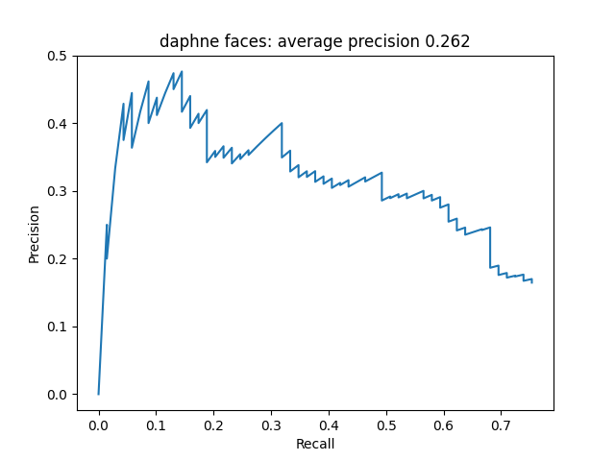
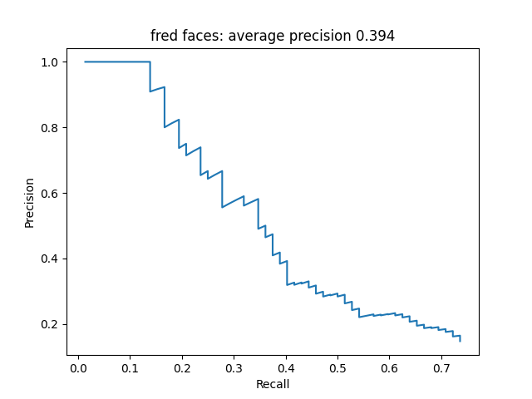

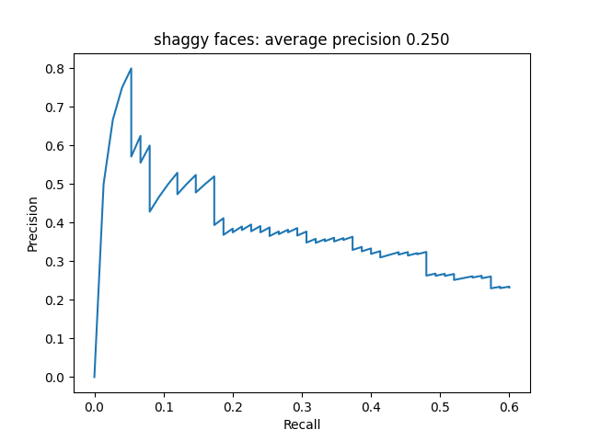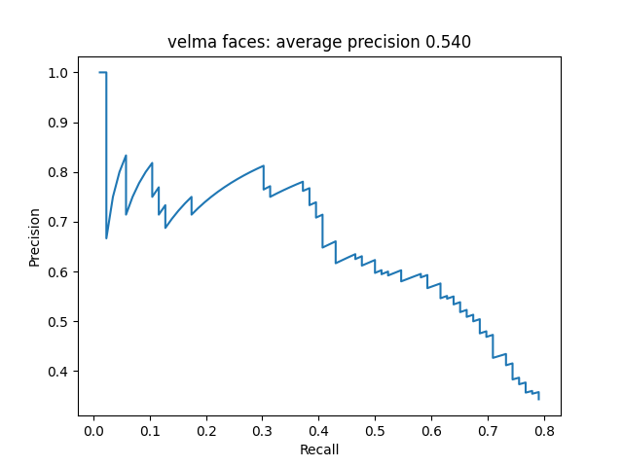

Since histograms of oriented gradients had their limitations, I decided to train a neural network for this task. I chose YOLOv5 model since it performs well in computer vision tasks. The hardest part with training this model was preparing data in a format which is used specifically by yolo. It was necessary to generate a mapping between paths to images which were scattered around different subfolders for each character and annotations. In yolo_train.py file prepare_data function is responsible for generating annotations in yolo specific format: instead of having bounding rectangle determined by min and max coordinates, x_center, y_center, width and height data was required. Also, these variables were normalized between 0 and 1. generate_path_lists function is saving a file which contains all the paths towards all the train images. Similar logic was applied in prepare_yolo_validation function. After preparing data, I started to train yolov5 model using ultralytics library. I set image_size = 300, batch_size = 8 and trained my model only for 5 epochs due to the limitations of my GPU. However, even with these parameters the model achieved great performance. Around 0.94 AP score on detection and 95+ AP score on character recognition. By training model for more epochs, increasing image size and using different image transforms even greater performance can be achieved.

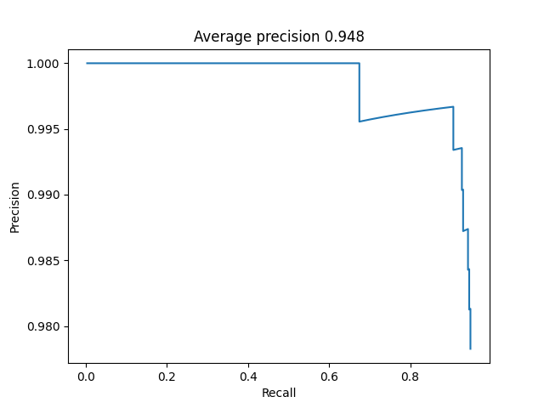

By comparing hog approach with yolo neural network it is obvious that yolo significantly beats classical approaches. Since images contain a lot of pixels, neural networks are better suited to finding non linear relationships in such data.

Code guide + project launch setup

Project contains the following python files: FacialDetector.py, image_processing.py, Parameters.py, RunProject.py, Visualize.py, yolo_train.py.
RunProject.py is the main entry point to the project, it runs detection and classification with hog descriptors. image_processing.py performs different operations on images and reads input data annotations. FacialDetector.py has methods for training svm classifiers, non-maximal suppression, main sliding window loop and evaluation of detections. yolo_train.py is a separate script for preparing data for yolo model, training it and getting its predictions for validation/test images. In MovieFaceDetection/CavaTema2… folder there are initial folders for this task with input images. Also this folder contains folder saved_files with hog descriptors, svm models, visuals which show detections and so on. It also has some files needed for yolo model.
In MovieFaceDetection/code folder there are scripts used for this project as well as yolov5.pt initial model. In runs folder there are different folders and files specific to yolo model and its training process. This folder also contains the best model which obtained 94+ AP score.

Output path to detections: detections output .npy files are saved in directory MovieFaceDetection/CAVA-2025-TEMA2/saved_files/solution for base solution with hog. For yolo solution the last folder in this path will be changed to yolo_solution. These folders contain subfolders task1 and task2 which contain .npy files for evaluation.

How to run: Both RunProject.py and yolo_train.py files can be launched without passing any command line arguments. Below are the details.
FaceDetection hog: run RunProject.py, specifically main() method, test_recognition() can be commented.
FaceRecognition hog: run RunProject.py, specifically test_recognition() method, main() can be commented.
YOLO detection and recognition: For testing purposes just run yolo_train.py
In run_yolo method it depends on desired execution. For training from scratch commented lines in run_yolo() should be uncommented to prepare data for yolo model and train it. Already trained model can also be used by loading it from runs/detect/train/weights/best.pt and running get_yolo_predictions function.

Paths adjustment: In evalueeaza_solutie.py solution path should be adjusted. For hog solution it should be: "../../saved_files/solution/",
for yolo: "../../saved_files/yolo_solution/"
In MoviFaceDetection/yolo_setup_data.yaml absolute path should be changed in path variable. The changed path should point to Cava-2025-Tema2 directory.

Validation vs testing: if test folder is used instead of validation, is_test variable in Parameters.py should be set to True. Also test folder should be named testare and have the same structure as validation folder, otherwise paths should be further adjusted manually.

