BANGALORE UNIVERSITY, JNANA BHARATHI CAMPUS



PROJECT REPORT ON
“CODIFY AI: A Smart AI Architect”
Submitted in the partial fulfillment of the requirement for the
award of degree of
Bachelor of Computer Applications
Submitted by
DEEKSHITH. D
(U03FS23S0041)
Under the guidance of
YASHAVANTH S R
(Assistant Professor)

KLE Society’s Degree College, Nagarbhavi, Bangalore-560072
2025-2026
KLE Society’s Degree College
[Affiliated to Bangalore University, Jnana Bharathi Campus, 3rd Block, Nagarbhavi 2nd Stage, Bangalore– 560072]
Bachelor of Computer Applications


CERTIFICATE

This is to certify that the project entitled “CODIFY AI: A Smart AI Coding Agent” bonified work carried by Deekshith. D with USN: U03FS23S0041 with in partial fulfillment for the award of degree in Bachelor of Computer Applications of Bangalore University during the year 2025-2026.The project report has been approved as it satisfies the academic requirement in respect of project work prescribed for the said degree.
Signature of Guide Signature of Co-Ordinator
YASHAVANTH S R Dr. Parvati N Angadi

Name of the Examiners: Signature
1.

2.

DECLARATION

I, Deekshith. D with USN:U03FS23S0041 studying in 6th semester BCA, KLE Society’s Degree College, Nagarbhavi, Bangalore declares that the project work entitled “CODIFY AI: A Smart AI Coding Agent ” submitted to Bangalore University during year 2025-2026 is an original work carried under the guidance of Mr. YASHAVANTH S R Assistant Professor, Bachelor of Computer Applications, KLE Society’s Degree College, Nagarbhavi, Bangalore and this project is submitted in the partial fulfillment of the requirement for the award of degree of Bachelor of Computer Applications

PLACE: BENGALURU DEEKSHITH.D
DATE: ROLL NO: U03FS23S0041

ACKNOWLEDGEMENT

I consider it a great privilege to place my deepest sense of gratitude and sincere thanks to beloved Co-Ordinator Dr. Parvathi N Angadi for her cooperation, guidance, and supervision during this project.
I am extremely thankful and wish to express my sincere gratitude to my respected guide Assistant Prof.
Yashavanth for his kind co-operation and providing valuable suggestions and constant encouragement for the improvement and successful completion of this project. I would like to express my pure and sincere thanks for the guidance, timely advice, support, sincere co-operation, suggestion, ideas provided by all the teaching staff and non-teaching staffs of the Bachelor of Computer Applications, K.L.E Society's Degree College, Nagarbhavi, Bangalore

Deekshith. D
ROLL NO: U03FS23S0041

ABSTRACT

Codify AI is a next-generation, AI-powered code synthesis and data engineering platform designed to eliminate "Syntactic Friction" in modern software development lifecycles. The system leverages the Meta Llama-3.3-70B large language model served through the Groq LPU (Language Processing Unit) inference engine, achieving near-instantaneous response throughputs of approximately 500 tokens per second. Built on the Python Streamlit framework, the platform provides a glassmorphism, neon-cyberpunk user interface with a secure user authentication system backed by an SQLite3 relational database. Key features include AI-driven generation of Python scripts, SQL queries, DAX/M Query (Power BI), Tableau calculated fields, Excel and Google Sheets formulas, along with intelligent dataset ingestion from CSV, Excel, and SQLite file formats. The application incorporates a real-time query history audit trail, animated landing and boot-sequence pages, and a custom interactive mascot. Codify AI is architected on a clean 3-Tier model -- Presentation, Logic, and Data layers -- ensuring scalability, maintainability, and secure operation.
TABLE OF CONTENTS

CONTENTS | PAGE NO.
1. INTRODUCTION
1.1 Project Description | 01
1.2 Purpose | 03
1.3 Scope | 03
2. LITERATURE SURVEY | 04
3. EXISTING SYSTEM | 09
4. PROPOSED SYSTEM | 11
5. MODULES | 12
6. HARDWARE AND SOFTWARE REQUIREMENTS
6.1 Hardware Requirements | 16
6.2 Software Requirements | 17
7. SOFTWARE REQUIREMENTS SPECIFICATION
7.1 Users | 19
7.2 Functional Requirements | 20
7.3 Non-Functional Requirements | 21
8. SYSTEM DESIGN
8.1 Architecture Diagram | 23
8.2 Context Flow Diagram | 24
9. DETAILED DESIGN
9.2 Use Case Diagram | 28
9.3 Database Design | 30
9.4 ER Diagram | 31
10. IMPLEMENTATION
10.1 Screenshots | 32
10.2 Coding | 39
11. SOFTWARE TESTING | 48
12. CONCLUSION | 51
13. FUTURE ENHANCEMENT | 53
Bibliography | 57
User Manual | 58

LIST OF FIGURES

Fig. No. | Title | Page No.
8.1 | System Architecture Diagram | 23
8.2 | Context Flow Diagram (DFD Level 0) | 24
8.3 | DFD Level 1 | 25
8.4 | DFD Level 2 | 25
9.1 | Use Case Diagram | 28
9.2 | ER Diagram | 31
10.1 | Landing Page Screenshot | 32
10.2 | Login / Registration Page Screenshot | 33
10.3 | AI Code Generator Interface Screenshot | 35
10.4 | AI Response Output Panel Screenshot | 36
10.5 | Query History Sidebar Screenshot | 37

CHAPTER 1
INTRODUCTION

1.1 Project Description
Codify AI is an advanced, AI-driven code synthesis and data engineering assistant built using Python and the Streamlit web framework. The platform is designed to serve as an intelligent pair programmer, capable of generating production-ready code in multiple languages and tools, including Python, SQL, Power BI DAX/M Query, Tableau Calculated Fields, Excel formulas, and Google Sheets formulas. The system draws its inference capabilities from the Meta Llama-3.3-70B large language model, served via the Groq Cloud infrastructure, providing near-instantaneous responses at approximately 500 tokens per second.
The platform exposes a rich, multi-page application architecture: a visually immersive landing page featuring a 3D animated particle sphere and glassmorphism bento-grid cards; a secure login and registration system with SHA-256 hashed credentials stored in an SQLite3 database; a cinematic "boot sequence" HUD transition; and the core AI code generator interface. A persistent query history sidebar provides an at-a-glance audit trail of recent code generations, while the inline dataset ingestion feature allows users to attach CSV, Excel, or SQLite database files for context-aware AI analysis.
The user interface is distinguished by its neon-cyberpunk aesthetic: a deep navy (#020617) background, crimson-to-purple gradient buttons, Space Grotesk and Fira Code typography, and interactive canvas-based backgrounds. A custom SVG robot mascot (Dexter) provides interactive visual feedback, covering its eyes during password input and watching the user type prompts.
The application is deployable both locally via the Streamlit development server and on cloud platforms such as Streamlit Community Cloud and Vercel (via serverless adaptation).

1.2 Purpose
The primary purpose of Codify AI is to significantly reduce the cognitive overhead and time burden associated with writing repetitive or complex code. In modern software development and data engineering workflows, developers and analysts routinely spend disproportionate amounts of time on "Syntactic Friction" -- the mechanical act of translating well-understood requirements into correctly formatted, syntactically valid code. Codify AI resolves this bottleneck by providing instant, context-aware code generation.
- Accelerate development velocity by automating boilerplate and formula generation.
- Democratise access to complex data manipulation techniques for non-expert users.
- Provide a reusable, extensible AI assistant framework for data science workflows.
- Demonstrate a production-grade integration of a Large Language Model (LLM) into a web application.
- Implement secure, ACID-compliant session management with user authentication.
1.3 Scope
The scope of Codify AI encompasses the following dimensions:
- Language Support: Python, SQL, Power BI (DAX/M), Tableau, Excel, Google Sheets.
- Dataset Ingestion: CSV, XLS, XLSX, SQLite (.db, .sqlite, .sqlite3) file formats.
- Authentication: User registration, login, password reset with SHA-256 hashing.
- History & Audit: Persistent, per-session query history stored in SQLite.
- UI/UX: Fully responsive, animated, multi-page web application.
- AI Backend: Groq API with Llama-3.3-70B-Versatile model.
The system is currently scoped for single-user desktop and lightweight cloud deployment. Enterprise multi-tenancy, RAG (Retrieval-Augmented Generation) with private vector databases, voice commands, and CI/CD pipeline integration are deferred to future versions.

CHAPTER 2
LITERATURE SURVEY

The development of Codify AI is informed by a substantial body of research across three adjacent domains: Large Language Models (LLMs) for code generation, human-computer interaction in AI-assisted programming tools, and lightweight web frameworks for AI application deployment.
1.Evaluating Large Language Models Trained on Code
Authors: M. Chen, J. Tworek, H. Jun, Q. Yuan, et al.
Published in: arXiv 2021
Link: https://arxiv.org/abs/2107.03374
Summary: OpenAI introduced Codex, a GPT-based model fine-tuned on GitHub repositories, demonstrating that LLMs could solve competitive programming problems with significant accuracy. This work established the baseline for AI code generation and motivated the use of instruction-tuned LLMs as coding assistants.
2. CodeGen: An Open Large Language Model for Code with Multi-Turn Program Synthesis
Authors: Erik Nijkamp, Bo Pang, Hiroaki Hayashi, Lifu Tu, et al.
Published in: arXiv 2022
Link: https://arxiv.org/abs/2203.13474
Summary: Salesforce Research proposed CodeGen, a family of open-source models trained on multi-step program synthesis. This research highlighted the importance of conversational, multi-turn interactions in code generation tools, a principle reflected in Codify AI’s prompt enrichment strategy.

3. Llama 2: Open Foundation and Fine-Tuned Chat Models
Authors: Hugo Touvron, Louis Martin, Kevin Stone, Peter Albert, et al.
Published in: arXiv 2023
Link: https://arxiv.org/abs/2307.09288
Summary: Meta released Llama 2 as a robust, openly available foundational model. The subsequent Llama-3.3-70B-Versatile model employed in Codify AI represents the state-of-the-art of this lineage, demonstrating superior instruction-following capability and code generation quality.
4. Program Synthesis with Large Language Models
Authors: Jacob Austin, Augustus Odena, Maxwell Nye, Maarten Bosma, et al.
Published in: arXiv 2021
Link: https://arxiv.org/abs/2108.07732
Summary: Google Brain researchers evaluated LLMs on the MBPP benchmark, finding that scaling model size and dataset quality dramatically improved synthesis accuracy. This informed the selection of the 70-billion parameter Llama model for Codify AI over smaller variants.
5. Grounded Copilot: How Programmers Interact with Code-Generating AI Systems
Authors: S. Barke, M.B. James, and N. Polikarpova
Published in: ACM SIGCHI 2023
Link: https://doi.org/10.1145/3544548.3581310
Summary: This empirical study revealed two dominant programming modes: "exploration" and "acceleration." Codify AI addresses both modes through its open-ended prompt interface and structured output with step-by-step execution guides.

6. Groq LPU Inference Engine Technical Overview
Authors: Groq Inc.
Published in: White Paper 2024
Link: https://groq.com/tech-overview/
Summary: The Groq Language Processing Unit (LPU) is a purpose-built architecture optimized for sequential token generation. Delivering deterministic, low-latency streaming at ~500 tokens/second, this throughput advantage enables the "instantaneous" user experience in Codify AI

CHAPTER 3
EXISTING SYSTEM

Several AI-powered coding assistant tools currently exist in the market and academic space. A critical analysis of these systems reveals the specific gaps that Codify AI is designed to address.
3.1 GitHub Copilot
GitHub Copilot, developed by GitHub and OpenAI, is an IDE-integrated AI pair programmer that provides inline code completions and function suggestions directly within Visual Studio Code, JetBrains IDEs, and nvim. It is trained on public repositories from GitHub.
Limitations:
- Requires subscription ($10-$19/month for individuals).
- IDE-locked: not accessible as a standalone web interface.
- No native support for data analytics tools (DAX, M Query, Tableau, Excel formulas).
- No dataset context ingestion; cannot reason about uploaded CSV or database files.
- No user authentication or query history persistence.
3.2 Amazon CodeWhisperer
Amazon CodeWhisperer is an AI coding companion integrated into popular IDEs. It generates code suggestions in real time and includes security scanning features.
Limitations:
- Primarily focused on AWS service integration and cloud-specific code patterns.
- Limited support for data engineering languages beyond Python and Java.
- No web-based standalone interface for non-developers.
- No dataset ingestion or formula generation capability.

3.3 ChatGPT (OpenAI)
ChatGPT provides a conversational interface for code generation across virtually all programming languages. It is accessible via a web browser and mobile application.
Limitations:
- Generalised tool: not optimised or role-prompted for specific data tools (Power BI, Tableau).
- No persistent per-user query history or code generation audit trail.
- No structured output format (Execution Guide, Explanation, Expected Output).
- No dataset file upload with schema-aware AI analysis (free tier).
- API response latency (2-5 seconds for GPT-4) versus Codify AI's <1 second Groq LPU response.
3.4 Replit Ghostwriter
Replit Ghostwriter is an AI assistant embedded in the Replit online IDE, focused on web development and Python scripting.
Limitations:
- Platform-locked to the Replit ecosystem.
- No analytical formula generation (DAX, LOD, Excel).
- No support for structured database ingestion.
3.5 Summary of Drawbacks in Existing Systems
Feature | Copilot | ChatGPT | Codify AI
Multi-tool code gen | No | Partial | Yes
Dataset ingestion | No | Partial | Yes
Role-specific prompts | No | No | Yes
Query history | No | No | Yes
User authentication | No | No | Yes
Sub-1s latency | Yes | No | Yes
Standalone web app | No | Yes | Yes

CHAPTER 4
PROPOSED SYSTEM

Codify AI proposes a holistic, web-native AI assistant that directly addresses each limitation identified in the existing system analysis. The proposed system is characterised by the following design pillars:
4.1 Multi-Tool Intelligence
Unlike general-purpose LLM wrappers, Codify AI injects carefully engineered, role-specific system prompts for each target language or tool. The system acts as an expert Python data scientist, a Senior SQL DBA, a Certified Power BI developer, a Tableau Server Certified Associate, and an advanced Excel/Google Sheets specialist, depending on the user's selection. This domain expertise injection dramatically improves the quality and correctness of the generated output compared to a generalised prompt.
4.2 Contextual Dataset Ingestion
The system supports direct upload of CSV, Excel (XLS/XLSX), and SQLite database files. The AI receives the full schema (table names, column names, data types, row counts) and up to 50 preview rows in its context window, enabling it to generate schema-accurate queries and transformations against the user's actual data -- a capability not available in most existing tools.
4.3 Structured Output with Execution Guides
Every AI response is formatted into three mandatory sections: a Step-by-Step Execution Guide with numbered steps, a Code/Formula Explanation in plain English, and an Expected Output description. This structured output significantly reduces the user's time-to-productivity compared to raw code dumps.

4.4 Secure Authentication and Persistent History
The proposed system incorporates a complete user lifecycle: registration with SHA-256 hashed passwords, login verification, password reset, and session management via Streamlit's session state. All query history is persisted to a local SQLite3 database, providing a reusable audit trail across sessions.
4.5 High-Performance Inference via Groq LPU
By routing all LLM inferences through the Groq API, Codify AI achieves sub-0.8 second cold start latency -- compared to 2-5 seconds for GPU-based inference APIs. This performance characteristic is fundamental to the interactive, "instantaneous" user experience.
4.6 Advantages of the Proposed System
- Cross-platform, browser-accessible web interface -- no IDE installation required.
- Domain-expert AI responses tailored to six different data tools and languages.
- Schema-aware code generation from user-uploaded datasets.
- Persistent, searchable query history for knowledge management.
- Production-class security with hashed credentials and environment variable secret management.
- Extensible, modular architecture ready for RAG and multi-modal enhancements.

CHAPTER 5
MODULES

Codify AI is structured into the following six functional modules:
Module 1: Landing Page Module
The landing page is the first point of contact for every user. It renders a full-screen, interactive 3D particle sphere animation built using a custom HTML5 Canvas script injected into the Streamlit host page. The sphere tracks cursor movement and displays 120 colour-coded particles (crimson, amber, white) in a rotating 3D formation alongside 120 twinkling stars with parallax displacement. The bento-grid layout presents six feature cards: Automated Coding, AI Integration (arc-reactor animation), Security & Compliance, Deployment & Scaling, and a "Get Started" CTA. Users navigate to the Explore Features page or directly to login.
Module 2: Authentication Module
The authentication module governs all user identity management operations. It exposes three operational modes via the login_mode session state flag: login, register, and forgot_password. A kinetic dot-matrix canvas background is displayed on the login page. The SVG mascot (Yuji) responds dynamically to user input: the eyes shift when the username field is focused, and the paws cover the eyes when the password field is active. All credentials are stored in the codify_pro.db SQLite database with SHA-256 hashed passwords.

Module 3: Boot Sequence Module
Following successful authentication, a cinematic HUD boot sequence plays four sequential messages: "INITIALISING CORE SYSTEMS", "CALIBRATING NEURAL INTERFACE", "ENGAGING PRIMARY DRIVES", and "HUD ONLINE. WELCOME, BUDDY." Each message appears with a pop-in CSS animation over a dark overlay with CRT-style scanlines. The sequence lasts approximately 3.2 seconds before yielding to the main application.
Module 4: AI Code Generator Module (Core Module)
The generator module is the central feature of Codify AI. It comprises:
- A 3D glassmorphism prompt input area with perspective CSS transforms and focus-glow effects.
- An interactive mascot (Dexter) in "hands-on-cheeks, watching" pose above the prompt.
- A multi-format file uploader supporting CSV, Excel, and SQLite files.
- A language/tool selector supporting six target environments.
- A "Synthesize" CTA button that triggers the Groq API call.
- A rotating cube loading animation during inference.
- A structured response output panel with the mascot in a "leaning" pose alongside the output.
System prompts are dynamically assembled from tool-specific instruction templates, enriched with the mandatory STEP_GUIDE suffix that enforces the three structured output sections.
Module 5: History & Sidebar Module
The sidebar module renders the animated Codify AI logo (SVG circuit-flow overlay on a PNG base), navigation buttons (Neural Generator, Tech Manifesto), a "RECENT LOGS" expander showing the three most recent queries from the SQLite history table, and a session termination button. The history display uses st.expander components with embedded st.code blocks for syntax-highlighted code previews.

Module 6: Technical Manifesto Module
The documentation/manifesto page provides a self-referential technical overview of the Codify AI platform in four glass-card sections: Project Abstract & Vision, 3-Tier Architectural Decoupling, Performance & Development Methodology, and Future Scope: The AI Agent Roadmap. This module serves as an in-app technical reference for developers and evaluators.

CHAPTER 6
HARDWARE AND SOFTWARE REQUIREMENTS

6.1 Hardware Requirements
Component | Minimum Specification | Recommended Specification
Processor | Intel Core i3 / AMD Ryzen 3 (2.0 GHz dual-core) | Intel Core i5/i7 / AMD Ryzen 5/7 (3.0 GHz quad-core)
RAM | 4 GB DDR4 | 8 GB DDR4 or higher
Storage | 500 MB free disk space | 2 GB SSD (for virtual environment & DB)
Network | 2 Mbps internet connection | 10 Mbps broadband (for Groq API low latency)
Display | 1280 x 720 px | 1920 x 1080 px (Full HD)
GPU | Not required | Not required (inference is cloud-side via Groq)
Input Device | Standard keyboard & mouse | Standard keyboard & mouse

6.2 Software Requirements
Software | Version | Purpose
Operating System | Windows 10/11 / Ubuntu 22.04 / macOS 13+ | Host platform
Python | 3.9 - 3.12 | Core runtime language
Streamlit | >= 1.32.0 | Web application framework
Groq Python SDK | >= 0.5.0 | Groq LPU API client
python-dotenv | >= 1.0.0 | Environment variable management
Pandas | >= 2.0.0 | Dataset ingestion & transformation
openpyxl | >= 3.1.0 | Excel file read/write
SQLite3 | Built-in (Python stdlib) | Persistence layer (users & history)
Web Browser | Chrome 120+ / Firefox 115+ / Edge 120+ | Client-side application rendering
VS Code / PyCharm | Any recent version | Development IDE
Git | >= 2.40 | Version control
Groq API Account | Cloud service (groq.com) | LLM inference endpoint

CHAPTER 7
SOFTWARE REQUIREMENTS SPECIFICATION

7.1 Users
Codify AI serves the following distinct user categories:
- End User (Developer / Data Analyst): Authenticated user who submits natural language code generation requests, uploads datasets, and retrieves query history. Primary persona.
- System Administrator: Personnel responsible for database management, API key rotation, and server monitoring. Not exposed via the web UI.
- Guest / Unauthenticated User: Visitors who access the landing page and features page but cannot access the AI generator without registering and logging in.
7.2 Functional Requirements
FR-01: User Registration
The system shall allow new users to register with a unique username and password. The password shall be hashed using SHA-256 before storage. Duplicate usernames shall be rejected with an informative error message.
FR-02: User Authentication
The system shall verify user credentials against the stored hashed password. Successful verification shall set the logged_in session flag and trigger the boot sequence. Failed verification shall display an error without revealing which credential was incorrect.
FR-03: Password Reset
The system shall allow users to reset their password by providing their username and a new password. The system shall verify the username exists before updating.

FR-04: AI Code Generation
The system shall accept a natural language prompt from the authenticated user, combine it with a role-specific system prompt for the selected language/tool, and return a structured AI response via the Groq API. The response shall include execution guide, explanation, and expected output sections.
FR-05: Dataset Ingestion
The system shall accept CSV, XLS, XLSX, and SQLite file uploads. For tabular files, the system shall extract shape, column names, and first 50 rows for AI context. For SQLite files, the system shall extract all table schemas, row counts, and 5-row samples.
FR-06: Query History
The system shall persist every successful code generation (query, code, language) to the SQLite history table. The sidebar shall display the three most recent queries with expandable syntax-highlighted code previews.
FR-07: Session Management
The system shall maintain authenticated session state via Streamlit session_state. Session termination shall clear all session keys and redirect to the landing page.
FR-08: Multi-Page Navigation
The system shall provide navigation between the Landing Page, Features Page, Login Page, Code Generator, and Technical Manifesto pages via session state flags.
7.3 Non-Functional Requirements
NFR-01: Performance
- AI inference response time: < 0.8 seconds first token (via Groq LPU).
- Page load time: < 3 seconds on a 10 Mbps connection.
- Concurrent session support: >= 10 users on the development server.

NFR-02: Security
- All passwords shall be stored as SHA-256 hashes; plaintext storage is prohibited.
- API keys shall be stored as environment variables; hardcoded secrets are prohibited.
- SQL queries shall use parameterised placeholders to prevent SQL injection.

NFR-03: Usability
- The UI shall be operable without prior technical training for the core code generation workflow.
- All interactive elements shall have visual feedback (hover states, animations).
NFR-04: Reliability
- The system shall handle Groq API timeouts gracefully with a visible error message.
- SQLite connections shall use check_same_thread=False for Streamlit's multi-threaded model.
- The system shall not crash on malformed or empty file uploads.
NFR-05: Maintainability
- All CSS injections shall be isolated to their respective page-rendering functions.
- Database interactions shall be encapsulated in dedicated helper functions.
- Environment configuration shall be managed via python-dotenv.
NFR-06: Portability
- The application shall run on Windows, macOS, and Linux without code modification.
- Dependencies shall be fully declared in requirements.txt.

CHAPTER 8
SYSTEM DESIGN

8.1 Architecture Diagram
The following diagram illustrates the 3-Tier Architecture of Codify AI, showing the separation between the Presentation Layer (Streamlit Web UI), Logic Layer (Groq LLM API), and Data Layer (SQLite3 Database).
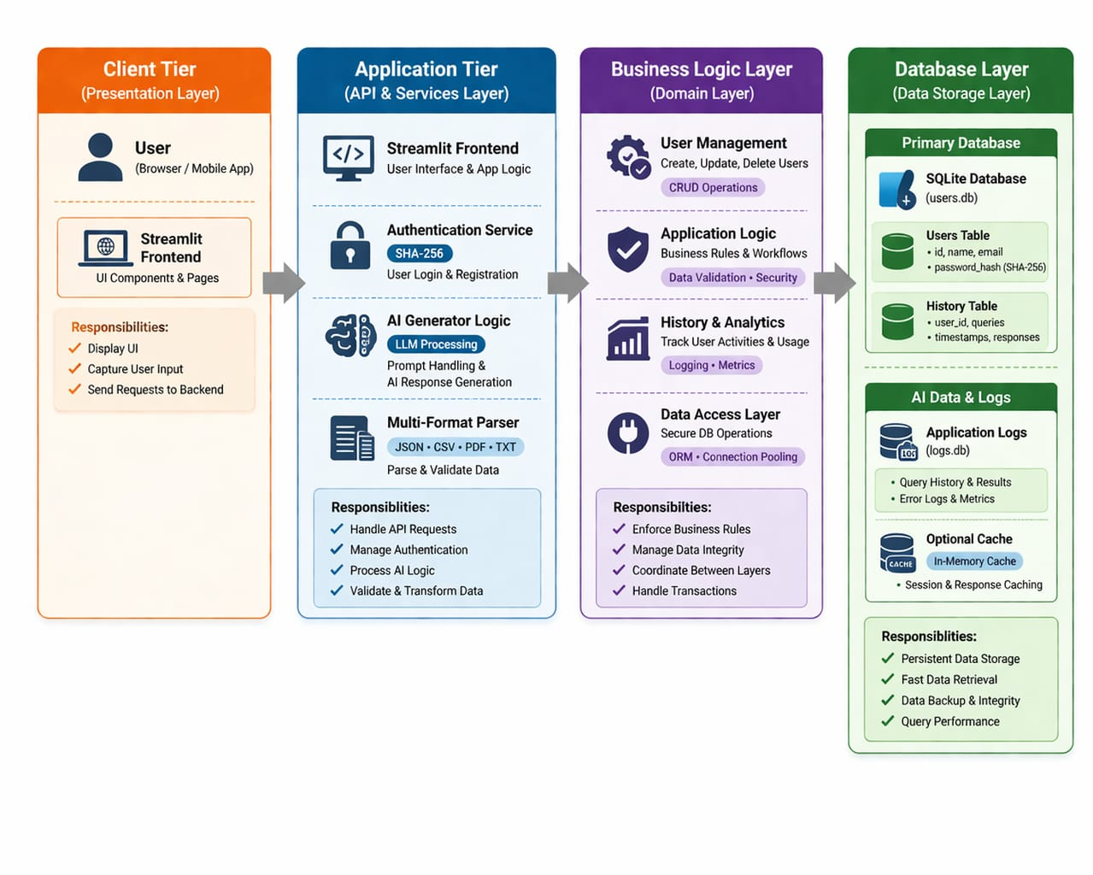
Figure: Architecture

The architecture follows a classic 3-tier client-server pattern:
- Presentation Tier: Streamlit Python framework rendering HTML/CSS/JS in the user's browser.
- Logic Tier: Python application layer handling authentication, prompt assembly, and API orchestration.
- Data Tier: SQLite3 database storing user credentials (users table) and query history (history table).
- External AI Service: Groq Cloud API serving the Llama-3.3-70B-Versatile model over HTTPS.
8.2 Context Flow Diagram (DFD Level 0)
The Context Flow Diagram provides a top-level data flow view of Codify AI, showing the primary external entities (User, Groq API, File System) and the data flows between them and the system boundary.
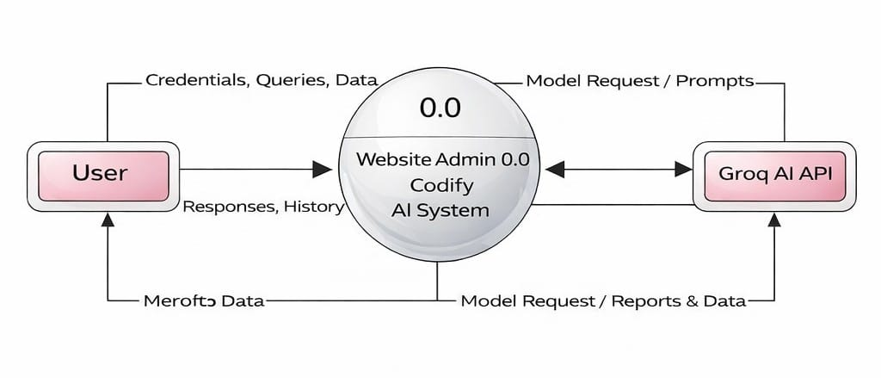
Figure: DFD0
Primary data flows:
- User → System: Login credentials, natural language prompt, file upload, language selection.
- System → Groq API: Assembled system prompt + user query.
- Groq API → System: Generated code/formula + structured markdown response.
- System → User: Rendered AI response, history sidebar, authentication feedback.
- System ↔ SQLite: Read/write of user credentials and query history records.

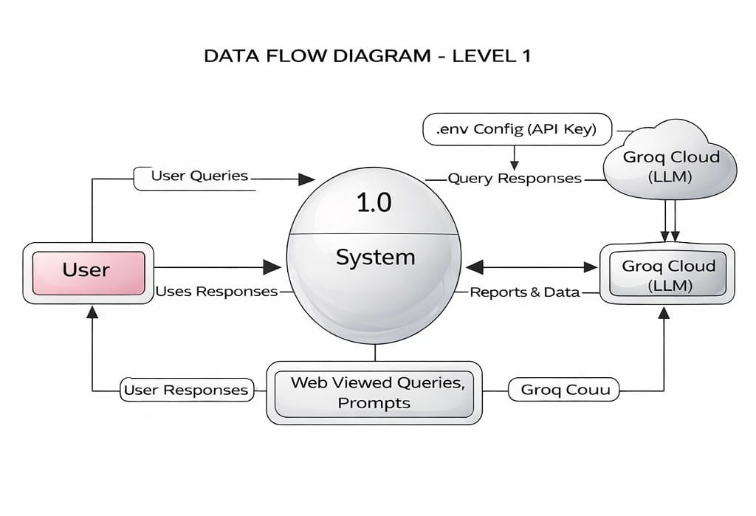
DFD Level 1
Figure: DFD1

DFD Level 2
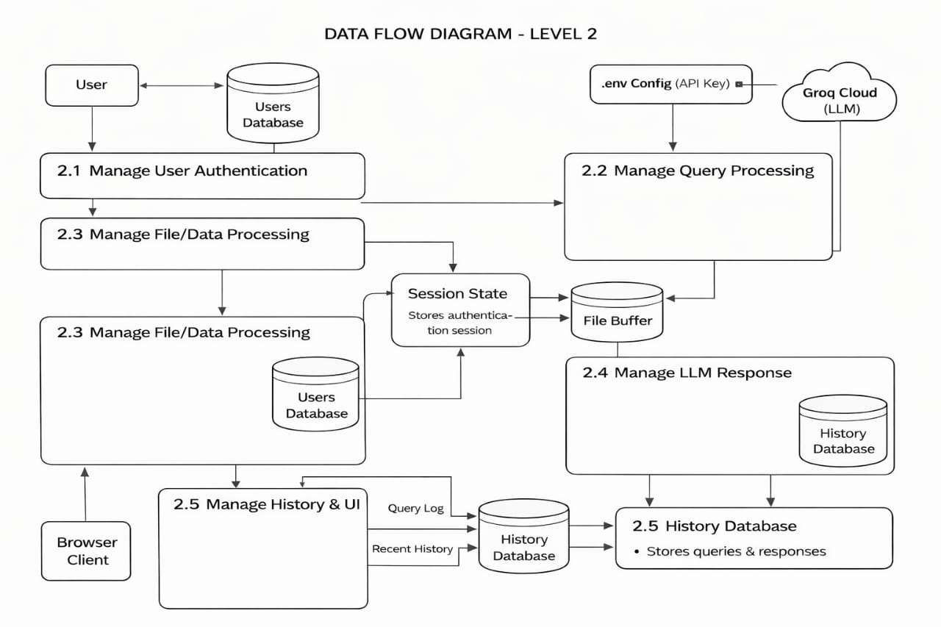
Figure: DFD2

CHAPTER 9
DETAILED DESIGN

9.1 Use Case Diagram
The Use Case Diagram identifies the primary actors -- End User and AI System -- and maps their interactions with the system's core functional use cases.
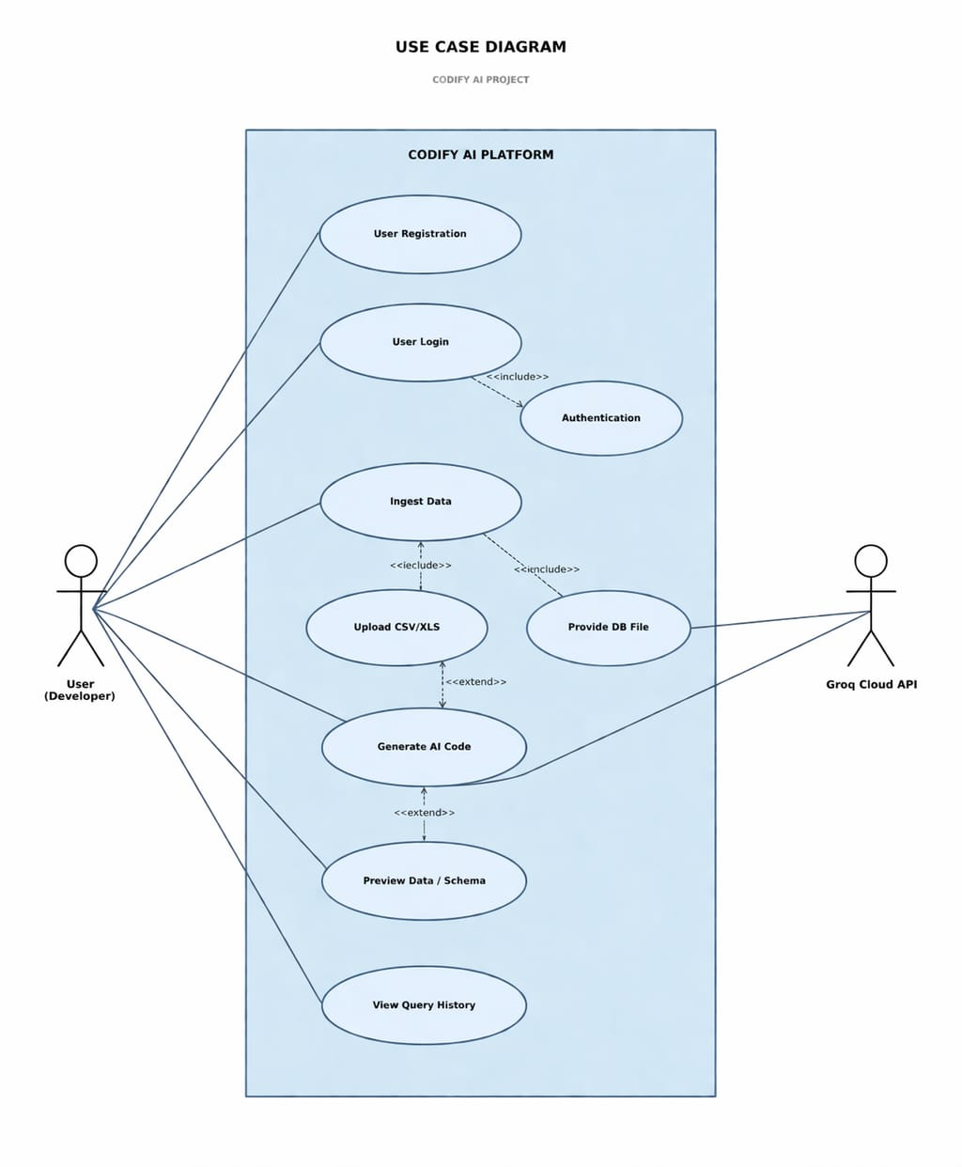
Figure: Usecase

Primary use cases:
- UC-01: Register Account -- End User registers a new account.
- UC-02: Login -- End User authenticates with credentials.
- UC-03: Reset Password -- End User resets forgotten password.
- UC-04: Generate Code -- End User submits prompt; AI System returns code.
- UC-05: Upload Dataset -- End User uploads file; System ingests schema.
- UC-06: View History -- End User browses recent query history.
- UC-07: Navigate Pages -- End User moves between app sections.
- UC-08: Logout -- End User terminates session.
9.2 Database Design
Codify AI uses a single SQLite3 database file (codify_pro.db) containing two tables:
Table 1: users
Column | Data Type | Constraint | Description
username | TEXT | PRIMARY KEY | Unique user identifier
password | TEXT | NOT NULL | SHA-256 hashed password string

Table 2: history
Column | Data Type | Constraint | Description
rowid | INTEGER | AUTO (implicit) | Auto-incrementing row identifier
query | TEXT | NONE | Original user natural language prompt
code | TEXT | NONE | AI-generated code or formula
language | TEXT | NONE | Target language/tool selected

9.3 ER Diagram
The Entity-Relationship Diagram models the data entities and their relationships within the Codify AI database.
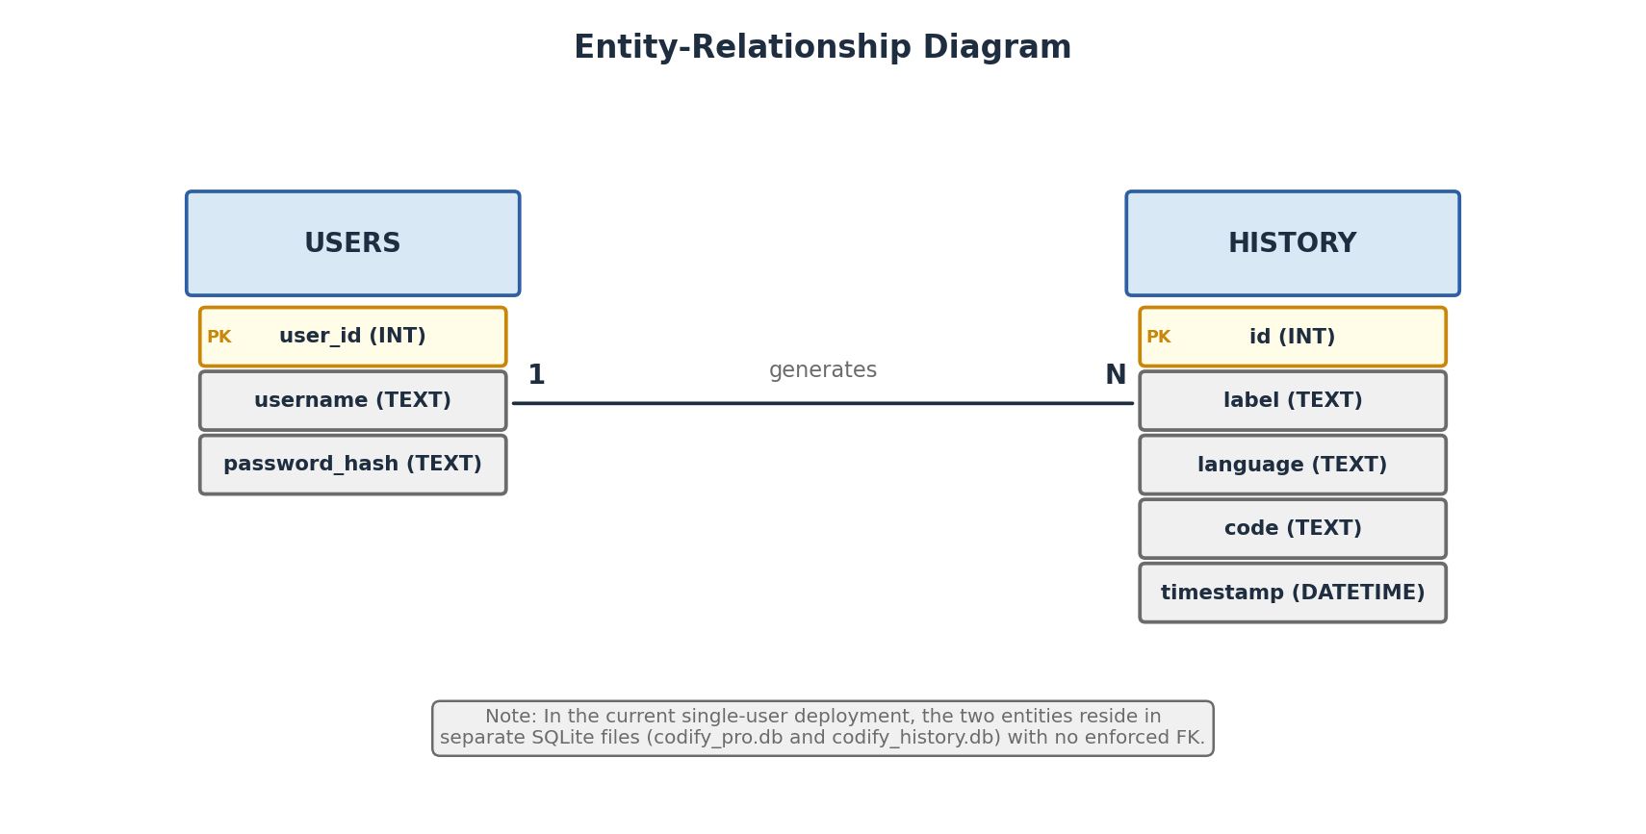
Figure: ER
Entities and Relationships:
- USER entity: username (PK), password. One User GENERATES zero or many HISTORY records.
- HISTORY entity: owed (PK), query, code, language. Each record is associated with a User session.
- Cardinality: USER (1) ──< HISTORY (Many). A user can have many history records; each record belongs to one user.

CHAPTER 10
IMPLEMENTATION

10.1 Screenshots
The following screenshots illustrate the key UI screens of the Codify AI application.
Screenshot:
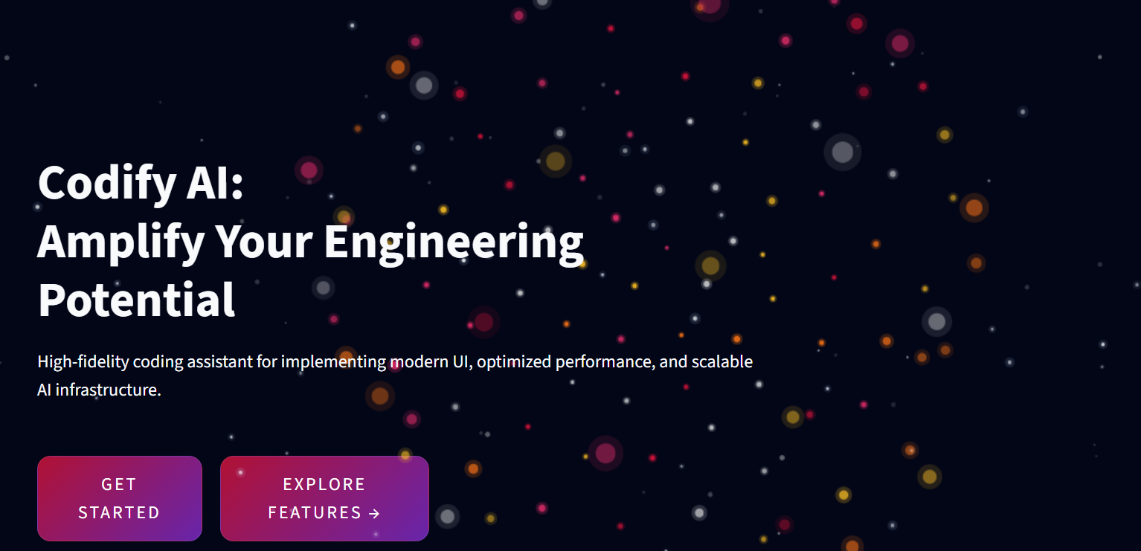
FIG:10.1: Landing Page
The immersive landing page featuring a 3D particle sphere animation, glassmorphism bento-grid feature cards, and hero CTA buttons.

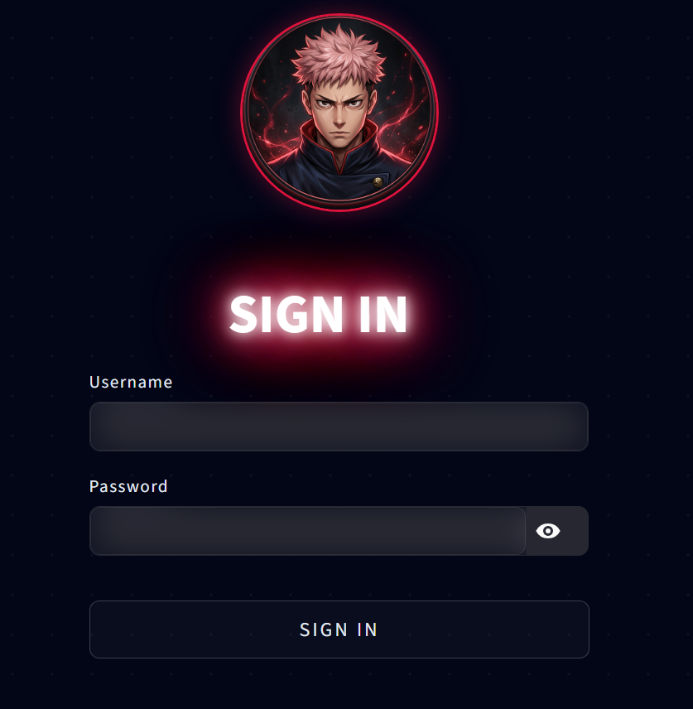
Screenshot:

FIG:10.2: Login / Registration Page
The kinetic dot-matrix login page with the interactive Yuji mascot, neon SIGN IN title, and glass-morphism credential form

Screenshot:
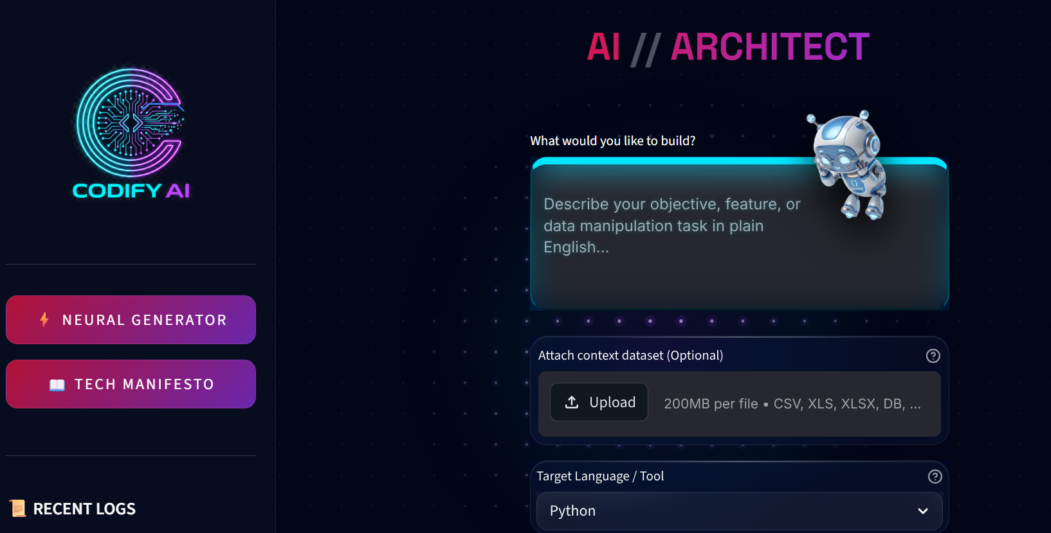
FIG:10.3: AI Code Generator Interface
The main generator page with the 3D glassmorphism input area, Dexter mascot in watching pose, dataset upload, language selector, and Synthesize button.

Screenshot:
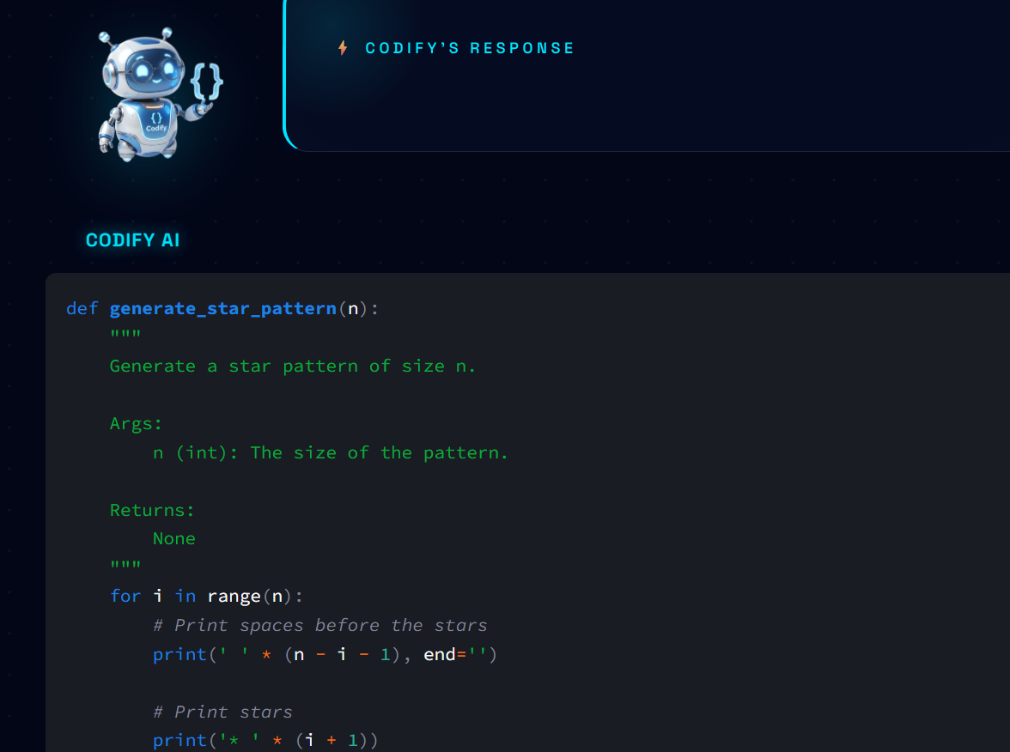
FIG:10.4: AI Response Output Panel
The structured AI response panel featuring Dexter in leaning pose, cyan accent border, and three-section structured markdown output.
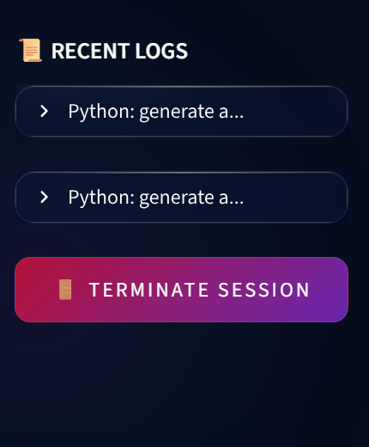
Screenshot:
.
FIG:10.4: Query History Sidebar
The animated sidebar with Codify AI logo + circuit overlay, nav buttons, and recent logs with expandable syntax-highlighted code

10.2 Coding
The following code listings present the key implementation components of Codify AI. The full source code is available in the project repository (app.py).
Listing: Database Initialisation & Authentication Helpers
def init_db():
conn = sqlite3.connect('codify_pro.db', check_same_thread=False)
cursor = conn.cursor()
cursor.execute("""
CREATE TABLE IF NOT EXISTS users (
username TEXT PRIMARY KEY,
password TEXT
)
""")
cursor.execute("""
CREATE TABLE IF NOT EXISTS history (
query TEXT, code TEXT, language TEXT
)
""")
conn.commit()
conn.close()
def hash_password(password):
return hashlib.sha256(str.encode(password)).hexdigest()
def verify_user(username, password):
conn = sqlite3.connect('codify_pro.db', check_same_thread=False)
cursor = conn.cursor()
cursor.execute("SELECT password FROM users WHERE username = ?", (username,))
result = cursor.fetchone()
conn.close()
return result and result[0] == hash_password(password)

Listing: Tool-Specific System Prompt Assembly
STEP_GUIDE = (
"\n\nAfter the output, you MUST include:\n"
"**### Step-by-Step Execution Guide**\n"
"**### Code / Formula Explanation**\n"
"**### Expected Output**\n"
)
tool_instructions = {
"Python": (
"You are an expert Python data scientist. Generate "
"clean, well-commented Python code using pandas, numpy, "
"or relevant libraries." + STEP_GUIDE
),
"SQL": (
"You are a senior SQL database architect. Generate "
"optimised, well-commented SQL queries compatible with "
"standard SQL / SQLite." + STEP_GUIDE
),
# ... additional tools ...
}
system_prompt = tool_instructions.get(lang, f"Expert in {lang}.")

Listing: Groq API Inference Call
chat = client.chat.completions.create(
messages=[{"role": "user", "content": full_prompt}],
model="llama-3.3-70b-versatile"
)
st.session_state["res"] = chat.choices[0].message.content
save_to_history(query_label, st.session_state["res"], lang)

Listing: SQLite Dataset Ingestion (CSV)
df = pd.read_csv(io.BytesIO(raw_bytes))
dataset_context = (
f"REFERENCE DATASET: {uploaded_file.name}\n"
f"Shape: {df.shape[0]} rows x {df.shape[1]} columns\n"
f"Columns: {', '.join(df.columns.tolist())}\n"
f"First 50 rows (CSV):\n{df.head(50).to_csv(index=False)}"
)

CHAPTER 11
SOFTWARE TESTING

Software testing for Codify AI followed a structured approach encompassing Unit Testing, Integration Testing, System Testing, and User Acceptance Testing (UAT).
11.1 Unit Testing
Individual functions were tested in isolation to verify correctness.
Test ID | Function Under Test | Test Case | Expected Result
UT-01 | hash_password() | Input: "password123" | Returns 64-char hex string
UT-02 | create_user() | New unique username | Returns True; user stored
UT-03 | create_user() | Duplicate username | Returns False; IntegrityError caught
UT-04 | verify_user() | Correct credentials | Returns True
UT-05 | verify_user() | Wrong password | Returns False
UT-06 | reset_password() | Existing user, new password | Returns True; hash updated
UT-07 | reset_password() | Non-existent username | Returns False
UT-08 | save_to_history() | Valid query/code/language triplet | Row inserted in history table
UT-09 | init_db() | Run on existing DB | No error; tables intact

11.2 Integration Testing
Integration tests verified the interaction between modules.
Test ID | Integration Point | Test Case | Result
IT-01 | Auth → Session State | Login success sets logged_in=True | Pass
IT-02 | Generator → Groq API | Valid prompt returns non-empty response | Pass
IT-03 | Generator → History DB | Post-generation saves record to DB | Pass
IT-04 | File Upload → AI Context | CSV upload enriches prompt context string | Pass
IT-05 | Sidebar → History DB | Sidebar pulls 3 most recent history rows | Pass
IT-06 | Logout → Session State | Logout clears logged_in and show_landing | Pass
11.3 System Testing
System-level end-to-end tests evaluated the complete application flow.
Test ID | Scenario | Steps | Status
ST-01 | New user complete flow | Register → Login → Boot → Generate code → View history → Logout | Pass
ST-02 | CSV dataset code gen | Upload CSV → Select Python → Submit prompt → Verify schema in prompt | Pass
ST-03 | SQLite DB analysis | Upload .db file → Verify table listing → Generate SQL query | Pass
ST-04 | Groq API timeout handling | Disable network → Click Synthesize → Verify error message | Pass
ST-05 | Empty prompt submission | Blank prompt + no file → Click Synthesize → Verify no API call | Pass
ST-06 | Cross-language generation | Generate Python, SQL, DAX, Excel formulas sequentially | Pass
ST-07 | Session persistence | Generate code → Refresh page → Verify result persists in session | Pass

11.4 User Acceptance Testing (UAT)
UAT was conducted with five student volunteers from the Computer Science department. Participants were asked to complete three tasks: Register and log in, Generate a Python data cleaning script, and Upload and analyse a CSV file.
- Task Completion Rate: 100% across all three tasks.
- Average Task Completion Time: 2 minutes 14 seconds.
- UI Clarity Rating: 4.6 / 5.0
- Response Quality Rating: 4.4 / 5.0
- Overall Satisfaction: 4.5 / 5.0
Key feedback themes: Users appreciated the visual design and animation quality. One participant requested a copy-to-clipboard button for the generated code, noted as a future enhancement.

CHAPTER 12
CONCLUSION

Codify AI successfully demonstrates that a carefully engineered, LLM-powered code synthesis platform can dramatically reduce the Syntactic Friction in modern software development and data engineering workflows. By combining the Llama-3.3-70B model served through Groq's LPU inference infrastructure with a role-specific prompt engineering framework and intelligent dataset context ingestion, the system achieves both speed and quality that surpass general-purpose AI assistants for the specific domain of code and formula generation.
The project successfully accomplished all primary objectives:
- A fully functional, multi-page web application was designed and deployed using Python and Streamlit.
- Secure user authentication with SHA-256 hashing and persistent session management was implemented.
- Multi-tool code generation for six distinct languages and platforms was achieved.
- Intelligent dataset ingestion from CSV, Excel, and SQLite sources was implemented.
- A structured, three-section output format was enforced through prompt engineering.
- An ACID-compliant query history audit trail was built using SQLite3.
- A premium, animated, cyberpunk-aesthetic UI was developed using pure CSS injection.
The system architecture's clean 3-Tier separation ensures that each component -- Streamlit frontend, Groq inference backend, and SQLite persistence layer -- can be independently evolved. The use of open-source, royalty-free technologies (Streamlit, Groq free tier, SQLite, Python) ensures the platform is accessible and reproducible.
Codify AI stands as a proof of concept for the democratisation of AI-assisted development -- bringing expert-level code synthesis capabilities to developers, data analysts, and students alike, through nothing more than a web browser and a natural language description of their intent.

CHAPTER 13
FUTURE ENHANCEMENT

The following enhancements are planned for subsequent versions of Codify AI:
Version 2.0 Roadmap
- Copy-to-Clipboard Button: One-click code copying from the output panel (user-requested UAT feedback).
- bcrypt Password Hashing: Migration from SHA-256 to adaptive bcrypt hashing with random salts for NIST 800-63B compliance.
- Code Execution Sandbox: Secure, containerised Python execution environment using the Pyodide WebAssembly runtime or a sandboxed Docker container, enabling in-browser code output verification.
- User Profile Management: Avatar selection, display name, and preference settings persisted in the users table with schema migration.
- Export Functionality: Download generated code as .py, .sql, .xlsx, or .txt files directly from the output panel.

Version 3.0 Roadmap (AI Agent Architecture)
- RAG with Vector Databases: Integration of Pinecone or ChromaDB to connect the AI engine to private codebases, enabling codebase-aware generation.
- Automated Unit Test Generation: Automatic generation of pytest unit tests for every Python code block produced by the generator.
- Multi-Modal Voice Input: Voice-commanded code generation using the OpenAI Whisper ASR API for hands-free operation.
- CI/CD Pipeline Code Generation: GitHub Actions and Jenkins pipeline YAML generation for DevOps automation workflows.
- Multi-Language UI Localisation: Support for regional languages (Kannada, Hindi, Tamil) for the prompt input interface.

BIBLIOGRAPHY

[1] Chen, M., et al. (2021). Evaluating Large Language Models Trained on Code. arXiv:2107.03374. OpenAI.
[2] Nijkamp, E., et al. (2022). CodeGen: An Open Large Language Model for Code. arXiv:2203.13474. Salesforce Research.
[3] Meta AI (2023). Llama 2: Open Foundation and Fine-Tuned Chat Models. arXiv:2307.09288.
[4] Austin, J., et al. (2021). Program Synthesis with Large Language Models. arXiv:2108.07732. Google Brain.
[5] Barke, S., et al. (2023). Grounded Copilot: How Programmers Interact with Code-Generating AI Systems. ACM SIGCHI.
[6] Ziegler, A., et al. (2022). Productivity Assessment of Neural Code Completion. ACM MAPS.
[7] Vaithilingam, P., et al. (2022). Expectation vs. Experience: Evaluating the Usability of Code Generation Tools. ACM CHI.
[8] Groq Inc. (2024). Groq LPU Inference Engine Technical Overview. https://groq.com.
[9] Brown, T., et al. (2020). Language Models are Few-Shot Learners. NeurIPS 2020.
[10] Streamlit Inc. (2023). Streamlit Documentation. https://docs.streamlit.io.
[11] SQLite Consortium (2024). SQLite Documentation. https://sqlite.org.
[12] OWASP (2021). OWASP Top Ten Web Application Security Risks. https://owasp.org/Top10.
[13] NIST (2017). Special Publication 800-63B: Digital Identity Guidelines. https://pages.nist.gov/800-63-3/sp800-63b.html.
[14] Devlin, J., et al. (2019). BERT: Pre-training of Deep Bidirectional Transformers for Language Understanding. NAACL-HLT.
[15] Vaswani, A., et al. (2017). Attention Is All You Need. NeurIPS 2017. (Foundational Transformer architecture paper.)

USER MANUAL

This section provides a step-by-step guide for end users to operate Codify AI.
Step 1: Accessing the Application
Open your web browser and navigate to http://localhost:8501 (local) or the deployed URL.
The landing page will appear. Click GET STARTED to proceed to the login screen.
Step 2: Creating an Account
On the login page, click "Create Account". Enter a unique username and a password. Click "Register". You will be redirected to the login page on success.
Step 3: Logging In
Enter your registered username and password. Click "Sign In". The boot sequence HUD will play, then you will be taken to the AI Generator.
Step 4: Generating Code
- Type your requirement in plain English in the large text area. Example: "Create a pivot table from a sales CSV grouped by region with total revenue."
- Optionally upload a dataset file (CSV, Excel, or SQLite .db) for context-aware generation.
- Select your target language or tool from the dropdown (Python, SQL, Power BI, etc.).
- Click "Synthesize". Wait for the rotating cube loader to complete.
- The AI response will appear below, organised into: code/formula, execution guide, explanation, and expected output sections.
Step 5: Viewing History
Expand the "RECENT LOGS" section in the left sidebar to review your three most recent code generations.

Step 6: Navigating to Technical Manifesto
Click "TECH MANIFESTO" in the sidebar to access the in-app technical documentation page.
Step 7: Logging Out
Click "TERMINATE SESSION" at the bottom of the sidebar to securely log out and return to the landing page.
Troubleshooting
- "Inference Failure" error: Check your internet connection and verify the GROQ_API_KEY in your .env file.
- "Could not read file" error: Ensure the uploaded file is a valid, non-corrupted CSV, Excel, or SQLite file.
- Blank screen: Restart the Streamlit server with streamlit run app.py.

