Codify AI - Project Diagrams
This document contains architectural and conceptual diagrams representing the structure and workflows of the Codify AI project.

1. System Architecture Diagram
This diagram illustrates the high-level decoupled architecture of the application, showing the interaction between the Streamlit frontend, the Groq Cloud AI engine, and the SQLite persistence layer.
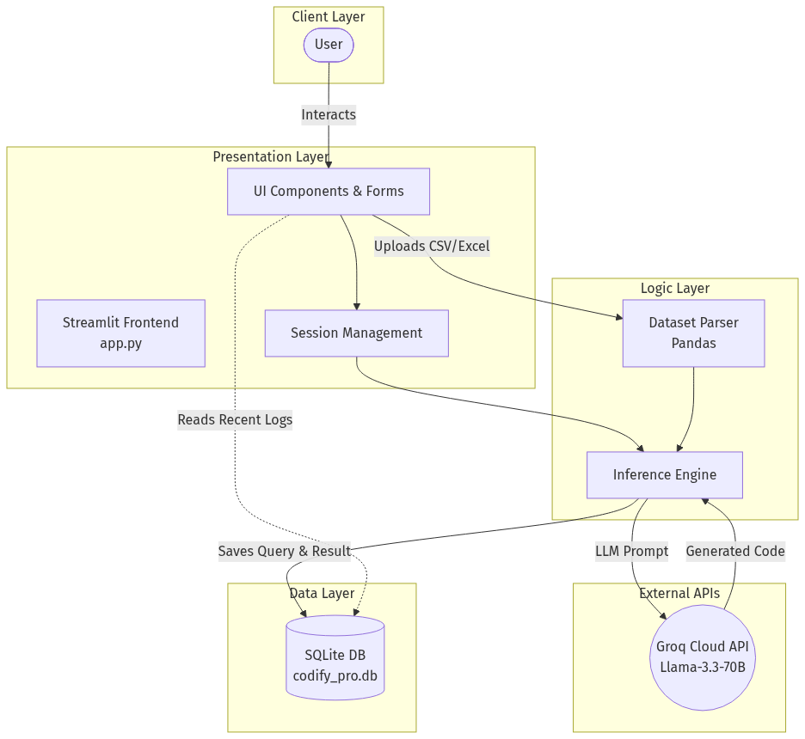

2. Sequence Diagram (Code Synthesis Flow)
This sequence diagram details the chronological execution of interactions when a user generates AI code or analyzes a dataset.
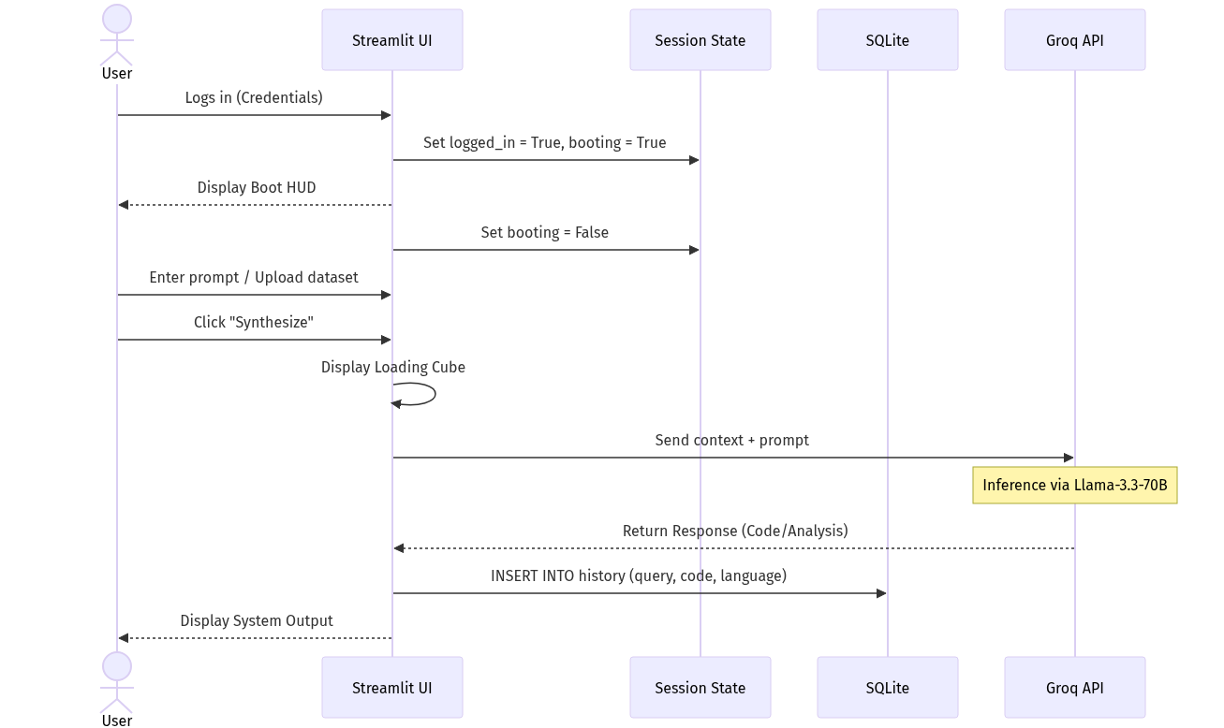

3. Entity-Relationship (ER) Diagram
This represents the schema design of the local SQLite database used for auditing and session history.
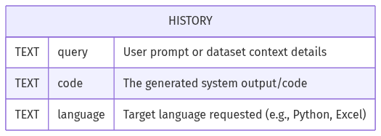

4. Activity Diagram (User Navigation Flow)
This state diagram captures the user's navigational flowchart through the different states of the application.
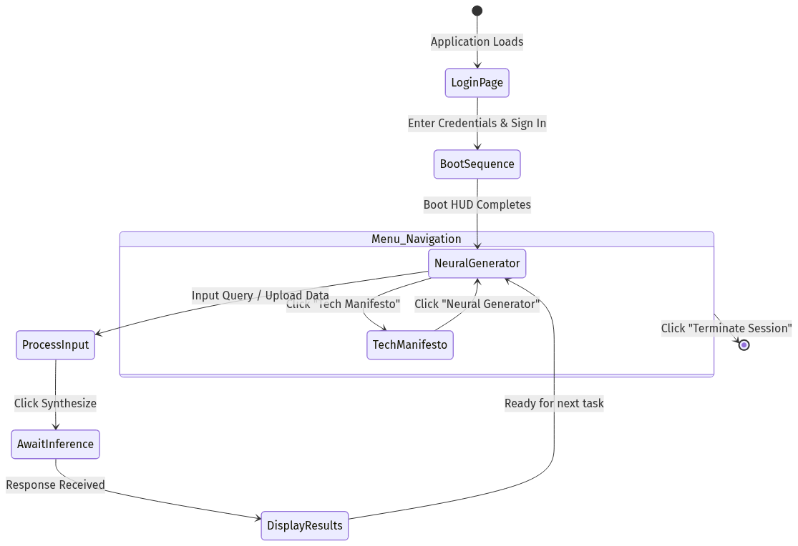

5. Data Flow Diagram (DFD - Level 1)
This Data Flow Diagram illustrates how information flows through the Codify AI system, including user inputs, external AI processing, and local data storage.
