**Selective Retrieval and Transmission of Audio Signals using FDM**

*Aadhitya S            CB.EN.U4ECE18101*

*Aadityan E            CB.EN.U4ECE18102*

*Aruneswari S        CB.EN.U4ECE18107*

*Chandhana S        CB.EN.U4ECE18112*

*Nirali M Dave         CB.EN.U4ECE18136*

*R R Prathiksha      CB.EN.U4ECE18144*

Abstract**— *Multiple signals (ranging anywhere from 3-6) given as an input to a common channel will be modulated separately using different modulation techniques such as Double Side-Band Suppressed Carrier modulation (DSB-SC) Technique and will be multiplexed using Frequency Division Multiplexing Algorithm (FDM) to ensure no mixing, overlapping, interference of any two or more signals takes place. Upon transmission, the user gets to choose the signal that he/she desires to listen to and the desired signal will be received at the receiver end.***

*Like with everything else in life, nothing is ideal and hence the signal gets corrupted by noise and in the simulation, it’s added to the signal and prior to demodulation, it’s removed and consequently, SNR bettered.*

1. Introduction

***Why multiplexing?***

**When we have multiple message signals, to transmit all of them, we’d require multiple channels but in order to reduce the number of channels, thereby also reducing the cost to materialise the channels, we come up with the concept of multiplexing.**

**Types of multiplexing:**

1. Frequency Division **Multiplexing** (FDM)
2. Wavelength Division **Multiplexing** (WDM) and,
3. Time Division **Multiplexing** (TDM).

**Frequency division multiplexing:**

Signals of different frequencies are combined for concurrent transmission. The total bandwidth is divided into a set of frequency bands that are far apart from each other.This is done by modulating each message signal with different carrier frequency.The modulated signals are combined and transmitted through a single communication channel , thus allowing multiple independent data streams to be transmitted simultaneously. Finally, it is demodulated at the receiver end and the original signal is extracted.

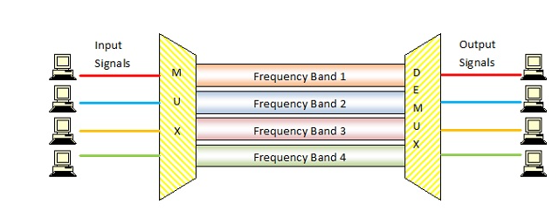

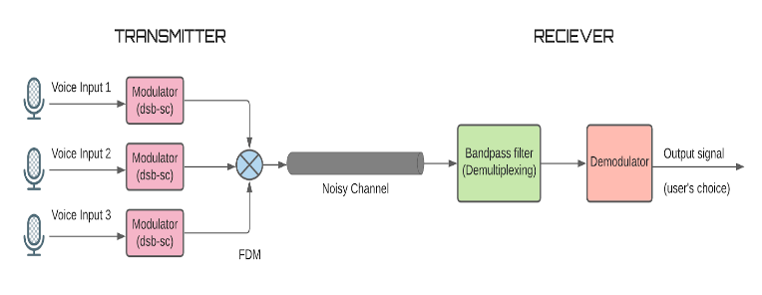

**REF: An Introduction to Analog and Digital Communications, 2nd edition**

**Modulation -Double-Sideband Suppressed-Carrier AM**

In the DSB-SC modulation, unlike in standard AM, the wave carrier is not transmitted and the modulated wave has the information only in the sidebands ; thus, much of the power is distributed between the side bands.

A DSB-SC AM signal is obtained by multiplying the message signal *m (t)* with the carrier signal

*c(t)=Ac cos(2πfct)*

Thus, we have the amplitude-modulated signal

*u (t) = m (t)c(t)*= *Acm (t) cos(2πfct)*

**Spectrum of the DSB-SC AM Signal**

**https://lh4.googleusercontent.com/A-avTpPNx0Xma7w6nnKELshajUl4IggHy242CQ0mMWztym_BACybRxMS3sfIdhy1DU2RAsqMBGorfgHPVk2DmglxJVFolC8_s4VvG-OQSUIkq7UwyLO36ldeKKqth2EG2Ocev2rj**

|  |  |
| --- | --- |
| **https://lh3.googleusercontent.com/5GBR4JZR6D_JKuLTGdvro-5Otq0kAIQ9_G0SnxA6Jz92OHa6c_nxqn9MfJEi7upCPtK3Wd_KuEnY01Q7szJKtaVnIQV4Rvg18KFOXnJW0_2yaJQiC7BFTsPX7RsT2iKfca9TQfWa**  **Magnitude spectra of message signal** | **https://lh6.googleusercontent.com/Xq4Vl79BdDWC_9dnnSPabUhY-QnqbY_878ACrC8Z9Hgu34AnzRkvpYZWcCEgkA4bQWQk1ho90QQvEZgoopGMEStK4crvz3n0MJbeIk9SmtA6exKsUqOgjUOdL5AXbDNi2QThWJ9s**  **Magnitude spectra of message**  **signal** |

**Bandwidth=** (fc + fm) - (fc - fm) = 2fm or 2W ( W is the highest frequency of the message signal)

. Captions of a single line (e.g. Fig. 2) must be centered whereas multi-line captions must be justified (e.g. Fig. 1). Captions with figure numbers must be placed after their associated figures, as shown in Fig. 1.

Internet email address or URL in your paper, you must type out the address or URL fully in Regular font.

Progress:

<https://github.com/Dexter-27/CT>

Get multiple audio inputs from user

DSBSC of audio signals using different methord mathlab and Simulink

FDM combining all audios into one channel

1. References

:

<https://www.ijsdr.org/papers/IJSDR1806010.pdf>

# DSB-SC Signal Generation by Dr.K.Vinoth Babu, VIT

Introduction to Analog and Digital Communications Second Edition Simon Haykin