**Name: Soriano, Dexter G. 7OOP   
Year&Sec: BSCS – C204 MTermLabTask#5**

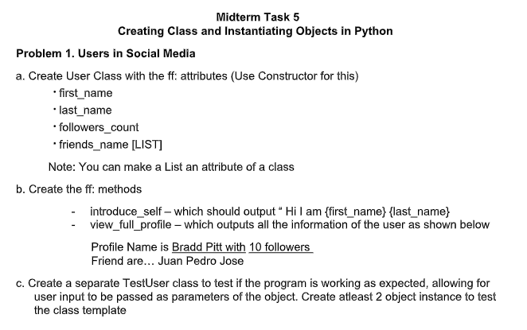 **SAMPLE OUTPUT**

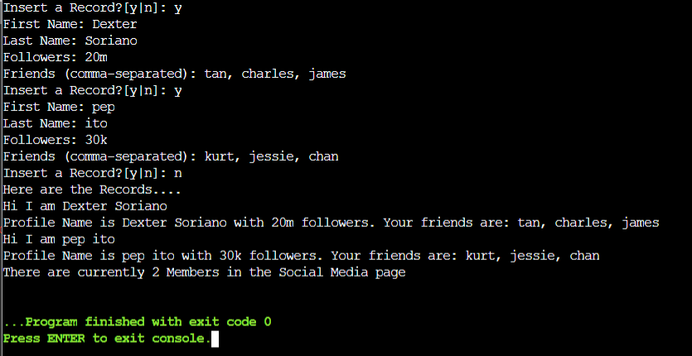 **CODE**

**Class User:**

**def __init__(self, first_name, last_name, followers_count, friends_name):**

**self.first_name = first_name**

**self.last_name = last_name**

**self.followers_count = followers_count**

**self.friends_name = friends_name**

**def introduce_self(self):**

**return f"Hi I am {self.first_name} {self.last_name}"**

**def view_full_profile(self):**

**friends_str = ", ".join(self.friends_name)**

**return f"Profile Name is {self.first_name} {self.last_name} with {self.followers_count} followers. Your friends are: {friends_str}"**

**class TestUser:**

**def __init__(self):**

**self.users = []**

**def create_user(self):**

**while True:**

**insert_record = input("Insert a Record?[y|n]: ")**

**if insert_record.lower() != 'y':**

**break**

**first_name = input("First Name: ")**

**last_name = input("Last Name: ")**

**followers_count = str(input("Followers: "))**

**friends_input = input("Friends (comma-separated): ")**

**friends_name = [friend.strip() for friend in friends_input.split(",")]**

**user = User(first_name, last_name, followers_count, friends_name)**

**self.users.append(user)**

**def display_records(self):**

**print("Here are the Records....")**

**for user in self.users:**

**print(user.introduce_self())**

**print(user.view_full_profile())**

**print(f"There are currently {len(self.users)} Members in the Social Media page")**

**# Example usage:**

**test_user = TestUser()**

**test_user.create_user()**

**test_user.display_records()**