NexCart - E-commerce Recommendation System
Final Project Report

Field | Details
Course | Z2004 Database Management Systems
Track | Track B - AI Recommendation Engine
Database Used | PostgreSQL
Application | Local Streamlit dashboard with optional FastAPI endpoint
Repository | https://github.com/Dexter087/Nexcart.git
Environment | PostgreSQL 18.3, Windows 11, Intel i5 CPU, 11.7 GB RAM
Database Name | nexcart_olist
Team Members | Daksha Mothukuri - ZDA24B030  Manoj Phani Varma Vadapalli - ZDA24B040  V S S Preeti Ananya Yamali - ZDA24B002
NexCart is a functional e-commerce recommendation system built on a live PostgreSQL database. It uses the Olist marketplace dataset, SQL-based collaborative filtering, performance indexing evidence, and a local Streamlit interface to demonstrate the working system.

1. Abstract and Project Objective
NexCart addresses a common e-commerce problem: customers face too many product choices, while the platform needs to recommend relevant products using transactional data. The project stores marketplace data in PostgreSQL and exposes recommendation results through Python application code.
The implementation focuses on database-backed recommendation rather than an external black-box recommender. Purchase history, product categories, customer identities, and order item relationships are combined through SQL joins and CTEs. Window functions are used to rank candidate products and keep the recommendation process explainable.
The final system includes schema design, Olist data loading, analytical SQL queries, performance benchmarking, a stored procedure for recommendation scores, a FastAPI recommendation endpoint, and a Streamlit dashboard for demonstration.

2. Final Requirement Mapping
Final Requirement | Evidence in NexCart
Working database system | PostgreSQL database nexcart_olist populated with seven Olist tables.
Track B recommendation engine | User-based collaborative filtering implemented in SQL and called from Python.
Python API | FastAPI endpoint in app/main.py returns top-N product recommendations.
Demonstrated app | Streamlit dashboard in app/streamlit_app.py connects to the same PostgreSQL database.
Performance evidence | queries/performance.sql captures before/after EXPLAIN ANALYZE evidence.
Stored procedure | refresh_product_recommendation_scores() updates product_recommendation_scores.

3. Dataset Description
The project uses the Olist Brazilian E-Commerce Public Dataset. The selected files represent a realistic marketplace system with customers, orders, order items, products, sellers, payments, and reviews. The dataset is suitable for Track B because it contains real transactional behaviour rather than artificial placeholder rows.
Table | Rows Loaded | Role in System
customers | 99,441 | Customer identity, unique customer grouping, and location.
sellers | 3,095 | Marketplace seller identity and seller location.
products | 32,951 | Product master data and product category information.
orders | 99,441 | Order status and order lifecycle timestamps.
order_items | 112,650 | Transactional line items linking orders, products, and sellers.
order_payments | 103,886 | Payment type, installment, and payment value records.
order_reviews | 99,224 | Review scores and optional review text fields.
The review file required LATIN1 handling during import because some review text contains Windows-encoded characters. The final README and load script include this encoding option so that the import can be repeated from Command Prompt without manual data editing.

4. Dataset Cleaning and Scope Decisions
The geolocation table was excluded because geographic coordinates were not required for recommendation logic or the main analytical queries. The category translation file was also excluded because the final schema stores product_category_name directly in products. This avoids foreign-key mismatches and keeps the transactional relationships stable.

5. Final Relational Schema
The implemented schema contains seven core tables and one derived recommendation score table. Customers place orders, orders contain order items, order items connect products and sellers, and each order can have related payment and review records. Primary keys and foreign keys enforce the core marketplace relationships.
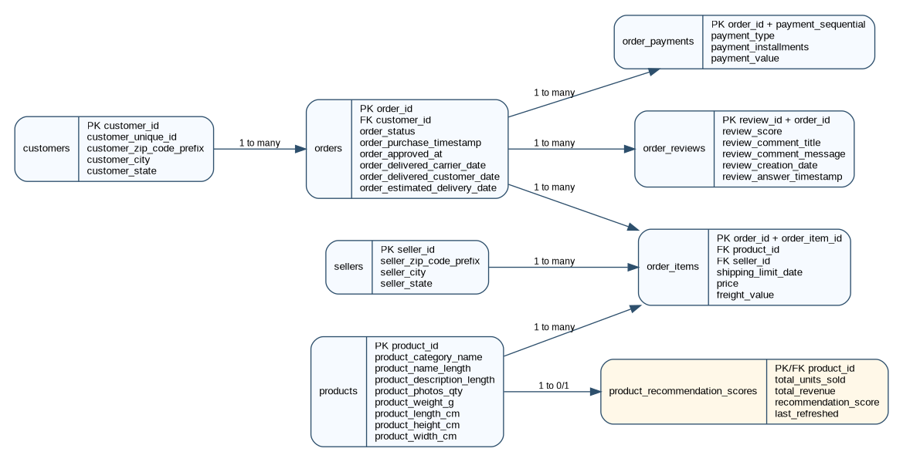
Figure 1. Final NexCart ER diagram and derived recommendation score table.

6. Normalization and Constraints
The final schema follows 3NF because each table represents one entity or relationship, and non-key columns describe only the key of their own table. For example, seller city and seller state are stored in sellers, customer city and customer state are stored in customers, and item-level price is stored in order_items because the price belongs to the transaction line item.
Table | Primary Key | Foreign Keys / Constraints
customers | customer_id | customer_state is required; customer_unique_id groups repeat customers.
sellers | seller_id | seller_state is required.
products | product_id | CHECK constraints prevent negative product lengths, weights, and photo counts.
orders | order_id | customer_id references customers(customer_id).
order_items | order_id + order_item_id | References orders, products, and sellers; price/freight must be non-negative.
order_payments | order_id + payment_sequential | References orders; payment_value must be non-negative.
order_reviews | review_id + order_id | References orders; review_score must be between 1 and 5.
The schema also supports cascading deletes on child tables for consistency. Although the dataset is static for the project, the constraints demonstrate how the database would protect relationships in a live marketplace system.

7. SQL Query Design
The analytical SQL file is designed to prove query coverage and to provide meaningful business outputs. It includes aggregations, joins, subqueries, CTEs, and window functions, with each query labelled by purpose.
Query Type | Implemented Examples | Why It Matters
Aggregation | Orders by customer state; average payment by payment type. | Shows marketplace volume and payment behaviour.
Join | Orders with customer location; order items with seller details. | Validates relationship traversal across normalized tables.
Subquery | Customers above average order count; products never sold. | Finds high-activity customers and inactive products.
CTE | Delivery delay calculation; category sales summary. | Breaks analysis into readable intermediate results.
Window Function | Customer spending rank; product price rank by category. | Ranks rows without losing row-level detail.
These queries are not only milestone evidence. Several of them also support the final app pages, including database summaries, category sales, payment summaries, and customer-level analysis.

8. Key Query Examples
The most important business queries are the state order-volume query, the category sales CTE, and the customer spending rank query. Together, they show that the schema supports operational and analytical views of the same normalized data.

9. Recommendation Engine Design
NexCart uses user-based collaborative filtering. The target customer is first mapped to customer_unique_id, which captures repeat-customer identity in the Olist data. The system then collects the target customer purchases and searches for other customers who overlap by exact product or product category.
Exact product overlap receives a higher weight than category overlap because it is a stronger signal. Candidate products are then collected from similar customers, while products already bought by the target customer are removed. The final products are ranked by collaborative score, number of similar customers, purchase count, and average price.
Stage | SQL Technique | Output
Target profile | JOIN customers, orders, order_items, products | Products and categories already bought by the selected customer.
Similarity scoring | CTEs and SUM OVER PARTITION BY | Weighted similar-customer scores.
Candidate generation | Anti-join with NOT EXISTS | Products not yet bought by the target customer.
Ranking | RANK and ROW_NUMBER window functions | Top-N recommendations with category diversity.
Fallback | Popularity ranking | Useful output when a customer has sparse purchase history.
The recommendation SQL is visible in queries/recommendation_queries.sql and is also embedded in app/recommender.py so that both the Streamlit dashboard and the API use the same database-backed logic.

10. Application Design
The final application is a local Streamlit dashboard connected to PostgreSQL through Python. Streamlit was selected for the demo because it gives a clear visual interface for database summaries, recommendation outputs, charts, performance results, and the stored procedure demonstration.
File | Responsibility
app/db.py | Loads .env settings, opens PostgreSQL connections, and executes queries.
app/recommender.py | Contains collaborative-filtering SQL, fallback ranking, and stored procedure helpers.
app/analytics.py | Contains dashboard analytics queries and performance summary values.
app/streamlit_app.py | Provides the local dashboard used for the project demo.
app/main.py | Provides FastAPI and CLI recommendation output for Python API evidence.
The dashboard contains six sections: Home, Database Summary, Recommendation Engine, SQL Analytics, Performance Evidence, and Stored Procedure Demo. This structure allows the demo video to move from setup to core functionality and finally to database performance evidence.

11. Performance Benchmarking Methodology
Performance testing was carried out on the same local PostgreSQL database and the same loaded dataset. The performance.sql script first drops milestone-specific indexes, runs ANALYZE, records EXPLAIN ANALYZE output for selected queries, creates indexes, runs ANALYZE again, and reruns the same queries.
Index | Justification
idx_orders_customer_id | Speeds up customer-specific order history and recommendation lookups.
idx_order_items_order_id | Speeds up joins from orders to order_items.
idx_order_items_product_id | Supports product-level aggregation and product-based recommendation logic.
idx_order_items_seller_id | Supports seller-level revenue and seller-performance queries.
idx_orders_purchase_timestamp | Supports time-based ordering and filtering of orders.
The benchmark queries were chosen because they represent different access patterns: a selective customer lookup, a full product-sales aggregation, and a seller revenue aggregation. This makes the evidence more realistic than testing only one easy query.

12. Performance Results
Query | Before Index | After Index | Plan Change / Interpretation
Customer order history | 6.521 ms | 0.162 ms | Strong improvement. Orders changed from sequential scan to idx_orders_customer_id index scan.
Top-selling products | 477.947 ms | 305.587 ms | Moderate improvement. Product index supported merge join, but full aggregation still remained costly.
Seller revenue ranking | 69.428 ms | 99.546 ms | Slower in this run. The query still used broad scans/hash aggregation because nearly all order_items were processed.
Precomputed score output | - | 42.359 ms | Uses product_recommendation_scores after stored procedure refresh.
The customer lookup shows the clearest indexing benefit because it filters down to one customer and then follows relationships through orders and order_items. The plan changed from scanning 99,440 irrelevant orders to using idx_orders_customer_id directly.
The top-selling-products query improved because idx_order_items_product_id allowed a merge join path. However, it still had to aggregate all 112,650 order_items and produce groups for 32,951 products, so the index could not remove the full aggregation cost.
The seller revenue query became slower after index creation in this run. This is acceptable to report honestly: indexes do not guarantee improvement for every query, especially when the planner must read almost the full fact table and aggregate by seller.

13. Stored Procedure and Recommendation Score Table
The stored procedure refresh_product_recommendation_scores() creates a database-side refresh mechanism for recommendation-related scores. It truncates and repopulates product_recommendation_scores from current order_items data, computing total units sold, total revenue, and a simple recommendation score.
Stored Procedure Result | Value
Products with scores | 32,951
Total units counted | 112,650
Total revenue counted | 13,591,643.70
Score-output query time | 42.359 ms
The procedure is useful for the demo because it shows a database feature that modifies derived data rather than only reading tables. In the Streamlit app, the Stored Procedure Demo page can call the procedure and then display the top recommendation score rows.

14. Security and Reproducibility
Local database credentials are not committed. The repository includes .env.example and .gitignore, while the real .env file is created locally by scripts/setup_env.cmd. This follows the no-secrets requirement and keeps the app reproducible on another machine.

15. Reproducibility Instructions
The repository is designed to be reproducible from Command Prompt on Windows. After placing the seven Olist CSV files inside dataset_olist, the user sets PGPASSWORD, runs scripts/setup_env.cmd, runs scripts/load_database.cmd, and starts the dashboard with scripts/run_app.cmd.
Step | Command / Evidence
Set password | set PGPASSWORD=your_password
Install app dependencies | scripts\setup_env.cmd
Load PostgreSQL database | scripts\load_database.cmd
Run Streamlit app | scripts\run_app.cmd
Optional API demo | scripts\run_api.cmd
The load script also saves report/performance_output.txt so the performance section can be regenerated from the same dataset and SQL file. The final demo can therefore show both the working app and the underlying database evidence.

16. Demo Plan
The 5-minute demo should show the repository structure, the local PostgreSQL row counts, the Streamlit home page, recommendations for at least three customers, SQL analytics charts, performance evidence, and the stored procedure refresh. If the app has a connection issue, the fallback is to show psql row counts, recommendation SQL output, and the captured performance_output.txt file.

17. Limitations
The Olist dataset is historical and does not include live browsing behaviour, impressions, add-to-cart events, or inventory availability. Recommendations are therefore based on completed purchase behaviour rather than real-time intent. Many Olist customers have only a small purchase history, so the system includes a popularity fallback for sparse cases.

18. Future Work
Future improvements can include a richer web frontend, inventory tables, product image features, product embeddings, hybrid ranking using review sentiment, and better cold-start handling for new users or new products. The project can also add a scheduled refresh job for product_recommendation_scores.

19. AI Usage Disclosure
AI tools were used for brainstorming, debugging SQL/Python structure, drafting documentation, and improving wording in the README and report. The generated content was reviewed and adapted for the actual NexCart schema, local PostgreSQL workflow, Olist dataset, and final DBMS requirements.

20. Conclusion
NexCart demonstrates a complete AI-integrated database system for e-commerce recommendations. It combines a normalized PostgreSQL schema, meaningful transactional data, analytical SQL, collaborative filtering with window functions, performance benchmarking, a stored procedure for derived recommendation scores, and a working local Streamlit app.

