Week 14: Automated Provisioning and Reliability Validation
Employee Skill Inventory (ESI)
Repository: https://github.com/Dexter3110/DevOps (branch feature/week14-provisioning-rollback)
Target node: WSL2 Ubuntu 24.04 with systemd, configured through a local connection
Tool: Ansible core 2.16.3
Execution: 10 October 2026, about 20:13 to 20:17 UTC (full demo run in one session)

1. Objective
Provision a clean target environment for the Employee Skill Inventory with Ansible, deploy the application, rerun the automation to demonstrate idempotency, perform a health check, and prove that a failed release can be recovered by rolling back to the previous stable release.

2. Result Summary
All eight stages of the reliability demonstration (A to H) completed as expected. The broken release was rejected with a loud failure, and the rollback restored the previous release with a passing health check.
Week 14 requirement | Evidence
Provision a clean target environment | Step A wiped the node, Step B rebuilt it from scratch: PLAY RECAP ok=14 changed=8 failed=0 (Figures 2 and 3)
Rerun the automation to show idempotency | Step C: PLAY RECAP ok=12 changed=0 failed=0 (Figure 4)
Deploy the application and run a health check | Steps B and D: /api/env returned HTTP 200 and {"environment":"dev","port":"8090"} (Figure 5)
Multi-release deployment | Step E deployed release v2 and /opt/esi/current moved to releases/v2 (Figure 6)
Failure detection | Step F: a corrupt release v3 failed the health check, the play failed with exit code 2 and printed systemd and journal diagnostics (Figure 7)
Rollback and recovery to the previous stable release | Step G: rollback.yml repointed current to v2, the service recovered, health check HTTP 200 (Figure 8)
Dry run | Step H: site.yml --check --diff reported changed=0 (Figure 9)

3. Environment and Prerequisites
Item | Value
Target node | Ubuntu 24.04 LTS on WSL2, systemd enabled
Ansible | ansible [core 2.16.3]
Connection | localhost with ansible_connection=local (inventory group [esi])
Application | esi-project-0.0.1-SNAPSHOT.jar (50,904,267 bytes), port 8090, profile dev
Privilege escalation | Passwordless sudo for the demo user through /etc/sudoers.d, because ansible.cfg sets become_ask_pass = False and the demo script runs the playbooks unattended
Configuration file | ANSIBLE_CONFIG is exported explicitly, because Ansible ignores ansible.cfg in a world-writable /mnt/c folder

4. Design

4.1 Release layout
Each version is installed into its own folder, and the service always runs the path /opt/esi/current. Changing the active version is a symlink change plus a restart, which is what makes rollback fast and safe.
/opt/esi/releases/v1/esi-project.jar
/opt/esi/releases/v2/esi-project.jar
/opt/esi/releases/v3/esi-project.jar (corrupt, used for the failure test)
/opt/esi/current -> /opt/esi/releases/<active version>

The systemd unit (templates/esi.service.j2) runs the JAR as the esi user with Restart=on-failure and RestartSec=10, and writes logs to /var/log/esi/app.log.

4.2 site.yml: deployment with a health gate
After the service is enabled and started, and any pending handlers have restarted it, the play verifies the result inside a block:
- wait_for polls 127.0.0.1 on the application port (delay 4 s, timeout 45 s).
- uri calls /api/env and requires HTTP 200 (up to 15 retries, 2 s apart).
- A debug task prints the release, port, profile and response.
The block is skipped in check mode. If any task in the block fails, a rescue section runs systemctl status and journalctl -u esi -n 30 to collect diagnostics, prints them, and then fails the play with a CRITICAL message that tells the operator to run rollback.yml. A bad release therefore cannot pass silently.

4.3 rollback.yml
- Fails immediately if the variable rollback_to is not provided.
- Checks that /opt/esi/releases/<rollback_to>/esi-project.jar exists and is a regular file, and aborts with a clear message if not.
- Repoints /opt/esi/current to the chosen release.
- Restarts the esi service.
- Runs the same wait_for and /api/env health check, with a rescue section that collects diagnostics and fails loudly.

4.4 wipe.yml
Returns the node to a pristine state: stops and disables the esi service, removes the systemd unit file, reloads systemd, deletes /opt/esi and /var/log/esi, and removes the esi user and group. It does not uninstall the OpenJDK package.

4.5 Demonstration script
ansible/demo_reliability.sh runs stages A to H in order, pauses between stages so each result can be captured, and writes the complete output to ansible/demo_reliability.log. It checks that the broken deployment really fails and reports [PASS] only in that case.

5. Pre-flight Checks
Before the demonstration, passwordless sudo was configured and verified, the JAR was confirmed to be present, and all three playbooks passed the syntax check:
echo "$USER ALL=(ALL) NOPASSWD:ALL" | sudo tee /etc/sudoers.d/90-$USER-nopasswd
sudo chmod 440 /etc/sudoers.d/90-$USER-nopasswd
sudo -n true && echo SUDO_OK
SUDO_OK

-rwxrwxrwx 1 sahil sahil 50904267 Oct 9 21:12 target/esi-project-0.0.1-SNAPSHOT.jar
for f in site.yml rollback.yml wipe.yml; do ansible-playbook -i inventory.ini $f --syntax-check; done
playbook: site.yml
playbook: rollback.yml
playbook: wipe.yml

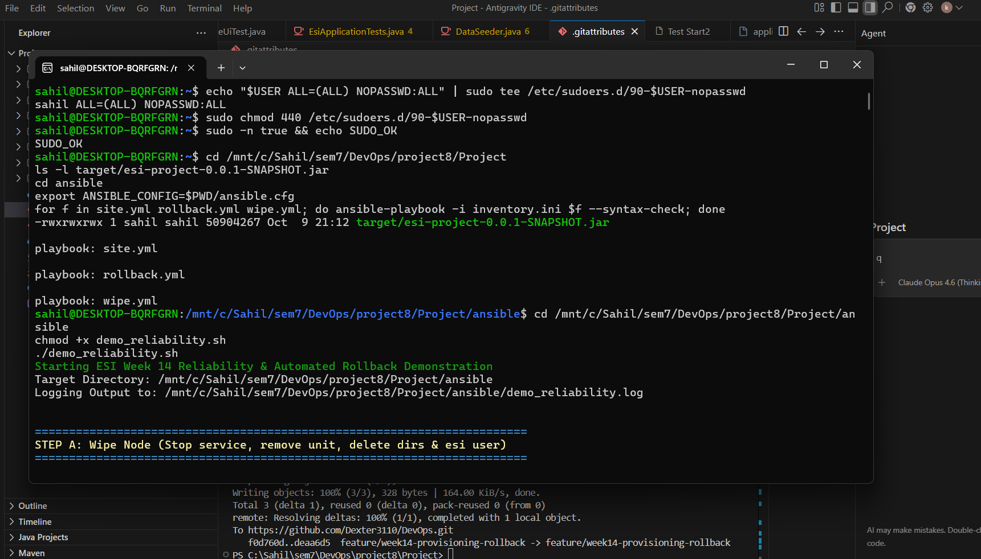
Figure 1: Pre-flight checks passed and the demonstration started at Step A

6. Demonstration

6.1 Step A: wipe the node
ansible-playbook -i inventory.ini wipe.yml

The service, unit file, application folders and the esi user were removed, and the script verified the clean state:
PLAY RECAP
localhost : ok=9 changed=5 unreachable=0 failed=0 skipped=0 rescued=0 ignored=0

Service status: inactive
Application dir: /opt/esi removed
ESI User: esi user removed

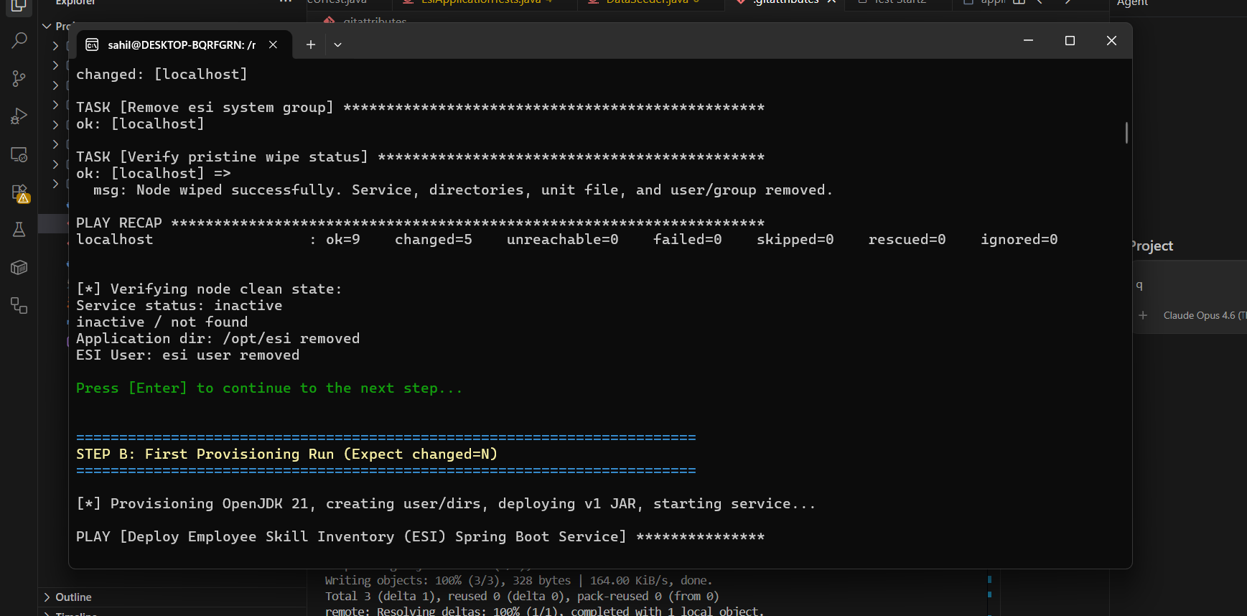
Figure 2: Step A wipe recap and clean-state verification

6.2 Step B: first provisioning run
ansible-playbook -i inventory.ini site.yml -e "release_version=v1"

The group, user, four directories, JAR copy, symlink, systemd unit, service enable and start, and the restart handler all reported changed, and the health check passed:
- 'Active Release: v1'
- 'Port: 8090'
- 'Profile: dev'
- 'Response: {''environment'': ''dev'', ''port'': ''8090''}'

PLAY RECAP
localhost : ok=14 changed=8 unreachable=0 failed=0 skipped=0 rescued=0 ignored=0

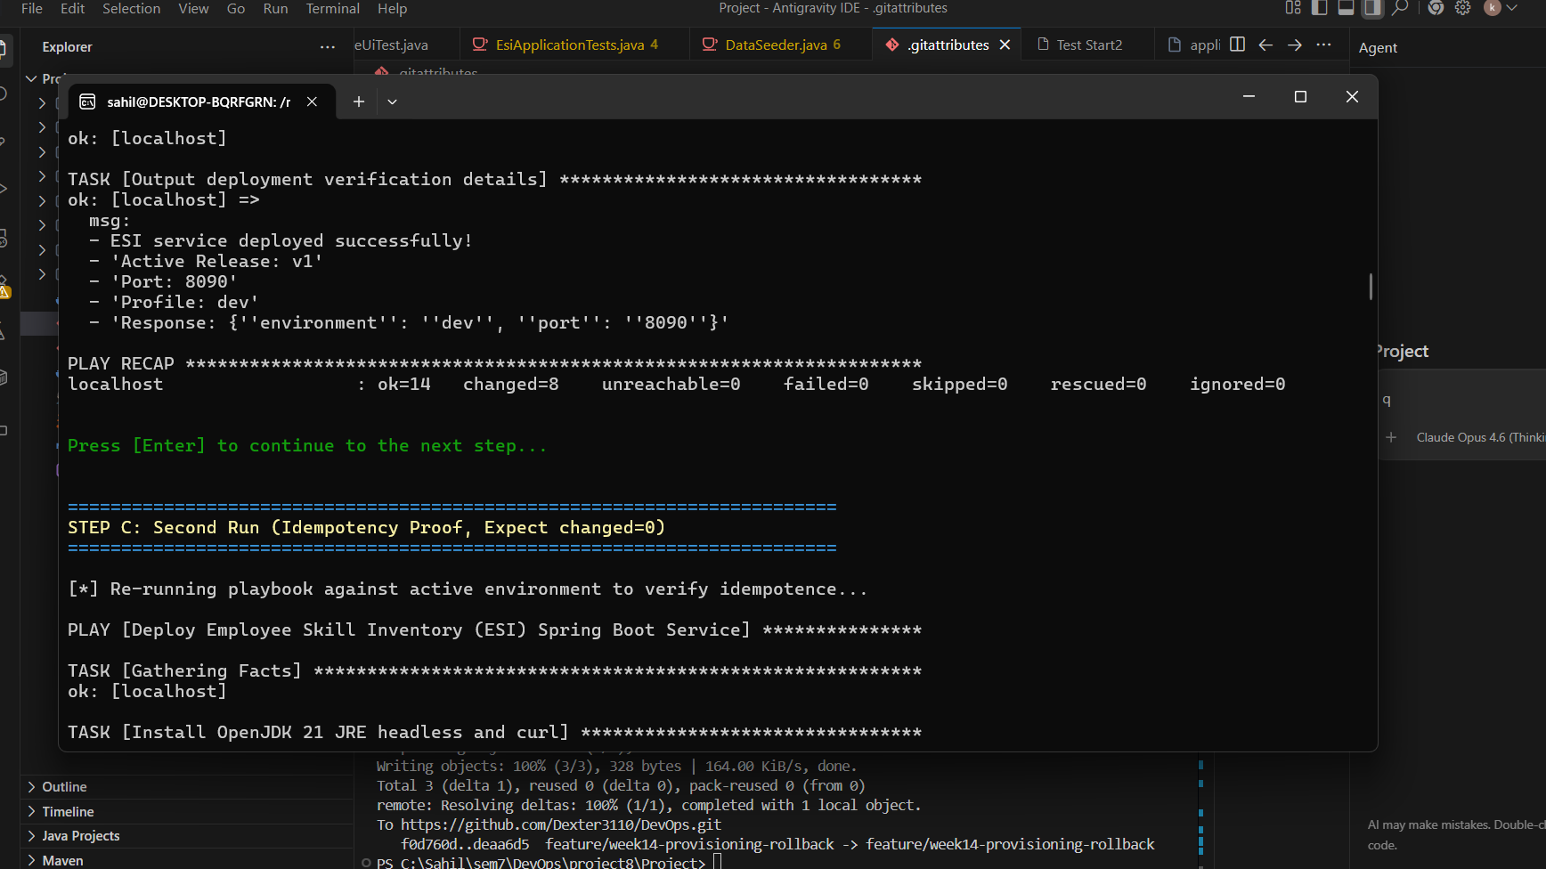
Figure 3: Step B first provisioning recap (changed=8, failed=0)

6.3 Step C: second run, idempotency proof
ansible-playbook -i inventory.ini site.yml -e "release_version=v1"

Run against the unchanged node, every task reported ok. No task changed anything:
PLAY RECAP
localhost : ok=12 changed=0 unreachable=0 failed=0 skipped=1 rescued=0 ignored=0

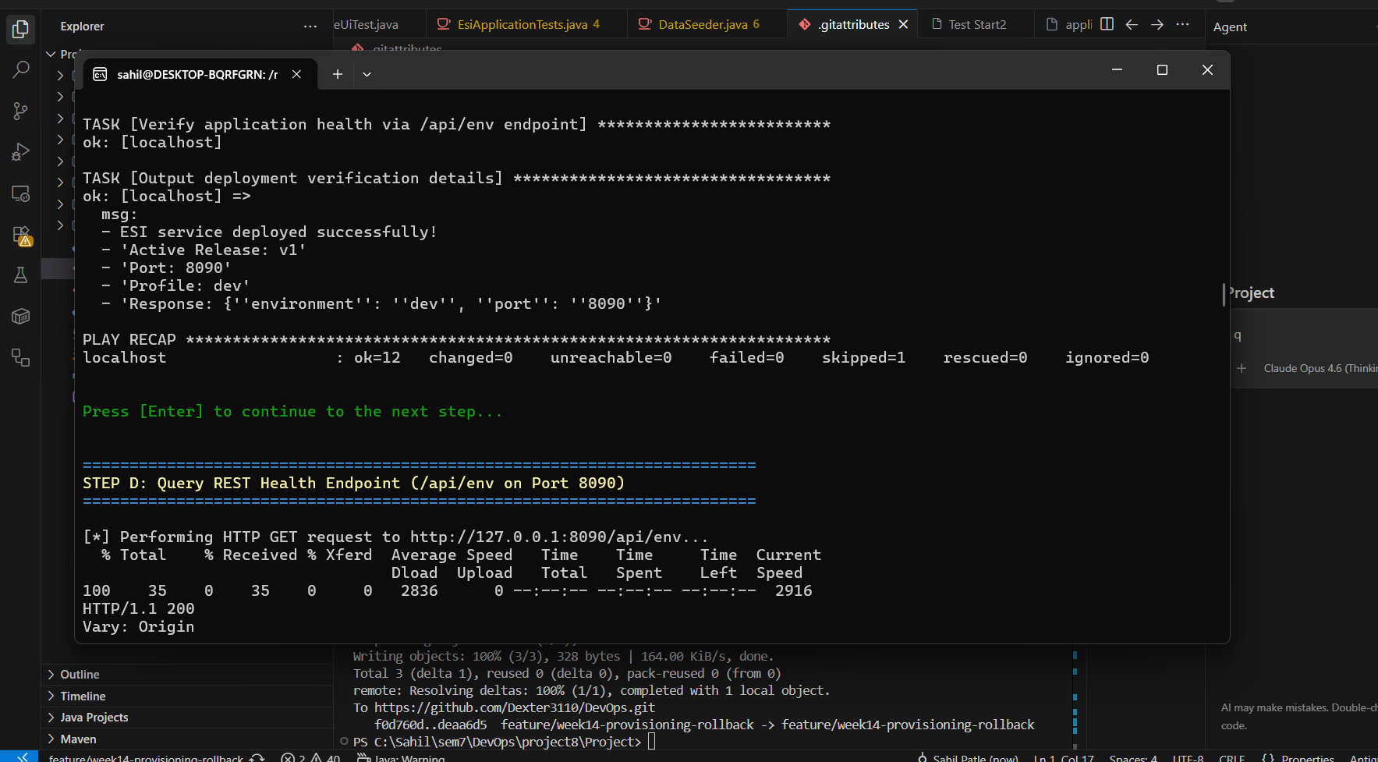
Figure 4: Step C idempotency recap (changed=0)

6.4 Step D: health check
curl -i http://127.0.0.1:8090/api/env

HTTP/1.1 200
Content-Type: application/json
Date: Sat, 10 Oct 2026 20:14:57 GMT

{"environment":"dev","port":"8090"}

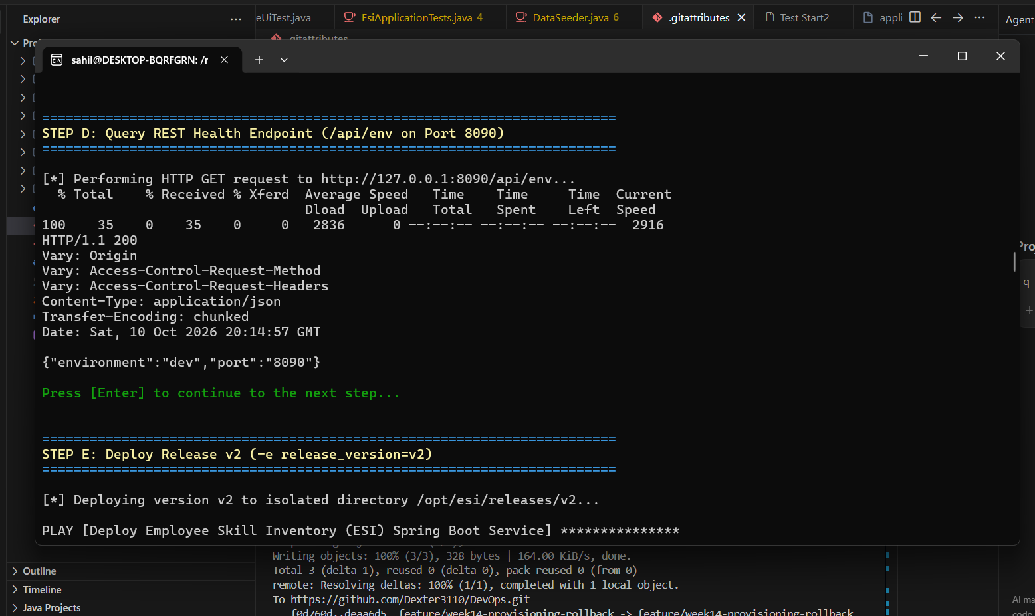
Figure 5: Step D health check returning HTTP 200

6.5 Step E: deploy release v2
ansible-playbook -i inventory.ini site.yml -e "release_version=v2"

The new release folder, the JAR copy and the symlink changed, and the handler restarted the service. The new version answered the health check:
PLAY RECAP
localhost : ok=13 changed=4 unreachable=0 failed=0 skipped=1 rescued=0 ignored=0

lrwxrwxrwx 1 root root 20 Oct 10 20:15 /opt/esi/current -> /opt/esi/releases/v2
Live API env: {"environment":"dev","port":"8090"}

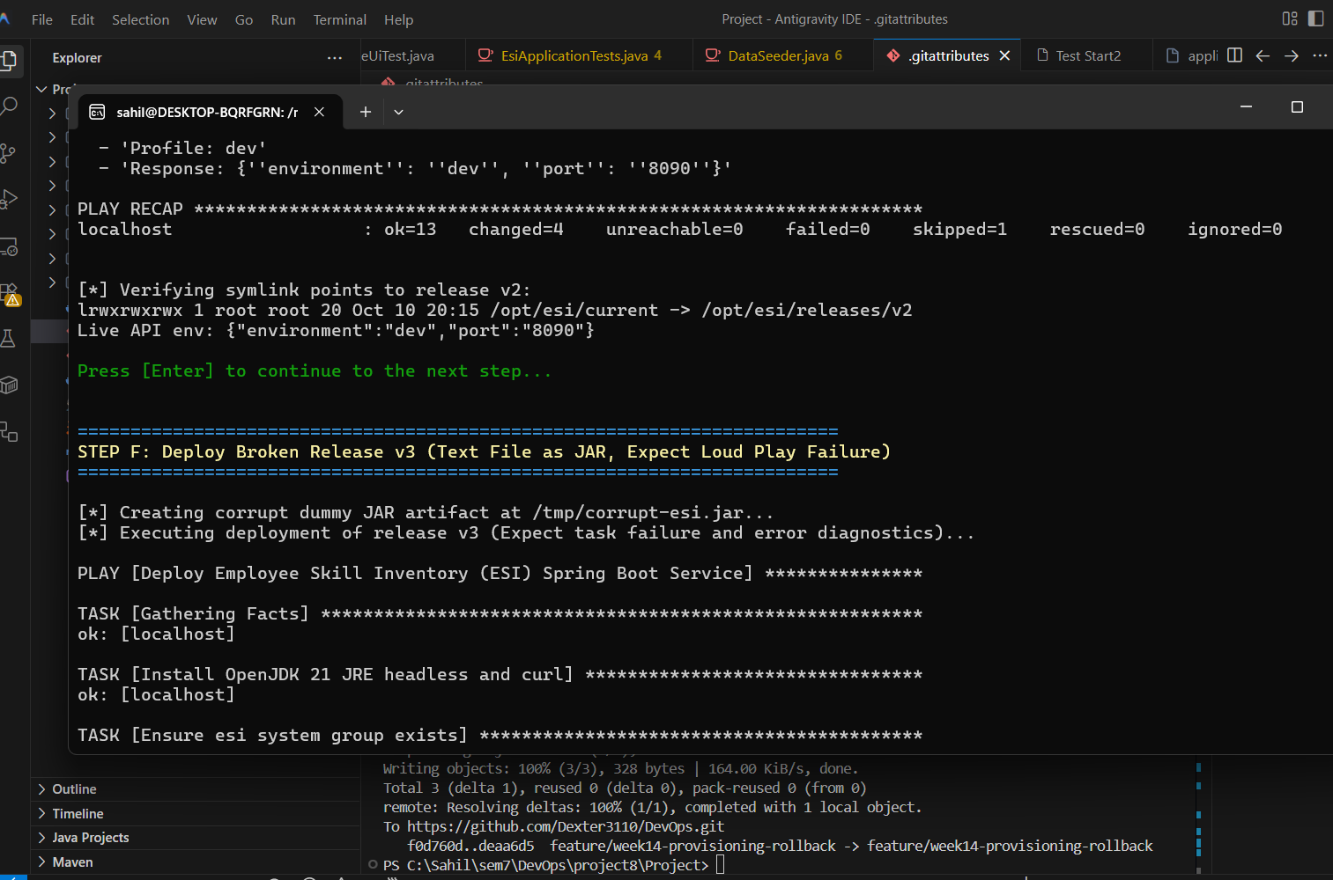
Figure 6: Step E release v2 deployed, current now points to v2

6.6 Step F: deploy a deliberately broken release v3
A text file was supplied in place of the JAR, so the service could not start:
echo "CORRUPT NON-JAVA FILE - INTENTIONAL FAILURE DEMONSTRATION" > /tmp/corrupt-esi.jar
ansible-playbook -i inventory.ini site.yml -e "release_version=v3" -e "jar_src=/tmp/corrupt-esi.jar"

The health gate stopped the deployment. After the 45-second wait the port was still closed, the rescue section printed the service status and journal, and the play failed:
TASK [Wait for application port to become ready]
fatal: [localhost]: FAILED! => changed=false
elapsed: 45
msg: Timeout when waiting for 127.0.0.1:8090

Active: activating (auto-restart) (Result: exit-code)
Process: ExecStart=/usr/bin/java -jar /opt/esi/current/esi-project.jar ... (code=exited, status=1/FAILURE)
esi.service: Scheduled restart job, restart counter is at 4.

TASK [Fail loudly - Deployment health check failed]
fatal: [localhost]: FAILED! => msg: 'CRITICAL: Deployment of release ''v3'' FAILED health checks
on port 8090! ... Run rollback.yml to restore previous version.'

PLAY RECAP
localhost : ok=13 changed=4 unreachable=0 failed=1 skipped=1 rescued=1 ignored=0

[PASS] Playbook failed loudly as expected with exit code 2.

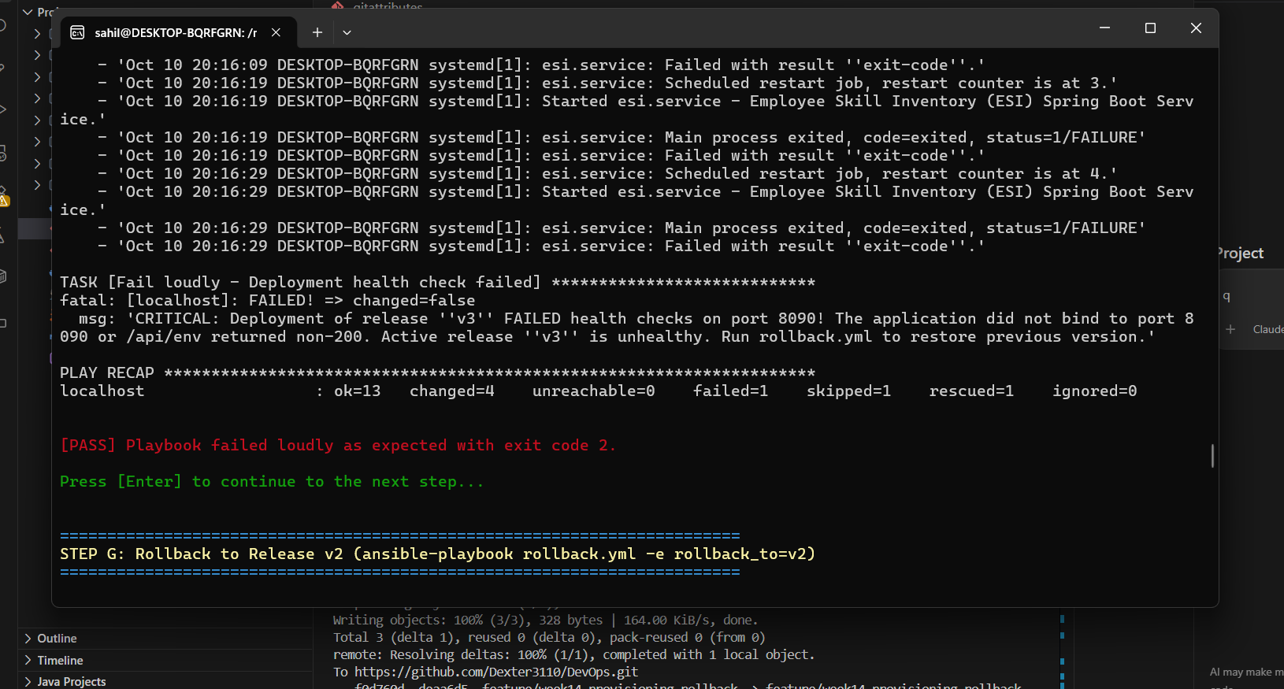
Figure 7: Step F broken release v3 rejected (failed=1, rescued=1, exit code 2)

6.7 Step G: rollback to release v2
ansible-playbook -i inventory.ini rollback.yml -e "rollback_to=v2"

- ROLLBACK SUCCESSFUL!
- 'Active Release: v2'
- 'Symlink: /opt/esi/current -> /opt/esi/releases/v2'
- 'Port: 8090'
- 'Response: {''environment'': ''dev'', ''port'': ''8090''}'

PLAY RECAP
localhost : ok=7 changed=2 unreachable=0 failed=0 skipped=2 rescued=0 ignored=0

The symlink, the three release folders and the health check after the rollback:
lrwxrwxrwx 1 root root 20 Oct 10 20:16 /opt/esi/current -> /opt/esi/releases/v2

drwxr-xr-x 2 esi esi 4096 Oct 10 20:13 v1
drwxr-xr-x 2 esi esi 4096 Oct 10 20:15 v2
drwxr-xr-x 2 esi esi 4096 Oct 10 20:15 v3

HTTP/1.1 200
Date: Sat, 10 Oct 2026 20:17:03 GMT
{"environment":"dev","port":"8090"}

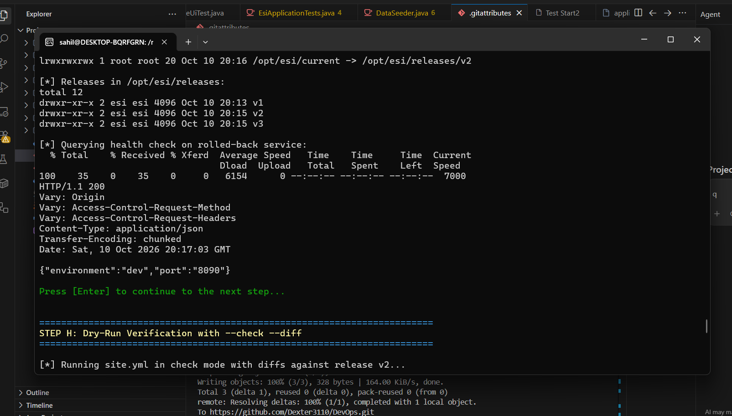
Figure 8: Step G after rollback, current -> v2 and health check HTTP 200

6.8 Step H: dry run with --check --diff
ansible-playbook -i inventory.ini site.yml -e "release_version=v2" --check --diff

In check mode the playbook predicted no changes against the recovered node. The health-check tasks are skipped by design in check mode:
PLAY RECAP
localhost : ok=9 changed=0 unreachable=0 failed=0 skipped=4 rescued=0 ignored=0

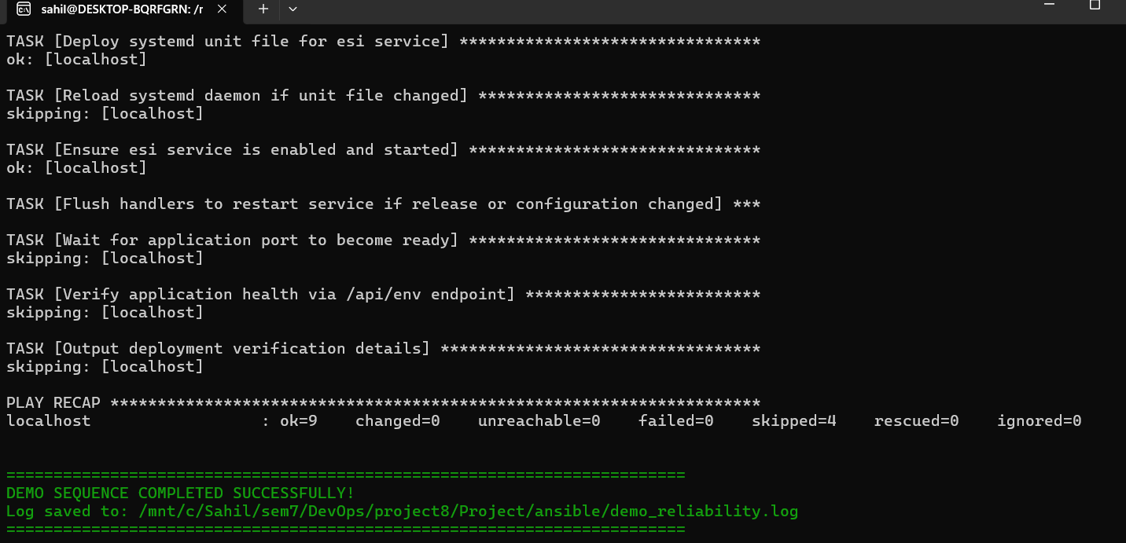
Figure 9: Step H check-mode recap (changed=0) and completion of the demonstration

7. Idempotency Evidence
The same playbook and the same variables were run twice. The first run built the environment, and the second run changed nothing:
Task | Step B (first run) | Step C (second run)
Install OpenJDK 21 JRE headless and curl | ok | ok
Ensure esi system group exists | changed | ok
Ensure esi system user exists | changed | ok
Ensure base and release directories exist (4 items) | changed | ok
Copy application JAR artifact | changed | ok
Update current release symlink | changed | ok
Deploy systemd unit file | changed | ok
Ensure esi service is enabled and started | changed | ok
Restart esi service (handler) | changed | not triggered
Health check | ok | ok
PLAY RECAP | ok=14 changed=8 | ok=12 changed=0

The eight changed tasks in the first run are the group, user, directories, JAR copy, symlink, unit file, service start and the restart handler. The OpenJDK package task shows ok in both runs because the package was already installed on the node.

8. Failure and Recovery Timeline
Time (UTC) | Event
20:13 | Release v1 provisioned and healthy (Steps B and C)
20:15 | Release v2 deployed; /opt/esi/current moved to v2; health check passed (Step E)
20:15 | Release v3 deployed with a corrupt JAR; the service restarted and exited with status 1
20:15 to 20:16 | systemd retried the service every 10 seconds (restart counter reached 4); the play waited 45 seconds for port 8090, then rescued and failed loudly (Step F)
20:16 | rollback.yml repointed current to v2 and restarted the service (Step G)
20:17 | Health check returned HTTP 200 on the rolled-back release (Step G)

9. Notes and Limitations
- The wipe returns users, folders, files, the unit and the service to a clean state, but leaves the OpenJDK package installed, so the package task shows ok in Step B.
- The /opt/esi/current symlink is owned by root:root, as shown by the listings above. The release folders are owned by esi. The service is not affected.
- Releases v1, v2 and v3 stay on disk after the demonstration. Old releases are not cleaned up automatically.
- Do not run site.yml without -e release_version after a rollback, because the default value v1 would move the symlink back to v1.
- The target is a single local WSL node and the application uses an in-memory H2 database, so data resets on every restart.

10. Deliverables Checklist
Deliverable | Where it is shown
Provisioned node | Steps A and B, Figures 2 and 3
Idempotency evidence | Step C and section 7, Figure 4
Health-check result | Step D, Figure 5, and the health checks inside each play
Rollback and recovery demonstration | Steps E to G and section 8, Figures 6 to 8
Dry-run evidence | Step H, Figure 9

11. Conclusion
A clean node was provisioned from nothing with one playbook, and running the same playbook again changed nothing, which proves idempotency. Releases are kept side by side behind a symlink, a corrupt release was caught by the health gate and failed the run loudly with diagnostics, and a single rollback command restored the previous stable release with a passing health check. The whole sequence is repeatable through the demonstration script.

