Week 10: Continuous Testing in Jenkins
Employee Skill Inventory (ESI)
Jenkins job: esi-build (pipeline from SCM, branch develop)
Repository: https://github.com/Dexter3110/DevOps

1. Objective
Integrate the Selenium WebDriver suite for the Employee Skill Inventory into the Jenkins pipeline so that:
- Test reports are published in Jenkins.
- Failed tests stop the pipeline before deployment.
- A deliberately introduced defect is detected, corrected, and the pipeline is rerun successfully.

2. Test Setup

2.1 Selenium suite (com.esi.selenium.EsiUiTest)
ID | Journey | What is asserted
UI-01 | Dashboard loads and ENV badge is visible | The envBadge element text matches ^ENV:.*
UI-02 | Add a new employee and see it in the list | The new employee appears in the list
UI-03 | Add a skill to the catalogue, then search for it | The skill is returned by the search
UI-04 | Assign a skill to an employee and verify the assignment | The assignment appears in the list

The tests run in headless Chrome, so they work under the Jenkins Windows service. The Selenium stage runs against a temporary instance of the packaged application on port 8099, and the suite is placed before the Deploy stage so that a failing test blocks deployment. Jenkins publishes the JUnit results on the Tests page of each build.

2.2 Fixes made before the defect demonstration
Problem | Cause | Fix | Commit
All 4 UI tests errored: session not created, ChromeDriver supports Chrome 152 only | ChromeDriver was older than the installed Chrome 154 | Upgraded selenium-java to 4.50.0 and let Selenium Manager select the matching driver | fix: upgrade Selenium to 4.50.0, use Selenium Manager
Failure screenshots were never saved (NoSuchSessionException: Session ID is null) | TestWatcher runs after @AfterEach, when driver.quit() had already closed the browser | Rewrote ScreenshotOnFailureExtension as a TestExecutionExceptionHandler, which runs while the browser is open and rethrows so the test still fails | fix: capture failure screenshot before browser closes

3. Baseline: All Tests Passing (Build #15)
Build #15 built commit dbb1628 ("fix: upgrade Selenium to 4.50.0, use Selenium Manager") from refs/remotes/origin/develop. It archived esi-project-0.0.1-SNAPSHOT.jar (48.55 MiB) and reported no test failures.
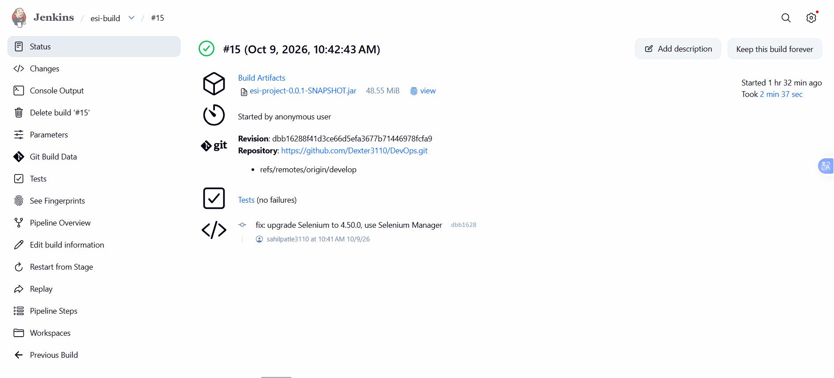
Figure 1: Build #15 status page with the archived artefact
All 18 tests passed: 14 in package com.esi and 4 in package com.esi.selenium.
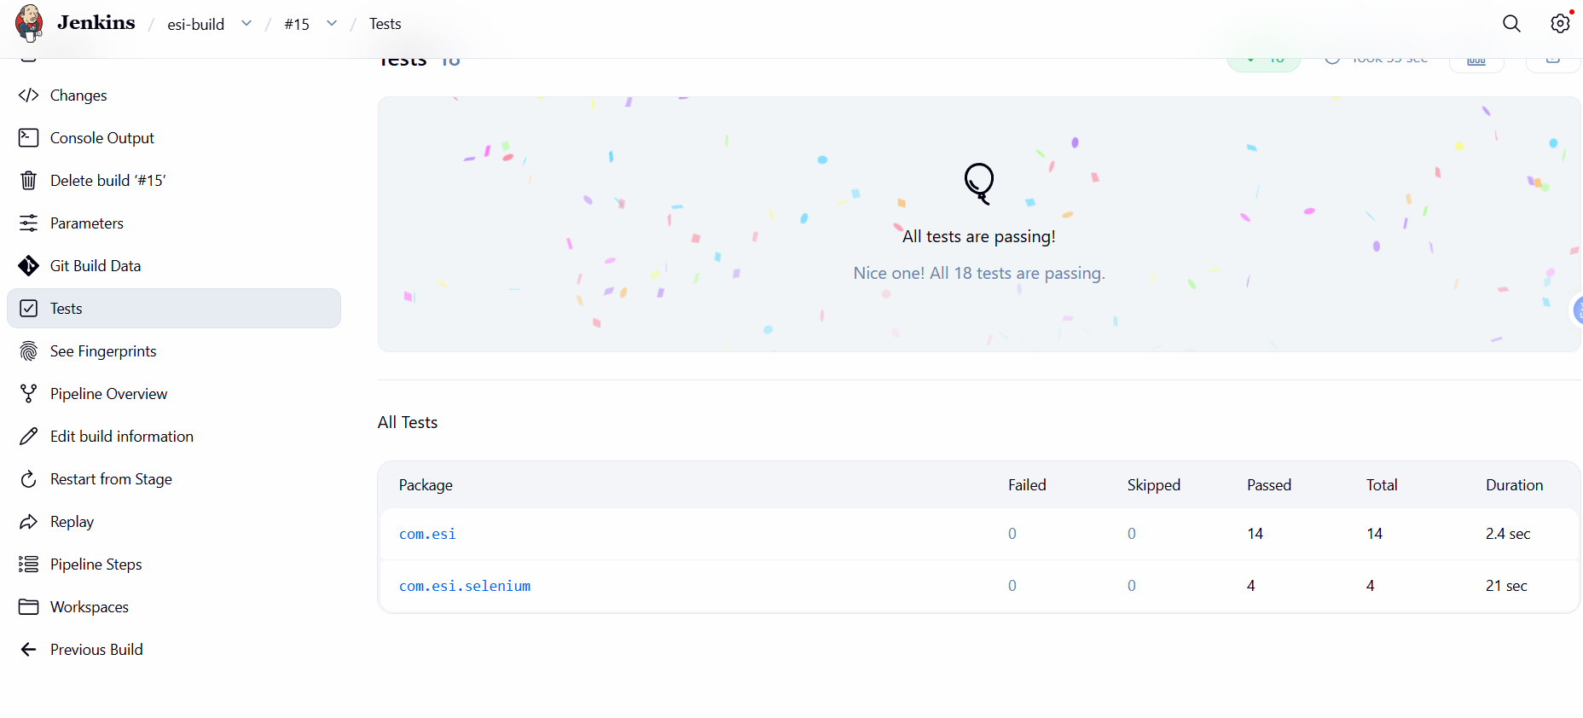
Figure 2: Build #15 test report, 18 of 18 passing

4. Deliberate Defect (Build #16)

4.1 The defect
One line in src/main/resources/static/js/app.js that builds the environment badge text was changed so that the badge started with "ENVIRONMENT:" instead of "ENV:".
- ...textContent = `ENV: ${...} · PORT ${info.port}`;
+ ...textContent = `ENVIRONMENT: ${...} · PORT ${info.port}`;

The application still works normally. Only the text asserted by journey UI-01 changed, so only that test is expected to fail.
Commit message: test: introduce deliberate defect for week 10 demo

4.2 Local verification
Before pushing, the suite was run locally against the application on port 8095:
mvn test "-Dtest=*UiTest" "-Dbase.url=http://localhost:8095"

Result: Tests run: 4, Failures: 0, Errors: 1. Only testDashboardLoadsAndEnvBadgeVisible failed:
Expected condition failed: waiting for text found by By.id: envBadge
to match pattern "^ENV:.*". Current text: "ENVIRONMENT: DEV · PORT 8095"

The console printed that the failure screenshot was saved to target\screenshots\testDashboardLoadsAndEnvBadgeVisible.png. The captured image shows the dashboard at the moment of failure, with the badge reading "ENVIRONMENT: DEV · PORT 8095".
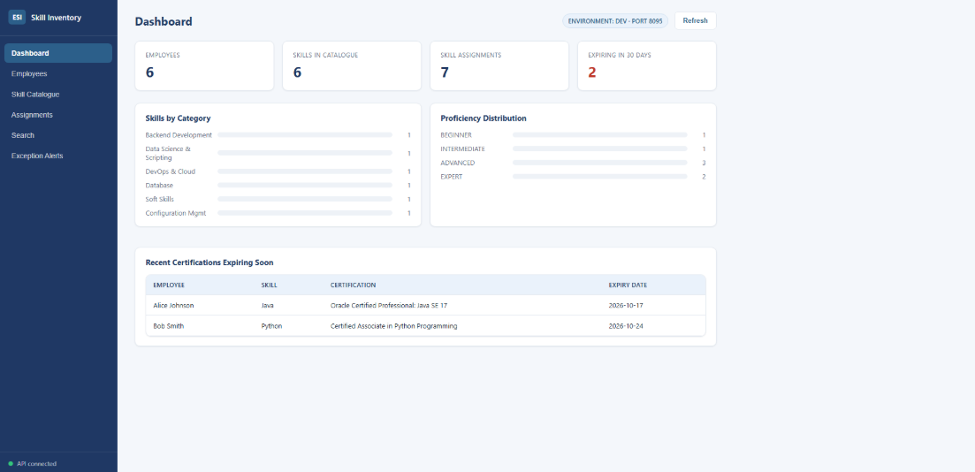
Figure 3: Failure screenshot captured by the test framework

4.3 Jenkins result
Pushing the defect to develop produced build #16, which failed. The Jenkins test report shows 1 failed and 17 passed. The failing test is testDashboardLoadsAndEnvBadgeVisible in com.esi.selenium.EsiUiTest, and Jenkins flags it as a Regression because it passed in build #15. All 14 tests in com.esi still passed.
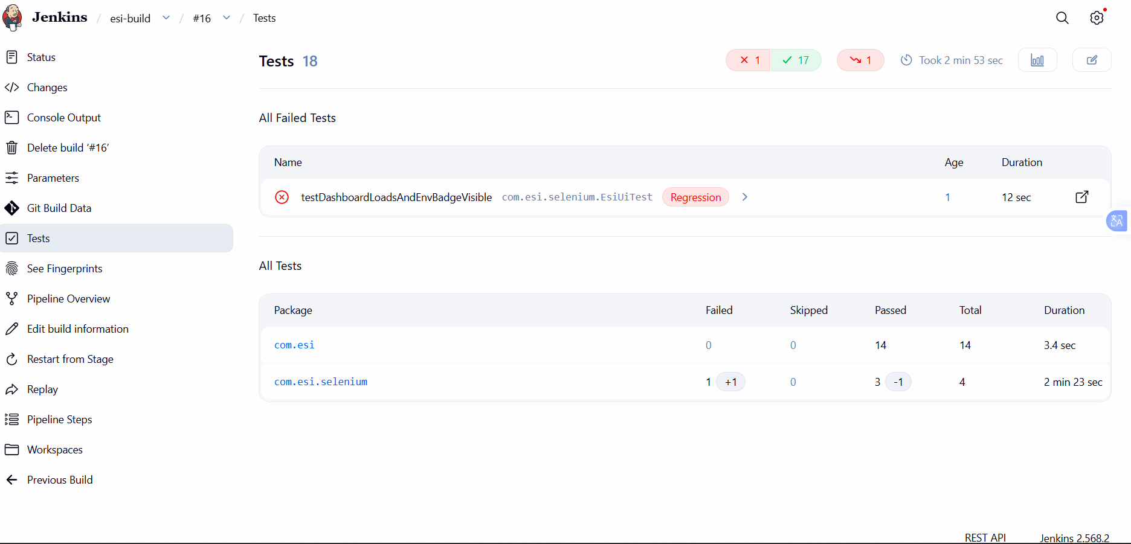
Figure 4: Build #16 test report with the failed test
Package | Failed | Passed | Total | Duration
com.esi | 0 | 14 | 14 | 3.4 s
com.esi.selenium | 1 | 3 | 4 | 2 min 23 s

5. Defect Correction and Rerun (Build #17)
The defect commit was reverted, restoring the original badge text:
git revert --no-commit HEAD
git commit -m "fix: correct defect found by Selenium test"
git push origin develop

Build #17 passed all 18 tests. In com.esi.selenium, failures dropped by 1 and passes rose by 1 compared with build #16, and Jenkins marks one test as fixed.
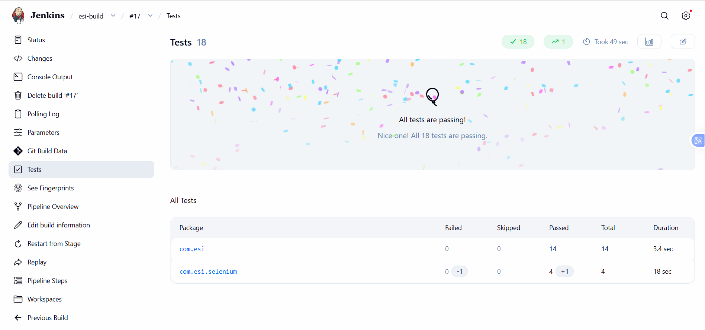
Figure 5: Build #17 test report, all tests passing
Package | Failed | Passed | Total | Duration
com.esi | 0 | 14 | 14 | 3.4 s
com.esi.selenium | 0 | 4 | 4 | 18 s

6. Build History Summary
Build | Change | Result | Tests | Meaning
#15 | fix: upgrade Selenium to 4.50.0, use Selenium Manager (dbb1628) | SUCCESS | 18 passed | Baseline
#16 | test: introduce deliberate defect for week 10 demo | FAILURE | 17 passed, 1 failed | Selenium detected the defect
#17 | fix: correct defect found by Selenium test | SUCCESS | 18 passed | Defect corrected, rerun green

7. Deliverables Checklist
Deliverable | Evidence
Jenkins test report | Figures 2, 4 and 5
Failed pipeline evidence | Build #16 (Figure 4) and the failure screenshot (Figure 3)
Defect correction commit | fix: correct defect found by Selenium test (section 5)
Successful rerun | Build #17 (Figure 5)

8. Conclusion
The Selenium suite now runs as part of the Jenkins pipeline and acts as a quality gate. A one-line change that broke a critical user journey was caught by the automated tests and reported as a regression in build #16. Reverting the change produced build #17, in which all 18 tests pass. The screenshot mechanism now captures the browser state at the moment of failure, which makes failures easier to diagnose.

