Employee Skill Inventory System
Week 3 Documentation
Requirements, Architecture and Technology Setup

1. SRS Summary
The MVP delivers five core capabilities: a skill catalogue, a create/update transaction for employee-skill records, a status view for skills/certifications, search and filter across employees, and exception alerts for expiring or missing mandatory skills. The system must support three roles (Employee, Manager, HR Admin) with role-based access, and must be deployable on a single Tomcat/Nginx server for the pilot.

Functional Requirements (summary)
- FR-1: Maintain a skill catalogue (name, category, description).
- FR-2: Create/update employee-skill records with proficiency level and optional certification/expiry date.
- FR-3: Approval workflow for submitted/updated records (Pending → Active/Rejected).
- FR-4: Search and filter employees by skill, proficiency and status.
- FR-5: Generate exception alerts for certifications expiring within 30 days.
- FR-6: Role-based authentication and authorisation.

Non-Functional Requirements (summary)
- Response time under 2 seconds for search queries on the pilot dataset (~500 employees).
- Deployed on open-source stack; no proprietary licensing cost.
- Basic audit logging of create/update/approve actions.

2. Use-Case Diagram
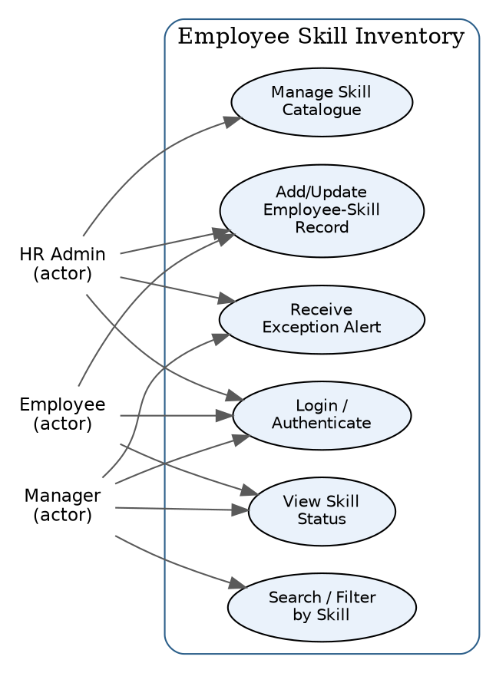

3. Architecture Diagram
A classic three-tier web architecture is used: browser-based client, a Java servlet/REST application layer running on Tomcat behind an Nginx reverse proxy, and a relational database for persistence.
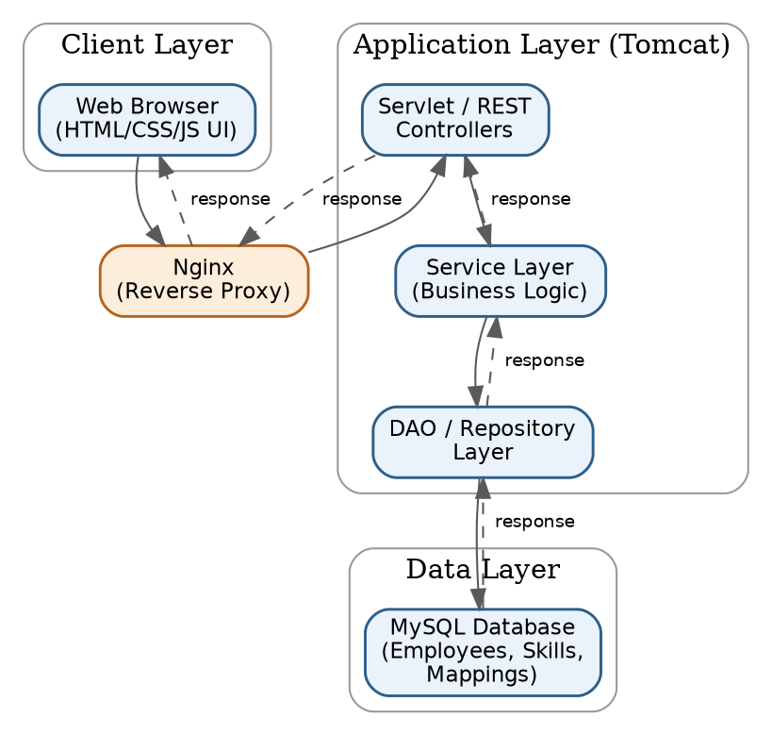

4. Data Model / API List

Core Tables
Table | Key Columns
employee | employee_id (PK), name, email, department, role
skill | skill_id (PK), name, category, description
employee_skill | id (PK), employee_id (FK), skill_id (FK), proficiency, cert_expiry, status
audit_log | id (PK), entity, action, user_id, timestamp

Core REST Endpoints
Method & Path | Purpose
GET /api/skills | List skill catalogue
POST /api/skills | Create a skill (HR Admin)
POST /api/employee-skills | Submit/update an employee-skill record
PUT /api/employee-skills/{id}/approve | Approve/reject a pending record (Manager/HR)
GET /api/employees/search?skill=&minLevel= | Search/filter employees by skill
GET /api/alerts/expiring | List certifications expiring within N days
POST /api/auth/login | Authenticate and issue session/JWT

5. Technology Stack Selection
Layer | Selection | Rationale
Language / Framework | Java 17, Servlets + Spring Boot (REST) | Team familiarity; strong Tomcat integration
Build Tool | Maven | Simple dependency management, wide IDE support
Database | MySQL 8 | Free, relational, good fit for structured skill data
Frontend | HTML5 / CSS3 / vanilla JS (or lightweight React) | Fast to build for a 15-week MVP
Deployment Target | Apache Tomcat 10 behind Nginx reverse proxy | Open-source, well understood, easy to secure with Nginx
Version Control / CI | GitHub + GitHub Actions | Free for small teams, integrates with Maven build

6. Local Development Setup (Working Setup)
- Install JDK 17, Maven 3.9+, MySQL 8, and Git.
- Clone the repository and run `mvn clean install` to build the skeleton project.
- Create local database `esi_dev` and run the initial schema script in /db/schema.sql.
- Run `mvn spring-boot:run` (or deploy the generated WAR to a local Tomcat 10 instance).
- Verify the app responds at http://localhost:8080/api/skills.
- Configure Nginx locally (optional for MVP dev) as a reverse proxy on port 80 → 8080 to mirror production.

