Week 13: Configuration Management with Ansible
Employee Skill Inventory (ESI)
Repository: https://github.com/Dexter3110/DevOps (ansible/ folder)
Target node: WSL2 Ubuntu 24.04 with systemd, configured through a local connection
Tool: Ansible core 2.16.3
Execution evidence: 9 October 2026, 21:18 UTC

1. Objective
Identify every server prerequisite of the Employee Skill Inventory (packages, users, folders, files, ports and services) and capture them in an Ansible playbook that configures the target node and deploys the application as a managed service.

2. Result Summary
The playbook ran to completion with no failures and left the ESI application running as a systemd service on port 8090, answering its health endpoint with HTTP 200.
Week 13 requirement | Evidence
Identify server prerequisites | Section 4: packages, user and group, folders, files, symlink, systemd unit, service and port
Ansible inventory and YAML playbook | ansible/inventory.ini, ansible/site.yml and ansible/templates/esi.service.j2 (syntax check passed, Figure 2)
First execution log | Section 7: PLAY RECAP ok=13 changed=2 unreachable=0 failed=0
Target node configured | Section 8: esi.service active (running) and enabled, release layout in /opt/esi, /api/env returns HTTP 200 and the dashboard loads on port 8090

3. Target Environment
Item | Value
Host operating system | Windows 11 with WSL2
Target node | Ubuntu 24.04 LTS (noble)
Init system | systemd (enabled with systemd=true under [boot] in /etc/wsl.conf; systemctl is-system-running returned "running")
Ansible | ansible [core 2.16.3], Python 3.12.3, Jinja 3.1.2
Connection | Local connection to localhost, with privilege escalation (-K asks for the sudo password)
Application artefact | esi-project-0.0.1-SNAPSHOT.jar, 50,904,267 bytes, built on Windows with mvn clean package -DskipTests

4. Configuration Specification

4.1 Server prerequisites
Category | Resource | Value | Owner / mode
Package | openjdk-21-jre-headless | Java 21 runtime for Spring Boot | root
Package | curl | HTTP checks and troubleshooting | root
Group | esi | System group for isolation | system
User | esi | System user with shell /usr/sbin/nologin | system
Folder | /opt/esi | Application base | esi:esi, 0755
Folder | /opt/esi/releases | Versioned releases | esi:esi, 0755
Folder | /opt/esi/releases/v1 | Active release (variable release_version) | esi:esi, 0755
Folder | /var/log/esi | Application log (app.log) | esi:esi, 0755
File | /opt/esi/releases/v1/esi-project.jar | Executable Spring Boot JAR | esi:esi, 0644
Symlink | /opt/esi/current | Points to the active release folder | root:root
Unit file | /etc/systemd/system/esi.service | Systemd service definition (from a Jinja2 template) | root:root, 0644
Service | esi.service | Enabled at boot and started | systemd
Port | 8090/tcp | HTTP port for the application and health check | -
Endpoint | /api/env | Returns the active profile and port, HTTP 200 | -

4.2 Playbook variables
Variable | Default | Meaning
app_port | 8090 | Port passed to the application as --server.port
app_profile | dev | Spring profile passed as --spring.profiles.active
release_version | v1 | Name of the release folder under /opt/esi/releases
jar_src | /mnt/c/Sahil/sem7/DevOps/project8/Project/target/esi-project-0.0.1-SNAPSHOT.jar | Path of the built JAR as seen from WSL

5. Playbook Design

5.1 File layout
ansible/
ansible.cfg Ansible settings
inventory.ini Target node (localhost, local connection)
site.yml Provisioning and deployment playbook
templates/
esi.service.j2 Jinja2 template for the systemd unit

5.2 Tasks, in execution order
# | Task | Purpose
1 | Gathering Facts | Collect information about the node
2 | Install OpenJDK 21 JRE headless and curl | Install the runtime and tools
3 | Ensure esi system group exists | Create the dedicated group
4 | Ensure esi system user exists | Create the non-login service user
5 | Ensure base and release directories exist | Create /opt/esi, releases, the release folder and /var/log/esi
6 | Copy application JAR artifact to release directory | Place the JAR in the release folder
7 | Update current release symlink | Point /opt/esi/current at the release
8 | Deploy systemd unit file for esi service | Render the unit from the Jinja2 template
9 | Reload systemd daemon if unit file changed | Conditional reload of systemd
10 | Ensure esi service is enabled and started | Enable at boot and start the service
11 | Restart esi service (handler) | Runs only when the JAR, symlink or unit changed
12 | Wait for application port to become ready | Poll port 8090 until it accepts connections
13 | Verify application health via /api/env endpoint | REST health check with retries
14 | Output deployment verification details | Print release, port, profile and response

Design points:
- Release folders and a symlink. Each version lives in /opt/esi/releases/<version>, and the service always runs /opt/esi/current. Switching or rolling back is a symlink change plus a restart.
- Least privilege. The application runs as the esi system user, which has no login shell.
- Managed restarts. A handler restarts the service only when something it depends on has changed, and systemd restarts it on failure (Restart=on-failure).
- Built-in verification. The play waits for the port and checks /api/env, so a broken deployment fails the run.

6. Setup and Pre-flight Checks
systemd was enabled in WSL, Ansible was installed, and the playbook syntax was checked before the run:
sudo apt update
sudo apt install -y ansible
ansible --version
systemctl is-system-running

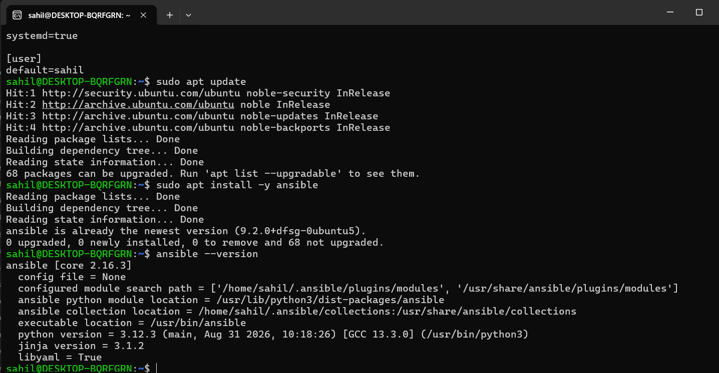
Figure 1: systemd=true in /etc/wsl.conf and Ansible core 2.16.3 installed
The JAR built on Windows is visible from WSL, and the playbook passes the syntax check:
ls -l /mnt/c/Sahil/sem7/DevOps/project8/Project/target/esi-project-0.0.1-SNAPSHOT.jar
cd /mnt/c/Sahil/sem7/DevOps/project8/Project/ansible
ansible-playbook -i inventory.ini site.yml --syntax-check

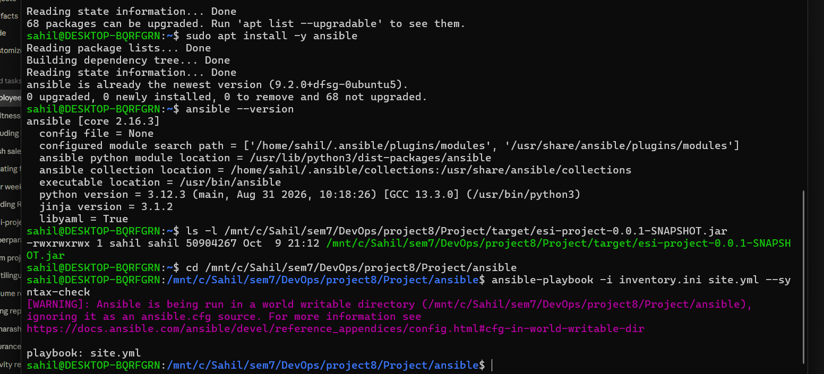
Figure 2: JAR visible from WSL and playbook syntax check (playbook: site.yml)
Ansible prints a warning that it ignores ansible.cfg because /mnt/c folders are world-writable. This is harmless. Setting the variable explicitly makes Ansible use the file:
export ANSIBLE_CONFIG=$PWD/ansible.cfg

7. Playbook Execution
ansible-playbook -i inventory.ini site.yml -K | tee ~/week13-run1.log

Output (the asterisk padding on the task lines is shortened):
BECOME password:

PLAY [Deploy Employee Skill Inventory (ESI) Spring Boot Service] ***

TASK [Gathering Facts] ***
ok: [localhost]

TASK [Install OpenJDK 21 JRE headless and curl] ***
ok: [localhost]

TASK [Ensure esi system group exists] ***
ok: [localhost]

TASK [Ensure esi system user exists] ***
ok: [localhost]

TASK [Ensure base and release directories exist] ***
ok: [localhost] => (item=/opt/esi)
ok: [localhost] => (item=/opt/esi/releases)
ok: [localhost] => (item=/opt/esi/releases/v1)
ok: [localhost] => (item=/var/log/esi)

TASK [Copy application JAR artifact to release directory] ***
changed: [localhost]

TASK [Update current release symlink] ***
ok: [localhost]

TASK [Deploy systemd unit file for esi service] ***
ok: [localhost]

TASK [Reload systemd daemon if unit file changed] ***
skipping: [localhost]

TASK [Ensure esi service is enabled and started] ***
ok: [localhost]

TASK [Flush handlers to restart service if release or configuration changed] ***

RUNNING HANDLER [Restart esi service] ***
changed: [localhost]

TASK [Wait for application port to become ready] ***
ok: [localhost]

TASK [Verify application health via /api/env endpoint] ***
ok: [localhost]

TASK [Output deployment verification details] ***
ok: [localhost] =>
msg:
- ESI service deployed successfully!
- 'Active Release: v1'
- 'Port: 8090'
- 'Profile: dev'
- 'Response: {''environment'': ''dev'', ''port'': ''8090''}'

PLAY RECAP ***
localhost : ok=13 changed=2 unreachable=0 failed=0 skipped=1 rescued=0 ignored=0

7.1 Reading the result
This run was made on a node that had already been provisioned by an earlier run of the same playbook. That is why most tasks report ok (the state already matched the specification) and only two report changed:
- Copy application JAR artifact: changed, because the JAR had just been rebuilt and its content differed.
- Restart esi service (handler): changed, because the handler runs when the JAR changes, so the new build is the one now running.
The result shows that the playbook changes only what has actually drifted. A run on a freshly wiped node and a run showing changed=0 are part of the week 14 provisioning demonstration.

8. Verification of the Configured Node

8.1 Service state
sudo systemctl status esi --no-pager

● esi.service - Employee Skill Inventory (ESI) Spring Boot Service
Loaded: loaded (/etc/systemd/system/esi.service; enabled; preset: enabled)
Active: active (running) since Fri 2026-10-09 21:18:22 UTC
Main PID: 3907 (java)
Memory: 320.6M
CGroup: /system.slice/esi.service
└─3907 /usr/bin/java -jar /opt/esi/current/esi-project.jar
--spring.profiles.active=dev --server.port=8090

8.2 Release layout, health check and run logs
The release folder, the current symlink (pointing at releases/v1) and the esi owner of the release folders are shown below, followed by the health check returning HTTP 200 and the JSON body, and the saved execution log with its recap:
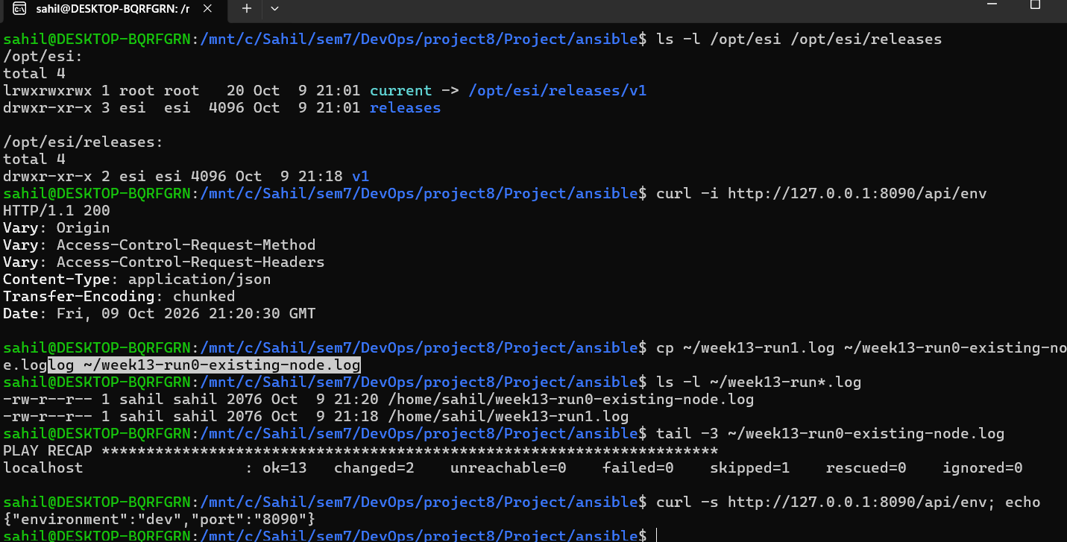
Figure 3: /opt/esi layout, /api/env HTTP 200, saved log recap (ok=13 changed=2 failed=0) and JSON response

8.3 Access from Windows
WSL2 forwards localhost, so the application is reachable from the Windows browser. The health endpoint returns the profile and port:
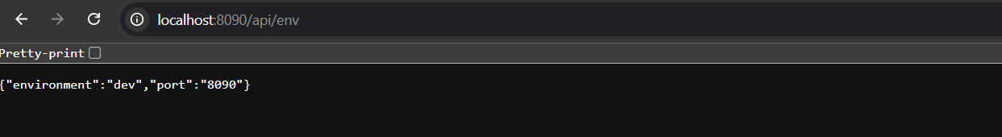
Figure 4: http://localhost:8090/api/env in the browser
The dashboard served by the systemd service shows the environment badge "ENV: DEV · PORT 8090":
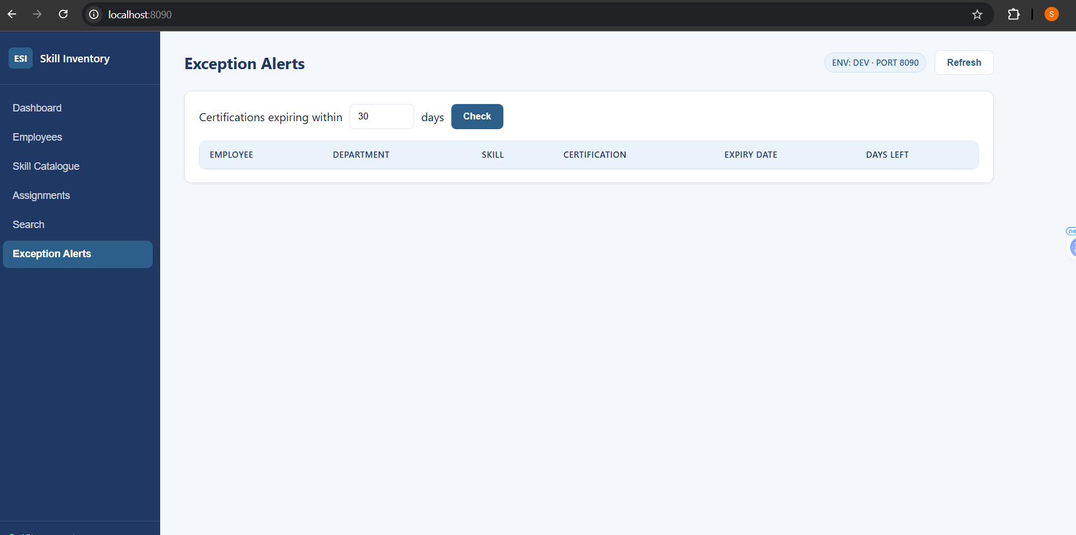
Figure 5: ESI dashboard served from the Ansible-configured node on port 8090

9. Notes and Limitations
- The current symlink is owned by root:root. This is cosmetic, because the service reads the release folder it points to, which is owned by esi.
- The JAR is copied from the Windows file system through /mnt/c. The jar_src variable must be changed if the project folder moves.
- The target is a local WSL node. The same playbook works against a remote Ubuntu host by changing the inventory.
- A clean-node provisioning run, an idempotency run with changed=0, and rollback are covered in week 14.

10. Troubleshooting Reference
Symptom | Cause and fix
Missing sudo password | Run the playbook with -K and enter the Ubuntu password
Failed to connect to bus | systemd is not enabled. Set systemd=true in /etc/wsl.conf and run wsl --shutdown
Could not find or access the JAR | Build it with mvn clean package -DskipTests and check jar_src
ansible.cfg ignored warning | Folder is world-writable under /mnt/c. Use export ANSIBLE_CONFIG=$PWD/ansible.cfg
Timeout waiting for port 8090 | Read /var/log/esi/app.log and journalctl -u esi -n 50 --no-pager
Port 8090 already in use | Find it with sudo ss -ltnp | grep 8090, or deploy with -e app_port=8091

11. Deliverables Checklist
Deliverable | Where it is shown
Configuration specification | Section 4 (prerequisites and variables) and the Markdown spec in docs/
Ansible inventory and playbook | Section 5 and the ansible/ folder; syntax check in Figure 2
First execution log | Section 7 (PLAY RECAP ok=13 changed=2 failed=0)
Evidence of the configured target node | Section 8 (Figures 3 to 5)

12. Conclusion
The server prerequisites of the Employee Skill Inventory are now captured as code. One playbook installs the runtime, creates the service user and folders, deploys the JAR as a versioned release, installs a systemd unit, starts the service and verifies it over HTTP. The run completed with no failures, and a repeat run changed only the two items affected by the rebuilt JAR, which is the behaviour required for the idempotency and rollback work in week 14.

