**Criterion B: Design**

**Overview**

This project is going to be based off an Arduino Mega 2560. It is important to understand a few basic things about this device before I proceed with this section.

* The Arduino Mega works very similarly to an Arduino Uno, but the Mega has a much greater number of pins.
* The Arduino IDE uses a special version of C/C++, and has two major parts
  + void setup – this runs once every time the device starts up
  + void loop – this runs repeatably after the setup function is run

Beyond these two fundamental functions I will be adding several others to more clearly organize my program. These include:

* **Calibrate** – this function will calibrate the device so that the device gets a better idea of what environmental changes it should expect
* **RecordingOn** – this function will make sure that the device has been calibrated before the device starts recording data. This also forces the device to wait for a user input to start recording.
* **RecordingOff** – this function will only run if the device is already recording. This function will take the data it collected, display it, then wait for user input to delete that data and then be ready to collect more data.

Lesser functions such as the ones below are summarized.

* **UpdateLCD** – this function simply formats the display with some values that are (almost) always shown.
* **TestAcceptC** – this bool makes sure that the calibration value isn’t too big or small.

**Program**

Core Algorithm:

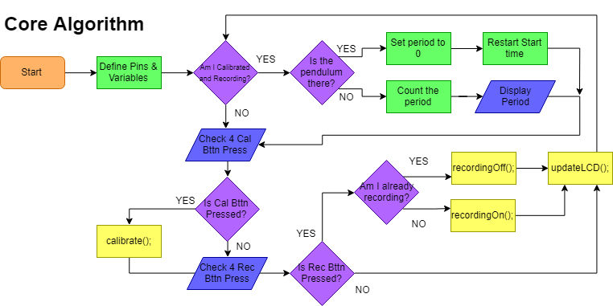

Here is the algorithm for the calibrate function:

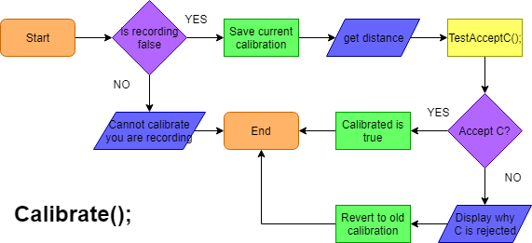

Recording Functions:

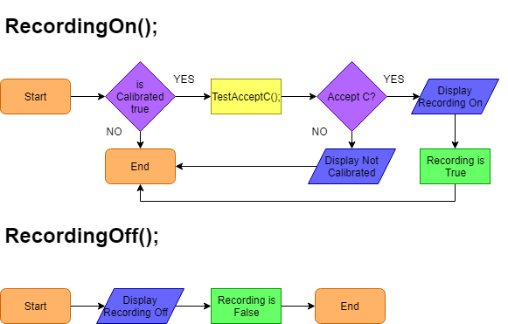

**Circuit**

List of Materials:



Circuit Diagram:

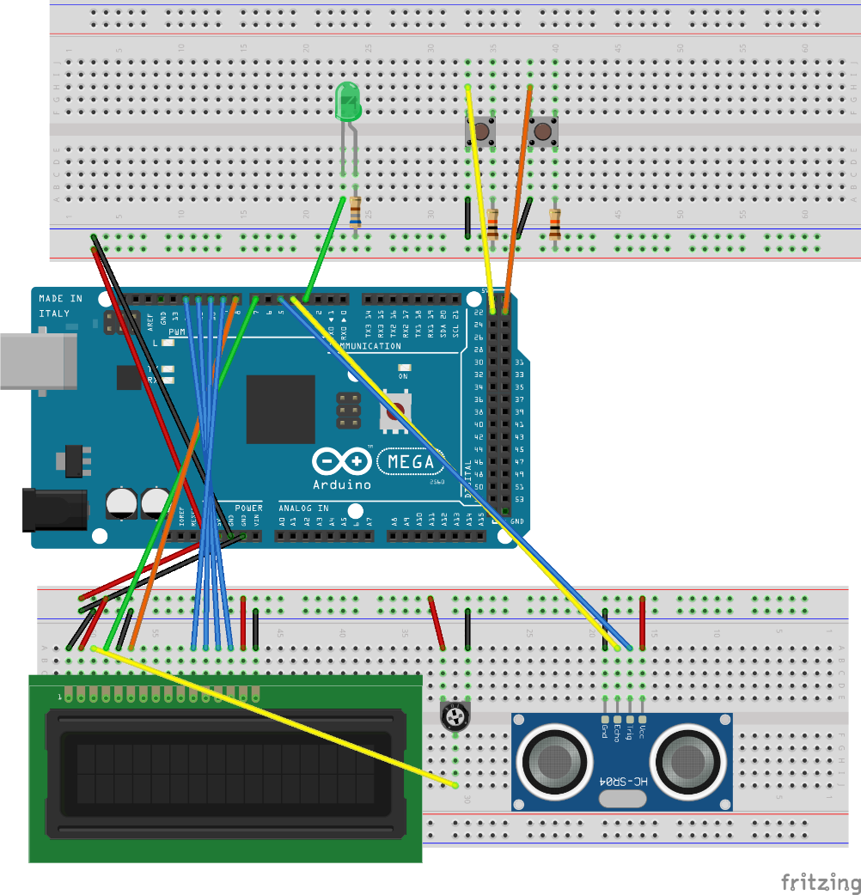

**WORDCOUNT:** 263