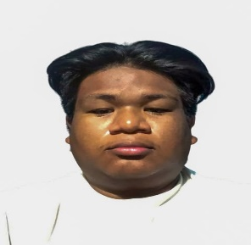**Name (Last, First, M.I.):** Apundar, Jeremy V.

**Address:** 283 Sitio Hulo Proper, Sapang Palay, CSJDM, Bulacan

**Contact No:** 09093642460

**Email Address:** apundarjeremy@gmail.com

**OBJECTIVES:**

Seeking an OJT/Internship in Information Systems to apply my knowledge, gain hands-on experience, and complete my 600-hour training. Eager to learn and contribute while improving my technical and problem-solving skills.

**EDUCATIONAL BACKGROUND**

|  |  |  |
| --- | --- | --- |
| **COLLEGE** | | |
| **SCHOOL** | **COURSE** | **DURATION** |
| BESTLINK COLLEGE OF THE PHILIPPINES | BACHELOR OF SCIENCE IN INFORMATION SYSTEM | 4THYEAR, EXPECTED GRADUATION 2025 |
|  | | |
| **SENIOR HIGH SCHOOL** | | |
| **SCHOOL** | **STRAND** | **DURATION** |
| BESTLINK COLLEGE OF THEPHILIPPINES | INFORMATION AND COMMUNICATION TECHNOLOGY | 2019-2021 |
|  | | |
| **SECONDARY** | | |
| **SCHOOL** | | **DURATION** |
| SAPANG PALAY NATIONAL HIGH SCHOOL | | 2015-2019 |
|  | | |
| **ELEMENTARY** | | |
| **SCHOOL** | | **DURATION** |
| BAGONG BUHAY E CENTRAL SCHOOL | | 2008-2015 |

**SEMINARS AND TRAININGS ATTENDED**

|  |  |  |
| --- | --- | --- |
| **TITLE/TOPIC** | **LOCATION** | **DURATION** |
| COMPUTER SYSTEMS SERVICING NC 2 | PUROK 7 MATIYAGA STREET, BAGONG BUHAY AVE, CSJDM, BULACAN. | 35 - DAYS |

**CERTIFICATE:**

**COMPUTER SYSTEMS SERVICING NC 2**

**PERSONAL INFORMATION**

|  |  |
| --- | --- |
| Date of Birth: | JULY 31, 2002 |
| Place of Birth: | BULACAN |
| Age: | 22 |
| Status: | SINGLE |
| Height: | 5’7 |
| Weight: | 105 |
| Mothers Name: | EUNICE APUNDAR |
| Fathers Name: | RENIE APUNDAR |
| Occupation: | STUDENT |

_______________________ Date Accomplished:

Signature over Printed Name