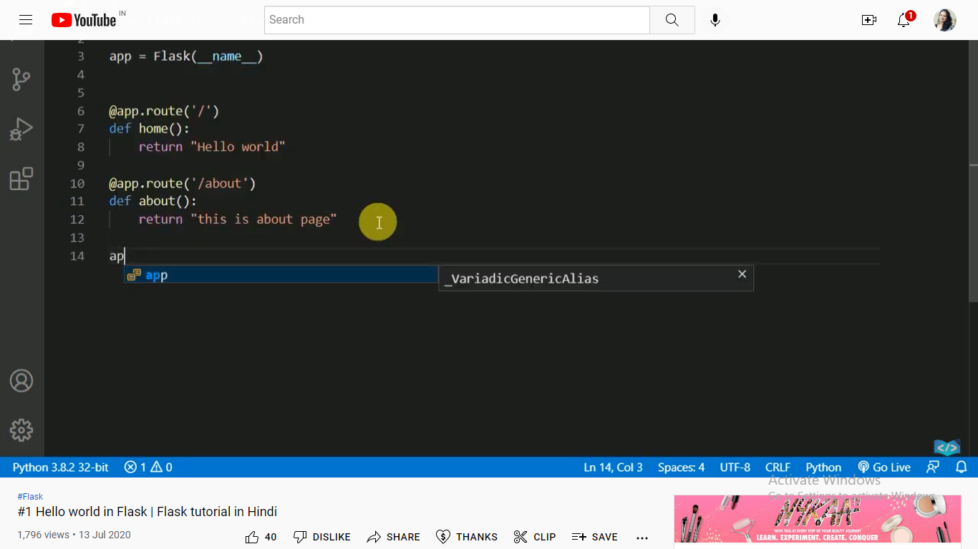
For import flast
app=Flask(__name__) :for Flask constructor takes the name of current module (__name__) as argument.
Address responding uase @app.route() : The route() function of the Flask class is a decorator, which tells the application which URL should call the associated function.
app.route(rule, options)
- The rule parameter represents URL binding with the function.
- The options is a list of parameters to be forwarded to the underlying Rule object.

Ex.@app.rount(localhostaddress/about)-->output(this is about page )
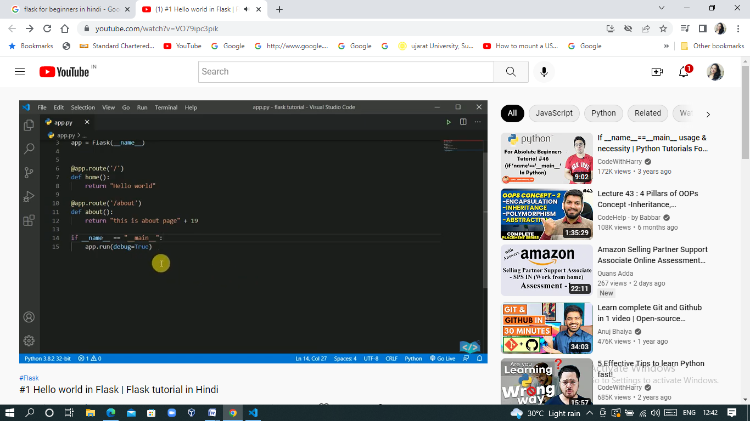
Debug mode activate for main file
