DEYAR IDHILIE SECURITY HOMEWORK REPORT

11820626

\*at the beginning the user could choose the algorithm to use :

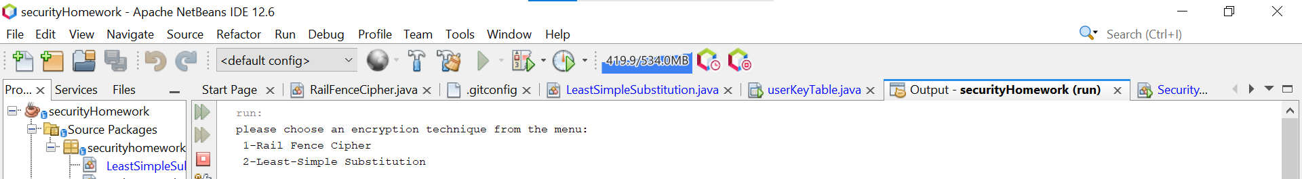\*then, what is wanted to be preformed using this algo/technique. It could be encryption, decryption,

cracking

\* to choose rails fence cipher, the user will enter 1

\*to choose encryption using the rails fence cipher, the user need to enter a

1→a

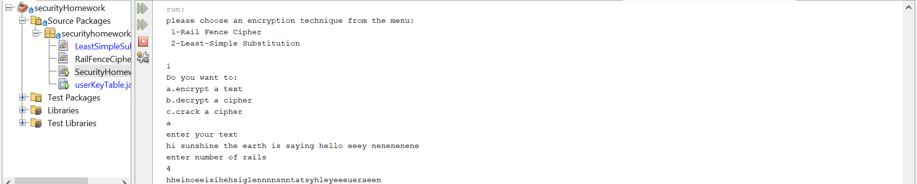\*to encrypt a ciphered text using rails fence ciphered

\* the user will choose 1 then b

1→b

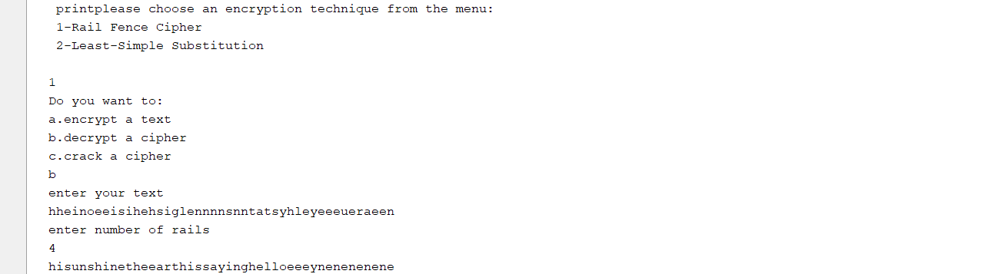\* to crack a cipher using rails fence cipher

\*choose 1 then c

1→c

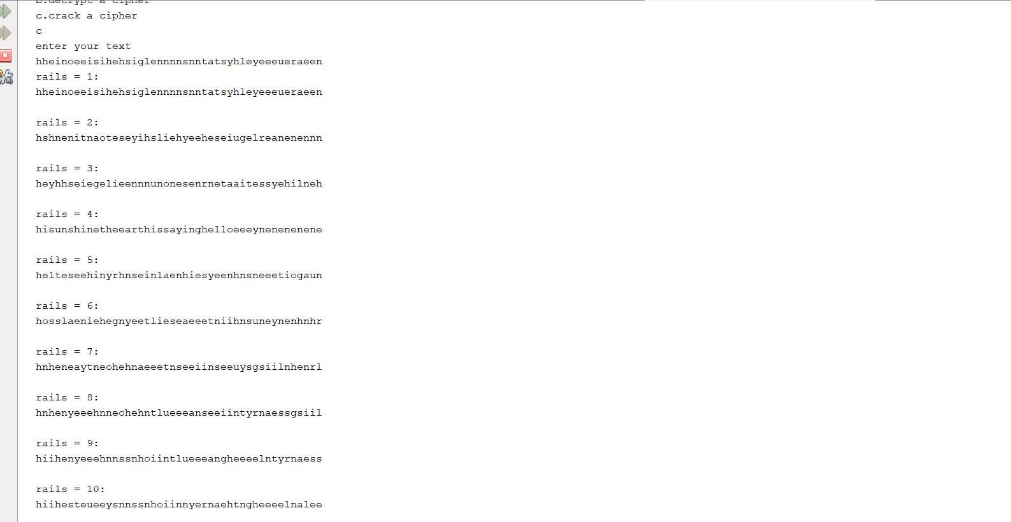\*as shown above, the program will try to crack the text using different number of rails from 1 to 10

\* to choose working with least simple substitution, the user need to choose 2

\* to encrypt a text using least simple substitution , choose a

2→a

\*then choose if u either want the program to generate a table key or you want to enter it by yourself

\*choose 1 for pc generated key

\*choose 2 to enter ur key by urself

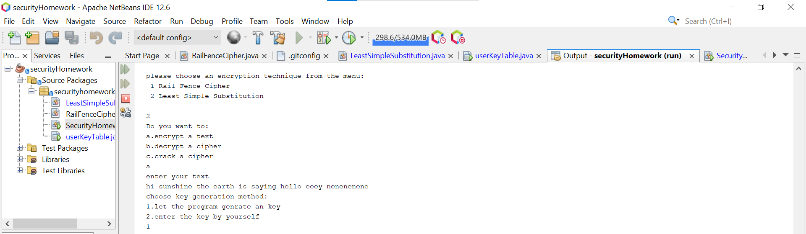2→ a → 1

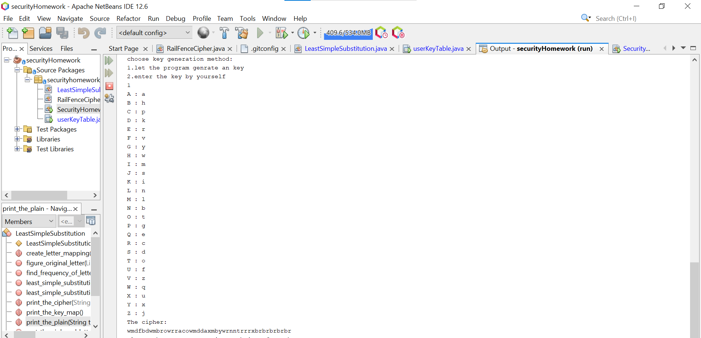2→ a→ 2

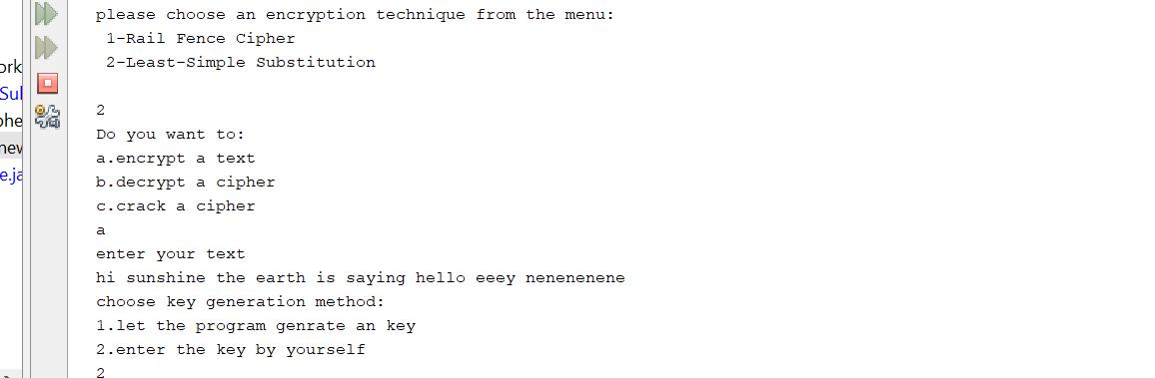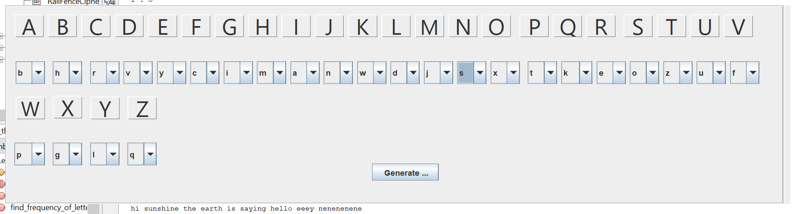

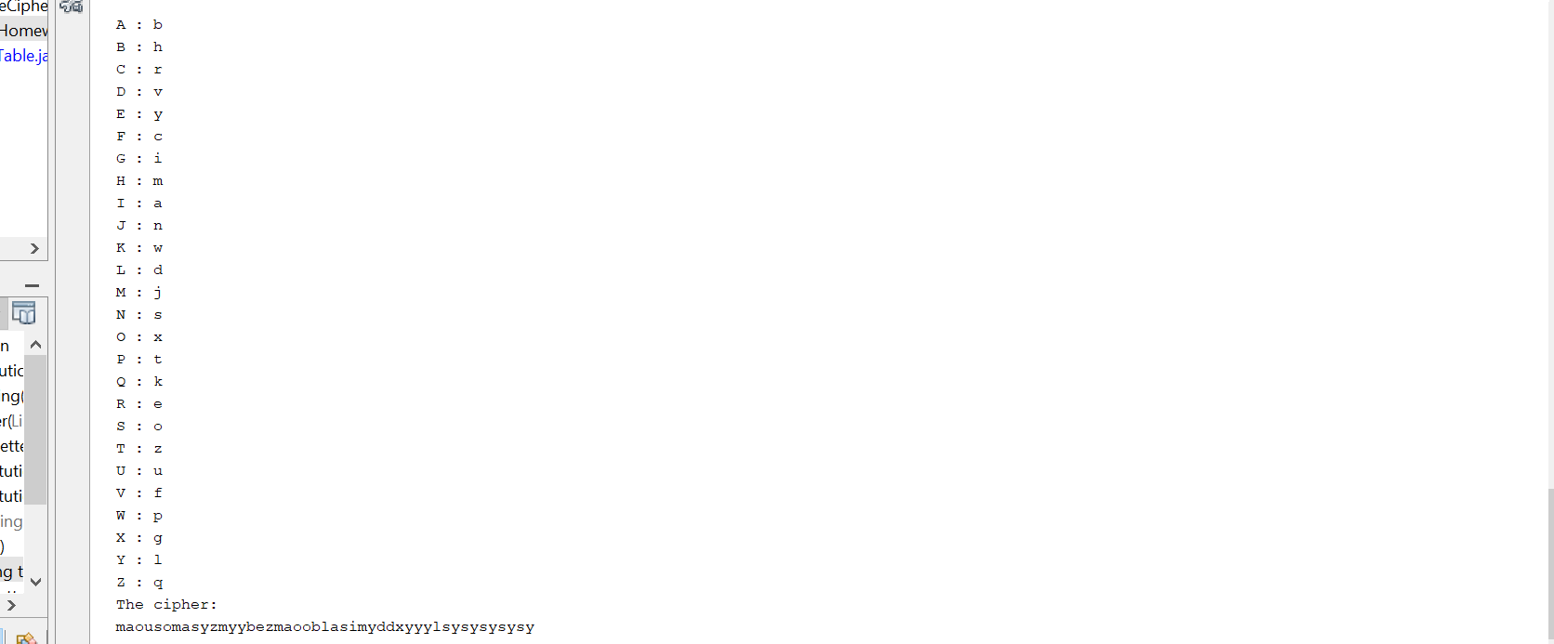\*to decrypt a cipher using least simple substitution

2→b

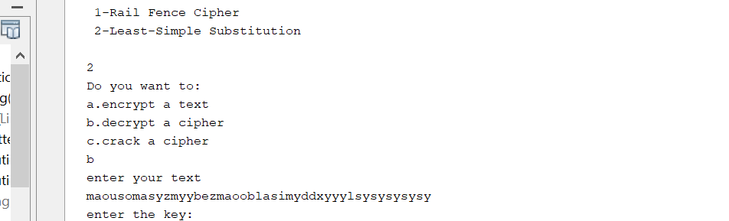

now enter the key

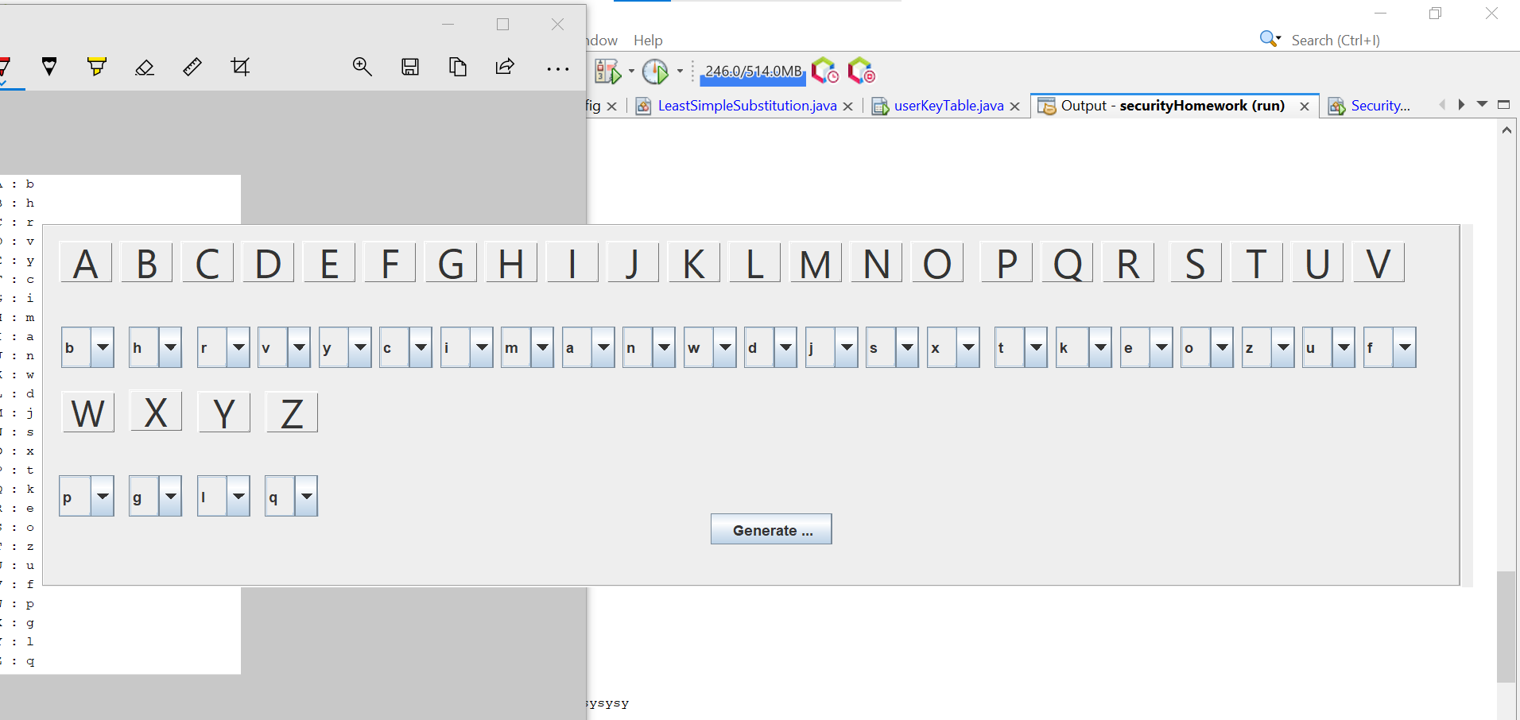

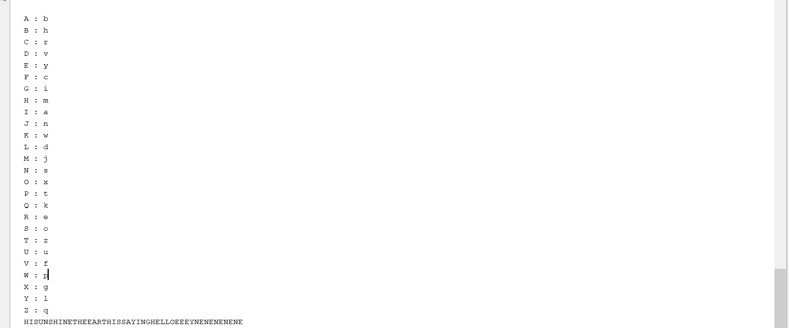\* now lets try to analyze a cipher ,

the original text

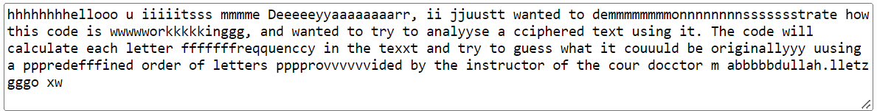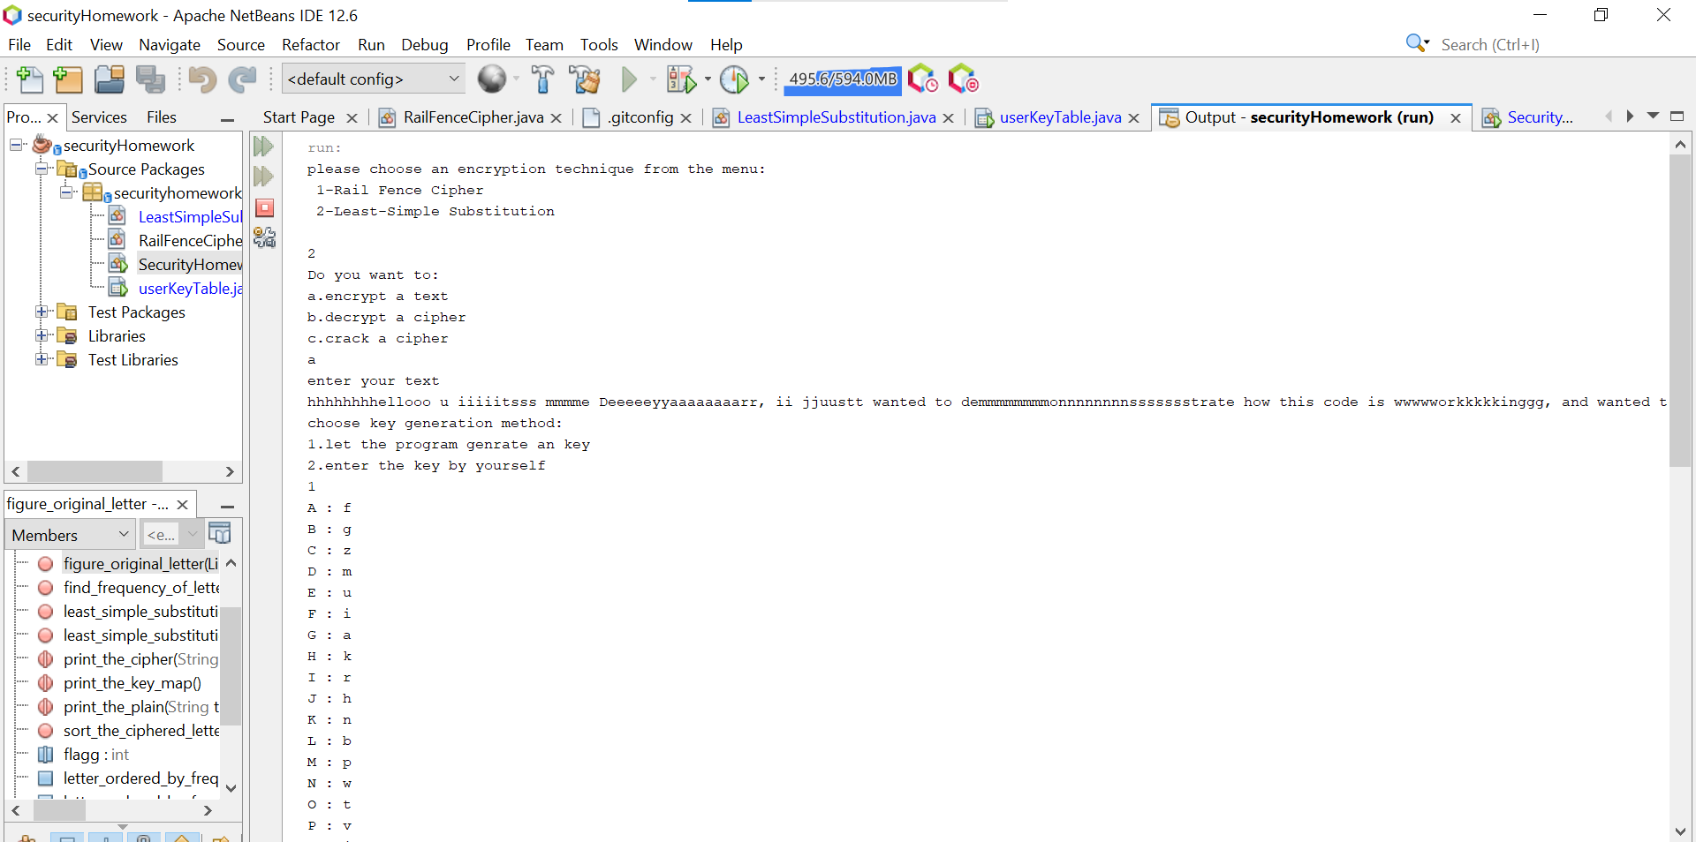\*lets encrypt

the cipher

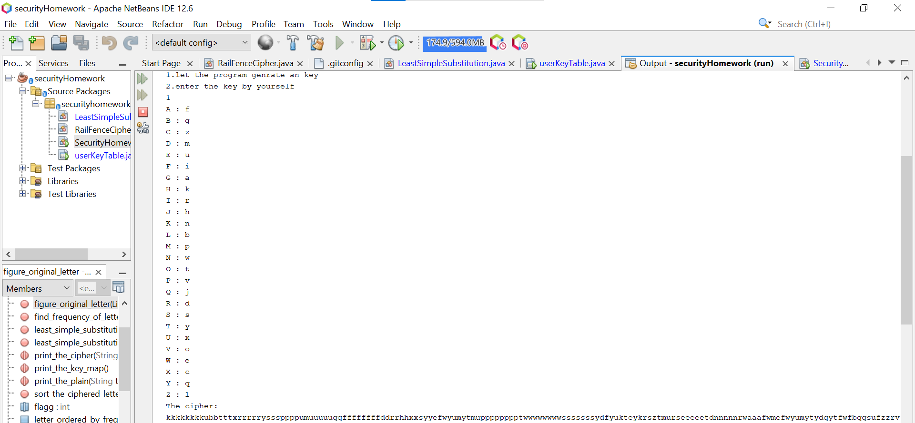

lets now analyze the cipher to see if we could get the original text

