**4.1.1 Architecture System Diagram**

**Pre - Flooding**

**During Flooding**

Flood Related

Variable

Situation

Assessment

observe

Email

flag

warming

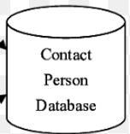

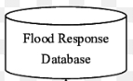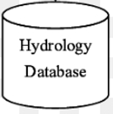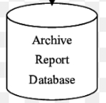

**Post - Flooding**

activate

Post - mortem

SMS

Archive Report

send

Get data

Report Generator Agent

Virtual Emergency Operation Centre

Notification

Agent

**Figure 4.1.1 Architecture System Diagram**

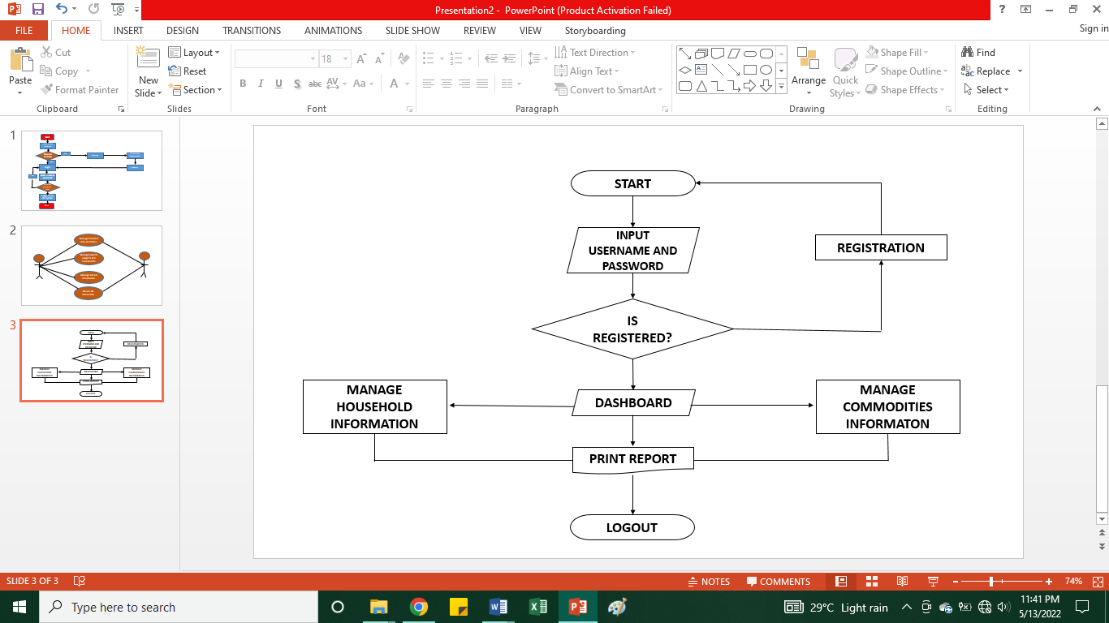**4.1.2 Flow Chart**

Flowchart Bulan Web-Based Incident, Activity Report and Monitoring Information System for Municipal Disaster Risk Reduction and Management Office (MDRRMO)

1. Put yes/no in the decision “is registered?”. To point the flow of the system if the decision would be true or false.
2. If the is registered is true. Put two objects where there is a page for the admin and for the user/employee not only the dashboard.
3. The put in each object what the admin can do in the system and what can the employee/user do in the system.

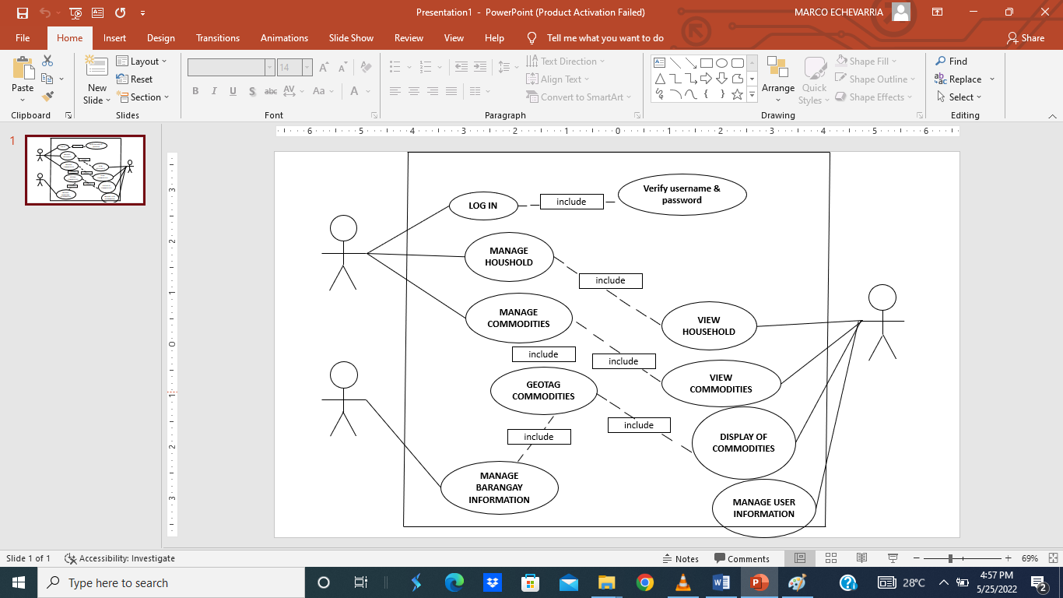**4.1.3 Use Case Diagram**

**Figure 4.1.3 Use Case Diagram of the system**

1. **There should only have 2 persons in this diagram that represents the admin and the employee.**
2. **Just put things that the two users can do in the system and connect. It to the person. Example: The admin can make his own report and also the employee but only the admin can review the report.**

Admin

Employee

**4.1.4 Activity Diagram**

