CANDIDATE: BOATENG, DENNIS
TITLE / TOPIC: EXPLAINABLE DEEP LEARNING FOR EARLY ALZHEIMER’S DETECTION: A MULTI-MODAL APPROACH USING OMICS, BIOMETRICS AND COGNITION

BACKGROUND AND RATIONALE
Alzheimer’s disease (AD) is a debilitating type of dementia that affects memory, thinking and behavior patterns[1]. It is mainly characterized by executive dysfunction and mental disorder in most individuals. Several countries are currently affected by an increasing burden of AD, with a major risk factor relating to advanced age. While ageing remains unavoidable with an increased life expectancy, it transforms the shape of the age pyramid, predisposing individuals to AD. WHO reports that the cost of caring for the 14.1 million people living with dementia in Europe amounted to US$ 439 billion (EURO 392) or US$ 31,144 ( EURO 27,815) per person with dementia[2]. At the same time, estimates predict that by the year 2050, the burden of persons with Alzheimer’s and other dementias will be increased to more than 152 million[3]. The suggested increase in trends and estimates could be highly underestimated as few persons present themselves to be diagnosed by professionals due to the long path in health care and cost implications. The pathways available for AD diagnosis are time-consuming[4], expensive[5, 6] and sometimes invasive leading to undesired progression and health outcomes. Even more worrying, individuals without financial barriers are not guaranteed the availability of trained medical professionals for early screening coupled with a clinical diagnosis that may be subjective. As a matter of urgency, scientists and researchers need to generate robust and innovative ideas for AD detection. It is estimated that a greater proportion of the aged population remains undiagnosed of AD, especially in its early development stages (preclinical and mild cognitive impairment).

Deep Learning (DL) methods have increasingly been used to offer solutions to reveal complex patterns in the detection of diseases using biomedical data. Despite their limitations including user-friendly tools, interpretability and generalizability when deployed, they still offer promising advantages that are sustainable in screening AD conveniently at its early stages. Deep learning methods require robust, reproducible, explainable and scalable frameworks with the potential to facilitate early detection and improve patient outcomes. DL methods are essential in the early detection of individual health and safety status yet before they are symptomatic, facilitating our ease in complementing medical assessment. However, traditional AI models are often black-box systems, making it difficult for clinicians to trust and interpret their predictions. An urgent need for Explainable Artificial Intelligence (XAI) methodologies[7] is required as ingredients in the decision-making process to enhance their adoption in routine clinical practice. For DL applications to play a critical role, they must be well understood by practitioners to complement their efforts through a safe, transparent and trustworthy framework. DL models designed with physician usability in mind would greatly improve monitoring and diagnosis efforts for AD detection considering its prevalence.

JUSTIFICATION AND RELEVANCE OF THE STUDY

AD is a multi-faceted disease influenced by genetic, physiological and cognitive factors. There have been several ongoing efforts in literature to use Artificial Intelligence in predicting AD considering its devastating effects on cognitive function and quality of life. Current screening strategies (CT/MRI/PET) scans used as gold standards provide evidence in the late stages of AD development. A holistic and comprehensive approach is essential for the early detection of Alzheimer’s in individuals who have not yet developed symptoms. However, several techniques proposed for AD detection are stand-alone or single-modality [8-13] frameworks that require integration. The majority of implementations have been limited in precision and real-time monitoring capabilities. While such methods often provide acceptable levels of accuracy, sensitivity and specificity, integrating multi-modality data- including (genomics, proteomics, epigenetics), biometric features (EEG, speech, heart rate, facial expressions) and cognitive assessment could significantly improve detection accuracy. This is because each modality presents a unique biological and physiological insight for AD characterization.

Omics data has been used to identify genetic risk factors (Tau, Amyloid-beta) at the molecular level linked to AD pathology. While biometric data (EEG, speech, heart rate, facial expressions) offers subtle neurological and behavioural changes with non-invasive diagnostic abilities. Cognitive tests validate AI predictions against traditional clinical evaluations. While all these diverse sources of data have huge potential, they are yet to be galvanized into a multi-modality framework for early detection. To the best of our knowledge, reporting details of several DL models have remained inconsistent and misunderstood by healthcare practitioners who require them in their routine healthcare practice, considering AD prediction. There is a general appetite from medical practitioners to acquire insights as to how AI models predict AD with transparency. XAI identifies key biomarkers that contribute to AD predictions with human-interpretable explanations that increase their adoption in clinical settings. It will therefore be important to contribute to the significant gap in the literature by examining the key issues relating to multi-modalities combined with XAI to improve AD detection. There was a limited number of articles available on this subject matter of developing and using XAI to predict AD.

In recent times, tremendous progress has been made in gathering AD data that is currently available and accessible through public data repositories such as ADNI (Alzheimer’s Disease Neuroimaging Initiative), UK Biobank, and GEO (Gene Expression Omnibus). This opportunity provides unlimited and hidden potential to utilize multi-modal datasets in the presence of XAI. The main idea of this concept is to initially build feature extractors and integrate these feature vectors for prediction. We believe that the combined features considered hold untapped potential yet to be discovered. The study aims to improve prediction accuracy, model interpretability, and clinical applicability that could be significant in both clinical practice and public health by offering a data-driven approach. A definitive course of action for treatment and personalized interventions could be enforced and tailored to individual needs. I am eager to take on this challenge, delve deeper into this critical subject, and contribute to shaping informed policy decisions. In this regard, this proposal focuses on developing an XAI framework that integrates a multi-modal approach using omics, biometrics and cognitive datasets to provide key insights to enhance the early detection of AD. This proposal, therefore, seeks to address the under-listed issues.

- Few studies have been conducted on the topic, using a multimodal approach to detect AD. This approach uses deep learning to capture and leverage complex patterns and relationships within heterogeneous data. By integrating this framework, we will leverage complementary features to enhance the accuracy and robustness of AD detection.
- As an academic work, it is hoped that the results will contribute to existing knowledge on the subject by generating valuable insights on how explainable techniques make deep learning models more interpretable for medical practitioners.
- It will also contribute to new forms of hypothesis testing for key biomarkers that will be identified to be further explored in clinical trials for individuals to improve patient outcomes, reduce healthcare costs, and enhance their quality of life.
- The methodology could serve as a foundation for future studies in predictive modelling, personalized medicine, and targeted interventions for AD and other neurodegenerative disorders.
- Findings of the project work will be published in local and international journals to add to existing methods of AD detection pushing the limits of what is currently possible to improve the lives of millions affected.

General Objective

To develop a robust and explainable multi-modal AI framework that integrates omics, biometric and cognitive data to enhance early detection of AD. This research aims to improve prediction accuracy, interpretability, and clinical usability, ensuring that AI-driven diagnostics are transparent and trustworthy for healthcare professionals.

Specific Objectives
- To acquire and preprocess relevant features from each modality from the comprehensive dataset comprising omics, biometric and cognitive data from individuals diagnosed with AD.
- To design and implement a multi-modal framework that fuses omics (genomics, proteomics), biometrics (EEG, speech, facial expression, heart rate) and cognitive features for AD detection, considering techniques such as convolutional neural networks (CNNs), recurrent neural networks (RNNs), transformers, long short-term memory (LSTM)
- To implement and optimize explainable AI techniques (SHAP, attention mechanism) to interpret model decisions, maximizing the discriminative power of the deep learning model for AD detection.
- To train and validate models using publicly available datasets on real-world clinical data, and evaluate the performance of the proposed methodology using appropriate metrics such as accuracy, sensitivity, and specificity.
- To compare the performance of the proposed methodology with existing ML and single-modality approaches for AD.
- To validate the clinical relevance of the developed interpretable AI tool that can be integrated into the workflow of medical professionals.
- To disseminate the findings of the research through publications in peer-reviewed journals, presentations at conferences, and knowledge exchange activities, contributing to the advancement of knowledge in the field of AD detection and explainable multi-modal AI methodologies.

Research Questions

- How can relevant features be extracted and preprocessed from multi-modal datasets comprising omics, biometrics and cognitive datasets for the early detection of AD?
- How can a multi-modal framework using omics, biometrics and cognitive features effectively fuse to improve AD detection, maximising the discriminative power of the DL model for AD detection?
- How can explainable AI techniques (SHAP, attention mechanisms) enhance the interpretability and key features identified contributing to AD detection?
- How can publicly available datasets (ADNI, UK Biobank) be used to train and validate the proposed models in terms of evaluation metrics (accuracy, sensitivity, specificity, AU-ROC) and effectiveness?
- How does the multi-modal AI approach compare to single-modality and existing machine-learning models and does this significantly improve in performances across the different models in AD detection?
- How can the developed interpretable AI tool be integrated as a clinical utility into routine workflows to assist medical professionals in improving patient outcomes and quality of life and any limitations in such implementation for a real-world AD detection?
- How can the findings of the research contribute to the advancement of multi-modal AI and the best strategies for disseminating through peer-reviewed publications and knowledge exchange activities for AD detection?

METHODS

The intended project shall be carried out by acquiring heterogeneous data that includes omics, biometrics and cognitive features in consultation with the supervisor from publicly available sources on individuals with AD and healthy controls. The data acquired will be pre-processed and cleaned by handling missing values and outliers and encoding all variables correctly. A DL model will be developed using architectures such as convolutional neural networks (CNNs) to learn from the data. Concepts of explainable AI such as attention mechanisms, gradient-based methods, or surrogate models to interpret model predictions will also be implemented. To assess the accuracy of the model performance, standard metrics such as accuracy, sensitivity, specificity, and area under the ROC curve (AUC) will be used. Finally, an interpretation of the analysis and its comparison to other models shall be explored to gain insights into risk factors for AD.

PHASE 1
Data collection and preprocessing
The intended research proposal will be executed by gathering diverse data that includes omics, biometric and cognitive data records in public repositories such as ADNI (Alzheimer’s Disease Neuroimaging Initiative), UK Biobank, and GEO (Gene Expression Omnibus) from individuals diagnosed with Alzheimer's disease at various stages and from healthy controls. The data will be cleaned and preprocessed to remove noise, artefacts, and inconsistencies. Missing data will be handled with appropriate techniques and standardized into formats to ensure compatibility across modalities.
PHASE 2
Model Development and Explainability
A fusion strategy to integrate the extracted features from different modalities into a unified representation will be conducted. A deep learning model shall be developed and trained with the capability to learn complex patterns and relationships from multi-modal data. DL mechanisms such as CNNs for medical images, RNNs, Graph Neural Networks (GNN) for omics interactions and transformers for integrating heterogeneous data. Each modality will explore relevant features based on literature and importance selection. The concepts of explainable AI will be used to identify relevant features for predictions using multimodal feature attributes with the help of SHAP, LIME and integrated Gradients.

PHASE 3
Model evaluation and comparison
The model shall be cross-validated and evaluated using appropriate cross-validation techniques to ensure generalizability performance. Metrics such as accuracy, sensitivity, specificity, and area under the ROC curve (AUC) shall be assessed for the model's performance. Attention Mechanisms to interpret critical input features from a multi-modal framework shall be developed. Also, an evaluation of the clinical validity of the model's performance in clinical settings through collaboration with medical professionals in real-world scenarios will be conducted. Model outputs will be validated through expert evaluations, where neurologists and clinicians assess the reliability of DL-driven explanations.

PHASE 4
Model interpretation and representation
A unique model interpretation and visualization will be used for the predictions providing insights into features contributing to early Alzheimer's disease. This phase will focus on enhancing model transparency, interpretability, and clinical usability by integrating advanced explainable techniques and visualization mechanisms. Transformer-based attention heatmaps will illustrate which features the model focuses on during decision-making, providing an interpretable layer for clinicians. A human-in-the-loop system will be incorporated to refine model explanations based on expert feedback, ensuring alignment with clinical understanding of Alzheimer’s disease progression.

A VISUAL STRATEGY OF EXPLAINABLE DEEP LEARNING METHODOLOGY FOR AD DETECTION
STEPS PROCEDURE
Identify repositories with omics, biometric and cognitive features and extract them.
PHASE 1
DATA ACQUISITION

OMICS
Pre-process data to extract features from each modality. Handle missingness and outliers in data for model integration.
COGNITIVE
BIOMETRIC

MODEL DEVELOPMENT AND EXPLAINABILITY
Architecture exploration and implementation of CNNs, RNNs, GNNs and transformers
PHASE 2

MODEL EVALUATION AND COMPARISON
Generate metrics of accuracy, sensitivity, specificity, and area under the ROC curve (AUC) performed
PHASE 3
Generate representation and interpretations of the clinical utility of the model in real-world settings.
MODEL INTERPRETATION AND REPRESENTATION

List of Acronyms

Alzheimer Disease AD
Artificial Intelligence AI
Area Under Receiver Operator Characteristics AUROC
Convolution Neural Network CNN
Deep Learning DL
Local Interpretable Model-agnostic Explanations LIME
Recurrent Neural Network RNN
Shapley Additive Explanation SHAP
Explainable Artificial Intelligence XAI

PROVISIONAL TIME PLAN FOR IMPLEMENTATION
PROVISIONAL TIME PLAN FOR IMPLEMENTATION (October 2025 to October 2031)
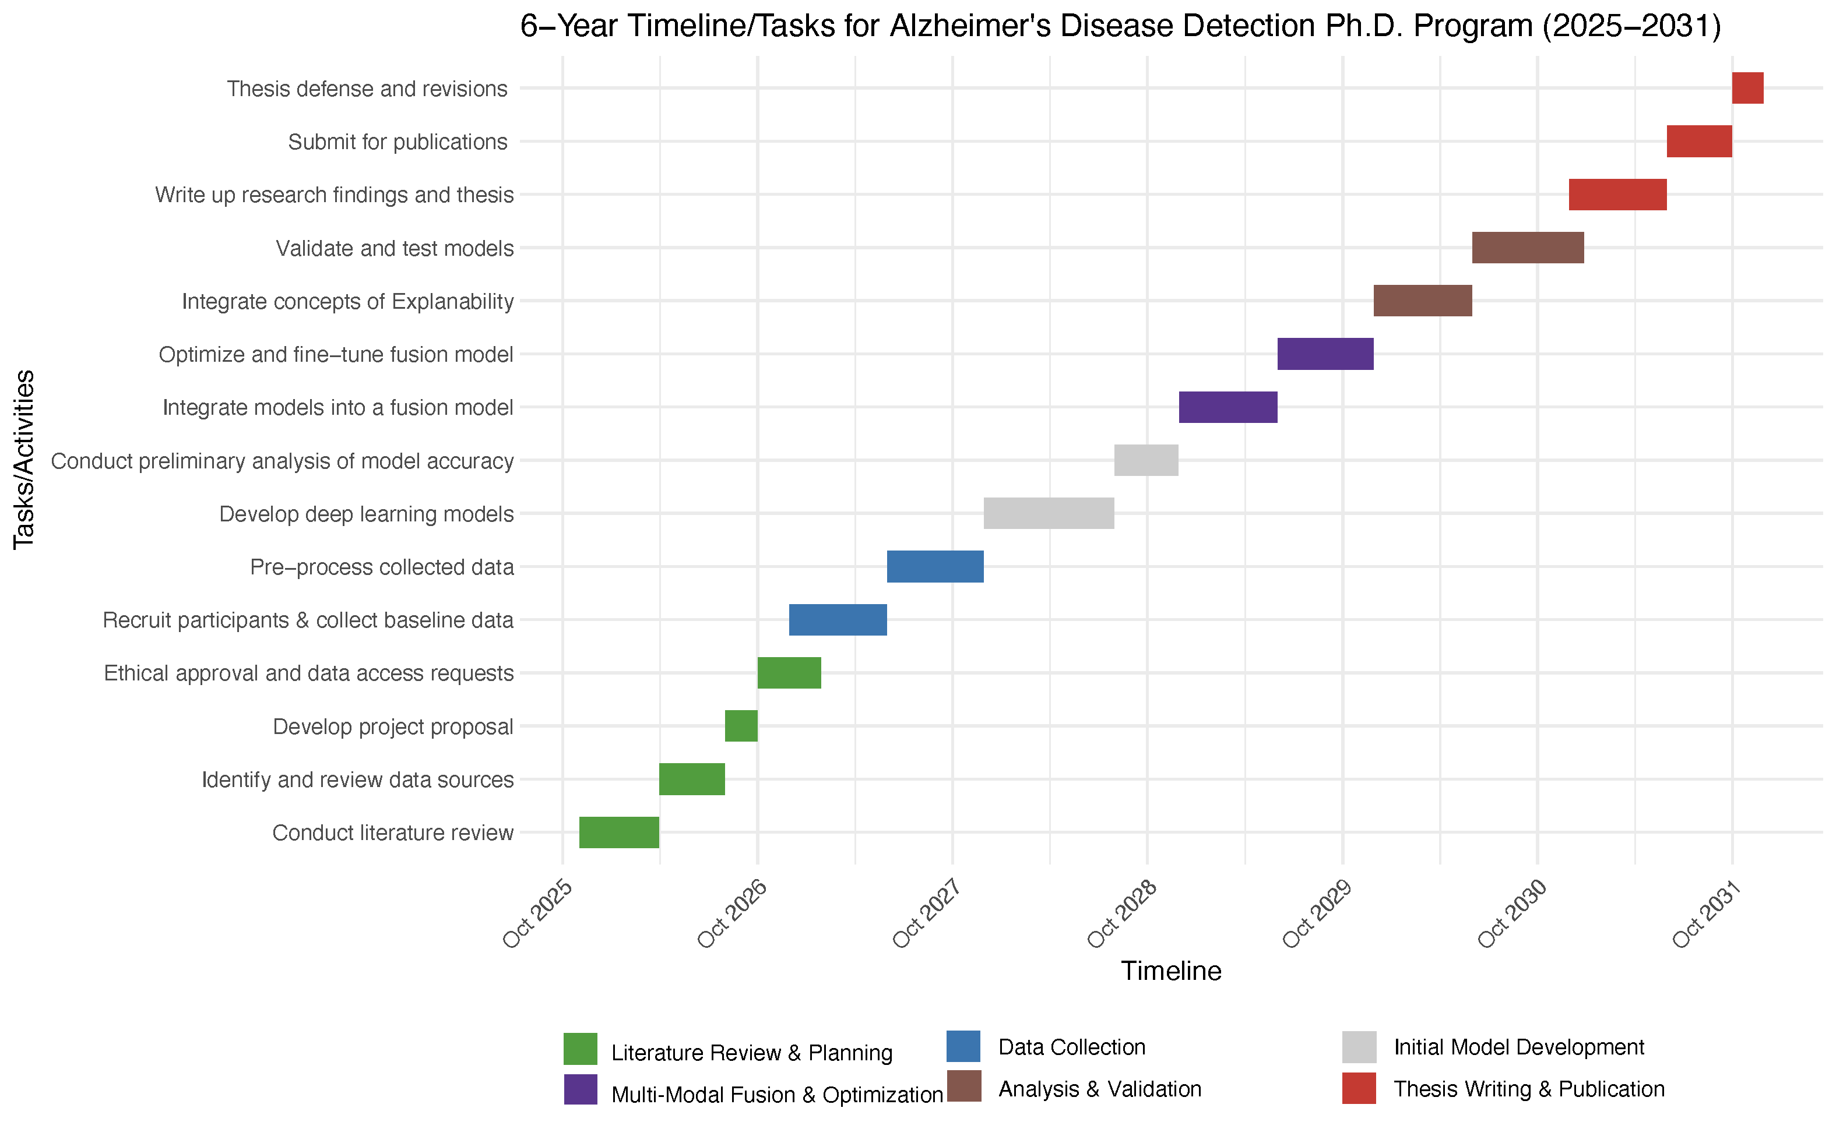

REFERENCES

1. Upadhyaya, P., V. Seth, and M. Ahmad, Therapy of Alzheimer’s disease: An update. Afr J Pharm Pharmacol, 2010. 4(6): p. 408-21.
2. Jönsson, L., The personal economic burden of dementia in Europe. The Lancet Regional Health–Europe, 2022. 20.
3. Nichols, E., et al., Estimation of the global prevalence of dementia in 2019 and forecasted prevalence in 2050: an analysis for the Global Burden of Disease Study 2019. The Lancet Public Health, 2022. 7(2): p. e105-e125.
4. Dubois, B., et al., Timely diagnosis for Alzheimer’s disease: a literature review on benefits and challenges. Journal of Alzheimer's disease, 2016. 49(3): p. 617-631.
5. Bloom, B.S., N. de Pouvourville, and W.L. Straus, Cost of illness of Alzheimer's disease: how useful are current estimates? The gerontologist, 2003. 43(2): p. 158-164.
6. DeKosky, S.T. and J.-M. Orgogozo, Alzheimer disease: diagnosis, costs, and dimensions of treatment. Alzheimer Disease & Associated Disorders, 2001. 15: p. S3-S7.
7. Kinger, S. and V. Kulkarni. Explainable ai for deep learning based disease detection. in Proceedings of the 2021 Thirteenth International Conference on Contemporary Computing. 2021.
8. Uddin, K.M.M., et al., A novel approach utilizing machine learning for the early diagnosis of Alzheimer's disease. Biomedical Materials & Devices, 2023. 1(2): p. 882-898.
9. Adelson, R.P., et al., Machine Learning Approach for Improved Longitudinal Prediction of Progression from Mild Cognitive Impairment to Alzheimer’s Disease. Diagnostics, 2023. 14(1): p. 13.
10. Zhao, Z., et al., Conventional machine learning and deep learning in Alzheimer's disease diagnosis using neuroimaging: A review. Frontiers in computational neuroscience, 2023. 17: p. 1038636.
11. Tan, M.S., et al., A review on omics-based biomarkers discovery for Alzheimer's disease from the bioinformatics perspectives: statistical approach vs machine learning approach. Computers in biology and medicine, 2021. 139: p. 104947.
12. Kim, J.-S., et al., Blood Pressure and Heart Rate Variability in Alzheimer's Disease. Dementia and Neurocognitive Disorders, 2015. 14(3): p. 128-134.
13. Grueso, S. and R. Viejo-Sobera, Machine learning methods for predicting progression from mild cognitive impairment to Alzheimer’s disease dementia: a systematic review. Alzheimer's research & therapy, 2021. 13: p. 1-29.

