

HOTEL RESERVATION SYSTEM

by

DEYON ROSE BABU THOMAS

(2348513)

RIDHIN ISSAC ABRAHAM

(2348546)

SAMSON SABU

(2348549)

A project report submitted in partial fulfillment of the requirements for the award of degree of MSc Artificial Intelligence and Machine Learning of CHRIST (Deemed to be University)

October – 2023



CERTIFICATE

*This is to certify that the project report titled* ***HOTEL RESERVATION SYSTEM*** *is a bonafide record of work done by* ***DEYON ROSE BABU THOMAS (2348513), RIDHIN ISSAC ABRAHAM (2348546), SAMSON SABU (2348549)*** *of CHRIST (Deemed to be University), Bengaluru, in partial fulfillment of the requirements of 1st Trimester of MSc Artificial Intelligence and Machine Learning during the academic year 2023-24.*

**Course Teacher**

Valued-by: (Evaluator Name and Signature)

|  |  |  |  |
| --- | --- | --- | --- |
|  |  |  |  |
| 1. |  |  |  |
|  |  |  |  |
| 2. |  |  | : |

Date of Exam:

**Abstract**

**HOTEL RESERVATION SYSTEM**

Hotel Reservation System is an online web application platform that enables the user to book their rooms according to their convenience. This Web application helps customers to check the room availability, browse through the reviews, to get more details about the hotel, and also to contact and make the booking. This application is developed using web technologies such as HTML, CSS, JAVASCRIPT, PHP PDO(PHP Data Objects), MYSQL. The customer can view the availability based on their convenience. Based on the availability of the room, the customer can book the rooms by giving their details. The customer can also view the past reviews. The admin panel module contains the following operations such as, update profile, view bookings & delete bookings, view admins.

Students Signature

1.

2.

3.

1. **Database Specifications**

**Introduction about the Database**

MySQL is an Oracle-backed open source [relational database](https://www.techtarget.com/searchdatamanagement/definition/relational-database) management system (RDBMS) based on Structured Query Language ([SQL](https://searchsqlserver.techtarget.com/definition/SQL)). MySQL runs on virtually all platforms, including Linux, UNIX and Windows. Although it can be used in a wide range of applications, MySQL is most often associated with web applications and online publishing.MySQL is an important component of an open source enterprise stack called LAMP. LAMP is a web development platform that uses Linux as the operating system, Apache as the web server, MySQL as the relational database management system and PHP as the object-oriented scripting language.

The Database contains the following tables:

ADMIN TABLE:-Contain the details of admin with admin id,name,password

MESSAGE TABLE:-Contains the details of queries of the users.which contains number,Id,email,name,and messages

BOOKING TABLE:Contains all the booking details it includes booking id,useri id,check-in,check-out,adults,children,email,name,number,room.

ER DIAGRAM:

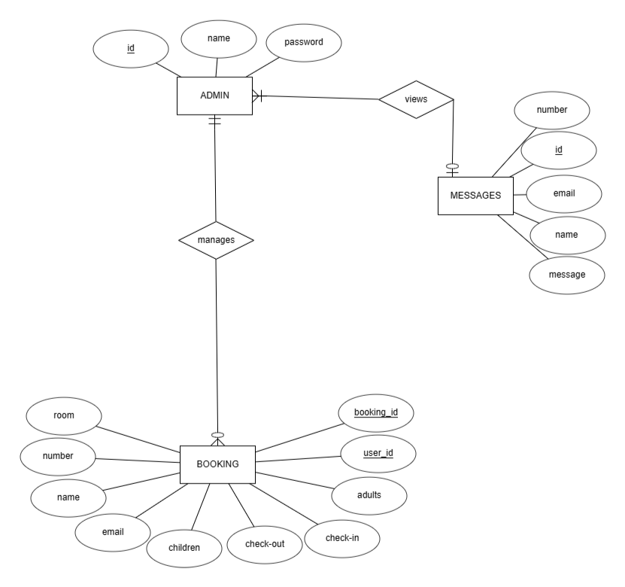

|  |  |  |
| --- | --- | --- |
| ADMIN TABLE | | |
| **Sno** | **Name of the Attributes** | **Description of the Attributes** |
| 1 | admin_id | Specific admin ID for each user |
| 2 | name | Name given for the admin |
| 3 | Password | Password given while creating the admin |

|  |  |  |
| --- | --- | --- |
| MESSAGE TABLE | | |
| **Sno** | **Name of the Attributes** | **Description of the Attributes** |
| 1 | email | Email id of the user when making the reservation |
| 2 | id | Attribute to generate ID for each user |
| 3 | message | Custom messages that user can give |
| 4 | name | Name of a particular user |
| 5 | number | Number of the user |

|  |  |  |
| --- | --- | --- |
| BOOKING TABLE | | |
| **Sno** | **Name of the Attributes** | **Description of the Attributes** |
| 1 | Check-in | Check in date given by the user to make the reservation |
| 2 | Check-out | Check out date given by the user to make the reservation |
| 3 | Adults | To store the number of adults |
| 4 | room | To store the number of rooms |
| 5 | children | To store the number of children |

Operation to be performed on the database:

* A guest will be able to make a reservation by inserting name, email ID, number of rooms, check-in and check-out.
* The guest will be able to send messages to the admin regarding any queries they have.
* Admin will be able to view the messages and also the booking.
* Admin can update his own profile and create another admins.
* Admin will be able to delete the booking that is made by the guest users.
* The guest will be able to cancel the bookings that are made.

1. **Front-End Specifications**

**Introduction about the Front-End Technology**

PHP(short for Hypertext PreProcessor) is the most widely used open source and general purpose server side scripting language used mainly in web development to create dynamic websites and applications. PHP can actually do anything related to server-side scripting or more popularly known as the backend of a website. For example, PHP can receive data from forms, generate dynamic page content, can work with databases, create sessions, send and receive cookies, send emails etc. There are also many hash functions available in PHP to encrypt user’s data that makes PHP secure and reliable to be used as a server-side scripting language.

phpMyAdmin is a free software tool written in PHP, intended to handle the administration of MySQL over the Web. phpMyAdmin supports a wide range of operations on MySQL. Frequently used operations (managing databases, tables, columns, relations, indexes, users, permissions, etc) can be performed via the user interface, while you still have the ability to directly execute any SQL statement.

JavaScript is a lightweight, cross-platform, single-threaded, and interpreted compiled programming language. It is also known as the scripting language for webpages. It is well-known for the development of web pages, and many non-browser environments also use it.JavaScript is a weakly typed language (dynamically typed). JavaScript can be used for Client-side developments as well as Server-side developments. JavaScript is both an imperative and declarative type of language. JavaScript contains a standard library of objects, like Array, Date, and Math, and a core set of language elements like operators, control structures, and statements.

HTML stands for HyperText Markup Language. It is used to design web pages using a markup language. HTML is a combination of Hypertext and Markup language. Hypertext defines the link between web pages. A markup language is used to define the text document within the tag which defines the structure of web pages. This language is used to annotate (make notes for the computer) text so that a machine can understand it and manipulate text accordingly. Most markup languages (e.g. HTML) are human-readable. The language uses tags to define what manipulation has to be done on the text.

Cascading Style Sheets, fondly referred to as CSS, is a simply designed language intended to simplify the process of making web pages presentable. CSS allows you to apply styles to web pages. More importantly, CSS enables you to do this independently of the HTML that makes up each web page. It describes how a webpage should look: it prescribes colours, fonts, spacing, and much more. In short, you can make your website look however you want. CSS lets developers and designers define how it behaves, including how elements are positioned in the browser.While HTML uses tags, CSS uses rulesets. CSS is easy to learn and understand, but it provides powerful control over the presentation of an HTML document.

|  |  |  |
| --- | --- | --- |
| **Homepage** | | |
| **Sno** | **Name of the Control** | **Description of the Control** |
| 1 | Home button | This will direct us to the landing page |
| 2 | About | Description about the hotel |
| 3 | Gallery | Images of the hotel |
| 4 | Make a Reservation | Lands to the reservation section |
| 5 | Contact | It navigates to the contact us section of the page |
| 6 | Review | Shows us the previous reviews |
| 7 | My booking | Shows us the details about the previous booking |
| 8 | Check Availability | To check the available rooms |
| 9 | Book Now | Confirms the booking checking the availability |

|  |  |  |
| --- | --- | --- |
| **My Bookings** | | |
| **Sno** | **Name of the Control** | **Description of the Control** |
| 1 | Cancel booking | It will cancel the bookings that are made |

|  |  |  |
| --- | --- | --- |
| **Admin Panel** | | |
| **Sno** | **Name of the Control** | **Description of the Control** |
| 1 | Update Profile | To update the admin details of the current logged in admin |
| 2 | View Booking | It navigates to booking page |
| 3 | View admin | Details of the admin |
| 4 | View message | Navigates to the messages page to view |
| 5 | Login | Lands to the login page |
| 6 | Register | To add new admin to the admin page |

1. **Screen Shots**
2. Home page

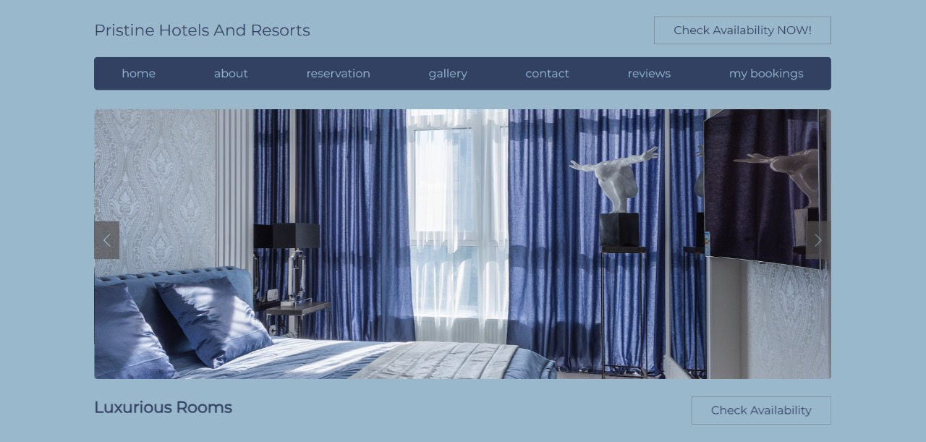

1. Make a Reservation Page

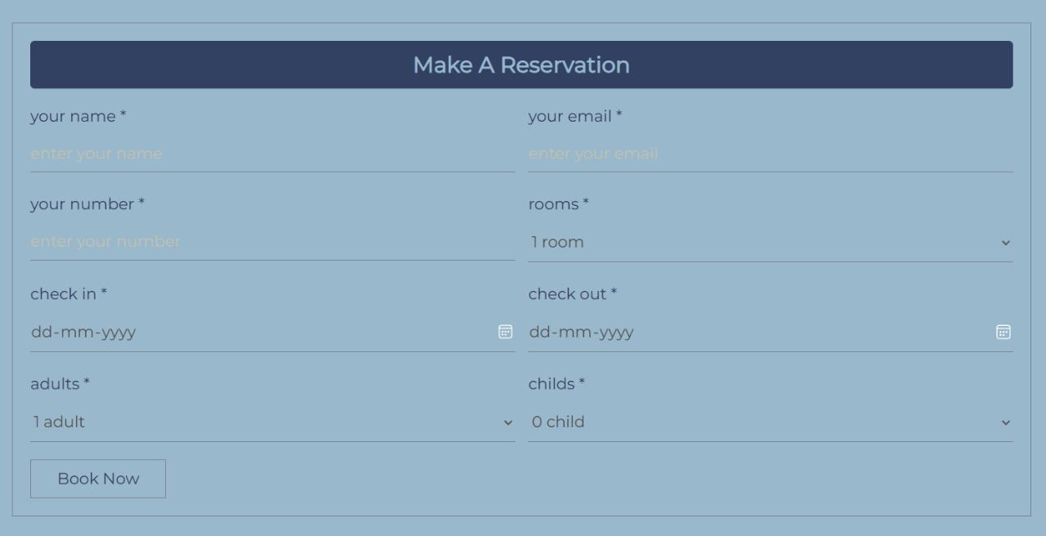

1. Admin Panel

1. Messages page

1. **Git-Hub Link and References**

Git-Hub Link: [samsomsabu/Hotel-Reservation-System (github.com)](https://github.com/samsomsabu/Hotel-Reservation-System)

References:

1. [CSS Introduction - GeeksforGeeks](https://www.geeksforgeeks.org/css-introduction/)
2. [HTML Introduction - GeeksforGeeks](https://www.geeksforgeeks.org/html-introduction/)
3. [Introduction to JavaScript - GeeksforGeeks](https://www.geeksforgeeks.org/introduction-to-javascript/)
4. [PHP: Documentation](https://www.php.net/docs.php)