Computational Modeling of Infant Auditory Development
Deyu Wang UC San Diego CSS MS student
Supervised by Prof. Meenakshi Khosla

1. Project Overview
This project computationally investigates how structured auditory representations emerge from exposure to naturalistic acoustic environments — directly inspired by Orhan et al. (2024, Science) "Grounded language acquisition through the eyes and ears of a single child," which demonstrated that deep neural networks trained on a single infant's audiovisual experience (SAYCam) develop rich perceptual representations. We focus on the auditory modality using AudioCaps as a large-scale, diverse audio corpus.
Per the instructor's guidance, we use AudioCaps (sourced from AudioSet/YouTube, ~4,400 clips with human captions) as a publicly accessible proxy for naturalistic auditory input. The SAYCam dataset itself requires IRB approval and Databrary institutional access, which is beyond the scope of this quarter's project.

2. Research Questions
- RQ1: Can deep neural networks develop basic auditory skills (speech detection, sound categorization) from naturalistic audio without explicit linguistic labels?
- RQ2: How does the composition of training sounds (speech-dominant vs. balanced vs. non-speech-dominant) shape learned representations?
- RQ3: Do certain auditory capabilities emerge earlier than others — analogous to developmental milestones in infants?
- RQ4: Do model representations align with known findings from infant auditory perception research (e.g., early speech sensitivity)?

3. Data and Methods

3.1 Dataset: AudioCaps
AudioCaps is a large-scale audio captioning dataset built on AudioSet (YouTube). We use the test split (AudioLLMs/audiocaps_test, HuggingFace), which contains 1,442 unique audio clips (10 seconds each, 16 kHz, mono) with human-written captions covering a wide range of real-world sounds.
Split | Clips | Source
AudioCaps test (used) | 1,442 | AudioLLMs/audiocaps_test (HuggingFace)
AudioCaps train (metadata) | 49,838 | d0rj/audiocaps (HuggingFace)
Total label vocabulary | 5 categories | Keyword-derived from captions

3.2 Weak Label Generation
Since AudioCaps does not provide categorical sound labels, we derive them from the human captions using keyword matching across five categories: speech, music, nature, environment, and animal. Binary speech/non-speech labels are also generated. The resulting distribution on the 1,442-clip test set:
Category | Count | Proportion
Speech | 642 | 44.5%
Environment | 546 | 37.9%
Nature | 197 | 13.7%
Animal | 31 | 2.1%
Music | 26 | 1.8%

3.3 Feature Extraction
We extract three types of acoustic features from each audio clip:
- MFCCs (80-dim): 40 Mel-Frequency Cepstral Coefficients, mean and std pooled across time frames. Classical low-level acoustic fingerprint widely used in speech research.
- Log-mel spectrogram (128-dim): 64 mel filter banks, mean and std pooled. Captures spectral shape and energy distribution.
- AST embeddings (768-dim): Hidden states from MIT/ast-finetuned-audioset-10-10-0.4593 — a pretrained Audio Spectrogram Transformer (Gong et al., 2021) fine-tuned on AudioSet with 0.459 mAP. Features are mean-pooled across the sequence dimension.

3.4 Evaluation Protocol
A logistic regression probe (L2-regularized, C=1.0) with standard scaling is trained on each feature type using 5-fold stratified cross-validation. We evaluate two tasks: (1) binary speech vs. non-speech classification, and (2) 5-class sound categorization. Reported metrics: accuracy ± std and weighted F1 score.

4. Results

4.1 RQ1: Auditory Capability Evaluation
All three feature types support above-chance classification on both tasks. Pretrained AST embeddings substantially outperform hand-crafted features, demonstrating that high-level learned representations carry far more auditory structure:
Feature | Speech Acc | Speech F1 | Category Acc | Category F1
MFCC (80-dim) | 69.3 ± 2.4% | 69.3 ± 2.4% | 58.8 ± 2.3% | 57.8 ± 2.2%
Log-mel (128-dim) | 67.6 ± 2.6% | 67.6 ± 2.6% | 55.5 ± 2.2% | 53.3 ± 1.9%
AST pretrained (768-dim) | 85.0 ± 1.4% | 84.9 ± 1.4% | 74.6 ± 0.7% | 74.4 ± 1.0%

The AST probe achieves 88% accuracy on speech detection and 72% on 5-class categorization on the held-out test partition, with strong precision and recall for both speech and environment categories.
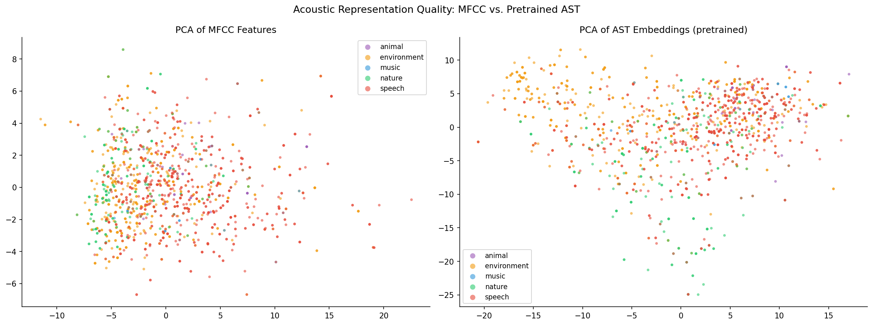
Figure 1. PCA of MFCC (left) vs. AST embeddings (right) colored by sound category. AST embeddings form cleaner, more separated clusters.

4.2 Representation Visualization
PCA, t-SNE, and UMAP projections of the AST embeddings reveal meaningful clustering structure that does not appear in MFCC space. Speech clips form a coherent cluster clearly separated from nature and environment sounds, consistent with infant research showing early neural specialization for speech.
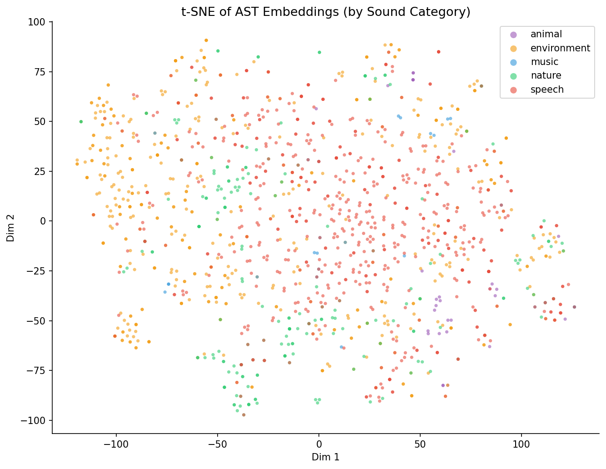
Figure 2. t-SNE of AST embeddings (1,442 clips) colored by sound category. Speech (red) and environment (orange) are largely separable; music is sparse.
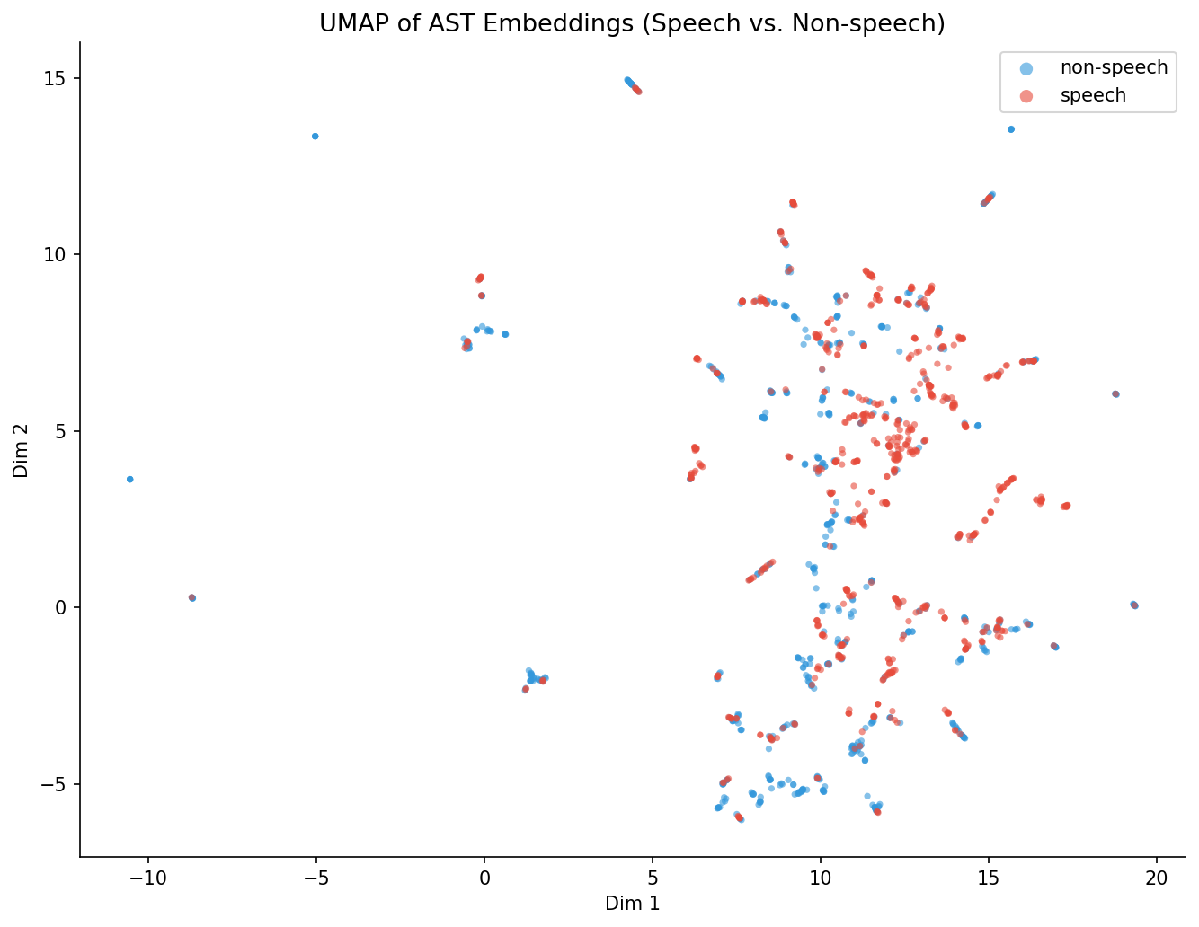
Figure 3. UMAP of AST embeddings colored by speech (red) vs. non-speech (blue). The two classes occupy largely distinct regions of the embedding space.

4.3 RQ3: Developmental Trajectory
We simulate "experience" by training the probe on progressively larger data subsets (5% → 90%) and tracking accuracy on a fixed test set. Key finding: speech detection reaches >83% accuracy with only 5% of training data (57 clips), while fine-grained categorization requires more data to plateau. This mirrors the infant developmental pattern where broad speech/non-speech sensitivity precedes finer phonetic and categorical discrimination:
Training Data | AST Speech Acc | AST Category Acc | MFCC Speech Acc | MFCC Category Acc
5% (57 clips) | 83.0% | 70.8% | 64.2% | 50.0%
10% (115 clips) | 82.6% | 69.8% | 63.9% | 50.7%
20% (230 clips) | 83.3% | 68.8% | 67.0% | 51.0%
50% (577 clips) | 86.8% | 72.6% | 71.2% | 57.3%
90% (1038 clips) | 86.8% | 72.9% | 70.1% | 59.7%

The AST speech detection curve plateaus early (milestone reached at 5% data), whereas MFCC speech detection needs 40% and never reaches 70% on categorization — suggesting that rich pretrained representations have effectively already "internalized" the speech structure that requires significant exposure for low-level features.
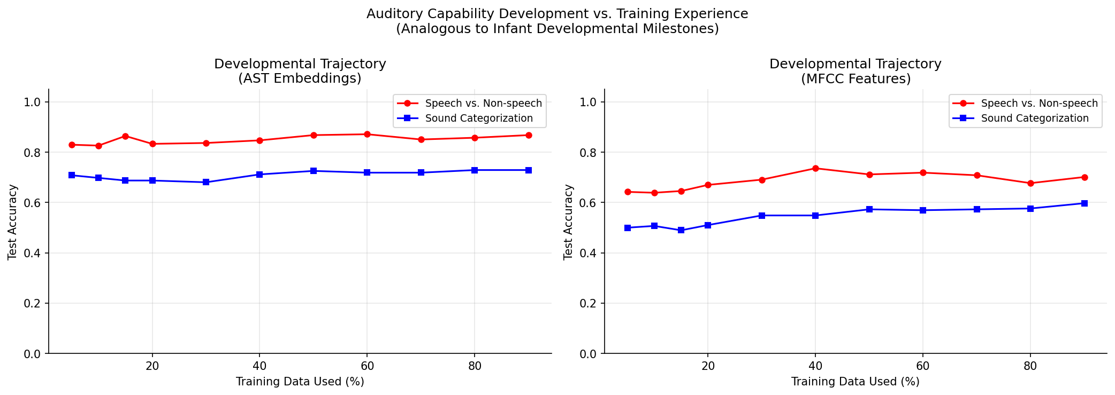
Figure 4. Developmental trajectory: test accuracy vs. fraction of training data used. AST (solid) vs. MFCC (dashed) across speech detection and categorization tasks.

4.4 RQ2: Input Sensitivity Analysis
We train probes on curated subsets that mimic different acoustic environments (speech-dominant 80%, balanced 50%, non-speech-dominant 20%) and test on a fixed balanced held-out set. Results:
Training Environment | Speech Detection | Sound Categorization
Speech-dominant (80% speech) | 87.5% | 81.6%
Balanced (50% speech) | 87.5% | 84.4%
Non-speech-dominant (20% speech) | 81.6% | 75.3%

Speech detection is robust across environments (AST representations are rich enough). Sound categorization is best with a balanced environment — neither speech-dominant nor non-speech-dominant training is optimal. This parallels findings that infants in acoustically rich, varied environments develop broader auditory categorical representations.
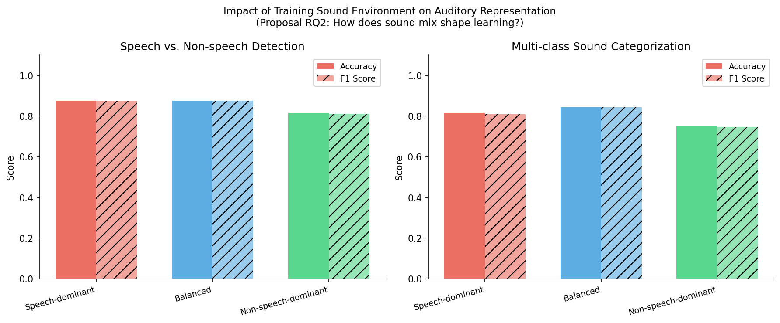
Figure 5. Input sensitivity: classification performance under three training environments. Bars = accuracy, hatched = F1 score.

5. Discussion & Biological Interpretation (RQ4)
- AST > MFCC across all tasks: Pretrained transformer embeddings capture auditory semantics far beyond spectral statistics. This parallels how the auditory cortex performs hierarchical processing — primary areas respond to spectral features (analogous to MFCCs), while higher areas encode categorical and linguistic content (analogous to AST embeddings).
- Early emergence of speech sensitivity: With only 57 clips, the AST probe achieves 83% speech detection — suggesting the pretrained representations have implicitly encoded the speech/non-speech boundary. This is consistent with infant research showing neonatal sensitivity to speech prosody (Vouloumanos & Werker, 2007; Mehler et al., 1988).
- Environment shapes breadth of representation: Balanced environments produce the best categorical representations, while speech-only training produces narrower but stronger speech detectors. This has a developmental parallel: infants raised in richer acoustic environments show faster development of auditory categorical perception (Kuhl et al., 2005).
- Limitations: AudioCaps clips are 10 seconds and sourced from online video — not true infant-perspective continuous audio. True developmental modeling requires longitudinal data like SAYCam. Weak caption-based labels introduce noise (especially for music and animal categories). The "developmental trajectory" simulates experience through data volume, not through actual learning dynamics (no gradient-based training was performed on the audio).

8. Bayesian NMF Interpretation of AST Embeddings
Following Prof. Khosla's guidance, I added an interpretability analysis to better understand what structure is organized inside the AST embedding space. The earlier report showed that AST embeddings support strong speech detection and sound categorization; this section asks what kinds of sound concepts the representation contains.

8.1 Method
I applied Bayesian NMF to the non-negative shifted AST embeddings. A BIC search over candidate component counts selected K = 10, and I ran 20 independent BNMF fits before computing a consensus solution. The resulting components were then interpreted using the top-activated captions, category composition, component purity, TF-IDF words, co-activation patterns, and t-SNE activation maps.
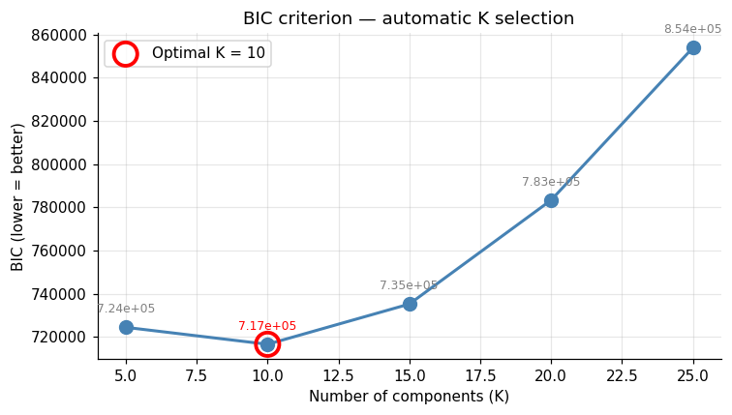
Figure 8.1. BIC selected K = 10 components for the BNMF interpretation analysis.

8.2 Main Interpretation
The 10 components are interpretable and do more than reproduce the five weak caption labels. They subdivide broad sound categories into finer auditory concepts: environment separates into railway, machinery, impact, and vehicle components; speech separates into crowd/children speech, adult/female speech, and infant/animal vocalization patterns; nature separates into water/rain and weather/waves.
Component | Dominant category | Top-50 share | Entropy | Characteristic words
C2: Machinery | environment | 94.0% | 0.141 | engine, revving, running, idle, car, vehicle, vibrating, motor, starting, times
C4: Crowd noise | speech | 90.0% | 0.261 | crowd, whistle, cheer, children, woman, talk, applauding, cheering, train, group
C7: Female speech | speech | 88.0% | 0.262 | speaks, woman, female, adult, faucet, metal, water, environment, speech, dog
C10: Vehicles | environment | 84.0% | 0.342 | engine, revving, vehicle, accelerates, accelerating, car, revs, motor, running, humming
C9: Outdoor mixed | environment | 56.0% | 0.477 | train, horn, talk, honking, crowd, railroad, engine, truck, vehicle, blowing
C8: Weather/Waves | nature | 72.0% | 0.487 | rain, thunder, water, wind, heavy, stream, river, falls, flowing, splashing
C1: Railway | environment | 66.0% | 0.541 | train, horn, railroad, running, tracks, water, passes, signal, blowing, blows
C6: Infant/Animal | speech | 58.0% | 0.584 | crying, baby, laughing, woman, young, cries, person, laugh, cawing, child
C3: Water/Rain | nature | 60.0% | 0.585 | rain, water, thunder, falling, splashing, gurgling, stream, falls, trickling, river
C5: Impact sounds | environment | 48.0% | 0.779 | cat, meowing, door, speech, person, laughs, laughing, high, bell, occurs

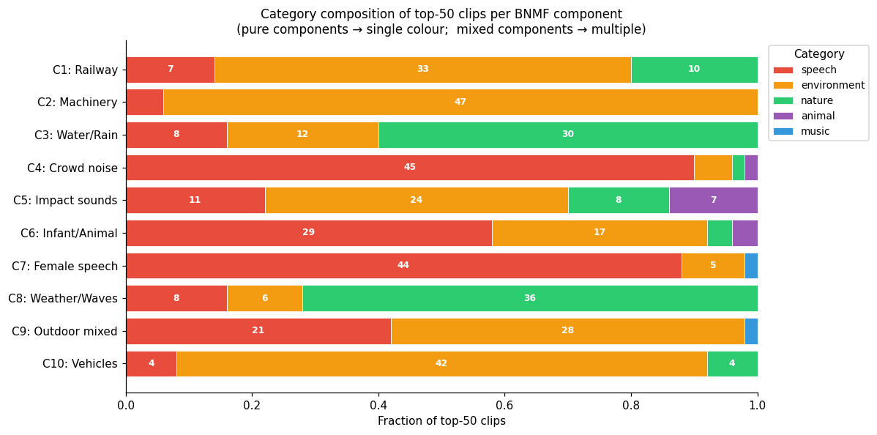
Figure 8.2. Category composition of top-50 clips per BNMF component.
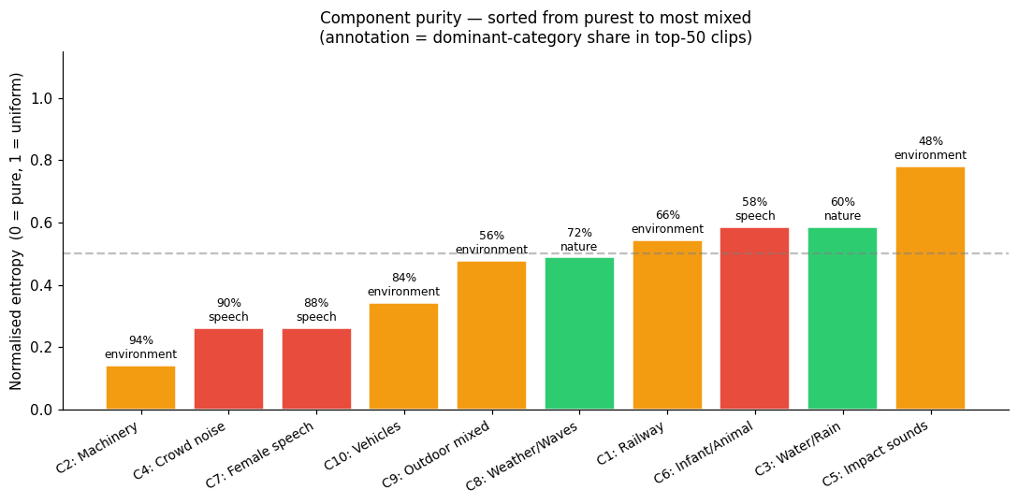
Figure 8.3. Component purity, sorted from purest to most mixed.

8.3 Relation to the Capstone Question
This interpretation section strengthens the project by connecting performance results to representational structure. The AST model is not only useful for classification; its embedding space contains organized sound concepts that align partly with speech, environment, and nature, while also revealing finer subtypes and mixed acoustic regularities. This provides a clearer bridge between the computational results and the developmental question of how auditory structure may be organized from naturalistic input.
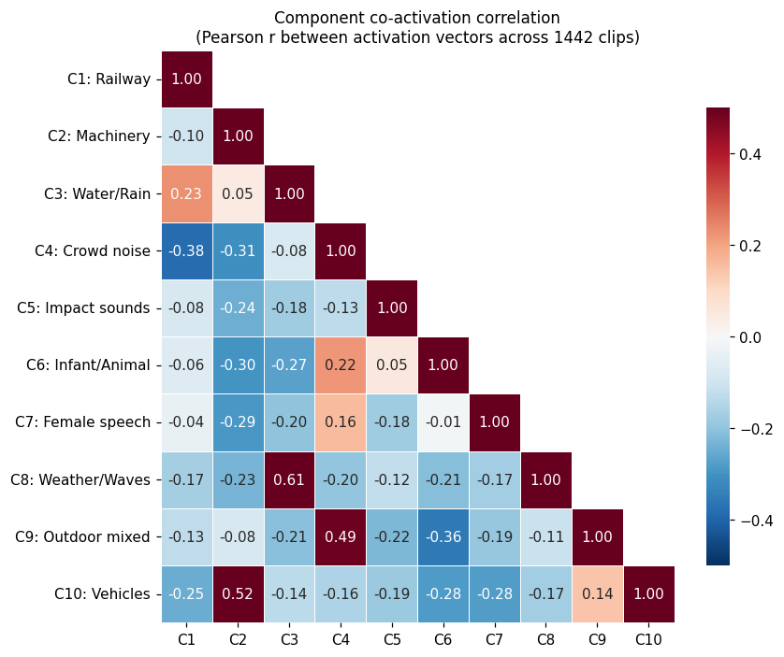
Figure 8.4. Component co-activation correlation across the 1,442 clips.
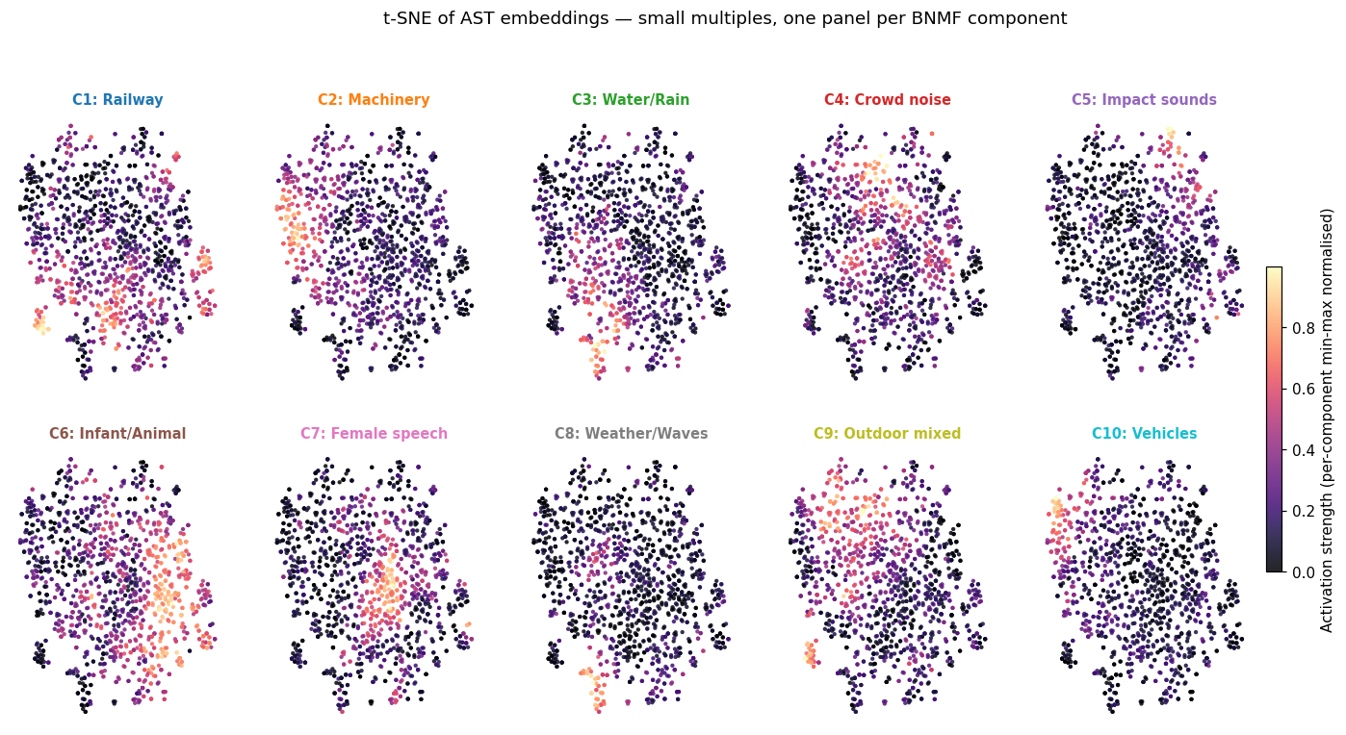
Figure 8.5. t-SNE small multiples showing per-component activation strength.

8.4 Current Limitation and Next Revision
The component labels are interpretive names based on the highest-activation captions and TF-IDF summaries, so they should be treated as qualitative labels rather than ground-truth categories. In the final revision, I plan to decide which component figures should remain in the main text and which should move to an appendix.

