BNMF Interpretation Addendum
  - Capstone progress update: interpreting AST auditory representations
Student: Deyu Wang
Advisor: Prof. Meenakshi Khosla
Date: May 28, 2026
Purpose: this addendum is meant to update the previously reviewed capstone report. It focuses on the new interpretation section rather than re-explaining the earlier dataset, classification, and developmental-trajectory results.

1. What Changed Since the Previous Report
- Added a Bayesian NMF interpretation pipeline for the AST embedding space.
- Selected the number of components using BIC; the best value was K = 10.
- Ran 20 independent BNMF fits and built a consensus component solution.
- Generated component-level interpretation outputs: category composition, purity, co-activation, weight-space similarity, TF-IDF words, and t-SNE activation panels.
- Prepared an extended notebook so the analysis can be reviewed from cached outputs.

2. Short Interpretation Summary
The new analysis decomposes the pretrained AST representation into interpretable sound components. Instead of only asking whether AST can classify speech or sound category, this section asks what kinds of acoustic concepts are organized inside the learned representation.
The components are not just copies of the five weak labels. They subdivide broad categories into more specific auditory concepts: environment separates into railway, machinery, impacts, and vehicles; speech separates into crowd/children speech, adult speech, and infant/animal vocalization patterns; nature separates into water/rain and weather/waves.

3. Component Overview
Component | Dominant category | Top-50 share | Entropy | Characteristic words
C2: Machinery | environment | 94.0% | 0.141 | engine, revving, running, idle, car, vehicle, vibrating, motor, starting, times
C4: Crowd noise | speech | 90.0% | 0.261 | crowd, whistle, cheer, children, woman, talk, applauding, cheering, train, group
C7: Female speech | speech | 88.0% | 0.262 | speaks, woman, female, adult, faucet, metal, water, environment, speech, dog
C10: Vehicles | environment | 84.0% | 0.342 | engine, revving, vehicle, accelerates, accelerating, car, revs, motor, running, humming
C9: Outdoor mixed | environment | 56.0% | 0.477 | train, horn, talk, honking, crowd, railroad, engine, truck, vehicle, blowing
C8: Weather/Waves | nature | 72.0% | 0.487 | rain, thunder, water, wind, heavy, stream, river, falls, flowing, splashing
C1: Railway | environment | 66.0% | 0.541 | train, horn, railroad, running, tracks, water, passes, signal, blowing, blows
C6: Infant/Animal | speech | 58.0% | 0.584 | crying, baby, laughing, woman, young, cries, person, laugh, cawing, child
C3: Water/Rain | nature | 60.0% | 0.585 | rain, water, thunder, falling, splashing, gurgling, stream, falls, trickling, river
C5: Impact sounds | environment | 48.0% | 0.779 | cat, meowing, door, speech, person, laughs, laughing, high, bell, occurs

4. Key Figures to Review
The figures below are the best places to inspect the new interpret section. The full set is included in the figures folder.
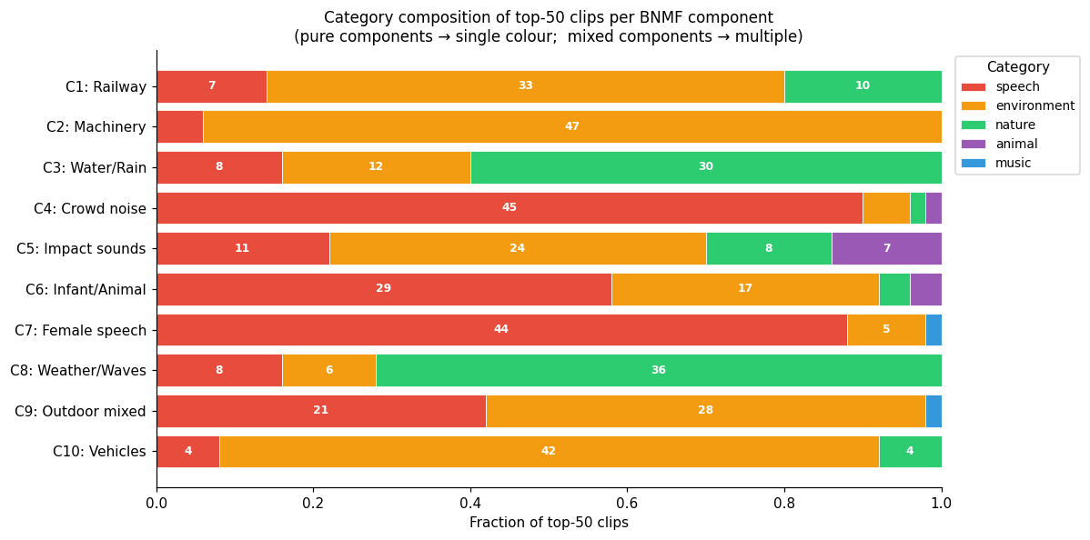
Figure 1. Category composition of the top-50 clips for each BNMF component.
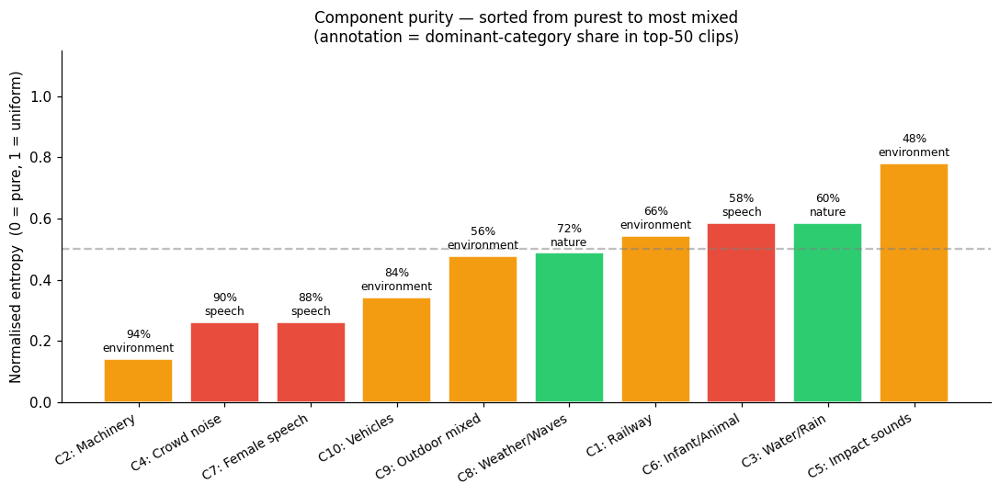
Figure 2. Component purity, sorted from purest to most mixed.
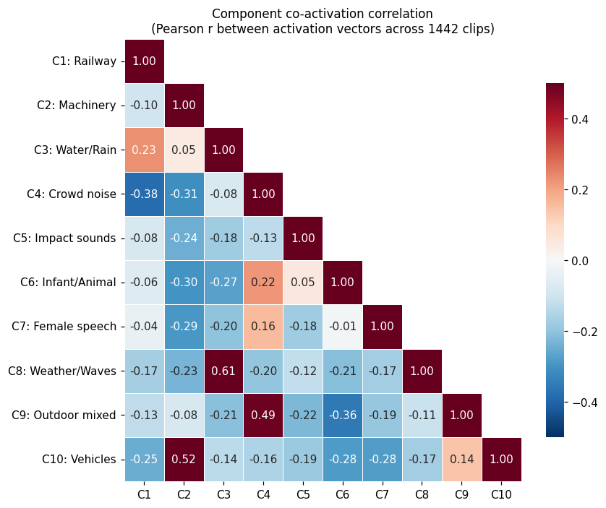
Figure 3. Component co-activation correlation across clips.
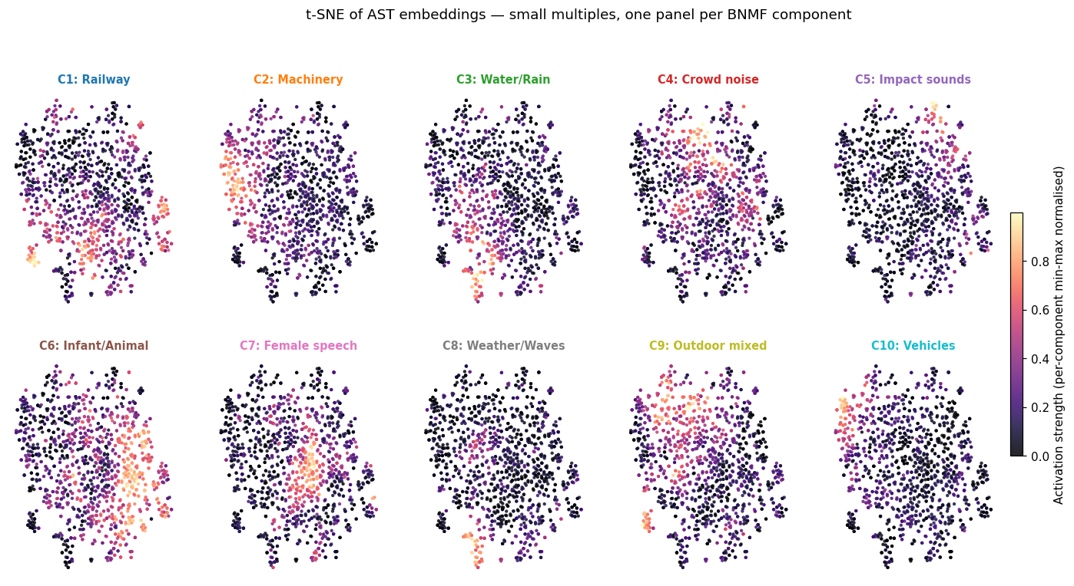
Figure 4. t-SNE panels colored by per-component activation strength.

5. How This Fits the Final Report
My current plan is to keep the earlier classification and developmental results as the empirical foundation, then add this BNMF section as the interpretability bridge. The main claim is modest: AST embeddings contain structured auditory subcategories that are partly aligned with the weak labels but also reveal finer sound concepts and mixed acoustic regularities.
The main open decision is how much of this component analysis should appear in the report body versus an appendix. I would like guidance on which figures are most convincing and whether the component names are clear enough.

6. Included Files for Verification
File | Reason included
capstone_bnmf_analysis.ipynb | Extended notebook with the new interpretation analysis
component_purity.csv | Component purity and entropy summary
component_top_words.csv | TF-IDF words used to label components
09_bnmf_interpret.py | Script that runs BIC search, consensus BNMF, and base visualizations
make_analysis_notebook.py | Script that builds the extended interpretation notebook

