Is There a Gender Pay Gap? Evidence from 11,187 Large UK Employers
Deyu Wang (5796695)
12 十月 2026

Method
Data were taken from the UK Government’s gender pay gap service for the 2025-26 reporting year. Reporting is compulsory for every UK employer with 250 or more employees, so the file is closer to a census of large employers than to a sample of them. The analysis used the complete set of 11,187 employer returns; no employer was excluded and there were no missing values on the outcome.
The outcome was each employer’s mean hourly gender pay gap, defined by the reporting service as the difference between the male and the female mean hourly rate, expressed as a percentage of the male rate. Positive values therefore mean that women at that employer were paid less per hour, on average, than men. The unit of analysis is the employer rather than the employee: each employer contributes one value regardless of its headcount.
For the sector comparison, employers were classified using their reporting deadline, since public sector employers were required to report by 31 March 2026 and businesses and charities by 5 April 2026.
All analyses were conducted in R. Two-tailed tests were used throughout, with alpha set at .05.

Results

The overall pay gap
Across the 11,187 employers, the mean hourly gender pay gap was 11.50% in women’s disfavour (SD = 15.99, Mdn = 10.64%). The distribution is shown in Figure 1. It is centred clearly to the right of parity: women were paid less per hour at 85.01% of employers and more at only 14.43%.
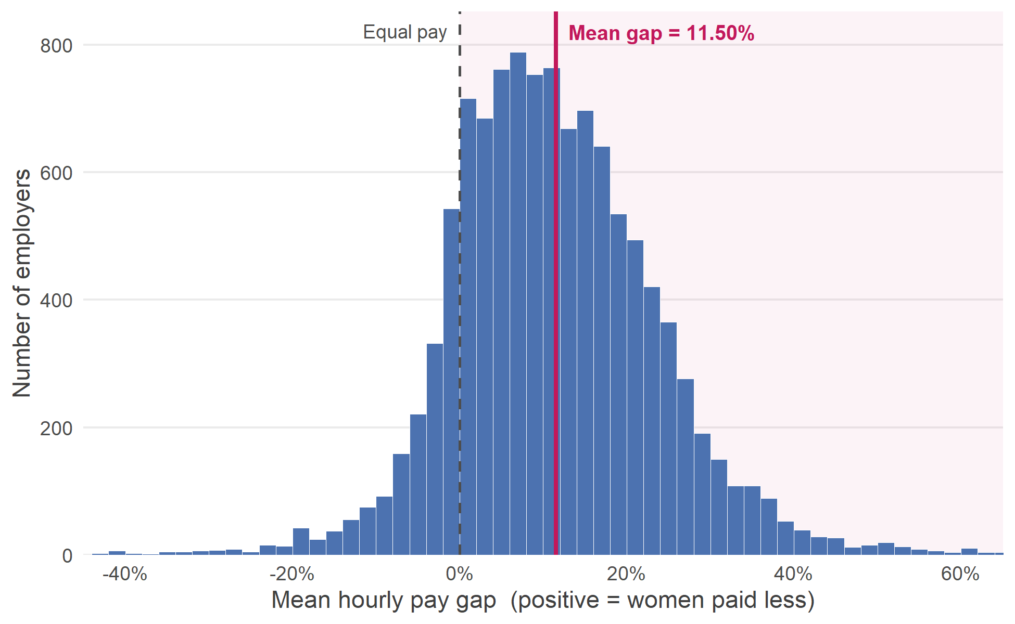
Figure 1. Distribution of the mean hourly gender pay gap across 11,187 UK employers, 2025-26 reporting year. Positive values indicate that women are paid less per hour than men. The dashed line marks parity and the solid line the mean gap. The x axis is clipped at -40% and +60% for legibility; 121 employers fall outside this range and are retained in all analyses.
A one-sample t-test compared the mean employer-level gap against the value of 0% that equal average hourly pay would produce. Women at large UK employers were paid significantly less per hour than men: the mean gap of 11.50% was reliably greater than zero, t(11186) = 76.06, p < .001, 95% CI [11.20, 11.80], d = 0.72. In practical terms, a typical large UK employer pays women about 11.50 pence less for every pound it pays men.

Public sector versus business and charity
Descriptive statistics by sector are given in Table 1.
Table 1. Mean hourly gender pay gap by sector.
Sector | N | M (%) | SD | Mdn (%) | IQR (pp) | % favouring women
Business / Charity | 9242 | 11.11 | 16.91 | 10.1 | 15.81 | 15.76
Public Sector | 1945 | 13.35 | 10.42 | 13.2 | 14.40 | 8.07
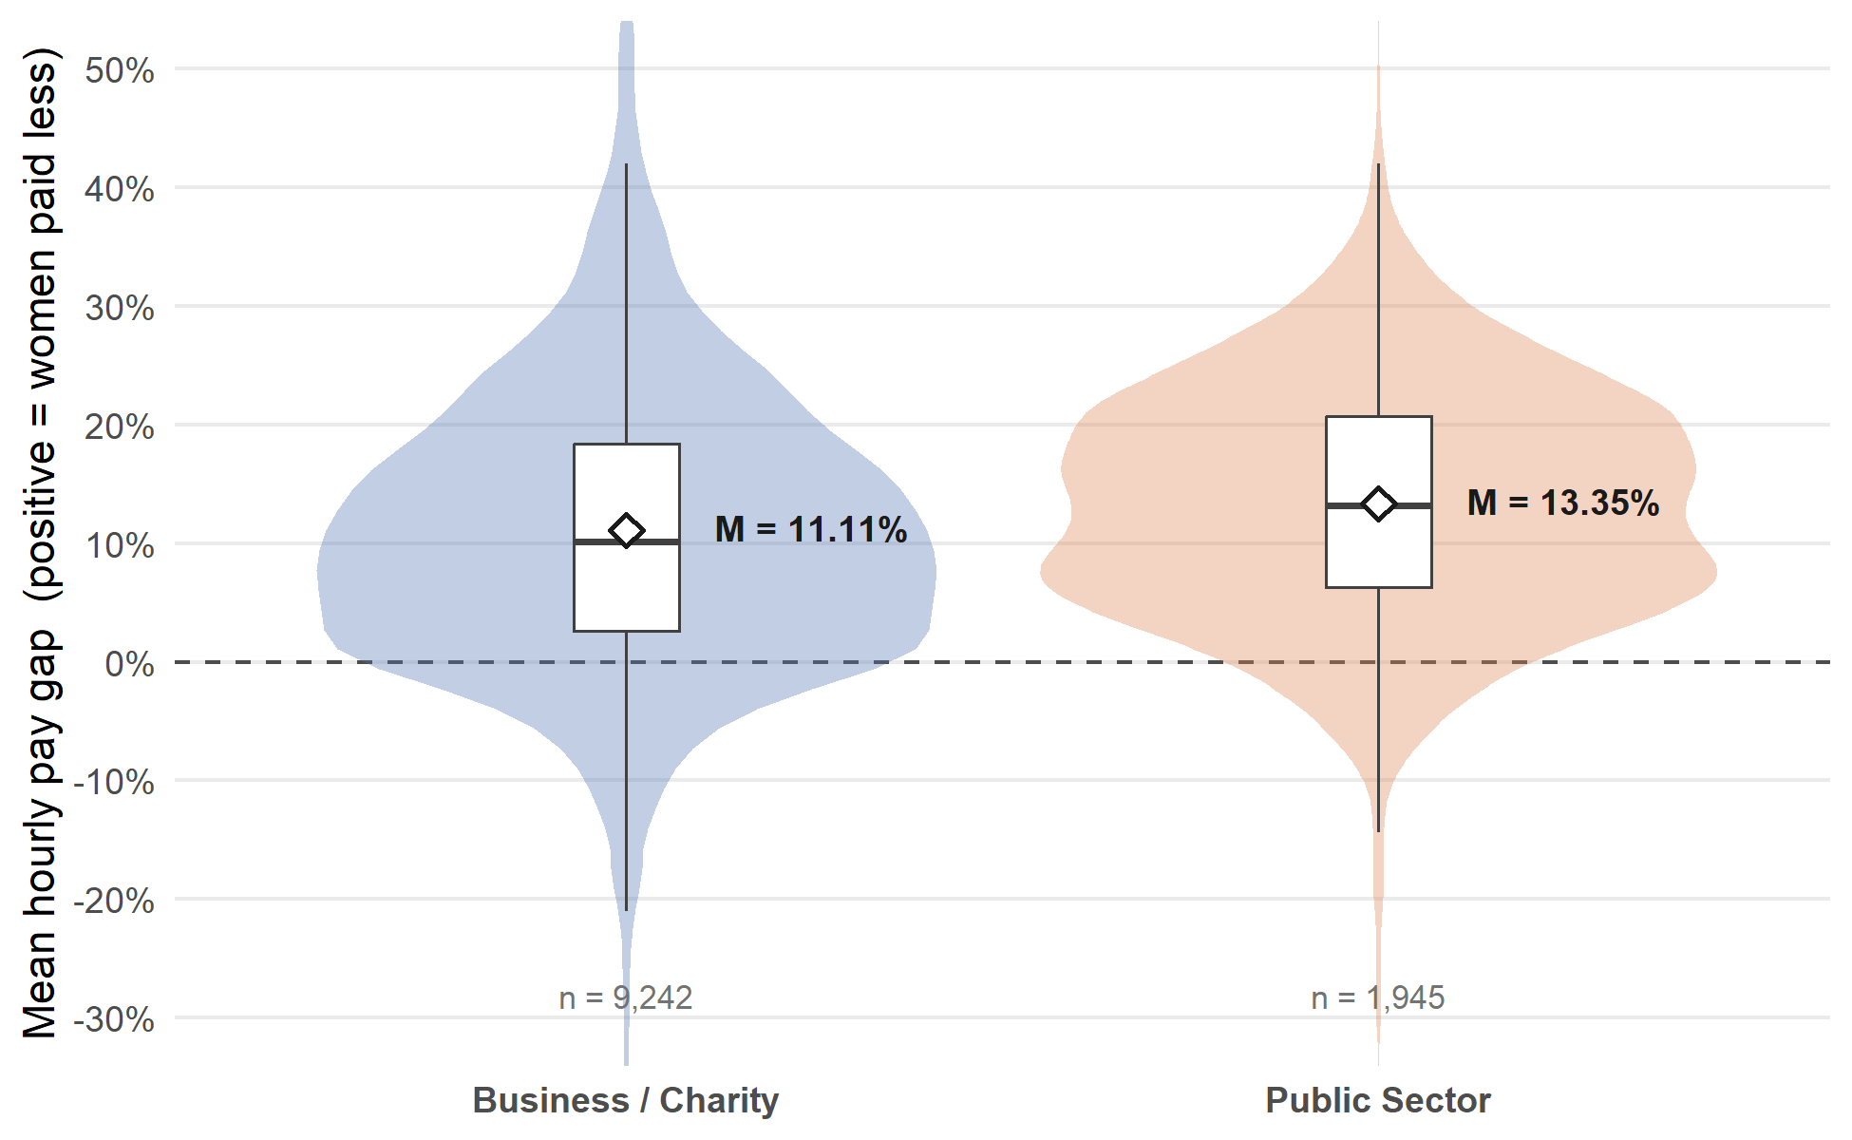
Figure 2. Mean hourly gender pay gap by sector. Violins show the shape of each distribution, boxes the median and interquartile range, and white diamonds the sector means with 95% confidence intervals. The y axis is clipped at -30% and +50% for legibility; all observations are retained in the analysis.
Contrary to the expectation that public bodies would perform better, public sector employers reported a significantly larger mean hourly pay gap (M = 13.35%, SD = 10.42, n = 1,945) than businesses and charities (M = 11.11%, SD = 16.91, n = 9,242). The difference of 2.23 percentage points was statistically significant, Welch’s t(4413.10) = 7.58, p < .001, 95% CI [1.66, 2.81], d = 0.14. Welch’s test was used because the two groups had unequal variances.
The difference in standard deviations is not evidence of a generally wider spread among businesses and charities. It comes from a small number of extreme returns in that group, including the minimum value of -757.00%; the interquartile ranges were very similar (15.81 against 14.40 percentage points). What did differ was how consistently the gap ran against women, which it did at all but 15.76% of businesses and charities and all but 8.07% of public sector employers.

Discussion
Among large UK employers in 2025-26 there is a gender pay gap, it runs against women, and the hypothesis of average parity can be rejected. A mean gap of 11.50% is also a substantial difference in hourly pay, not just a detectable one, and it is found at roughly six employers in every seven.
Three limitations apply. The unit of analysis is the employer, so every employer counts equally whether it employs 250 people or 250,000; this is the mean of employer gaps rather than the gap facing the average UK worker. The reported gap is also a raw difference in average hourly pay rather than a measure of equal pay for equal work, so it combines unequal pay for comparable roles with occupational segregation, meaning who occupies the senior and the junior positions. Finally, the figures are self-reported, and only employers with 250 or more staff are required to report, so smaller employers are absent entirely.
The sector comparison needs one further caution. The classification rests on the reporting deadline, which is a reliable but indirect marker of sector, and the standardised difference between sectors is small. The conclusion to draw is that the public sector is not the better performer here, not that it is markedly worse.

