MySQL数据库基础
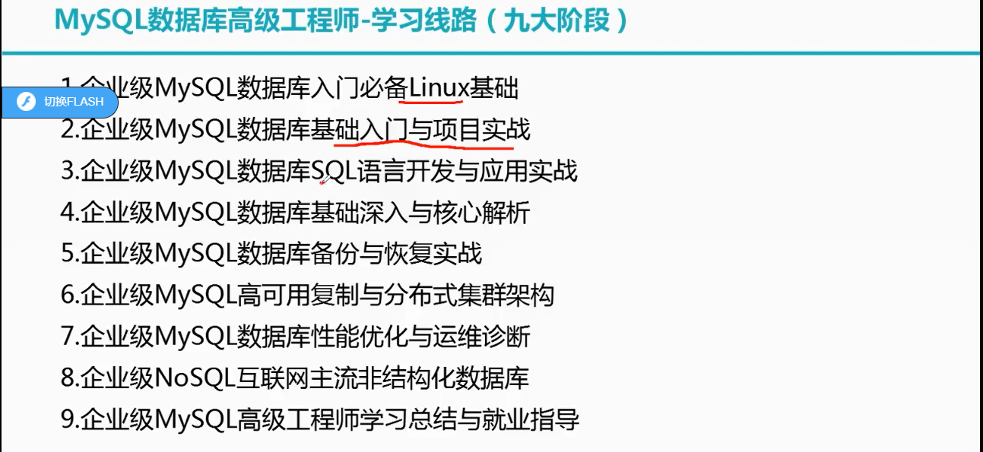

一、为什么要学习数据库
数据库是保存数据的容器，包括数组、集合、文件等。数据库能持久化到数据到本地，并且可以实现结构化查询，方便管理。

二、数据库的相关概念
DBMS
数据库管理系统（database management system）数据库是通过DBMS创建和操作容器。常见的数据库管理系统有MySQL、Oracle、DB2、SqlServer。

DB
数据库（DataBase）是存储数据的仓库。它保存了一系列有组织的数据。

SQL
结构化查询语言（structure query language），专门用来与数据库通信的语言。不是某个特定数据库供应商专有的语言，几乎所有的DBMS都支持SQL，并且简单易学。虽然简单但实际上是一种强有力的语言，灵活使用其语言元素，可以进行非常复杂和高级的数据库操作。

三、MySQL基础-数据库存储数据的特点
1.将数据放到表中，表再放到数据库中；
2.一个数据库中可以有多个表，每个表都有一个名字，用来标识自己，表名具有唯一性；
3.表具有一些特性，这些特性定义了数据在表中如何存储，类似Java中“类”的设计；
4.表由列组成，我们也称为字段。所有表都是由一个或多个列组成的，每一列类似Java中类的“属性”；
5.表中的数据是按行存储的，每一行类似于Java中的对象。

四、初始Mysql

MySQL软件产品的介绍
MySQL数据库隶属于MySQLAB公司，总部位于瑞典，后被oracle收购。
优点：
-成本低：开放源代码，一般可以免费使用
-性能高：执行很快
-简单：很容易安装和使用
DBMS分为两类：
-基于共享文件系统的DBMS（access）
-基于客户机-服务器的DBMS（MySQL、Oracle、DB2）
MySQL版本
-社区版（免费）GPL协议
-企业版（收费）

MySQL软件的安装和卸载
安装之前保持环境清洁，如果之前安装过，需要卸载，卸载需要卸载MySQL软件和清理注册表。
Mysql的安装一般是指mysql server的安装，安装前确定要安装的版本，5.5,5.6,5.7等
安装步骤如下：
1.清理安装环境，下载对应操作系统的Mysql软件

2.window操作系统安装

3.ubuntu操作系统安装

4.centos操作系统卸载

卸载步骤如下：
1.windows操作系统卸载

2.ubuntu操作系统卸载

3.centos操作系统卸载

MySQL服务配置文件介绍
Window操作系统下，配置文件是安装目录中的my.ini文件，具体内容如下：
[client]
# 设置mysql客户端默认字符集
default-character-set=utf8

[mysqld]
# 设置3306端口
port = 3306
# 设置mysql的安装目录
basedir=D:\\apps\\mysql-8.0.18-winx64
# 设置 mysql数据库的数据的存放目录，MySQL 8+ 不需要以下配置，系统自己生成即可，否则有可能报错
# datadir=C:\\web\\sqldata
# 允许最大连接数
max_connections=20
# 服务端使用的字符集默认为8比特编码的latin1字符集
character-set-server=utf8
# 创建新表时将使用的默认存储引擎
default-storage-engine=INNODB

Linux操作系统下，配置文件是安装目录中的my.cnf文件，具体内容如下：

MySQL服务的启动和停止
Windows下启动
以管理员身份启动命令行，
启动：net start mysql
停止：net stop mysql

【不一定是mysql，具体的服务名在安装时可以指定】

MySQL服务的登录和退出
方法一、可以使用mysql自带的客户端登陆，如下，
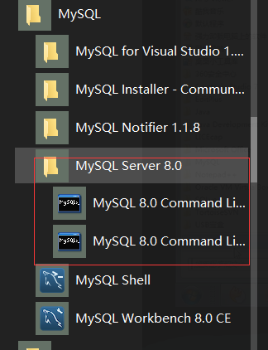
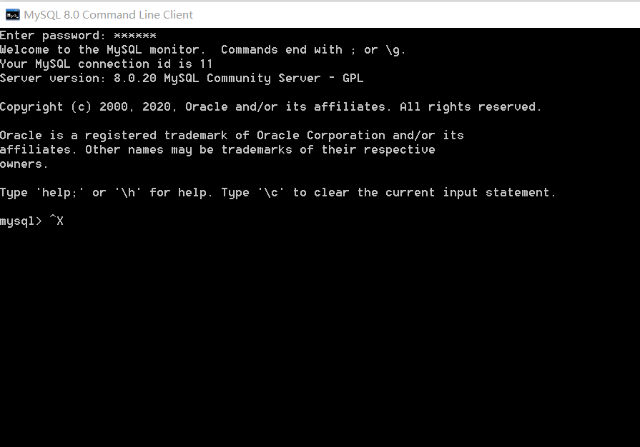

方法二、使用命令行登陆
Mysql -h【主机名】-P【端口号】 -u【用户名】-p【用户密码】
如果是本机，可以忽略主机名和端口号

退出使用exit或者ctrl+c

MySQL的常见命令
mysql>show databases；#显示所有数据库，默认显示系统自带的数据库
+--------------------+
| Database |
+--------------------+
| information_schema | #数据库信息数据库
| mysql |
| performance_schema | #性能信息数据库
| test | #测试数据库
| sys |
+--------------------+

mysql> use information_schema;#切换数据库
mysql> show tables;#显示当前数据库中所有表
mysql> show tables from mysql; #显示指定数据库中所有表
mysql> select database();#查看数据库
mysql> select version();#查看MySQL服务器的版本，非对话形式使用mysql --version或者mysql -V
mysql> select now();#查看数据库当前时间
mysql> desc tables;#查看数据表信息desc后面跟具体的表名

其他的还有对数据库的增删查改和对数据表的增删查改

MySQL的语法规范
1.不区分大小写，但建议关键字大写，表名、列名小写；
2.每条命令用分号结尾；
3.每条命令根据需要可以进行缩进或换行；
4.注释
#：单行注释
--：单行注释
/* */：多行注释

MySQL图形化用户界面
SQLyog
Navicat
Mysql WorkBench

五、DQL（data query language）语言的学习

示例表构建
CREATE DATABASE IF NOT EXISTS `myemployees` DEFAULT CHARACTER SET gb2312;
USE `myemployees`;
DROP TABLE IF EXISTS `locations`;
CREATE TABLE `locations` (
`location_id` int(11) NOT NULL AUTO_INCREMENT,
`street_address` varchar(40) DEFAULT NULL,
`postal_code` varchar(12) DEFAULT NULL,
`city` varchar(30) DEFAULT NULL,
`state_province` varchar(25) DEFAULT NULL,
`country_id` varchar(2) DEFAULT NULL,
PRIMARY KEY (`location_id`)
) ENGINE=InnoDB AUTO_INCREMENT=3201 DEFAULT CHARSET=gb2312;
DROP TABLE IF EXISTS `departments`;
CREATE TABLE `departments` (
`department_id` int(4) NOT NULL AUTO_INCREMENT,
`department_name` varchar(3) DEFAULT NULL,
`manager_id` int(6) DEFAULT NULL,
`location_id` int(4) DEFAULT NULL,
PRIMARY KEY (`department_id`),
KEY `loc_id_fk` (`location_id`),
CONSTRAINT `loc_id_fk` FOREIGN KEY (`location_id`) REFERENCES `locations` (`location_id`)
) ENGINE=InnoDB AUTO_INCREMENT=271 DEFAULT CHARSET=gb2312;
DROP TABLE IF EXISTS `jobs`;
CREATE TABLE `jobs` (
`job_id` varchar(10) NOT NULL,
`job_title` varchar(35) DEFAULT NULL,
`min_salary` int(6) DEFAULT NULL,
`max_salary` int(6) DEFAULT NULL,
PRIMARY KEY (`job_id`)
) ENGINE=InnoDB DEFAULT CHARSET=gb2312;
DROP TABLE IF EXISTS `employees`;
CREATE TABLE `employees` (
`employee_id` int(6) NOT NULL AUTO_INCREMENT,
`first_name` varchar(20) DEFAULT NULL,
`last_name` varchar(25) DEFAULT NULL,
`email` varchar(25) DEFAULT NULL,
`phone_number` varchar(20) DEFAULT NULL,
`job_id` varchar(10) DEFAULT NULL,
`salary` double(10,2) DEFAULT NULL,
`commission_pct` double(4,2) DEFAULT NULL,
`manager_id` int(6) DEFAULT NULL,
`department_id` int(4) DEFAULT NULL,
`hiredate` datetime DEFAULT NULL,
PRIMARY KEY (`employee_id`),
KEY `dept_id_fk` (`department_id`),
KEY `job_id_fk` (`job_id`),
CONSTRAINT `dept_id_fk` FOREIGN KEY (`department_id`) REFERENCES `departments` (`department_id`),
CONSTRAINT `job_id_fk` FOREIGN KEY (`job_id`) REFERENCES `jobs` (`job_id`)
) ENGINE=InnoDB AUTO_INCREMENT=207 DEFAULT CHARSET=gb2312;
insert into `locations`(`location_id`,`street_address`,`postal_code`,`city`,`state_province`,`country_id`) values (1000,'1297 Via Cola di Rie','00989','Roma',NULL,'IT'),(1100,'93091 Calle della Testa','10934','Venice',NULL,'IT'),(1200,'2017 Shinjuku-ku','1689','Tokyo','Tokyo Prefecture','JP'),(1300,'9450 Kamiya-cho','6823','Hiroshima',NULL,'JP'),(1400,'2014 Jabberwocky Rd','26192','Southlake','Texas','US'),(1500,'2011 Interiors Blvd','99236','South San Francisco','California','US'),(1600,'2007 Zagora St','50090','South Brunswick','New Jersey','US'),(1700,'2004 Charade Rd','98199','Seattle','Washington','US'),(1800,'147 Spadina Ave','M5V 2L7','Toronto','Ontario','CA'),(1900,'6092 Boxwood St','YSW 9T2','Whitehorse','Yukon','CA'),(2000,'40-5-12 Laogianggen','190518','Beijing',NULL,'CN'),(2100,'1298 Vileparle (E)','490231','Bombay','Maharashtra','IN'),(2200,'12-98 Victoria Street','2901','Sydney','New South Wales','AU'),(2300,'198 Clementi North','540198','Singapore',NULL,'SG'),(2400,'8204 Arthur St',NULL,'London',NULL,'UK'),(2500,'Magdalen Centre, The Oxford Science Park','OX9 9ZB','Oxford','Oxford','UK'),(2600,'9702 Chester Road','09629850293','Stretford','Manchester','UK'),(2700,'Schwanthalerstr. 7031','80925','Munich','Bavaria','DE'),(2800,'Rua Frei Caneca 1360 ','01307-002','Sao Paulo','Sao Paulo','BR'),(2900,'20 Rue des Corps-Saints','1730','Geneva','Geneve','CH'),(3000,'Murtenstrasse 921','3095','Bern','BE','CH'),(3100,'Pieter Breughelstraat 837','3029SK','Utrecht','Utrecht','NL'),(3200,'Mariano Escobedo 9991','11932','Mexico City','Distrito Federal,','MX');
insert into `departments`(`department_id`,`department_name`,`manager_id`,`location_id`) values (10,'Adm',200,1700),(20,'Mar',201,1800),(30,'Pur',114,1700),(40,'Hum',203,2400),(50,'Shi',121,1500),(60,'IT',103,1400),(70,'Pub',204,2700),(80,'Sal',145,2500),(90,'Exe',100,1700),(100,'Fin',108,1700),(110,'Acc',205,1700),(120,'Tre',NULL,1700),(130,'Cor',NULL,1700),(140,'Con',NULL,1700),(150,'Sha',NULL,1700),(160,'Ben',NULL,1700),(170,'Man',NULL,1700),(180,'Con',NULL,1700),(190,'Con',NULL,1700),(200,'Ope',NULL,1700),(210,'IT ',NULL,1700),(220,'NOC',NULL,1700),(230,'IT ',NULL,1700),(240,'Gov',NULL,1700),(250,'Ret',NULL,1700),(260,'Rec',NULL,1700),(270,'Pay',NULL,1700);
insert into `jobs`(`job_id`,`job_title`,`min_salary`,`max_salary`) values ('AC_ACCOUNT','Public Accountant',4200,9000),('AC_MGR','Accounting Manager',8200,16000),('AD_ASST','Administration Assistant',3000,6000),('AD_PRES','President',20000,40000),('AD_VP','Administration Vice President',15000,30000),('FI_ACCOUNT','Accountant',4200,9000),('FI_MGR','Finance Manager',8200,16000),('HR_REP','Human Resources Representative',4000,9000),('IT_PROG','Programmer',4000,10000),('MK_MAN','Marketing Manager',9000,15000),('MK_REP','Marketing Representative',4000,9000),('PR_REP','Public Relations Representative',4500,10500),('PU_CLERK','Purchasing Clerk',2500,5500),('PU_MAN','Purchasing Manager',8000,15000),('SA_MAN','Sales Manager',10000,20000),('SA_REP','Sales Representative',6000,12000),('SH_CLERK','Shipping Clerk',2500,5500),('ST_CLERK','Stock Clerk',2000,5000),('ST_MAN','Stock Manager',5500,8500);
insert into `employees`(`employee_id`,`first_name`,`last_name`,`email`,`phone_number`,`job_id`,`salary`,`commission_pct`,`manager_id`,`department_id`,`hiredate`) values (100,'Steven','K_ing','SKING','515.123.4567','AD_PRES',24000.00,NULL,NULL,90,'1992-04-03 00:00:00'),(101,'Neena','Kochhar','NKOCHHAR','515.123.4568','AD_VP',17000.00,NULL,100,90,'1992-04-03 00:00:00'),(102,'Lex','De Haan','LDEHAAN','515.123.4569','AD_VP',17000.00,NULL,100,90,'1992-04-03 00:00:00'),(103,'Alexander','Hunold','AHUNOLD','590.423.4567','IT_PROG',9000.00,NULL,102,60,'1992-04-03 00:00:00'),(104,'Bruce','Ernst','BERNST','590.423.4568','IT_PROG',6000.00,NULL,103,60,'1992-04-03 00:00:00'),(105,'David','Austin','DAUSTIN','590.423.4569','IT_PROG',4800.00,NULL,103,60,'1998-03-03 00:00:00'),(106,'Valli','Pataballa','VPATABAL','590.423.4560','IT_PROG',4800.00,NULL,103,60,'1998-03-03 00:00:00'),(107,'Diana','Lorentz','DLORENTZ','590.423.5567','IT_PROG',4200.00,NULL,103,60,'1998-03-03 00:00:00'),(108,'Nancy','Greenberg','NGREENBE','515.124.4569','FI_MGR',12000.00,NULL,101,100,'1998-03-03 00:00:00'),(109,'Daniel','Faviet','DFAVIET','515.124.4169','FI_ACCOUNT',9000.00,NULL,108,100,'1998-03-03 00:00:00'),(110,'John','Chen','JCHEN','515.124.4269','FI_ACCOUNT',8200.00,NULL,108,100,'2000-09-09 00:00:00'),(111,'Ismael','Sciarra','ISCIARRA','515.124.4369','FI_ACCOUNT',7700.00,NULL,108,100,'2000-09-09 00:00:00'),(112,'Jose Manuel','Urman','JMURMAN','515.124.4469','FI_ACCOUNT',7800.00,NULL,108,100,'2000-09-09 00:00:00'),(113,'Luis','Popp','LPOPP','515.124.4567','FI_ACCOUNT',6900.00,NULL,108,100,'2000-09-09 00:00:00'),(114,'Den','Raphaely','DRAPHEAL','515.127.4561','PU_MAN',11000.00,NULL,100,30,'2000-09-09 00:00:00'),(115,'Alexander','Khoo','AKHOO','515.127.4562','PU_CLERK',3100.00,NULL,114,30,'2000-09-09 00:00:00'),(116,'Shelli','Baida','SBAIDA','515.127.4563','PU_CLERK',2900.00,NULL,114,30,'2000-09-09 00:00:00'),(117,'Sigal','Tobias','STOBIAS','515.127.4564','PU_CLERK',2800.00,NULL,114,30,'2000-09-09 00:00:00'),(118,'Guy','Himuro','GHIMURO','515.127.4565','PU_CLERK',2600.00,NULL,114,30,'2000-09-09 00:00:00'),(119,'Karen','Colmenares','KCOLMENA','515.127.4566','PU_CLERK',2500.00,NULL,114,30,'2000-09-09 00:00:00'),(120,'Matthew','Weiss','MWEISS','650.123.1234','ST_MAN',8000.00,NULL,100,50,'2004-02-06 00:00:00'),(121,'Adam','Fripp','AFRIPP','650.123.2234','ST_MAN',8200.00,NULL,100,50,'2004-02-06 00:00:00'),(122,'Payam','Kaufling','PKAUFLIN','650.123.3234','ST_MAN',7900.00,NULL,100,50,'2004-02-06 00:00:00'),(123,'Shanta','Vollman','SVOLLMAN','650.123.4234','ST_MAN',6500.00,NULL,100,50,'2004-02-06 00:00:00'),(124,'Kevin','Mourgos','KMOURGOS','650.123.5234','ST_MAN',5800.00,NULL,100,50,'2004-02-06 00:00:00'),(125,'Julia','Nayer','JNAYER','650.124.1214','ST_CLERK',3200.00,NULL,120,50,'2004-02-06 00:00:00'),(126,'Irene','Mikkilineni','IMIKKILI','650.124.1224','ST_CLERK',2700.00,NULL,120,50,'2004-02-06 00:00:00'),(127,'James','Landry','JLANDRY','650.124.1334','ST_CLERK',2400.00,NULL,120,50,'2004-02-06 00:00:00'),(128,'Steven','Markle','SMARKLE','650.124.1434','ST_CLERK',2200.00,NULL,120,50,'2004-02-06 00:00:00'),(129,'Laura','Bissot','LBISSOT','650.124.5234','ST_CLERK',3300.00,NULL,121,50,'2004-02-06 00:00:00'),(130,'Mozhe','Atkinson','MATKINSO','650.124.6234','ST_CLERK',2800.00,NULL,121,50,'2004-02-06 00:00:00'),(131,'James','Marlow','JAMRLOW','650.124.7234','ST_CLERK',2500.00,NULL,121,50,'2004-02-06 00:00:00'),(132,'TJ','Olson','TJOLSON','650.124.8234','ST_CLERK',2100.00,NULL,121,50,'2004-02-06 00:00:00'),(133,'Jason','Mallin','JMALLIN','650.127.1934','ST_CLERK',3300.00,NULL,122,50,'2004-02-06 00:00:00'),(134,'Michael','Rogers','MROGERS','650.127.1834','ST_CLERK',2900.00,NULL,122,50,'2002-12-23 00:00:00'),(135,'Ki','Gee','KGEE','650.127.1734','ST_CLERK',2400.00,NULL,122,50,'2002-12-23 00:00:00'),(136,'Hazel','Philtanker','HPHILTAN','650.127.1634','ST_CLERK',2200.00,NULL,122,50,'2002-12-23 00:00:00'),(137,'Renske','Ladwig','RLADWIG','650.121.1234','ST_CLERK',3600.00,NULL,123,50,'2002-12-23 00:00:00'),(138,'Stephen','Stiles','SSTILES','650.121.2034','ST_CLERK',3200.00,NULL,123,50,'2002-12-23 00:00:00'),(139,'John','Seo','JSEO','650.121.2019','ST_CLERK',2700.00,NULL,123,50,'2002-12-23 00:00:00'),(140,'Joshua','Patel','JPATEL','650.121.1834','ST_CLERK',2500.00,NULL,123,50,'2002-12-23 00:00:00'),(141,'Trenna','Rajs','TRAJS','650.121.8009','ST_CLERK',3500.00,NULL,124,50,'2002-12-23 00:00:00'),(142,'Curtis','Davies','CDAVIES','650.121.2994','ST_CLERK',3100.00,NULL,124,50,'2002-12-23 00:00:00'),(143,'Randall','Matos','RMATOS','650.121.2874','ST_CLERK',2600.00,NULL,124,50,'2002-12-23 00:00:00'),(144,'Peter','Vargas','PVARGAS','650.121.2004','ST_CLERK',2500.00,NULL,124,50,'2002-12-23 00:00:00'),(145,'John','Russell','JRUSSEL','011.44.1344.429268','SA_MAN',14000.00,0.40,100,80,'2002-12-23 00:00:00'),(146,'Karen','Partners','KPARTNER','011.44.1344.467268','SA_MAN',13500.00,0.30,100,80,'2002-12-23 00:00:00'),(147,'Alberto','Errazuriz','AERRAZUR','011.44.1344.429278','SA_MAN',12000.00,0.30,100,80,'2002-12-23 00:00:00'),(148,'Gerald','Cambrault','GCAMBRAU','011.44.1344.619268','SA_MAN',11000.00,0.30,100,80,'2002-12-23 00:00:00'),(149,'Eleni','Zlotkey','EZLOTKEY','011.44.1344.429018','SA_MAN',10500.00,0.20,100,80,'2002-12-23 00:00:00'),(150,'Peter','Tucker','PTUCKER','011.44.1344.129268','SA_REP',10000.00,0.30,145,80,'2014-03-05 00:00:00'),(151,'David','Bernstein','DBERNSTE','011.44.1344.345268','SA_REP',9500.00,0.25,145,80,'2014-03-05 00:00:00'),(152,'Peter','Hall','PHALL','011.44.1344.478968','SA_REP',9000.00,0.25,145,80,'2014-03-05 00:00:00'),(153,'Christopher','Olsen','COLSEN','011.44.1344.498718','SA_REP',8000.00,0.20,145,80,'2014-03-05 00:00:00'),(154,'Nanette','Cambrault','NCAMBRAU','011.44.1344.987668','SA_REP',7500.00,0.20,145,80,'2014-03-05 00:00:00'),(155,'Oliver','Tuvault','OTUVAULT','011.44.1344.486508','SA_REP',7000.00,0.15,145,80,'2014-03-05 00:00:00'),(156,'Janette','K_ing','JKING','011.44.1345.429268','SA_REP',10000.00,0.35,146,80,'2014-03-05 00:00:00'),(157,'Patrick','Sully','PSULLY','011.44.1345.929268','SA_REP',9500.00,0.35,146,80,'2014-03-05 00:00:00'),(158,'Allan','McEwen','AMCEWEN','011.44.1345.829268','SA_REP',9000.00,0.35,146,80,'2014-03-05 00:00:00'),(159,'Lindsey','Smith','LSMITH','011.44.1345.729268','SA_REP',8000.00,0.30,146,80,'2014-03-05 00:00:00'),(160,'Louise','Doran','LDORAN','011.44.1345.629268','SA_REP',7500.00,0.30,146,80,'2014-03-05 00:00:00'),(161,'Sarath','Sewall','SSEWALL','011.44.1345.529268','SA_REP',7000.00,0.25,146,80,'2014-03-05 00:00:00'),(162,'Clara','Vishney','CVISHNEY','011.44.1346.129268','SA_REP',10500.00,0.25,147,80,'2014-03-05 00:00:00'),(163,'Danielle','Greene','DGREENE','011.44.1346.229268','SA_REP',9500.00,0.15,147,80,'2014-03-05 00:00:00'),(164,'Mattea','Marvins','MMARVINS','011.44.1346.329268','SA_REP',7200.00,0.10,147,80,'2014-03-05 00:00:00'),(165,'David','Lee','DLEE','011.44.1346.529268','SA_REP',6800.00,0.10,147,80,'2014-03-05 00:00:00'),(166,'Sundar','Ande','SANDE','011.44.1346.629268','SA_REP',6400.00,0.10,147,80,'2014-03-05 00:00:00'),(167,'Amit','Banda','ABANDA','011.44.1346.729268','SA_REP',6200.00,0.10,147,80,'2014-03-05 00:00:00'),(168,'Lisa','Ozer','LOZER','011.44.1343.929268','SA_REP',11500.00,0.25,148,80,'2014-03-05 00:00:00'),(169,'Harrison','Bloom','HBLOOM','011.44.1343.829268','SA_REP',10000.00,0.20,148,80,'2014-03-05 00:00:00'),(170,'Tayler','Fox','TFOX','011.44.1343.729268','SA_REP',9600.00,0.20,148,80,'2014-03-05 00:00:00'),(171,'William','Smith','WSMITH','011.44.1343.629268','SA_REP',7400.00,0.15,148,80,'2014-03-05 00:00:00'),(172,'Elizabeth','Bates','EBATES','011.44.1343.529268','SA_REP',7300.00,0.15,148,80,'2014-03-05 00:00:00'),(173,'Sundita','Kumar','SKUMAR','011.44.1343.329268','SA_REP',6100.00,0.10,148,80,'2014-03-05 00:00:00'),(174,'Ellen','Abel','EABEL','011.44.1644.429267','SA_REP',11000.00,0.30,149,80,'2014-03-05 00:00:00'),(175,'Alyssa','Hutton','AHUTTON','011.44.1644.429266','SA_REP',8800.00,0.25,149,80,'2014-03-05 00:00:00'),(176,'Jonathon','Taylor','JTAYLOR','011.44.1644.429265','SA_REP',8600.00,0.20,149,80,'2014-03-05 00:00:00'),(177,'Jack','Livingston','JLIVINGS','011.44.1644.429264','SA_REP',8400.00,0.20,149,80,'2014-03-05 00:00:00'),(178,'Kimberely','Grant','KGRANT','011.44.1644.429263','SA_REP',7000.00,0.15,149,NULL,'2014-03-05 00:00:00'),(179,'Charles','Johnson','CJOHNSON','011.44.1644.429262','SA_REP',6200.00,0.10,149,80,'2014-03-05 00:00:00'),(180,'Winston','Taylor','WTAYLOR','650.507.9876','SH_CLERK',3200.00,NULL,120,50,'2014-03-05 00:00:00'),(181,'Jean','Fleaur','JFLEAUR','650.507.9877','SH_CLERK',3100.00,NULL,120,50,'2014-03-05 00:00:00'),(182,'Martha','Sullivan','MSULLIVA','650.507.9878','SH_CLERK',2500.00,NULL,120,50,'2014-03-05 00:00:00'),(183,'Girard','Geoni','GGEONI','650.507.9879','SH_CLERK',2800.00,NULL,120,50,'2014-03-05 00:00:00'),(184,'Nandita','Sarchand','NSARCHAN','650.509.1876','SH_CLERK',4200.00,NULL,121,50,'2014-03-05 00:00:00'),(185,'Alexis','Bull','ABULL','650.509.2876','SH_CLERK',4100.00,NULL,121,50,'2014-03-05 00:00:00'),(186,'Julia','Dellinger','JDELLING','650.509.3876','SH_CLERK',3400.00,NULL,121,50,'2014-03-05 00:00:00'),(187,'Anthony','Cabrio','ACABRIO','650.509.4876','SH_CLERK',3000.00,NULL,121,50,'2014-03-05 00:00:00'),(188,'Kelly','Chung','KCHUNG','650.505.1876','SH_CLERK',3800.00,NULL,122,50,'2014-03-05 00:00:00'),(189,'Jennifer','Dilly','JDILLY','650.505.2876','SH_CLERK',3600.00,NULL,122,50,'2014-03-05 00:00:00'),(190,'Timothy','Gates','TGATES','650.505.3876','SH_CLERK',2900.00,NULL,122,50,'2014-03-05 00:00:00'),(191,'Randall','Perkins','RPERKINS','650.505.4876','SH_CLERK',2500.00,NULL,122,50,'2014-03-05 00:00:00'),(192,'Sarah','Bell','SBELL','650.501.1876','SH_CLERK',4000.00,NULL,123,50,'2014-03-05 00:00:00'),(193,'Britney','Everett','BEVERETT','650.501.2876','SH_CLERK',3900.00,NULL,123,50,'2014-03-05 00:00:00'),(194,'Samuel','McCain','SMCCAIN','650.501.3876','SH_CLERK',3200.00,NULL,123,50,'2014-03-05 00:00:00'),(195,'Vance','Jones','VJONES','650.501.4876','SH_CLERK',2800.00,NULL,123,50,'2014-03-05 00:00:00'),(196,'Alana','Walsh','AWALSH','650.507.9811','SH_CLERK',3100.00,NULL,124,50,'2014-03-05 00:00:00'),(197,'Kevin','Feeney','KFEENEY','650.507.9822','SH_CLERK',3000.00,NULL,124,50,'2014-03-05 00:00:00'),(198,'Donald','OConnell','DOCONNEL','650.507.9833','SH_CLERK',2600.00,NULL,124,50,'2014-03-05 00:00:00'),(199,'Douglas','Grant','DGRANT','650.507.9844','SH_CLERK',2600.00,NULL,124,50,'2014-03-05 00:00:00'),(200,'Jennifer','Whalen','JWHALEN','515.123.4444','AD_ASST',4400.00,NULL,101,10,'2016-03-03 00:00:00'),(201,'Michael','Hartstein','MHARTSTE','515.123.5555','MK_MAN',13000.00,NULL,100,20,'2016-03-03 00:00:00'),(202,'Pat','Fay','PFAY','603.123.6666','MK_REP',6000.00,NULL,201,20,'2016-03-03 00:00:00'),(203,'Susan','Mavris','SMAVRIS','515.123.7777','HR_REP',6500.00,NULL,101,40,'2016-03-03 00:00:00'),(204,'Hermann','Baer','HBAER','515.123.8888','PR_REP',10000.00,NULL,101,70,'2016-03-03 00:00:00'),(205,'Shelley','Higgins','SHIGGINS','515.123.8080','AC_MGR',12000.00,NULL,101,110,'2016-03-03 00:00:00'),(206,'William','Gietz','WGIETZ','515.123.8181','AC_ACCOUNT',8300.00,NULL,205,110,'2016-03-03 00:00:00');
以上表模型如下
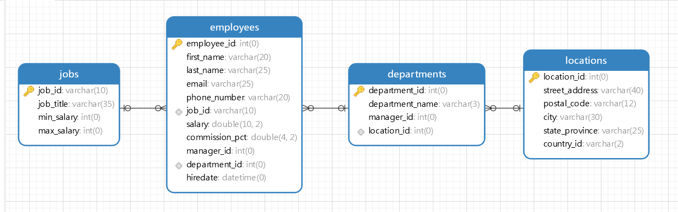

基础查询
/*
语法：
select 查询列表 from 表名；
说明：
1.查询列表可以是：表中的字段、常量值、表达式、函数
2.查询的结果是一个虚拟的表格
*/
use myemployees;

#1.查询表中的单个字段
select last_name from employees;

#2.查询表中多个字段
select last_name,salary,email from employees;

#3.查询表中的所有字段
##第一种方式：写出所有字段
select
employee_id,
first_name,
last_name,
email,
phone_number,
job_id,
salary,
commission_pct,
manager_id,
department_id,
hiredate
from
employees;

##第二种方式：使用*号匹配符
select * from employees;

#4.查询常量值
select 100;
select 'john';
#5.查询表达式
select 100%98;
#6.查询函数
select version();
#7.起别名(便于理解，如果要查询的字段有重名的情况，使用别名可以区分开)
##方式一：使用as
select 100%98 as 结果;
select last_name as 姓,first_name as 名 from employees;
##方式二：使用空格
select last_name 姓,first_name 名 from employees;

##案例查询别名中不能有关键字，如果有需要使用引号引起来
select salary as out put from employees;#out是关键字
select salary as "out put" from employees;

#8.去重
select distinct department_id from employees;

#9.+号的作用
/*
java中的+号：
运算符，两个操作数都为数值型
连接符，只要有一个操作数为字符串
mysql中仅仅只有一个功能：运算符
mysql中使用concat()函数连接字符串
*/
select 123+90 as result;#两个操作数都为数值型，则做加法运算
select '123'+90 as result;
#两个操作数一方为字符型，试图将字符型转换成数值型，如果转换成功，则继续做加法运算
select 'join'+90 as result;#如果转换失败，则将字符型数值转换成0
select null+90 as result;#只要其中一方为null，则结果肯定为null

##案例：查询员工名和姓连接成一个字段，并显示为姓名
select last_name+first_name as 姓名 from employees;#结果和要求不一致
select concat(last_name," ",first_name) as 姓名 from employees;

条件查询
/*
语法：
select 查询列表 from 表名 where 筛选条件;

筛选条件分类：
1.按条件表达式筛选
条件运算符：>、<、=、!=、<>、>=、<=
2.按逻辑表达式筛选
逻辑运算符：&& || ！
and or not
&&和and：两个条件都为true，结果为true，反之为false
||和or：只要一个条件为true,结果为true，反之为false
!和not：如果连接的条件本身为false，如果为true，反之为false

3.模糊查询
like
between ... and ...
in
is null
*/
#1.按条件表达式筛选
##案例1：查询员工工资大于1200的员工信息
select * from employees where salary>1200;
##案例2：查询部门编号不等于90号的员工名和部门编号
select last_name,department_id from employees where department_id <> 90;

#2、按逻辑表达式筛选
##案例1：查询工资在10000到20000之间的员工名、工资以及奖金
select last_name,salary,commission_pct from employees where salary>10000 and salary<20000;
##案例2：查询不猛编号不是在90到110之间，或者工资高于15000的员工信息
select * from employees where department_id < 90 or department_id>110 or salary>15000;
select * from employees where not(department_id < 90 and department_id>110) or salary>15000;

#3.模糊查询
##案例1：查询姓名中包含字符a的员工信息
select * from employees where last_name like '%a%';# 通配符%表示0个或任意多个字符，通配符_表示任意单个字符
##案例2：查询员工名中第三个字符为n，第五个字符为l的员工名和工资
select last_name,salary from employees where last_name like '__n_l%';
##案例3：查询员工名中第二个字符为_的员工名
select last_name from employees where last_name like '_\_%';# _需要用\转义
select last_name from employees where last_name like '_$_%' escape '$';#或者使用escape关键词代表转义
##案例4：between and,查询员工编号在100到120之间的员工信息
select * from employees where employee_id between 100 and 120;
##案例5：in，查询员工的工种编号是IT_PROC、AD_VP、AD_PRES中的一个员工名和工种编号
select last_name,job_id from employees where job_id in ('IT_PROC','AD_VP','AD_PRES');#使用in提高语句简洁度，in列表的值类型必须一致或兼容，in不支持模糊匹配
##案例6：is null,查询没有奖金的员工名和奖金率
select last_name,commission_pct from employees where commission_pct is null
##案例7：is not null,查询有奖金的员工名和奖金率
select last_name,commission_pct from employees where commission_pct is not null
##案例8：安全等于<=>,查询工资为1200的员工信息
select * from employees where salary<=>12000;#安全等于可以判断数值和null，但是不建议使用

排序查询
/**
排序查询
语法
select 查询列表 from 表名 【where 筛选条件】 order by 排序列表【asc|desc】
特点：
1.asc代表的是升序，desc代表的是降序，如果不写默认是升序
2.order by子句中可以支持单个字段、多个字段、表达式、函数、别名
3.order by子句一般放在查询语句的最后面，limit子句除外
*/

#案例1：查询员工信息，要求工资从高到低排序
select * from employees order by salary desc;
select * from employees order by salary asc;

#案例2：查询部门编号>=90的员工信息，按入职时间的先后进行排序
select * from employees where department_id>=90 order by hiredate asc;#和筛选条件配合使用

#案例3：【按表达式排序】按年薪的高低显示员工的信息和年薪
select *,salary*12*(1+IFNULL(commission_pct,0))) 年薪 from employees order by salary*12*(1+IFNULL(commission_pct,0))) desc;

#案例4：【按别名排序】按年薪的高低显示员工的信息和年薪
select *,salary*12*(1+IFNULL(commission_pct,0))) 年薪 from employees order by 年薪 desc;

#案例5：【按函数排序】按照姓名长度显示员工的信息
select *,length(last_name) name_length from employees order by name_length desc;
#案例6：【按照多个字段排序】查询员工信息，要求先按工资升序，再按员工编号降序
select * from employees order by salary asc,employee_id desc;

常见函数
字符函数
#字符函数

#（1）length()
select length("john");
select length("张三丰aaaa");#utf8 一个中文字符3个字节 gbk 一个中文字符2个字节

show variables like '%char%';
#（2）concat()拼接字符串
select concat(last_name, '_', first_name) from employees;

#(3)upper():变变大写；lower()：变小写
select upper('john');
select upper('joHn');
##示例：将姓变大写，名变小写，然后拼接
select concat(upper(last_name),'_', lower(first_name)) 姓名 from employees; #函数可以嵌套函数
#（4）substr()|substring()截取字符串 索引从1开始
select substr("李莫愁爱上了陆展元", 7) output;#截取从指定索引处后面所有字符
select substr("李莫愁爱上了陆展元", 1, 3) output;#截取从指定索引处指定字符长度的字符

##示例：姓名中首字符大写，其它字符小写，然后用_拼接，显示出来
select concat(upper(substr(last_name, 1,1)),'_',lower(substr(last_name, 2))) from employees;

#(5)instr() 返回子串第一次出现的索引，如果找不到返回0

select instr('杨不悔爱上了殷六侠殷六侠殷六侠', '殷六侠') as output;

#（6）trim()去掉前后空格
select length(trim(' 张翠山 ')) as output;
select trim('a' from 'aaaaaa张aaaaaa翠aaaaa山aaaaaa') as output;

#（7）lpad()用指定的字符实现左填充指定长度
select lpad('殷素素',10,'*') as output;

#（8）rpad()用指定的字符实现右填充指定长度
select lpad('殷素素',10,'*') as output;

#（9）replace() 字符替换
select replace('张三丰爱上了周芷若','周芷若','赵敏') as output;

数学函数
#（1）round()四舍五入
select round(1.55);
select round(-1.55);
select round(1.567, 2);#保留小数点后2位小数

#（2）cell()向上取整,大于等于参数的最小整数
select cell(0.1);
select cell(-1.02);
#（3）floor()向下取整，返回小于等于参数的最大整数
select floor(-9.99);

#(4)truncate()截断
select truncate(1.6999, 1);
#(5)mod()取余
select mod(10,3);
select mod(-10,-3);
select 10%3;

日期函数
#（1）now()返回当前系统日期+时间
select now();

#（2）curdate()返回当前系统日期，不包含时间
select curdate();

#（3）curtime()放回当前系统时间，不包含日期
select curtime();

#（4）可以获得指定的部分，年，月，日，小时，分钟，秒
select year(now()) 年;
select year('1998-1-1') 年;
select year(hiredate) 年 from employees;

select month(now()) 月;
select monthname(now()) 月;
#（5）将日期格式的字符转换成指定格式的日期
select str_to_date('9-13-1999','%m-%d-%Y');
#（6）date_format():将日期转换成字符
select date_format('2018/6/6','%Y年%m月%d日');

select last_name,date_format(hiredate,'%m月/%d日 %y年') 入职日期
from employees
where commission_pct is not null;

其他函数
select version();
select database();#查看当前数据库
select user();
select password(‘字符’);
select md5(‘字符’)

流程控制函数
#流程控制函数
#（1）if()函数： if...else...的效果
select if(10<5, '大', '小');
select last_name,commission_pct,if(commission_pct is null, '没奖金，呵呵','有奖金，哈哈')
from employees;

#（2）case函数：switch case的效果

/**
JAVA中：
switch(变量或表达式){
case 常量1: 语句;
case ...
default:
...
}

mysql中
case 杨判断的字段或表达式
when 常量1 then 要显示的值1或语句1;
when 常量2 then 要显示的值2或语句2;
...
else 眼小时的值n或者语句n；
end
*/

/**
案例：查询员工工资，要求
部门号=30，显示工资为1.1倍
部门号=40，显示工资为1.2倍
部门号=50，显示工资为1.3倍
其他部门，显示原工资
*/

select salary, department_id,
case department_id
when 30 then salary*1.1
when 40 then salary*1.2
when 50 then salary*1.3
else salary
end as 新工资
from employees;

#（3）case函数：类似于多重if
/**
java中
if(条件1){
语句1;
} else if条件2) {
语句2；
}
...
else {
语句n;
}

mysql中
case
when 条件1 then 要显示的值1或者语句1;
when 条件2 then 要显示的值2或者语句2;
...
else 要显示的值n或语句n;

**/

/**
案例：查询员工工资的情况
如果工资>20000,显示工资A级别
如果工资>15000,显示工资B级别
如果工资>10000,显示工资C级别
否则显示D级别
*/

select salary,
case
when salary>20000 then 'A'
when salary>15000 then 'B'
when salary>10000 then 'C'
else 'D'
end as 工资级别
from employees;

分组函数
功能：用作统计使用，又称为聚合函数或统计函数或组函数

分类：
sum求和
avg平均值
max最大值
min最小值
count计算个数

（1）简单使用
select sum(salary) from employees;
select avg(salary) from employees;
select min(salary) from employees;
select max(salary) from employees;
select count(salary) from employees;

（2）参数支持哪些类型
sum和avg适合处理数值型字段；
max、min、count适合处理任何类型

（3）是否忽略null
sum、avg、max、min、count都会忽略null

（4）和distinct搭配使用,去掉重复值
select sum(distinct salary), sum(salary) from employees;

select count(distinct salary), count(salary) from employees;

（5）count函数的详细介绍
select count(salary) from employees;
select count(*) from employees;
select count(1) from employees;
select count('崔霞') from employees;

MYISAM存储引擎下，count(*)效率高
INNODB存储引擎下，count(*)和count(1)效率c差不多，但是比count(字段)要高，因为后者有空值判断等过滤过程。
（6）和分组函数一同查询的字段有限制
select avg(salary),employee_id from employees;
和分组函数一同查询的字段要求是group by后面的字段

分组查询
#分组查询

/**

分组数据：GROUP BY
功能：可以使用GROUP BY子句将表中的数据分成若干组

语法：
select column,group_function(column)
from table
[where condition]
[group by group by expression]
[order by column]
明确：where一定在select后面

特点：
1.分组查询中的筛选条件分为两类
分组前筛选，数据源是原始表，位置是group by子句的前面
分组后筛选，数据源是分组后的结果集，位置是group by子句的后面

分组后的筛选需要将筛选条件放到having子句后面.

*/

#案例1：查询每个工种的最高工资
select max(salary),job_id
from employees
group by job_id;

#案例2：查询每个位置上的部门个数
select count(*),location_id
from departments
group by location_id;

#案例3：【添加筛选条件】查询邮箱中包含a字符的，每个部门的平均工资

select round(avg(salary), 2),department_id
from employees
where email like '%a%'
group by department_id;

#案例4：【添加筛选条件查询】查询有奖金的每个领导手下员工的最高工资
select max(salary),manager_id
from employees
where commission_pct is not null
group by department_id;

#案例5：【添加分组后的筛选条件】查询哪个部门的员工个数>2
#首先查询每个部门的员工个数
#根据查询结果进行筛选，查询哪个部门的员工个数大于2

select count(*), department_id
from employees
group by department_id
having count(*)>2;

#案例6：【添加分组后的筛选条件】查询每个工种有奖金的员工的最高工资>12000的工种编号和最高工资
select max(salary), job_id
from employees
where commission_pct is not null
group by job_id
having max(salary) > 12000;

#案例7：查询领导编号大于102的每个领导首先的最低工资大于5000的领导编号是哪个

select min(salary), manager_id
from employees
where manager_id>102
group by manager_id
having min(salary)>5000;

#案例8:【按表达式或函数分组】按员工姓名的长度，查询每一组员工的个数，筛选员工个数大于5的。
select count(*),length(last_name)
from employees
group by length(last_name)
having count(*)>5;

#案例9：【按多个字段分组】查询每个部门每个工种的员工的平均工资
select avg(salary),department_id,job_id
from employees
group by job_id,department_id

#案例10：【添加排序】查询每个部门每个工种的员工的大于10000的平均工资，并按照平均工资的高低显示
select avg(salary),department_id,job_id
from employees
where department_id is not null
group by job_id,department_id
having avg(salary) > 10000
order by avg(salary) desc;

连接查询
#连接查询
/*
含义：又称多表查询，当我们要查询的字段来自于多个表示，就会用到多表查询

笛卡尔乘积现象：假设表1有m行，表2有n行，结果=m*n行，发生原因是没有有效的连接条件，可以通过添加有效的连接条件。

连接查询按年代分类：
sql92标准：仅仅支持内连接
sql99标准：支持内连接，左外连接，右外连接，交叉连接

连接查询按功能分类：
内连接：等值连接，非等值连接，自连接
外连接：左外连接，右外连接，全外连接
交叉连接

sql92-等值连接：
多表等值连接的结果为多表的交集部分
n表连接，至少需要n-1个连接条件
多表的顺序没有要求
一般需要为表取别名
可以搭配子句使用，比如排序、分组、筛选
语法：
select 查询列表
from 表1 别名,表2 别名
where 表1.key=表2.key
[and 筛选条件]
[group by 分组字段]
[having 分组后筛选]
[order by 排序字段]

sql92-非等值连接：
语法：
select 查询列表
from 表1 别名,表2 别名
where 非等值的连接条件
[and 筛选条件]
[group by 分组字段]
[having 分组后筛选]
[order by 排序字段]

sql92-自连接：
语法：
select 查询列表
from 表 别名1,表 别名2
where 别名1.key=别名2.key
[and 筛选条件]
[group by 分组字段]
[having 分组后筛选]
[order by 排序字段]

sql99语法
select 查询列表
from 表1 别名 [连接类型]
join 表2 别名
on 连接条件
where 筛选条件

连接类型分类：
内连接：inner
外连接-左外：left [outer]
外连接-右外：right [outer]
外连接：full [outer]
交叉连接：cross

内连接特点：
添加排序、分组、筛选
inner可以省略
筛选条件放在where后面，连接条件放在on后面，提高分离性，便于阅读
inner join 连接和sql92中的等值连接效果是一样的，都是查询多表的交集

外连接应用场景：
用于查询一个表中有，另一个表中没有的记录

外连接特点：
外连接的查询结果为主表中的所有记录，若果从表中有和它匹配的，则显示匹配的值，如果从表中没有和它匹配的，则显示null，外连接查询结果等于内连接查询结果加主表中有而从表中没有的记录
左外连接中，left左边的是主表；右外连接，right join右边的是主表
左外和右外交换两个表的顺序可以实现同样的效果

全外连接特点：
全外连接查询结果=内连接的结果+表一中有但是表二中没有的+表二中有但表一中没有的
mysql不支持 oracle支持

交叉连接特点：

笛卡尔乘积的结果

sql92 vs sql99：
sql99功能更加丰富
sql99语法可读性更强
*/
#1.sql92连接
#案例1：【等值连接】查询员工名和对应的部门名
select last_name,department_name from employees,departments
where employees.department_id=departments.department_id

#案例2：【为表起别名】查询员工工种名、工种号、员工名,如果为表取了别名，则查询的字段就不能使用原来的表名去限定
select last_name,e.job_id,job_title
from employees as e,jobs as j
where e.job_id=j.job_id

#案例3：【为表起别名】查询员工工种名、工种号、员工名,如果为表取了别名，则查询的字段就不能使用原来的表名去限定，两个表的顺序是可以调换的
select last_name,e.job_id,job_title
from jobs as j,employees as e
where e.job_id=j.job_id

#案例4：【等值连接加筛选】查询有奖金的员工名，部门名
select last_name,department_name
from employees e, departments d
where e.department_id=d.department_id and e.commission_pct is not NULL;

#案例5：【自连接】查询员工和上级的名称

select employee_id,last_name, employee_id, last_name
from employees e, employees m
where e.manager_id = m.employee_id;

#案例6：【等值连接-sql99】查询员工名、部门名
select last_name,department_name
from employees e
inner join departments d
on e.department_id=d.department_id;

#案例7：【等值连接-sql99】查询名字中包含e的员工名和工种名（添加筛选条件）
select last_name,job_title
from employees e
inner join jobs j
on e.job_id = j.job_id
where e.last_name like '%e%';

#案例8：【等值连接-sql99】查询部门个数大于3的城市名和部门个数（添加分组和筛选条件）

select city,count(*) 部门个数
from departments d
inner join locations l
on d.location_id=l.location_id
group by city
having count(*)>3;

#案例9：【等值连接-sql99】查询哪个部门的员工个数大于3的部门名和员工个数，并按个数排序（添加排序）
select count(*),department_name
from employees e
inner join departments d
on e.department_id=d.department_id
group by department_name
having count(*) > 3
order by count(*);

#案例10：【等值连接-sql99】查询员工名、部门名、工种名，并按部门名降序
select last_name,department_name,job_title
from employees e
inner join departments d on e.department_id=d.department_id
inner join jobs j on e.job_id=j.job_id
order by department_name desc;

#案例11：【非等值连接-sql99】查询员工工资级别

#案例12：【自连接-sql99】查询员工的名字、上级的名字
select e.last_name,m.last_name
from employees e join employees m
on e.manager_id=m.employee_id;

子查询
#子查询

/*
含义：
出现在其他语句中的select语句，称为子查询或内查询
内部嵌套其他select语句的查询，即外部的查询语句，称为主查询或外查询

按子查询出现的位置分类：
select后面：仅仅支持标量子查询
from后面：支持表子查询
where或having后面：支持标量子查询，列子查询，行子查询
exists后面（相关子查询）：表子查询

按结果集的行列数不同：
标量子查询（结果集只有一行一列）
列子查询（结果集只有一列多行）
行子查询（结果集有一行多列或多行多列）
表子查询（结果集一般为多行多列）

特点：
子查询放在小括号内
子查询一般放在条件的右侧
标量子查询，一般搭配着当行操作符使用：> < >= <= <>
列子查询一般搭配着多行操作符使用：in any some all

select 后面子查询
form后面子查询
where后面子查询
having后面子查询
exists后面子查询

*/

#案例1：【标量子查询】谁的工资比Abel高？
select *
from employees
where salary > (select salary from employees where last_name='Abel') ;

#案例2：返回job_id与141号员工相同，salary比143号员工多的员工姓名，job_id和工资

select last_name,job_id,salary
from employees
where job_id=(
select job_id from employees where employee_id=141
) and salary > (
select salary from employees where employee_id=143
)

分页查询
应用场景
当要显示的数据，一页显示不全，需要分页提交sql请求
语法：
select 查询列表
from 表1
[join type] join 表2
on 连接条件
where 筛选条件
group by 分组字段
having 分组后排序
order by 排序的字段
limit offset,size;

offeset 要显示条目的起始索引（其实索引从0开始）
limit要显示的条目个数

#案例1：查询前5条员工信息
select * from employees limit 0,5;
select * from employees limit 5;

#案例2：查询第十一条到第25条员工信息
select * from employees limit 10, 15

#案例3：有奖金的员工信息，并且工资较高的前十名显示出来
select * from employees
where commission_pct is not null
order by salary desc
limit 10;

特点：
- limit子句放在查询语句最后；
- 公式
要显示的页数是page，每页条目数size
select 查询列表
from 表
limit (page-1) *size,size;

union联合查询
应用场景：
将多条查询语句的结果合并成一个结果

六、DML（data manipulation language）语言的学习

七、DDL（data definition language）语言的学习

八、TCL（transaction control language）语言的学习

九、视图（view）的讲解

十、存储过程和函数

十一、流程控制结构

MySQL数据库高级

一、mysql的架构介绍
1. Mysql简介
Mysql内核
sql优化攻城狮
mysql服务器的优化
各种参数常量设定
查询语句优化
主从复制
软硬件升级
容灾备份
sql编程

2.Mysql的linux版本安装

1） RPM安装
确定版本
下载rpm包，然后使用rpm命令安装
rpm -qa | grep -i mysql

查看Mysql安装时创建的mysql用户和mysql用户组；
cat /ect/passwd| grep mysql
cat /etc/group| grep mysql

查看mysql版本
mysqladmin --version

查看mysql服务是否启动
ps -ef | grep mysql

启动和停止mysql
service mysql start|stop

2）ROOT密码设置和开机启动
首次连接成功，注意，Mysql默认没有密码，所以使用mysql命令可以直接连接登录。可以按照安装完成时的提示进行root用户密码设置。
设置开机启动mysql
chkconfig mysql on
chkconfig --list | grep mysql 查看开始设置
cat /etc/inittab
或者使用ntsysv设置

3）安装位置

ps -ef | grep mysql
路径 | 解释 | 备注

4）修改字符集

查看字符集
show variables like ‘character%’;
show variables like ‘%char%’;

3.Mysql配置文件

4.Mysql逻辑架构介绍
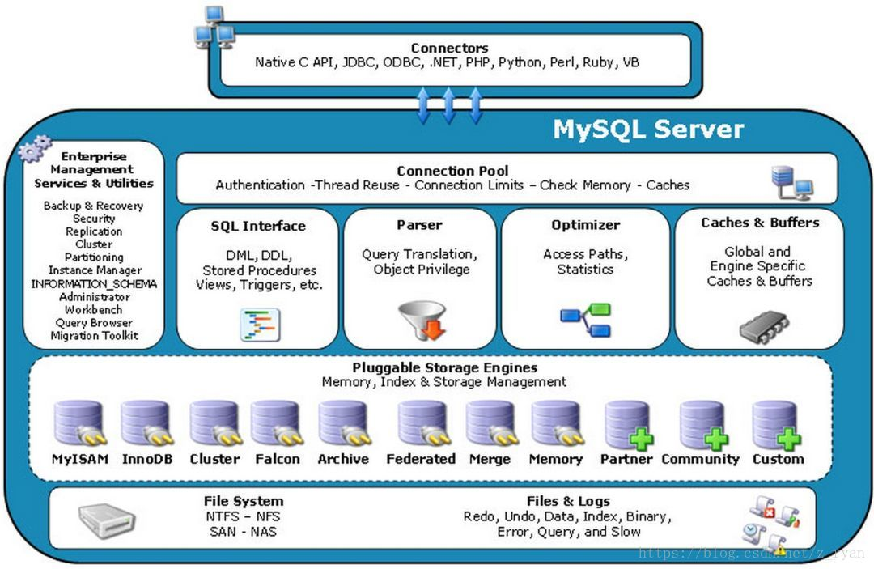

（1）Connectors

（2）Connection Pool

（3）Management Serveices & Utilities

（4）SQL Interface

（5）Parser

（6）Optimizer

（7）Cache & Buffer

（8）Plunggable Storage Engines

（9）File System

（10）Files & Logs

连接层

服务层

引擎层

存储层

和其它数据库相比，Mysql有点与众不同，它的架构可以下多种不同场景中应用并发挥良好作用。主要体现在存储引擎的架构上，插件式的存储引擎架构将查询处理和其它的系统任务以及数据的存储提取相分离。这种架构可以根据业务的需求和实际需要选择合适的存储引擎。

5.Mysql存储引擎
对比项 | MyISAM | InnoDB
主外键 | 不支持 | 支持
事务 | 不支持 | 支持
行表锁 | 表锁，即使操作一条记录也会锁住整个表，不适合高并发操作 | 行锁，操作时只锁某一行，不对其它行有影响，适合高并发的操作
缓存 | 只缓存索引，不缓存真实数据 | 不仅缓存索引还要缓存真实数据，对内存要求较高，而且内存大小对性能有决定性的影响
表空间 | 小 | 大
关注点 | 性能 | 事务
默认安装 | Y | Y

Percona为Mysql数据库服务进行了改进，在功能和性能上较MySQL有这很显著的提升。该版本提升了在高负载情况下的InnoDB的性能，为DBA提供一些非常有用的性能诊断工具：另外有更多的参数和命令来控制服务器行为。
该公司新建了一款存储引擎脚xtradb完全可以替代innodb，并且在性能和并发上做得更好。
阿里巴巴大部分mysql其实使用的是percona的原型加以修改。

二、索引优化分析
1.系统变慢场景
性能下降SQL慢、执行时间长、等待时间长
（1）查询语句写的烂
（2）索引失效
（3）关联查询太多

（4）服务器调优及各个参数设置（缓冲、线程数等）

2.常用的join查询语句
（1）SQL执行顺序
手写和机读的顺序不同。
手写顺序：select+from -->join…on–>where -->group by+ having—>order by–>limit
机读顺序：
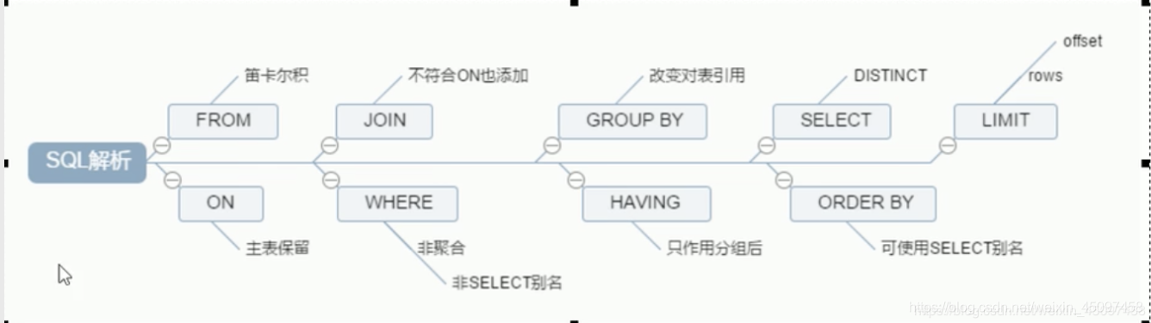

机读顺序和手写顺序的区别？就在于select的位置。在手写顺序的SELECT位于开头，在机读的顺序中SELECT位于GROUP BY之后。
口诀：来自于(from)MySQL的on(on)参加(join)了在InNoDB中(where)的选美，以年龄进行分组(group by)，所有(having)被选拔(select)的以身高进行排序(order by)但同时限制(limit)人数。
（2）jion图

七种JOIN理论
内连接
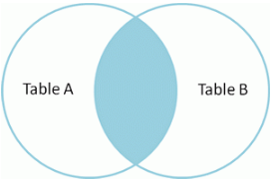

select * from A inner join B where A.key=B.key;

左连接
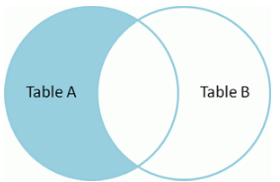

select * from A left join B on A.key=B.key where B.key is null;

右连接
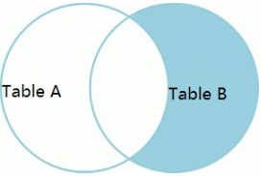

select * from A right join B on A.key=B.key where A.key is null;

左外连接
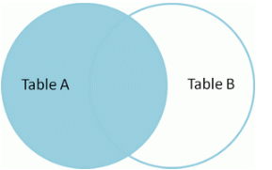

select * from A left join B on A.key=B.key;

右外连接
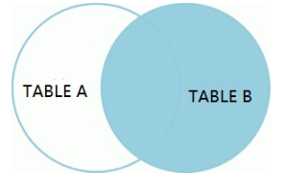
select * from A right join B on A.key=B.key

全外连接
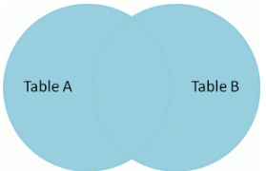

select * from A left join B where A.key=B.key union select * from A right join B where A.key=B.key;

两表独有数据集

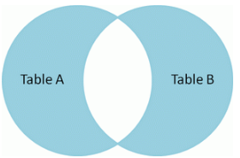

select * from A left join B on A.key=B.key where B.key is null
union
select * from A right join B on A.key=B.key where A.key is null;

（3）见表sql

（4）

3.索引简介
（1）索引是什么？
MySQL对索引的定义为：索引（Index）是帮助MySQL高效获取数据的数据结构
索引的本质：索引是数据结构
索引的目的：提高查询效率，可类比字典
例如如果要查“mysql”这个词，我们需要定位到m字母，然后从上往下找y字母，依次类推。
如果没有索引，那么可能需要从a-z找，会很麻烦。
所以索引可以简单理解为“排好序的快速查找数据结构”。
在数据之外，数据库系统还维护着满足特定查找算法的数据结构，这些数据结构以某种方式引用（指向）数据，这样就可以在这些数据结构上实现高级查找算法。这种数据结构，就是索引。
一般来说，索引本身也很大，不可能全部存储在内存中，因此索引往往以索引文件的方式存储在磁盘中。
我们常说的索引，若没有特别说明，都是指B树（多路搜索树，并不一定是二叉的）结构组织的索引。其中聚集索引，次要索引，覆盖索引，复合索引，前缀索引，唯一索引默认都是使用B+树索引。当然除了B+树这种类型的索引之外，还有哈希索引等。

（2）索引优势和劣势
优势：提高数据检索的效率，降低数据库的IO成本；通过索引列对数据进行排序，降低数据排序的成本，降低了CPU的消耗。
劣势：实际上索引也是一张表，该表保存了主键与索引字段，并指向实体表的记录，所以索引也是要占用空间的；虽然索引大大提高了查询速度，同时却会降低更新表的速度，如对表进行Insert、update和delete，因为更新表的时候，Mysql不仅要保存数据还要保存一下索引文件每次更新添加了索引列的字段，都会调整因为更新所带来的键值变化后的索引信息；索引只是提高效率的一个因素，如果MySQL有大数据量的表，就需要花时间研究建立最优秀的索引，或优化查询

（3）索引分类和建索引命令语句
索引分类
【单值索引】
一个索引只包含单个列，一个表可以有多个单列索引

【唯一索引】
索引列的值必须唯一，但允许有空值

【复合索引】
一个索引包含多个列

【基本语法】
创建索引
create [unique] index indexName on tableName(columnName(length));
修改表结构（添加索引）
alert table tableName add [unique] index [indexName] on (columnName(length));
创建表的时候直接指定
CREATE TABLE mytable(
ID INT NOT NULL,
username VARCHAR(16) NOT NULL,
INDEX [indexName] (username(length))
);
删除索引的语法
drop index [indexName] on tableName;
查看索引
可以通过添加 \G 来格式化输出信息
show index from tableName;\G

（4）索引结构与检索原理
Mysql索引结构 | 描述 | 原理
B树索引
Hash索引
full-text全文索引
R-Tree索引
B+树索引

（5）哪些情况适合建索引
主键自动建立唯一索引；
频繁作为查询条件的字段应该创建索引；
查询中与其他表关联的字段，外键关系建立索引；
频繁更新的字段不适合创建索引-因为每次更新不单单是更新了记录还会更新索引；
where条件里用不到的字段不创建索引；
单键/组合索引的选择，在高并发下倾向创建组合索引；
查询中排序的字段，排序字段若通过索引去访问将大大提高排序速度（索引干两件事，检索和排序，索引本身是有序的）；
查询中统计或者分组字段。

（6）哪些情况不适合建索引
表记录太少；
经常增删改（提高了查询的速度，却会降低更新表的速度，如对表进行insert、update和delete，因为更新表时，mysql不仅要保存数据还要更新保存一下索引文件）；
数据重复且分布平均的表字段，因为应该只为最经常查询和最经常排序的数据列建立索引，注意，如果某个数据列包含许多重复的内容，为它建立索引就没有太大实际的效果；

4.性能分析
（1）Mysql查询优化器
MySQL中有专门负责优化SELECT语句的优化器模块，主要功能：通过计算分析系统中收集到的统计信息，为客户端请求的Query提供它认为最有的执行计划（它认为最有的数据检索方式，但不见得是DBA认为是最优的，这部分最耗费时间）
当客户端向Mysql请求一条Query，命令解析器模块完成请求分类，区别是select并转发给MySQL查询优化器时，MySQL查询优化器首先会对整条Query进行优化，处理掉一些常量表达式的预算，直接换算成常量值。并对Query中的查询条件进行简化和转换，如去掉一些无用或显而易见的条件、结构调整等。然后分析Query中Hint信息（如果有），看显示Hint信息是否可以完全确定该Query的执行计划。如果没有Hint或Hint信息还不足以完全确定执行计划，则会读取所涉及对象的统计信息，根据Query进行写相应的计算分析，然后再得出最后的执行计划。

（2）MySQL常见瓶颈
CPU：CPU在饱和的时候，一般发生在数据装入内存或从磁盘上读取数据的时候
IO: 磁盘I/O瓶颈发生在装入数据远大于内存容量的时候
服务器硬件的性能瓶颈：top，free，iostat和vmstat来查看系统的性能瓶颈

（3）explain命令

5.索引优化

三、查询截取分析
1.查询优化

2.慢查询日志

3.批量数据脚本

4.Show Profile

5.全局查询日志

四、Mysql锁机制
1.概述

2.锁

行锁

表锁

五、主从复制

