|  |
| --- |
| InputRace |

|  |
| --- |
| InputName |

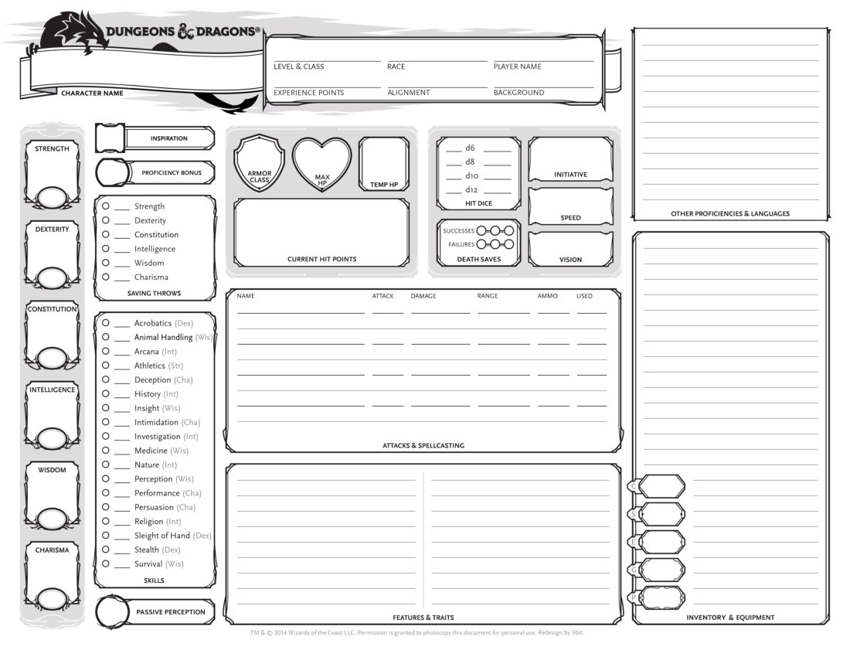

|  |
| --- |
| InputStr |
| InputDex |
| InputCons |
| InputInt |
| InputWis |
| InputCharisma |

InputHp

InputArmor

InputSpeed