Министерство образования и науки Российской Федерации

Федеральное государственное бюджетное образовательное учреждение

высшего образования

**«Пермский национальный исследовательский**

**политехнический университет»**

Кафедра «Информационные технологии и автоматизированные системы»

**О Т Ч Ё Т**

Лабораторная по Деревьям

Дисциплина: основы алгоритмизации и программирования

Семестр 2

Выполнил работу

студент группы ИВТ-22-2б

Кучугова Яна Александровна

Проверил

Доцент кафедры ИТАС

Полякова О.А.

Пермь, 2023

**Постановка задачи для конкретного варианта.**

Построить Дерево

**Код.**

#include <iostream>

#include <functional>

#include <string>

#include <sstream>

#include <SFML/Graphics.hpp>

#pragma comment (lib, "opengl32.lib")

#pragma comment (lib, "glu32.lib")

#pragma comment(lib,"glut32.lib")

using namespace std;

using namespace sf;

const float RAD = 35;

class Tree

{

private:

void add_left(const double& to_add)

{

Tree* new_tree = new Tree;

new_tree->data = to_add;

new_tree->parent = this;

left = new_tree;

++left->size;

}

void add_right(const double& to_add)

{

Tree* new_tree = new Tree;

new_tree->data = to_add;

new_tree->parent = this;

right = new_tree;

++right->size;

}

public:

Tree* parent;

Tree* left;

Tree* right;

int data;

int size;

float x = 500, y = 10;

int state, level = 1;

Tree()

{

parent = nullptr;

left = nullptr;

right = nullptr;

data = 0.0;

size = 0;

}

Tree(double data)

{

parent = nullptr;

left = nullptr;

right = nullptr;

data = data;

size = 1;

}

Tree(const Tree& another_one)

{

parent = another_one.parent;

left = another_one.left;

right = another_one.right;

data = another_one.data;

size = another_one.size;

}

void add(const int& to_add)

{

if (size == 0)

data = to_add;

else if (left == nullptr)

add_left(to_add);

else if (right == nullptr)

add_right(to_add);

else if (right->size < left->size)

right->add(to_add);

else

left->add(to_add);

++size;

}

void add_to_search(const int& to_add)

{

if (size == 0)

{

data = to_add;

size = 1;

}

else

{

if (to_add > data)

{

++size;

if (right == nullptr)

{

Tree* new_tree = new Tree;

new_tree->data = to_add;

new_tree->size = 1;

right = new_tree;

new_tree->parent = this;

}

else

{

right->add_to_search(to_add);

}

}

else if (to_add < data)

{

++size;

if (left == nullptr)

{

Tree* new_tree = new Tree;

new_tree->data = to_add;

new_tree->size = 1;

left = new_tree;

new_tree->parent = this;

}

else

{

left->add_to_search(to_add);

}

}

}

}

void generate()

{

cout << "Введите размер дерева: ";

int count;

cin >> count;

for (int i = 0; i < count; i++)

{

cout << "Введите число для добавления: ";

int to_add;

cin >> to_add;

add(to_add);

}

}

void generate_search()

{

cout << "Введите размер дерева поиска: ";

int count;

cin >> count;

for (int i = 0; i < count; i++)

{

cout << "Введите число для добавления: ";

double to_add;

cin >> to_add;

add_to_search(to_add);

}

}

void for_each(function<void(const int&)> func)

{

if (this != nullptr)

{

func(data);

if (left != nullptr)

left->for_each(func);

if (right != nullptr)

right->for_each(func);

}

}

Tree* convert_into_search()

{

Tree* new_tree = new Tree;

for_each([&](const double& data) { new_tree->add_to_search(data); });

return new_tree;

}

Tree* minimum();

Tree* minimum_search()

{

if (left == nullptr)

return this;

else

return left->minimum_search();

}

void remove()

{

Tree* to_delete = this;

Tree* dad = parent;

if (to_delete->left == nullptr and to_delete->right == nullptr)

del();

else if (to_delete->left == nullptr and to_delete->right != nullptr)

{

to_delete->data = to_delete->right->data;

to_delete->right->remove();

}

else if (to_delete->left != nullptr and to_delete->right == nullptr)

{

to_delete->data = to_delete->left->data;

to_delete->left->remove();

}

else

{

to_delete->data = to_delete->left->data;

to_delete->left->remove();

}

}

void remove_search()

{

Tree* to_delete = this;

Tree* dad = parent;

if (to_delete->left == nullptr and to_delete->right == nullptr)

del();

else if (to_delete->left == nullptr and to_delete->right != nullptr)

{

to_delete->data = to_delete->right->data;

to_delete->right->remove_search();

}

else if (to_delete->left != nullptr and to_delete->right == nullptr)

{

to_delete->data = to_delete->left->data;

to_delete->left->remove_search();

}

else

{

Tree* replacer = to_delete->right->minimum_search();

to_delete->data = replacer->data;

if (replacer == replacer->parent->left)

{

replacer->parent->left = replacer->right;

if (replacer->right != nullptr)

replacer->right->parent = replacer->parent;

}

else

{

replacer->parent->right = replacer->right;

if (replacer->right != nullptr)

replacer->right->parent = replacer->parent;

}

delete replacer;

}

}

Tree* find(const int& data)

{

if (this == nullptr)

return nullptr;

if (this->data == data)

return this;

if (left->find(data) != nullptr)

return left->find(data);

return right->find(data);

}

Tree* find_search(const int& data)

{

if (this == nullptr)

return nullptr;

if (this->data == data)

return this;

if (data > this->data)

return right->find_search(data);

return left->find_search(data);

}

void print_in_console()

{

if (this != nullptr)

{

cout << data << " ";

left->print_in_console();

right->print_in_console();

cout << endl;

}

}

friend ostream& operator<<(ostream& stream, const Tree* start)

{

if (start != nullptr)

{

stream << start->data;

}

return stream;

}

void del()

{

if (this != nullptr)

{

if (left != nullptr)

left->del();

if (right != nullptr)

right->del();

parent->size -= size;

if (this == parent->left)

parent->left = nullptr;

else

parent->right = nullptr;

delete this;

}

}

};

Tree* min_of_three(Tree* mas[3])

{

Tree* min = new Tree;

min = mas[0];

if (mas[1]->data < min->data)

min = mas[1];

if (mas[2]->data < min->data)

min = mas[2];

return min;

}

Tree* Tree::minimum()

{

Tree* mas[3];

mas[0] = this;

if (left != nullptr)

mas[1] = left->minimum();

else

mas[1] = this;

if (right != nullptr)

mas[2] = right->minimum();

else

mas[2] = this;

return min_of_three(mas);

}

int depth;

void count_levels(Tree* root)

{

if (root != nullptr)

{

if (root->parent != nullptr)

root->level = root->parent->level + 1;

if (depth < root->level)

depth = root->level;

count_levels(root->left);

count_levels(root->right);

}

}

void calculate_coords(Tree* node)

{

if (node != nullptr)

{

if (node->parent != nullptr)

{

if (node->level == 2)

node->x = node->x + node->state * (pow(2, depth - 1) / 2) * 40;

else

node->x = node->parent->x + node->state * (pow(2, depth - 1) / pow(2, node->level - 1)) * 40;

node->y = node->parent->y + 80;

}

if (node->left != nullptr)

{

node->left->state = -1;

calculate_coords(node->left);

}

if (node->right != nullptr)

{

node->right->state = 1;

calculate_coords(node->right);

}

}

}

void draw_lines(Tree* node, RenderWindow& window)

{

if (node != nullptr)

{

if (node->parent != nullptr)

{

vector<Vertex> line =

{

Vertex(Vector2f(node->parent->x + RAD, node->parent->y + RAD), Color::Black),

Vertex(Vector2f(node->x + RAD, node->y + RAD), Color::Black)

};

window.draw(&line[0], line.size(), Lines);

}

if (node->left != nullptr)

draw_lines(node->left, window);

if (node->right != nullptr)

draw_lines(node->right, window);

}

}

void draw_nodes(Tree* node, RenderWindow& window)

{

if (node != nullptr)

{

CircleShape circle(RAD);

circle.setPosition(node->x, node->y);

circle.setFillColor(Color::White);

circle.setOutlineColor(Color::Black);

circle.setOutlineThickness(3);

Font font;

font.loadFromFile("ofont.ru_CampusOtl.ttf");

stringstream txt;

txt << node->data;

Text text(txt.str(), font, 35);

text.setPosition(node->x + RAD / 2, node->y + RAD / 2);

text.setFillColor(Color::Black);

window.draw(circle);

window.draw(text);

if (node->left != nullptr)

draw_nodes(node->left, window);

if (node->right != nullptr)

draw_nodes(node->right, window);

}

}

void draw(Tree* tree)

{

RenderWindow MainWindow(VideoMode(1200, 500), "Our tree");

depth = 0;

count_levels(tree);

calculate_coords(tree);

while (MainWindow.isOpen())

{

Event event;

while (MainWindow.pollEvent(event))

{

if (event.type == Event::Closed)

{

MainWindow.close();

break;

}

}

MainWindow.clear(Color::White);

draw_lines(tree, MainWindow);

draw_nodes(tree, MainWindow);

MainWindow.display();

}

}

int main()

{

setlocale(LC_ALL, "RUS");

Tree* bush = new Tree;

bush->generate();

cout << "our tree: " << endl;

draw(bush);

bush->minimum()->remove();

cout << "after removing minimum: " << endl;

draw(bush);

Tree* search_bush = bush->convert_into_search();

cout << "after converting into search tree: " << endl;

draw(search_bush);

search_bush->minimum_search()->remove_search();

cout << "after removing minimum: " << endl;

draw(search_bush);

return 0;

}

**Результаты выполнения программы.**

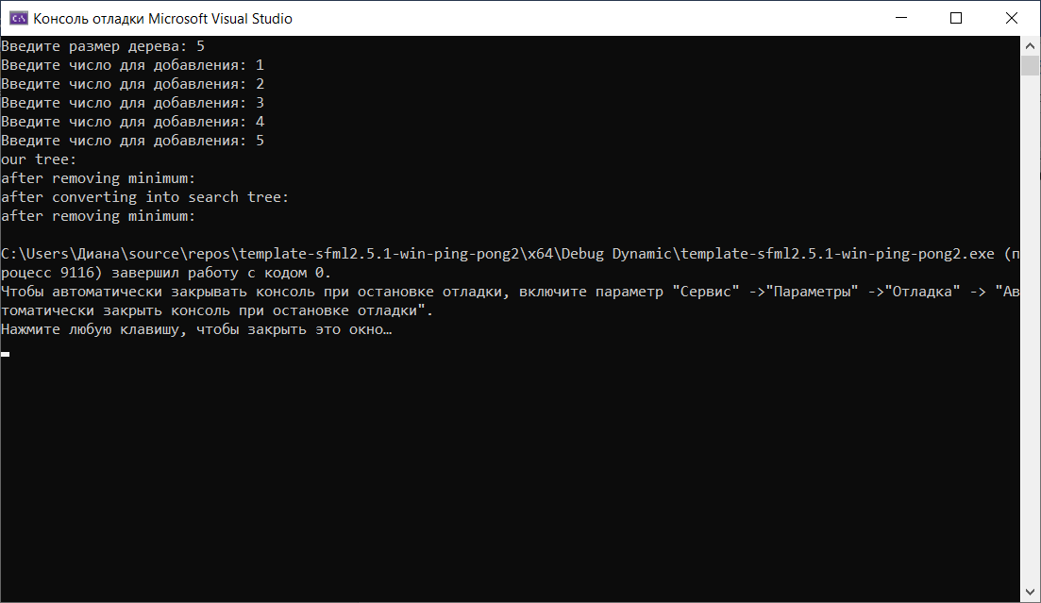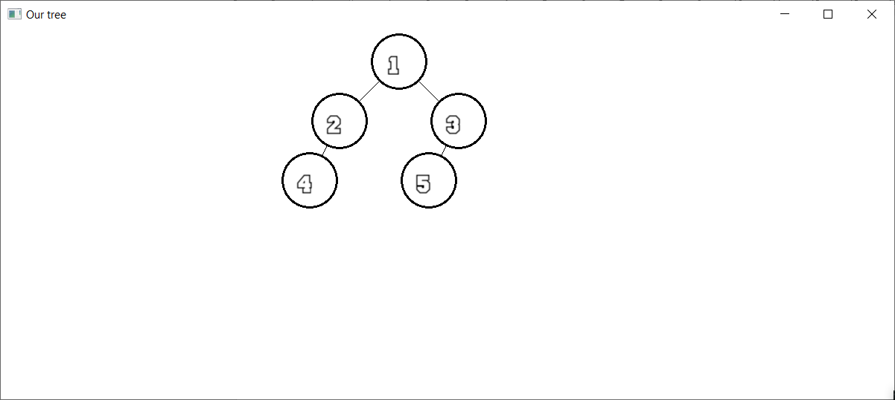

**UML-диаграмма**

