CprE 381 – Computer Organization and

Assembly-Level Programming

Proj-A Report

Lab Partners ______________________________________________

______________________________________________

______________________________________________

Section / Lab Time _________________________

Submit a typeset pdf version of this on Canvas by the due date. Refer to the highlighted language in the Proj-A instructions for the context of the following questions.

- [Part 0] Updated Project Team Contract (if applicable). With your project group members, create a list of best practices / tips for designing, compiling, and testing VHDL modules based on your experiences so far with these labs, both working individually and as a group.

- [Part 1 (a)] Draw a schematic for a 1-bit ALU that supports the following operations: add/sub (both signed and unsigned), slt, and, or, xor, nand, and nor. What are the inputs and outputs that are needed?

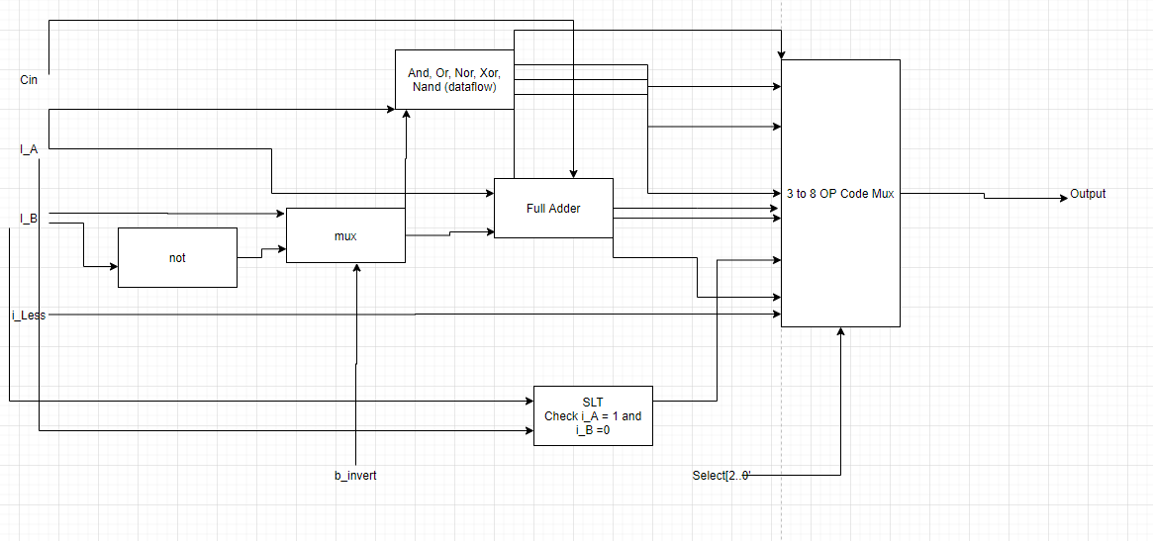

- [Part 1 (b)] In your project writeup, describe your design in terms of the VHDL coding style you chose and the control signals that are required.
Inputs: Cin, i_A, i_B, OpCodeSelectBit, B_invertSelectBit, and i_less.
Outputs: Output

Control signals would be the 3 bit op code selector and the b_invert selector. The coding style for the 1-bit ALU was dataflow as that seemed to be the easiest way to implement all the gates.

- [Part 1 (c)] Describe how the execution of the different operations corresponds to the Modelsim waveforms in your writeup.

- [Part 2 (a)] Draw a simplified schematic for this 32-bit ALU. Consider the following questions: how is Overflow calculated? How is Zero calculated? How is slt implemented?
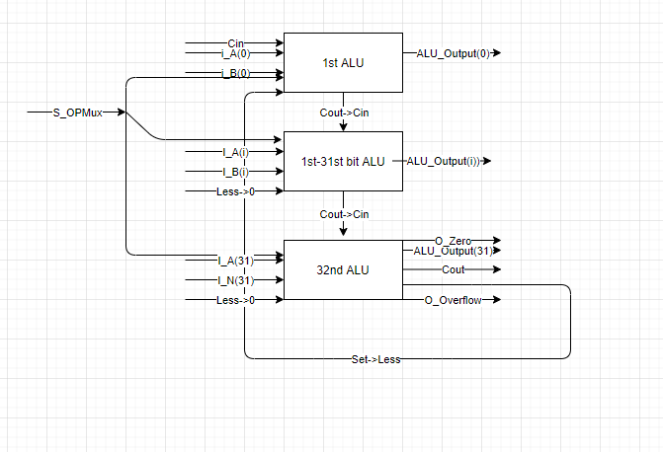
Overflow is calculated by xor 31st Cin and 31st Cout, Zero is calculated by nor’ing all the results and seeing if they all are 1’s, slt is a subtration
- [Part 2 (b)] In your writeup, describe what challenges (if any) you faced in implementing this module.
The difficulty was figuring how to set it up so that there was no loose wiring. This required separate alu’s for the 31st alu. Also, in our original our alu requires more inputs, but our 32 bit ALU only has 3 inputs. This resulted in 2 inputs having to be removed and I had to figure out how to implement them indirectly.

- [Part 2 (c)] Describe how the execution of the different operations corresponds to the Modelsim waveforms in your writeup.

- [Part 3 (a)] Describe the difference between logical (srl) and arithmetic (sra) shifts. Why does MIPS not have a sla instruction?

- [Part 3 (b)] In your writeup, briefly describe how your VHDL code implements both the arithmetic and logical shifting operations.

- [Part 3 (c)] In your writeup, explain how the right barrel shifter from part b) can be enhanced to also support left shifting operations.

- [Part 3 (d)] Describe how the execution of the different shifting operations corresponds to the Modelsim waveforms in your writeup.
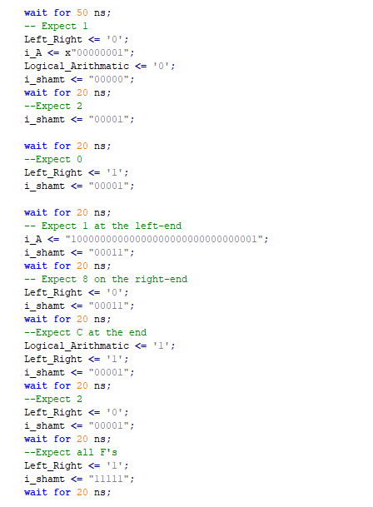
This is a small part of the tb, but it shows what the expected value based on the command. For example, shifting right 00001 to the left 1 would give us 00010 which is 2. Shifting a 00001 to the right by would give us 0 as it removes the bit from the sequence. Where I test the Logical_Arithmatic is near the bottom. For the expect C at the end makes sense as the byte 1000 turns to 1100 which is C in hex. Shift left arithmetic doesn’t do much as it wouldn’t copy the signed bit to the left as there’s no room.

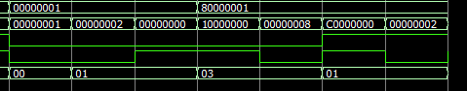
The difficulty of the barrel shifter is shifting its values to the right an extensive amount. Because of this, I tested shift right left and arithmetic by the 11111 or the max shift amount to see if it properly shifted and it did. I did this for all possible combos such as shift left, shift right, shift left + arithmetic, shift right + arithmetic. I even tested if shift amount was 0 if it still didn’t shift any amount and that worked as well. That was in the my 1st waveform.

- [Part 4(b)] Justify why your test plan is comprehensive. Include waveforms that demonstrate your test program is functioning.

- [Part 5(c) BONUS] Justify why your test plan is comprehensive. Include waveforms that demonstrate your test program is functioning.

- [Feedback] You must complete this section for your lab to be graded. Please complete each column separately for each team member; I expect it to take roughly 10 minutes (do not take more than 20 minutes).

  - How many hours did you spend on this lab?

Task | During lab time |  |  | Outside of lab time
Team Initials
Reading lab
Pencil/paper design
VHDL design
Assembly coding
Simulation
Debugging
Report writing
Other:
Total

  - If you could change one thing about the lab experience, what would it be? Why?

  - What was the most interesting part of the lab?

