CprE 381 – Computer Organization and

Assembly-Level Programming

Proj-B Report

Lab Partners David Quan

Curt Lengemann

______________________________________________

Section / Lab Time 1, Thursday 8:00 am

Submit a typeset pdf version of this on Canvas by the due date. Refer to the highlighted language in the Proj-B instructions for the context of the following questions.

- [Part 0] How are instruction and data memory initialized in the simulation? How does MARS interface with ModelSim?

The assembly code is compiled and ran on MARS. MARS will generate the hex files needed for the instruction and data memory for the Modelsim simulation. This is imported into Modelsim using the command to load a hex file into memory like we have been doing since lab 4.

- [Part 0] In the MIPS skeleton VHDL, how is a halting / termination condition detected? What MIPS assembly instruction does this correspond to?

When a syscall is detected and when $v0 (register 2) is set to 10 then the program should halt. This corresponds to a 6 0’s for a syscall opcode instruction, function call is 12, and $v0 is 10 then it halts the program.

- [Part 1 (a)] Modify the provided spreadsheet to include the list of M instructions to be supported in this phase alongside their binary Instruction OPcodes and Funct fields, if applicable. Create a separate column for each binary bit. Inside this spreadsheet, create a new column for the N control signals needed in your single-cycle processor implementation. The end result should be an M*N table where each row corresponds to the output of the control logic module for a given instruction. [You can attach the spreadsheet as a separate file, with a single spreadsheet for all Phase I and Phase II instructions.]

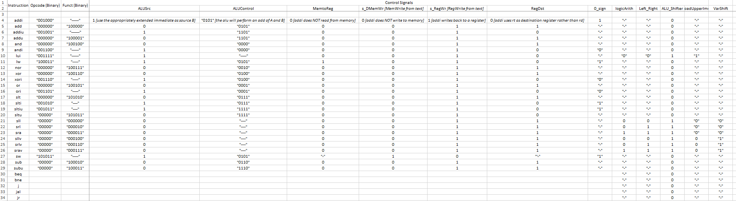
- [Part 1 (b)] Implement the control logic module using whatever method and coding style you prefer. Create a testbench to test this module individually, and show that your output matches the expected control signals from part 1a). [Please include waveforms and explanations.]
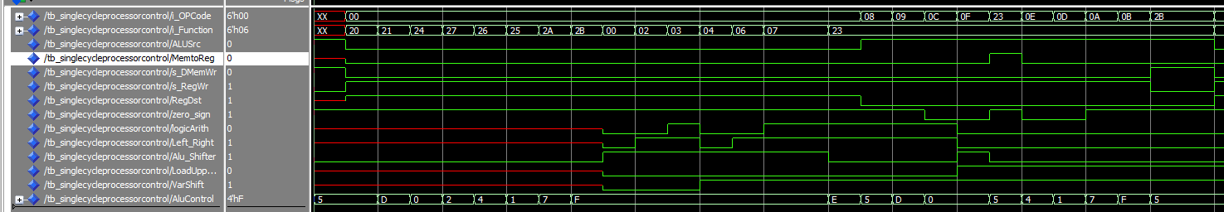
These waves correspond to our excel sheet. The order is in R-Type instructions -> different OPCodes. For example, the 1st one is OpCode 0 (R-Type) and i_Function 20 which is 32 in binary. This would be add and the signals follow our excel documentation.

- [Part 2] In your writeup, provide your schematic for this part, describe what challenges (if any) you faced in implementing this module.

This is Phase 1 Sketch. We had trouble with making sure that when reset was enabled that it wouldn’t write to register.

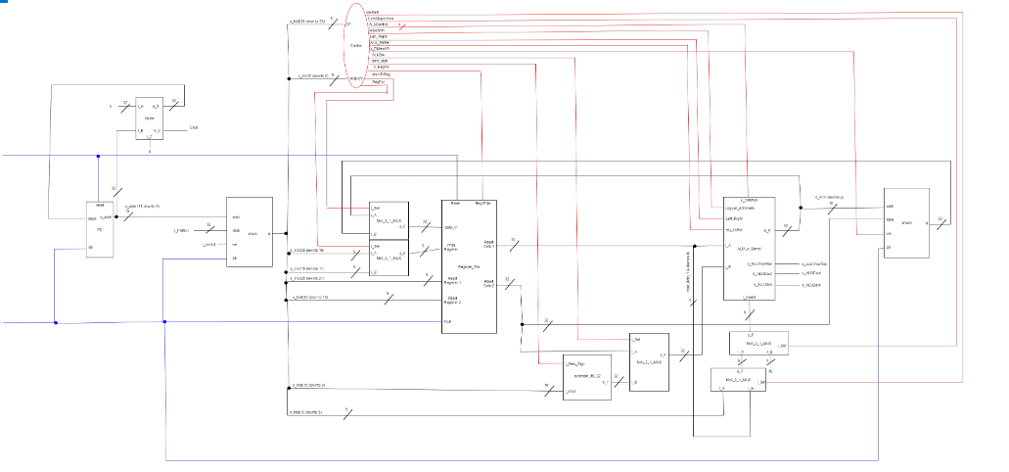

- [Part 4 (a)] Describe these possibilities as a function of the different control flow-related instructions.

- [Part 4(b)]

Waveform for Jr :

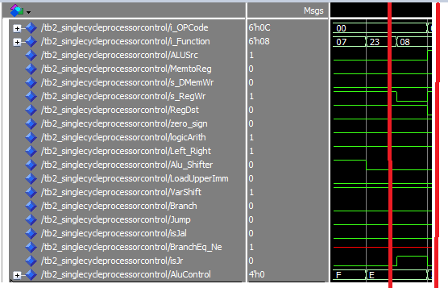
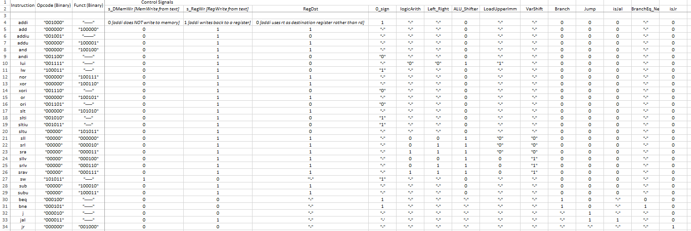
Control logic:

Our jr waveform matches our excel documentation.

Waveform for beq 04, bne 05, j 02, and jal 03. They also match our above excel sheet.
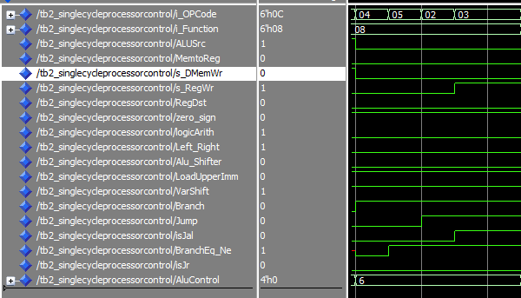

- [Part 4 (c)] Update your processor schematic for the instruction fetch logic and any other datapath modifications needed for control flow instructions. In your writeup, describe what additional control signals are needed.

We added these control logic
VarShift | Branch | Jump | isJal | BranchEq_Ne | isJr

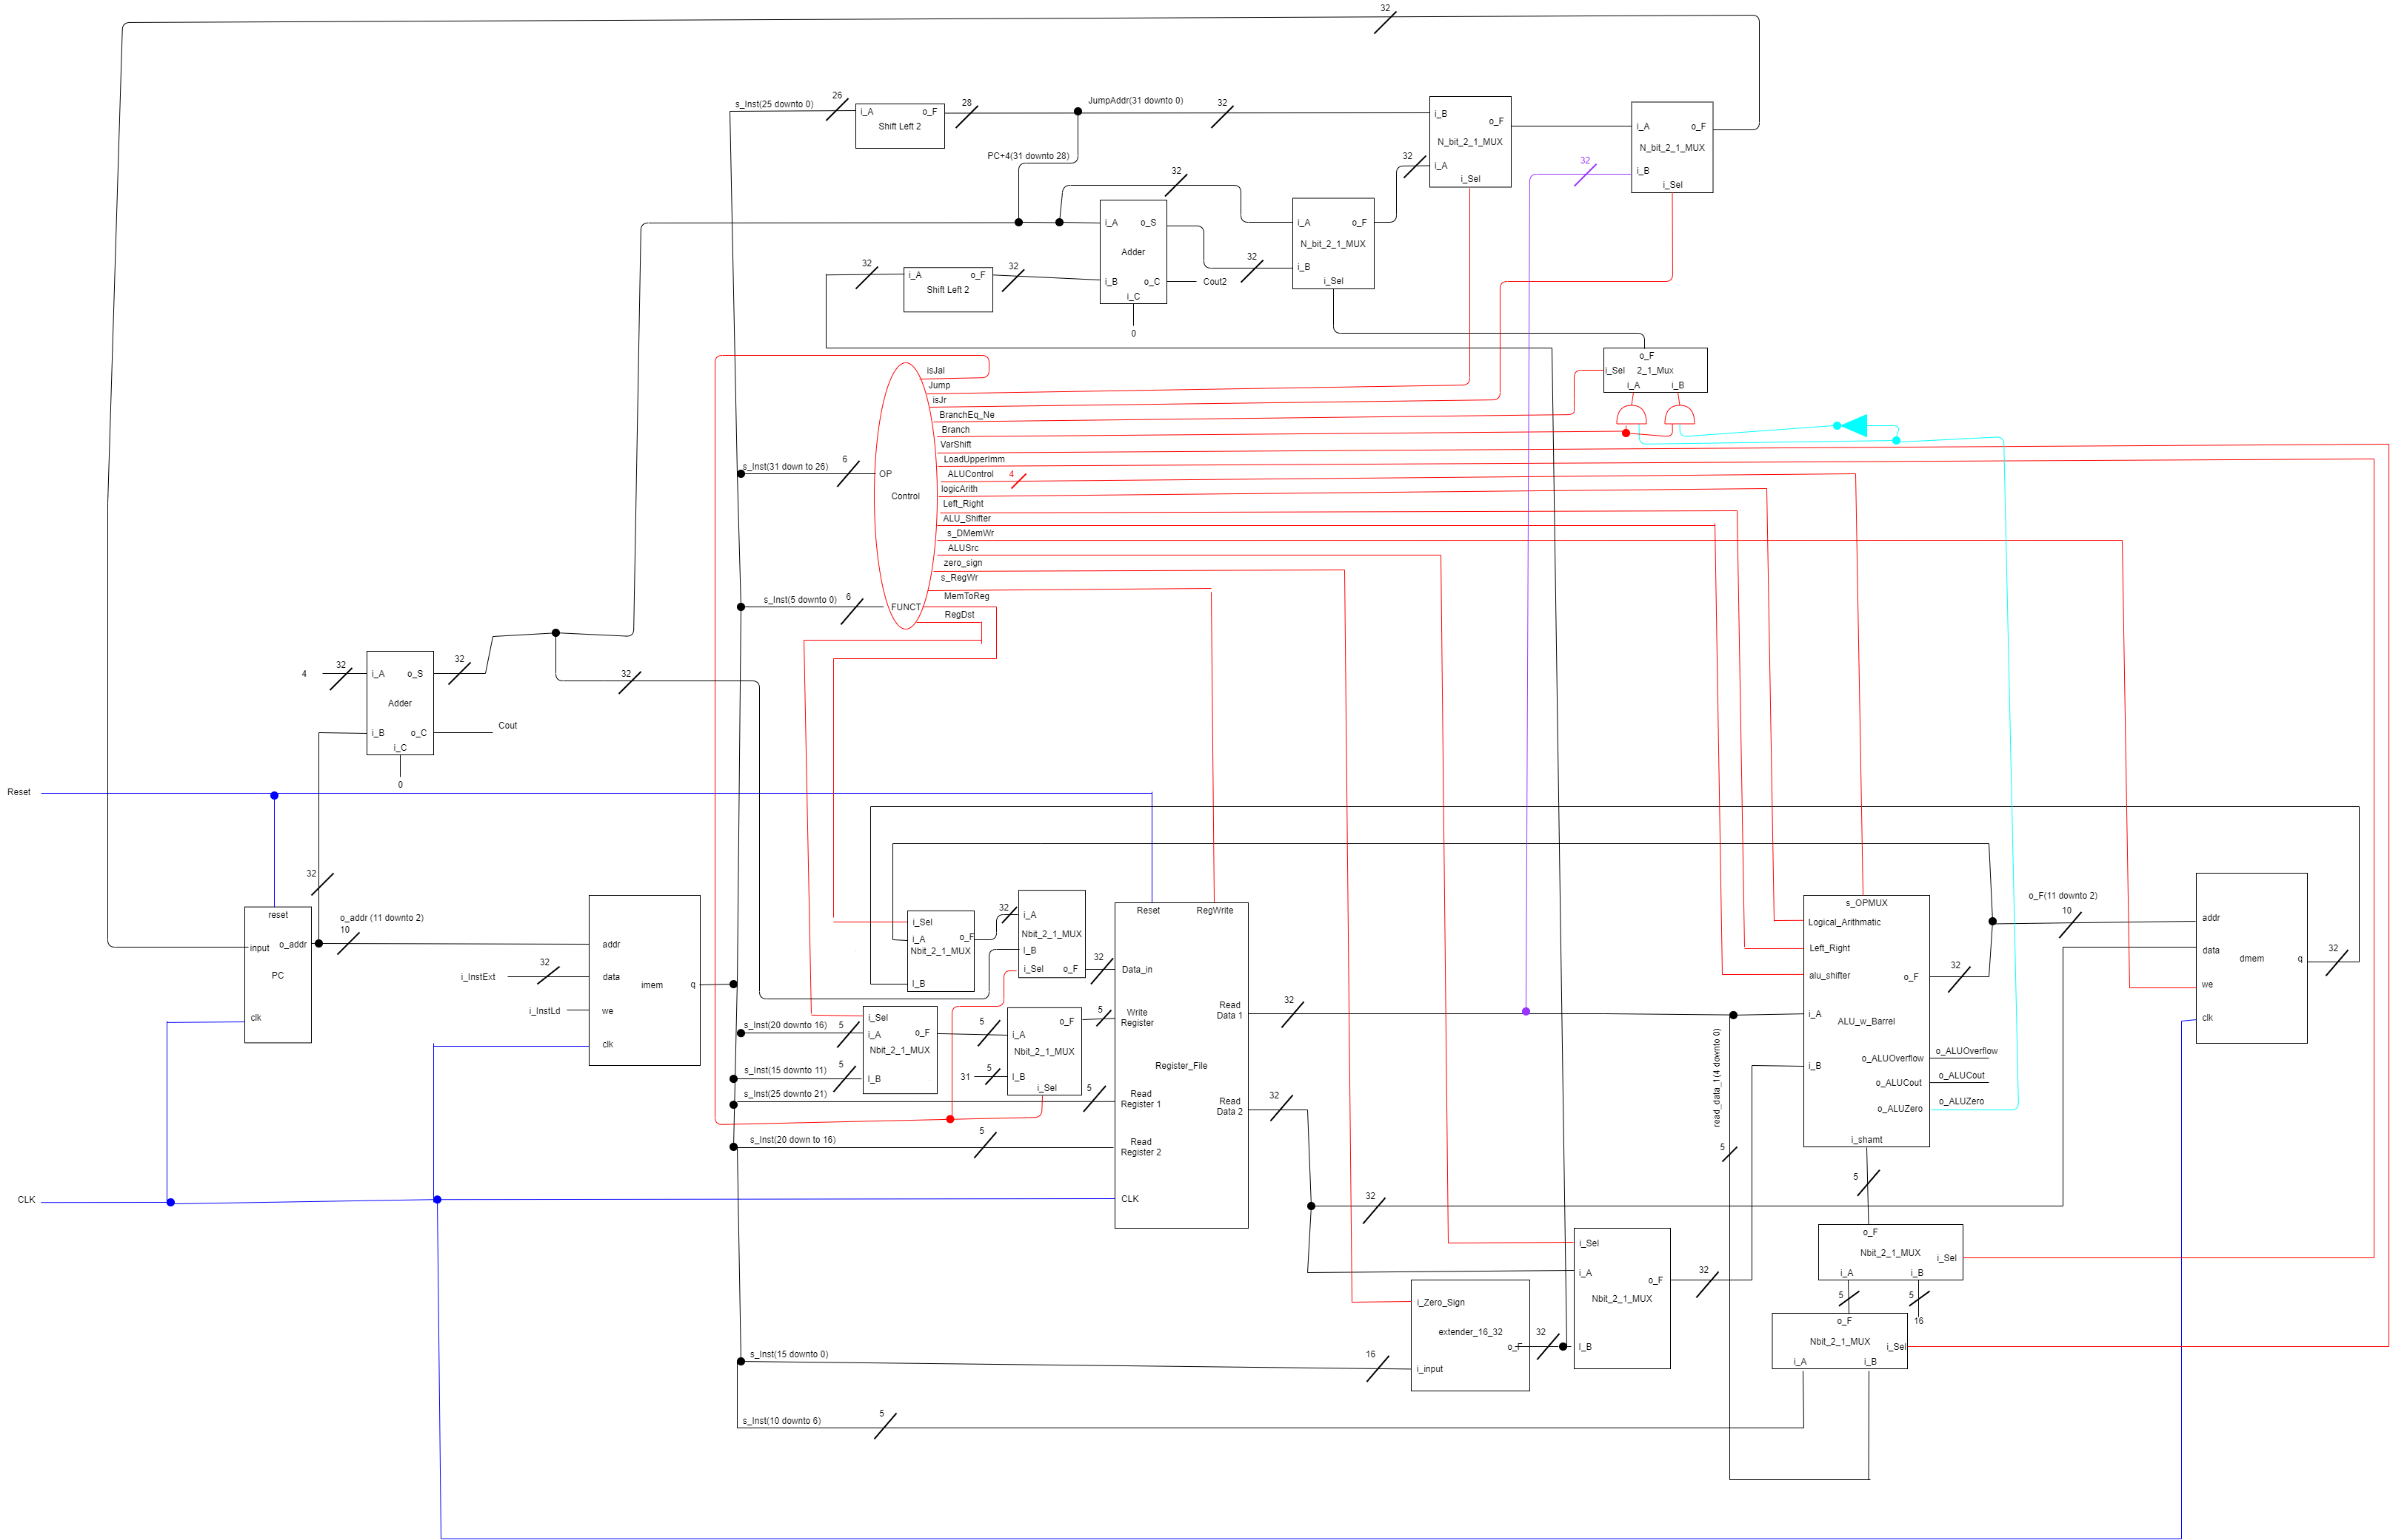
- [Part 4 (d)] Include ModelSim waveforms, and describe how the execution of the control flow possibilities corresponds to the waveforms in your writeup.
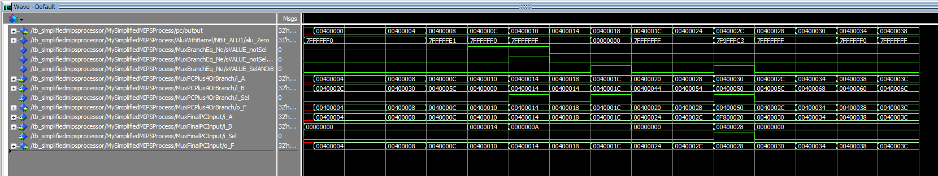
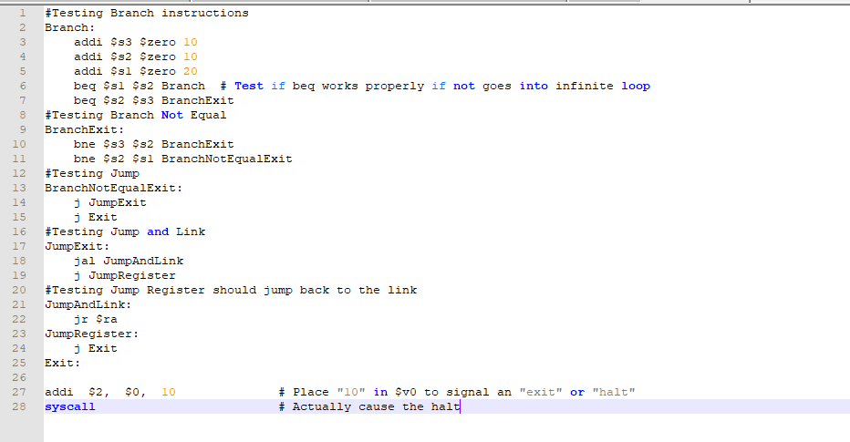
For the branch instructions you can see that alu_zero is a number that results in pc changing which is indicitave of a branch instruction working properly.

- [Part 5 (a)] In your writeup, show the ModelSim output for the individual instruction tests, and provide a discussion of result correctness. It may be helpful to also annotate the waveforms directly.
MIPS Program

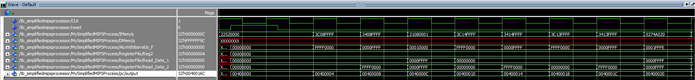
These are the overflow cases for add/addi this makes sense as it converts it to a lui and a ori instruction for a big number.
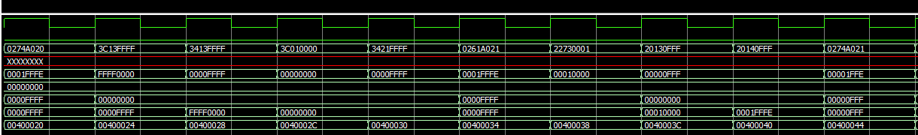
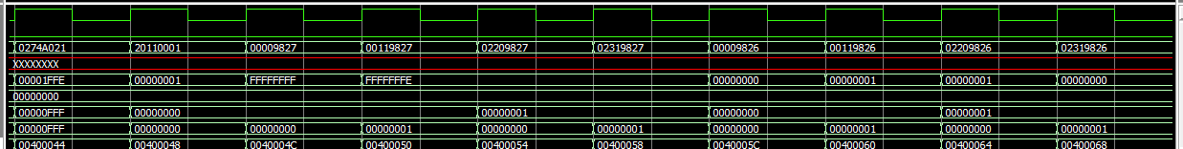
This is the start of the basic logic gates in order xor or and andi xori ori these makes sense as the output matches those basic logic gates.
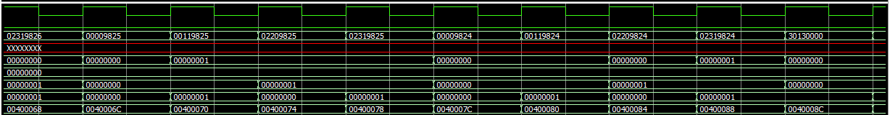
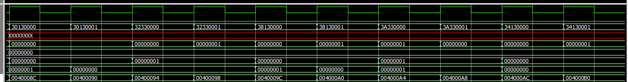
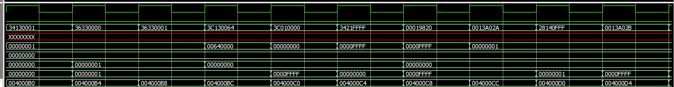
This is where our slt slti sltu and sltiu start at the 000FFFF this makes sense as it ouputs 1 only when slt is executed
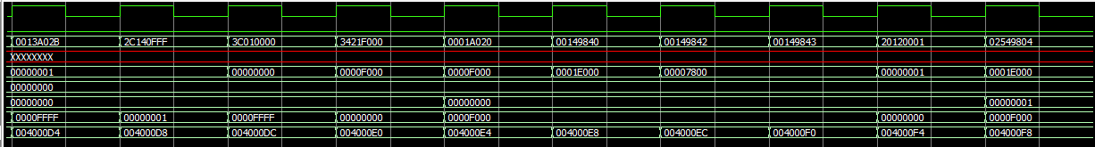
This is the start of shift instructions this output makes sense as F000 shifting left equals 1E000.
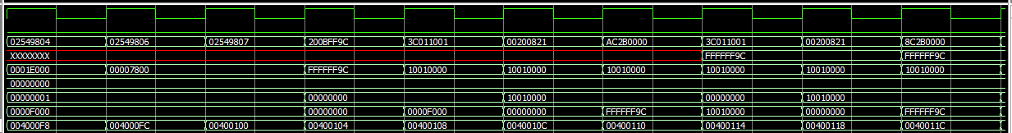
This is where sw works and it stores it into memory like it should. It outputs FFFFFF9C when lw is executed.
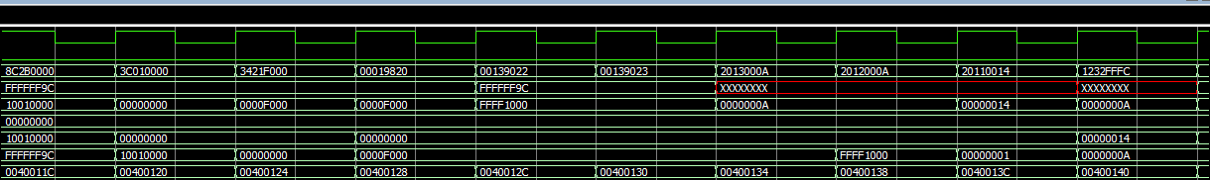
This is where sub is executes with 0 and F000 which gives us FFFF1000 which is expected.
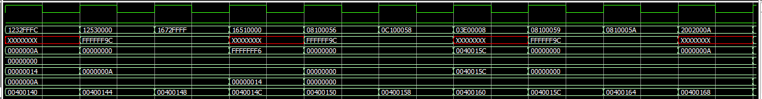
These are the branch and jump instructions that jumps the pc counter to values other than pc+4 which should happen for these instructions if jump executes
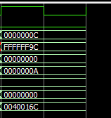
TB2.asm is what we ran.

- [Part 5 (b)] In your writeup, show the ModelSim output for the Bubblesort test, and provide a discussion of result correctness. It may be helpful to also annotate the waveforms directly.

- [Part 5 (c) BONUS] In your writeup, show the ModelSim output for the Mergesort test, and provide a discussion of result correctness. It may be helpful to also annotate the waveforms directly.

- [Part 7] Report the maximum frequency your processor can run at and determine what your critical path is. Draw this critical path on top of your top-level schematic. In your writeup, briefly discuss your critical path results. What components would you focus on to improve the frequency?

- [Feedback] You must complete this section for your lab to be graded. Please complete each column separately for each team member; I expect it to take roughly 10 minutes (do not take more than 20 minutes).

  - How many hours did you spend on this lab?

Task | During lab time |  |  | Outside of lab time
Team Initials
Reading lab
Pencil/paper design
VHDL design
Assembly coding
Simulation
Debugging
Report writing
Other:
Total

  - If you could change one thing about the lab experience, what would it be? Why?

  - What was the most interesting part of the lab?

