Homework 5

Danara flores

2024-11-18

homicides<- read.csv("/Users/danaraflores/Desktop/R programing 535/Homework 5/hw 5/data/homicide-data.csv")  
city_homicides <- homicides %>%  
 filter(city == "Baltimore")%>%  
 mutate( reported_date = ymd(reported_date),  
 month = month(reported_date),  
 year = year(reported_date),  
 year_mon = paste(year,month, sep = "-"))

MD_homs<- city_homicides %>%   
 group_by(year,month, year_mon) %>%  
 summarize(total = n(), .groups = "drop") %>%   
 mutate(year_mon = ym(year_mon),   
 season = if_else(month >= 5 & month <= 10, "Summer", "Winter"),   
 season = fct_relevel(season, c("Summer", "Winter")))

#work with Plot  
plot1<- ggplot( data = MD_homs)+  
 geom_bar(aes(x= year_mon, weight = total, fill= season))+   
 geom_smooth(aes(x = year_mon, y = total), color = "blue")+  
 scale_fill_manual(name = " ", values = c("Winter" = "slategray1",  
 "Summer" = "gray87"))+  
 theme_dark()+  
 ggtitle("Homicides in Baltimore, MD")+  
 xlab("Date")+  
 ylab("Monthly homicides")

freddie<-city_homicides %>%   
 filter(victim_last == "GREY") %>% #all the grays with an A are not freddie, has to use grey with E  
 mutate(date_arrest = as.Date(reported_date))  
  
#helped find the arrest date or reported date to be 2015- 04 -30. ymd

Freddie_plot<- ggplot( data = MD_homs)+  
 geom_bar(aes(x= year_mon, weight = total, fill= season))+   
 geom_smooth(aes(x = year_mon, y = total), color = "blue",span = 0.1)+   
 scale_fill_manual(name = " ", values = c("Winter" = "slategray1",  
 "Summer" = "gray87"))+   
 theme_dark()+  
 ggtitle("Homicides in Baltimore, MD")+  
 xlab("Date")+  
 ylab("Monthly homicides")+  
 geom_vline(xintercept = as.Date(freddie$date_arrest), color = "red", linetype = 2, size = 2)+  
 annotate("text",x = as.Date(freddie$date_arrest), y = 35, label = "Arrest of Freddie Grey", color = "white", hjust =1.05, size = 6) +  
 theme(legend.position = "bottom")  
  
print(Freddie_plot)

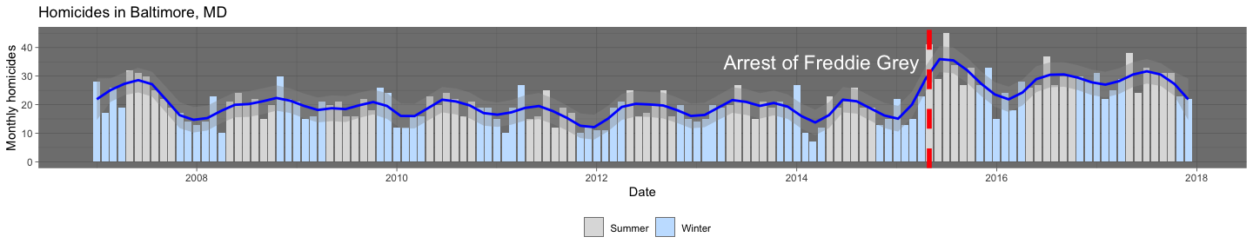

ggsave(filename = "HW_Homicides in Baltimore, MD.pdf", plot = Freddie_plot, path = "/Users/danaraflores/Desktop/R programing 535/Homework 5/hw 5/writing", width = 15, height = 4)