Problem 4. (15%) Consider the software testing process.  
(a) (5%) Explain what are system testing and acceptance testing.  
(b) (5%) Describe the differences between the white-box and black-box testing and

explain why they complement each other.  
(c) (5%) Draw the V-model which shows the development and testing activities

together in the software process?

(a)

**System testing**, where some or all of the components in a system are integrated and the system is tested as a whole. System testing should focus on testing component interactions

系統測試，系統中部份或全部的元件整合在一起，系統測試著重於測試元件整合

(維基百科)

**System testing** is testing conducted on a complete integrated system to evaluate the system's compliance with its specified [requirements](https://en.wikipedia.org/wiki/Requirements)

系統測試是在完整的整合測試上進行測試，以評估系統是否符合其指定需求

(精細版)

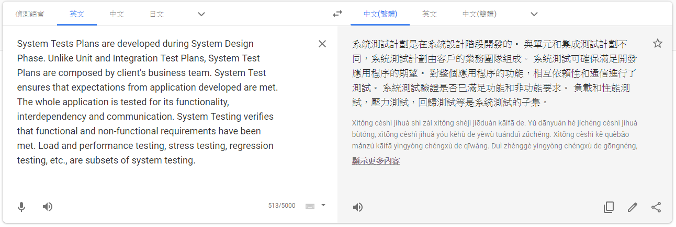

**Acceptance testing**

Customers test a system to decide whether or not it is ready to be accepted from the system developers and deployed in the customer environment. Primarily for custom systems

客戶測試一個系統以確認是否已準備好從系統開發人員接受並部屬在客戶環境中，主要用於定義系統

The acceptance testing process

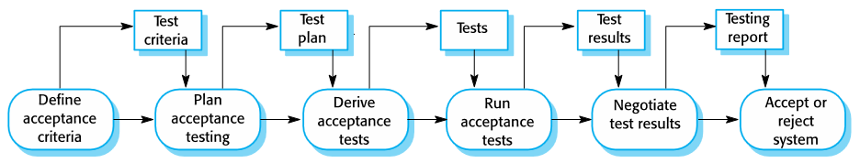

(b)

白箱測試技術：測試案例的設計是依靠程式設計與程式碼資訊

黑箱測試技術：測試案例的設計是依靠系統的輸入與輸出行為資訊

白箱測試(White-box testing)，又稱為結構測試(Structural testing)

依據程式碼內部結構資訊設計測試案例

• 根據程式碼判斷條件或迴圈，定義邏輯路徑，產生測試案例資料

優點：可有效測試程式細節，確保程式的穩定性

• 對程式結構或資料變數使用的錯誤特別有效

缺點：成本高、對需求規格錯誤的效果不好、對介面錯誤的效果不好

黑箱測試(Black-box testing)，又稱為功能測試(Functional testing)

依據軟體產品需求功能設計測試案例

• 不考慮軟體內部邏輯的結構，測試軟體界面，正確輸入、輸出

優點：可有效測試軟體功能是否符合需求或規格，不須具備程式碼結構知識

缺點：對程式細節的測試，如執行路徑、資料結構、條件判斷等，效果不好

(c)

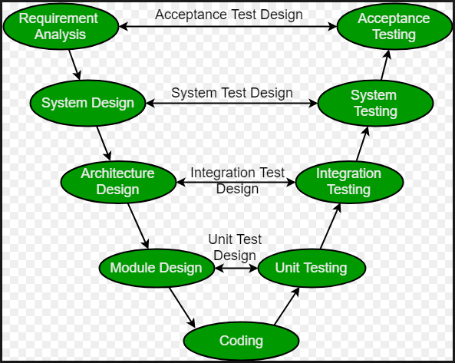

Testing can only show the presence of errors in a program. It cannot demonstrate that there are no remaining faults.

測試只能顯示程序中是否存在錯誤。 它無法證明沒有剩餘的故障。

Development testing is the responsibility of the software development team. A separate team should be responsible for testing a system before it is released to customers.

開發測試是軟件開發團隊的責任。 在將系統發布給客戶之前，應該由一個單獨的團隊負責測試系統。

Development testing includes unit testing, in which you test individual objects and methods component testing in which you test related groups of objects and system testing, in which you test partial or complete systems.

開發測試包括單元測試，您可以在其中測試單個對象和方法組件測試，在其中測試相關的對象組和系統測試，您可以在其中測試部分或完整系統。

When testing software, you should try to ‘break’ the software by using experience and guidelines to choose types of test case that have been effective in discovering defects in other systems.

在測試軟件時，您應該嘗試通過使用經驗和指南來“破解”軟件，以選擇在發現其他系統中的缺陷方面有效的測試案例類型。

Wherever possible, you should write automated tests. The tests are embedded in a program that can be run every time a change is made to a system.

只要有可能，您應該編寫自動化測試。 測試嵌入在每次對系統進行更改時都可以運行的程序中。

Test-first development is an approach to development where tests are written before the code to be tested.

測試優先開發是一種開發方法，其中測試在要測試的代碼之前編寫。

Scenario testing involves inventing a typical usage scenario and using this to derive test cases.

場景測試涉及發明典型的使用場景並使用它來指派測試案例。

Acceptance testing is a user testing process where the aim is to decide if the software is good enough to be deployed and used in its operational environment.

驗收測試是一個用戶測試過程，其目的是確定軟件是否足以在其操作環境中部署和使用。