**Lab 4 Report**

謝狄烽

110598087

2022/05/09

**Table of Content**

**1** **Test Plan** - 1 -

**1.1** **Summary/Scope** - 1 -

**1.2** **Features to be tested** - 2 -

**1.3** **Success criteria of completing the test** - 2 -

**1.4** **Test environment and/or infrastructure** - 2 -

**1.5** **Test approaches** - 3 -

**1.6** **Testing tasks** - 3 -

**2** **Test Design** - 3 -

**3** **Test Implementation** - 4 -

**4** **Test Results** - 5 -

1. **Test Plan**
   1. **Summary/Scope**

KeystoneJS網站提供以下功能：

* Post Features

1. Create a post on the Admin UI page
2. Edit a post on the Admin UI page
3. Delete a post on the Admin UI page
4. Search posts by keyword on the Admin UI page

* Comment Features

1. Create a comment on Admin UI page
2. Edit a comment on Admin UI page
3. Delete a comment on Admin UI page

* Category Features

1. Create a category on Admin UI page
2. Show posts of the specific category by pressing category name on the "Blog" page

* Enquiries Feature

1. Create an enquiry on the "Contact" page
2. Delete an enquiry on Admin UI page

* User Feature

1. Create a new user on Admin UI page (Name, Email, Phone, and Password must be set when creating the new user)

本次的測試目標為KeystoneJS網站提供之功能，並根據網站功能設計測試案例。

* 1. **Features to be tested**

根據KeystoneJS網站提供之功能，以下將提出8項待測試之功能：

* Post Features

1. Create a post on the Admin UI page
2. Edit a post on the Admin UI page
3. Delete a post on the Admin UI page
4. Search posts by keyword on the Admin UI page

* Comment Features

1. Create a comment on Admin UI page
2. Edit a comment on Admin UI page
3. Delete a comment on Admin UI page

* User Feature

1. Create a new user on Admin UI page (Name, Email, Phone, and Password must be set when creating the new user)
   1. **Success criteria of completing the test**
2. 所有根據測試需求設計的測試案例都須通過
3. 程式在測試過程中不可以發生任何一次網站異常現象或網站錯誤，如：找不到頁面、網站導向錯誤網址、網站關閉、崩潰
4. 一個功能在經過所有測試案例過後所觸發的使用者介面錯誤不可以超過2個，如：UI物件未出現
   1. **Test environment and/or infrastructure**

測試環境、工具，以及其版本如下所列：

1. Windows 10 64bit
2. Google Chrome 102.0.5005.63 (正式版本) (64 位元)
3. Selenium IDE 3.17.2
4. Keystone 4
   1. **Test approaches**
5. 根據網站所提供之功能，以及其功能之操作流程定義CFG，定義之CFG將置於網頁：<https://fanatical-pigeon-711.notion.site/Software-Testing-Lab4-CFG-128e85b1bba241528cc55d9c08dd5bf5>
6. 對可以輸入的功能採用ISP方式設計輸入資料
7. 採用Basis Path Coverage和Each Choice Criterion的方式進行測試
   1. **Testing tasks**

|  |  |  |  |
| --- | --- | --- | --- |
| **No.** | **Activity Name** | **Plan hours** | **Schedule Date** |
| 1 | 架設Docker環境 | 1 | 2022/06/01 |
| 2 | 熟悉Docker Desktop使用 | 1 | 2022/06/01 |
| 3 | 熟悉KeystoneJS功能 | 1 | 2022/06/02 |
| 4 | 設計CFG | 1 | 2022/06/03 |
| 5 | 設計ISP | 1 | 2022/06/03 |
| 6 | 實作測試案例 | 1 | 2022/06/04 |
| 7 | 完成Lab4報告 | 1 | 2022/06/05 |

1. **Test Design**

Test Case設計之細節以及所有測試項目皆列於檔案110598087_Lab4.xlsx內

1. **Test Implementation**

此處列出3項測試案例之實作，其餘實作存於Lab4/Test_Implementation內

1. *testCreateNewPost*

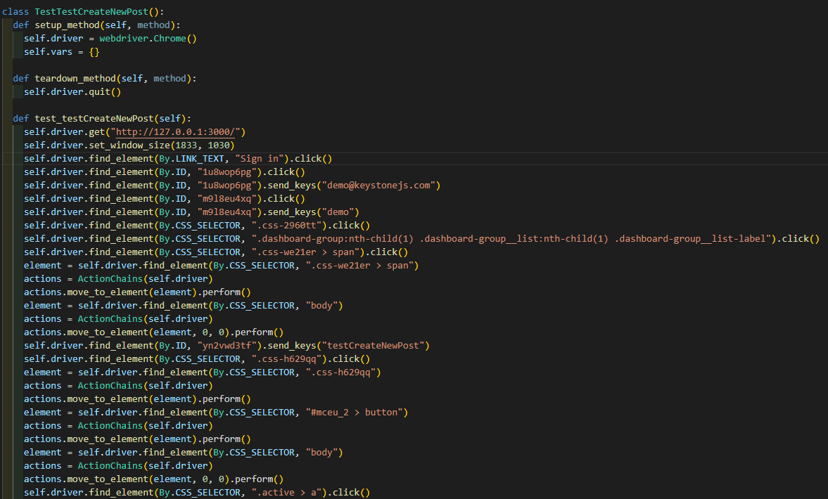

1. *testCreateNewComment*

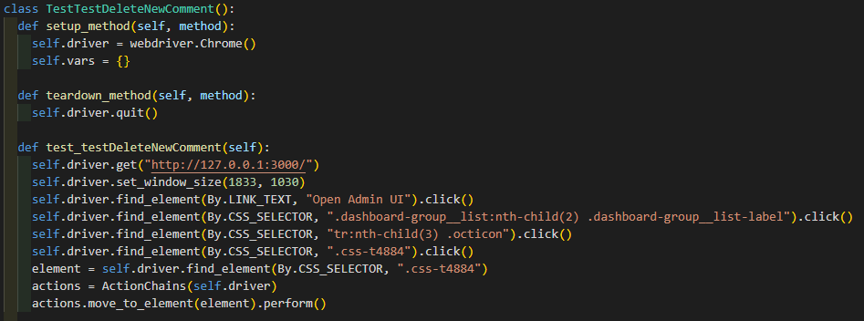

1. *testCreateNewUser*

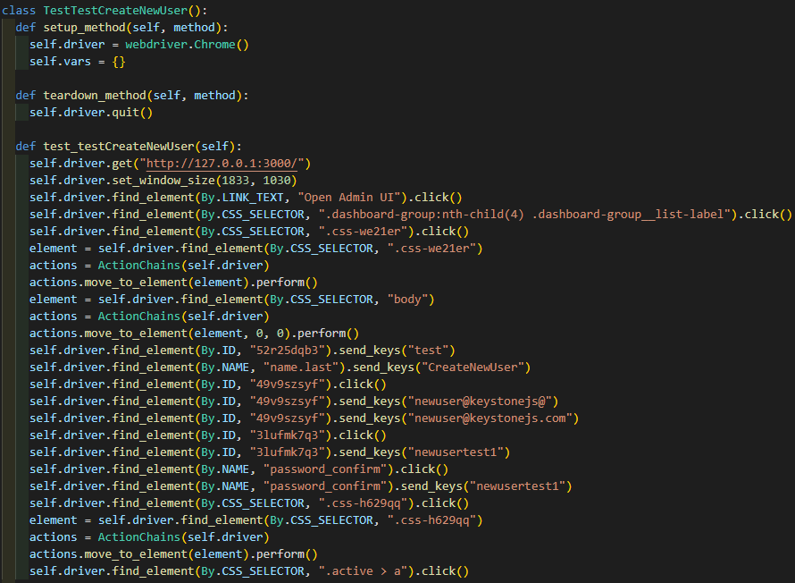

1. **Test Results**

