**Lab 5 Report**

謝狄烽

110598087

2022/06/17

**Table of Content**

**1** **Test Plan** - 1 -

**1.1** **Summary/Scope** - 1 -

**1.2** **Features to be tested** - 2 -

**1.3** **Success criteria of completing the test** - 2 -

**1.4** **Test environment and/or infrastructure** - 3 -

**1.5** **Test approaches** - 3 -

**1.6** **Testing tasks** - 3 -

**2** **Test Design** - 4 -

**3** **Test Implementation** - 4 -

**4** **Test Results** - 7 -

1. **Test Plan**
   1. **Summary/Scope**

KeystoneJS網站提供以下功能：

* Post Features

1. Create a post on the Admin UI page
2. Edit a post on the Admin UI page
3. Delete a post on the Admin UI page
4. Search posts by keyword on the Admin UI page

* Comment Features

1. Create a comment on Admin UI page
2. Edit a comment on Admin UI page
3. Delete a comment on Admin UI page

* Category Features

1. Create a category on Admin UI page
2. Show posts of the specific category by pressing category name on the "Blog" page

* Enquiries Feature

1. Create an enquiry on the "Contact" page
2. Delete an enquiry on Admin UI page

* User Feature

1. Create a new user on Admin UI page (Name, Email, Phone, and Password must be set when creating the new user)

本次的測試目標為KeystoneJS網站提供之功能，並根據網站功能設計測試案例。

* 1. **Features to be tested**

根據KeystoneJS網站提供之功能，以下將提出10項待測試之功能：

* Post Features

1. Create a post on the Admin UI page
2. Edit a post on the Admin UI page
3. Delete a post on the Admin UI page
4. Search posts by keyword on the Admin UI page

* Comment Features

1. Create a comment on Admin UI page
2. Edit a comment on Admin UI page
3. Delete a comment on Admin UI page

* Category Features

1. Create a category on Admin UI page
2. Show posts of category by pressing category name on "Blog" page

* User Feature

1. Create a new user on Admin UI page (Name, Email, Phone, and Password must be set when creating the new user)
   1. **Success criteria of completing the test**
2. 程式在測試過程中不可以發生任何一次網站異常現象或網站錯誤，如：找不到頁面、網站導向錯誤網址、網站關閉、崩潰。
3. 所有根據測試需求設計的測試案例都須通過，意即測試中會使用到的所有功能都必須正常運作。
4. 一個功能在經過所有測試案例過後所觸發的使用者介面錯誤不可以超過2個，如：UI物件未出現。
   1. **Test environment and/or infrastructure**

測試環境、工具，以及其版本如下所列：

1. Windows 10 64bit
2. Google Chrome 102.0.5005.63 (正式版本) (64 位元)
3. Chromedriver 102.0.5005.61
4. Python 3.7.6
5. Robot Framework 5.0.1
6. wxPython 4.0.7.post2
7. robotframework-ride 1.7.4.2
8. SeleniumLibrary 6.0.0
9. Keystone 4
   1. **Test approaches**
10. 根據網站所提供之功能，為待測試功能之操作流程定義CFG
11. 對功能內可輸入之欄位定義ISP之characteristics、blocks
12. 採用Basis Path Coverage和Base Choice Criterion的方式進行測試
13. 測試長度最長之Basis Path時，測試所有以Base Choice Criterion所設計出的輸入，其餘Basis Path若有欄位需要輸入，皆以Base中的輸入為測試用輸入
    1. **Testing tasks**

|  |  |  |  |
| --- | --- | --- | --- |
| **No.** | **Activity Name** | **Plan hours** | **Schedule Date** |
| 1 | 架設Docker環境 | 0.5 | 2022/06/17 |
| 2 | 熟悉Docker Desktop使用 | 0.5 | 2022/06/17 |
| 3 | 熟悉KeystoneJS功能 | 0.5 | 2022/06/17 |
| 4 | 設計CFG | 1 | 2022/06/17 |
| 5 | 設計ISP | 1 | 2022/06/17 |
| 6 | 實作測試案例 | 20 | 2022/06/18 |
| 7 | 完成Lab5報告 | 1 | 2022/06/19 |

1. **Test Design**

Test Case設計之細節以及所有測試項目皆列於檔案110598087_Lab5.xlsx內

1. **Keyword Design**

- Test Suite SetUp

- Test Suite TearDown

- Test TearDown

- Open Keystonejs

- Login As Administrator

- Input User Email

- Input User Password

- Wait For Element

- Scroll Down

- Enter Category Page

- Create Category

- Verify If Category Exist

- Delete Category

- Enter Post Page

- Create Post Node1

- Create Post Node2

- Create Post Node3

- Create Post Node4

- Create Post Node5

- Create Post Node6

- Create Post Node7

- Create Post Node8

- Create Post Node9

- Verify If Post Exist

- Delete Post

- Create Post For Edition

- Search Post

- Create Post For Comment

- Enter Comment Page

- Create Comment Node1

- Create Comment Node2a

- Create Comment Node2b

- Create Comment Node2c

- Create Comment Node2d

- Create Comment Node3

- Create Comment Node4

- Create Comment Node5

- Verify If Comment Exist

- Delete Comment

- Create Comment For Edition

- Goto Category Page

- Verify If Post In Category

- Enter User Page

- Create User Node1

- Create User Node2

- Create User Node3a

- Create User Node3b

- Create User Node3c

- Create User Node3d

- Create User Node3e

- Create User Node4

- Create User Node5

- Create User Node6

- Verify If User Exist

1. **Test Implementation**

此處列出3項測試案例之實作，其餘實作存於Lab4/Test_Implementation內

1. *TC-1-7-Base*

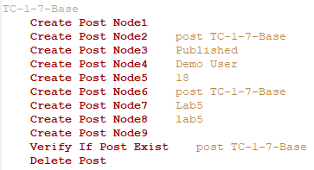

1. *TC-5-3-Base*

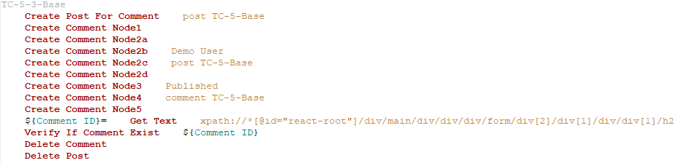

1. *TC-10-2-Base*

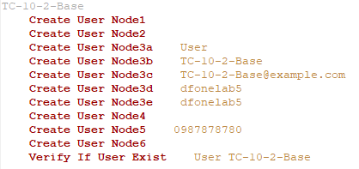

1. **Test Results**

