**CS 246**

**Winter 2023**

**TEAM CONTRACT**

**Team Members:**

1)_______Devin Freeman____________

2) _______Michael Paulsen___________

3) _______Steven Brady____________

4) _______Nehemiah John____________

| **Team Procedures** |
| --- |

## **Preferred communication** The team has 3 main methods of communication. In order from most frequently used to least:

* 1. Discord, team forum or direct message.
  2. Jira Project Management software
  3. Email

## Contact Information

* 1. Let's Code Discord Server: Team 3 Forum and text channel.
  2. HIP and Clavicle [Jira board](https://jarthur.atlassian.net/jira/software/projects/HIP/boards/5)
  3. Discord Usernames
     1. Michael: @mwpdx#2084
     2. Steven: @Stier#3654
     3. Devin: @¡¡¡BA§§_CA§E™!!!#7553
     4. Nehemiah: @Namsjam#7048
  4. Email Addresses
     1. Michael: [paulsenm@my.lanecc.edu](mailto:paulsenm@my.lanecc.edu)
     2. Steven: [bradys@my.lanecc.edu](mailto:brodys@my.lanecc.edu)
     3. Devin: [freemand@my.lanecc.edu](mailto:freemand@my.lanecc.edu)
     4. Nehemiah: [johnn@my.lanecc.edu](mailto:johnn@my.lanecc.edu)

## Decision Making

* 1. Final Design decisions are ultimately up to the client. Since Michael is in contact with the client and is the originator of the project idea, The team will refer to him for conflict concerning website design.
  2. Changes by any team-mate must have a reason behind the change. If another team member wishes to dispute the change, a vote will be tallied with team majority deciding the outcoming.
  3. If a team member is not present during a decision, vote or meeting, they have forfeited their right to have a say in the decision.

## **Meeting Agenda**

* 1. Collaborative aspects of meetings are often short decision making and clarifying sessions. After that, each member is responsible for the assignments they have taken on.
  2. Each meeting should start with an old business and new business review, in which the team first checks with each individual to identify the status of their assignments, and whether they may need assistants or not.

## **Record Keeping**

Links leading to documents and records relating to the project will be kept in 2 places:

* 1. Resource links are maintained on the Discord forum in which the group uses for communication.
  2. In addition all resource link are stored in the Jira project labeled with a title and a blue dot 🔵 marking it as a resource link.

## Asset Maintenance

* 1. Code will be stored on github. Main Repository & branch -<https://github.com/Dfreem/HipAndClavicle>. The procedure for merging individual branches into the main branch is as follows.
     1. A developer does a "reverse merge" of the main branch into their own branch to clear up any conflicts.
     2. The developer initiates a pull request that goes to one or more team members
     3. Team members review the code and approve it for merging.
     4. The developer merges their own branch into main.

| **Team Expectations** |
| --- |

## Team Roles

As this project is being developed in an Agile manner, the team is self regulating. Each team member will take a turn being the SCRUM master, and managing the SCRUM details such as the "Burn Down" chart that aids the team in planning and tracking sprints.

## Team Meetings

 The team will schedule and hold 2 meetings every week for the duration of the project.

* 1. Meetings will be held in the team discord server.
  2. Meeting times are Tuesday and Thursdays at 2:00pm.
  3. Meetings outside the normal time and place will be discussed and agreed on by all team members.
  4. A meeting template will be created and a format will be followed for each meeting. The different parts that each meeting will concentrate on are:
     1. Old Business - Discuss what we have been working on since the last meeting, and our status; IE do we need help, are we done how much longer?
     2. New Business - Discuss upcoming sprint and delegation of duties.
     3. Team decisions - Discuss
     4. Debrief - Summarize and clarify all the meeting notes and assignments. Double check that everything is recorded.

## **Communication Policy**

Communication is one of the main binding factors between this team.If a team member will be late, needs ectr

* 1. The team has established and will maintain a culture of open communication and active listening.
  2. We encourage all team members to voice their opinions and ideas. Every member's voice and ideas will have the same priority as the other team members.
  3. Each meeting will have a portion dedicated to going over any concerns a member may have and how to remedy the issue.

## **Delegation & Responsibilities**

Following are the techniques the team will use to keep members on track and focused.

* 1. Sprint's will be designed and optimized by the current SCRUM master.
  2. Once the sprint rough draft is ready, the team will discuss the delegations in the sprint, and either revise or approve the sprint.
  3. The team will hold "Stand Up" meetings 4 times a week to discuss current progress, possible issues, and future sprints.

## **Team Lead**

All of the team members will take a turn being the SCRUM master, which organizes the SCRUM meeting, finalizes the sprint planning and fills out the "Burn Down" chart to plan the next sprint.

* 1. Client Relations & Communication
  2. UI/UX overall design
  3. Look and Feel
  4. Epic Prioritie

## **Personal Accountability**

For each deliverable the team will draft a duties report describing what each member has worked on during the sprint. Any violations of this agreement will be recorded in the report of work done. An accumulation of 3 violations will result in a loss of the shared credit equal to the portion of skill points that are assigned to the task/epic with the missed deadline. These reports will include the following details:

* 1. Meeting Attendance
     1. If a team member will be missing a meeting they are to notify the other team members at least 12 hrs in advance.
     2. Team members are responsible for catching up on meeting notes & assignments
     3. If the absent team member also cannot provide a portion of their responsibilities concerning the meeting, then the notification of the team member's absence should be at least 24 hrs prior to the meeting time.
  2. Share of Responsibility report
  3. Deadlines missed
  4. Notes / Summary

## **Epics**

An epic is a collection of related user stories, features and tasks to accomplish the implementation of features in order to satisfy user stories and issues. Definitions of terms relating to Epics are listed:

* 1. **Epic**

As mentioned, an Epic is a collection of related features, user stories and tasks/issues that will be used to achieve the feature implementation.

* 1. **User Story**

A user story in general terms, is a statement related to a feature, written from the perspective of an end user. A user story is usually related to one or more features to be implemented.

* 1. **Feature**

A feature is a function of the application, something that it or a user can do or use. The necessity of a feature can be discovered with user stories. A user story is a focus on something the user should be able to do, and the feature is the specific way in which the application will allow that.

* 1. **Task**

A Task is the very basic building block of a User Story. In other words, a User Story is broken down into the smallest units of work possible. Once the parts of a user story cannot be broken down any smaller or simpler, that will be considered a task. A task may implement a part of a feature or even an entire feature depending on the complexity.

* 1. **Issue**

An issue is a problem that has been identified by either a team member or the client. These may occur during development or after delivery, however the team will only be responsible for the service and maintenance period specified in this contract. Issues will be prioritized and added to the appropriate sprint, which may or may not be the current sprint.

## **Delivery & Service Period**

The team will agree to considering any changes by the client during the development period. This does not mean that any change that is requested will be approved, but that it is the right of the customer to have a request be heard. The team will then need to discuss if the feature is possible, reasonable in the given timeframe and within the scope of the project.   
  
Once the project has been delivered to the client and ownership of all intellectual property has been completely transferred, The team will no longer be responsible for alterations, maintenance or administration of the finished project.  
  
An extended service period may be discussed at a later time, but was not agreed upon at the time of writing this contract, therefore is not an obligation of the team.

## **Communication Expectations**

Communication is essential to our team's core function. The team has a Discord server that is the base of communication. Messages that are directed at the entire team can be found here. Messages directed at specific team members or the team in general will require some kind of acknowledgement, not immediately, but within 48 hrs. The following is a list of requirements regarding team communications

* 1. Respond to communication attempts from other team members within 48 hrs maximum, pref 24hrs.
  2. If you will miss a team meeting, notify the team at least 12 hours prior unless it is an emergency that can not be helped.
  3. If you are behind or think you are unable to finish a task by the deadline, communicate that with your team members **before** the deadline. This will give ample time to make adjustments or re-allocate labor.
  4. Participate in and be present for team meetings. Contribute your opinion and knowledge when necessary.
  5. Be ready to report your status and needs at each team meeting. If no progress has been made since the last meeting, that is relevant and should be shared with the team at meeting time at the very latest but much sooner preferably.

| **Consequences for Failing to Follow Procedures and Fulfill Expectations** |
| --- |

## Infractions

Communication will be the main determining factor if a group member is unable to fulfill their commitment to the team, then that member should be honest and communicate the issue as early as they can. If communication is consistent, the team will make any efforts that are available in order to make up for any missed deadlines but are not obligated to do so. If a pattern of missing deadlines or a lack of communication is established by a team member, the rest of the team reserves the right to escalate the situation to instructor of the course, Brian Bird.

***************************************************************************

1. *I participated in formulating the standards, roles, and procedures as stated in this contract.*
2. *I understand that I am obligated to abide by these terms and conditions.*
3. *I understand that if I do not abide by these terms and conditions, I will face the consequences as stated in this contract.*



1) ___________________________________________________date_03/7/2023___

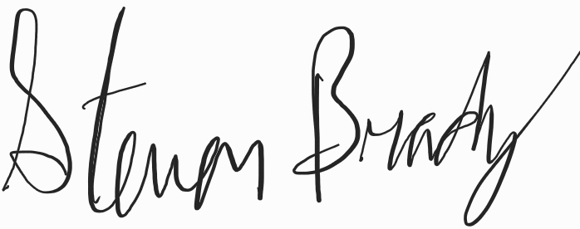

2) ___________________________________________________date______3/7/2023____________

3) ___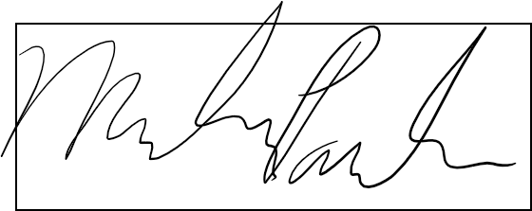________________________________________________date______04/08/2023____________

4) ___________________________________________________date: 4-9-23