Slide 1 | Cybersecurity Overview
TARGET: 3:00 | SCENARIO-LED PRESENTER NOTES
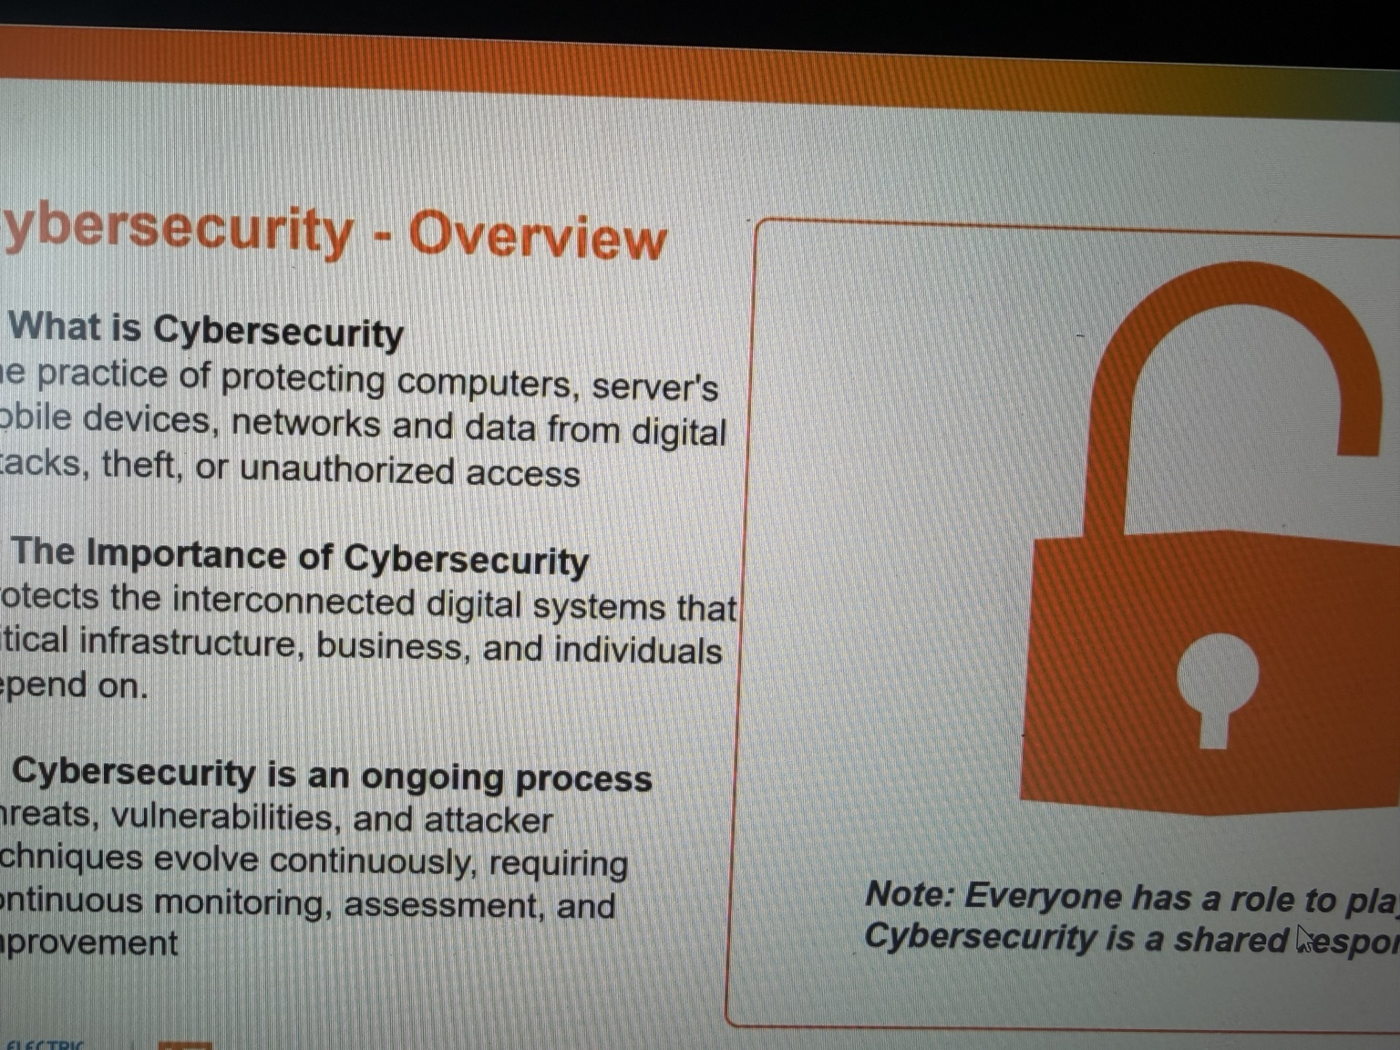

GENERAL TALKING POINTS
- Cybersecurity protects information and the technology that supports physical operations.
- Electric power is critical infrastructure; other essential services depend on it.
- Use the outage scenario: refrigerator → building → citywide consequences.
- Cyber incidents may affect visibility, control, equipment, and service continuity.
- Security requires daily decisions by engineering, operations, IT, vendors, and staff.

PRESENTER SCRIPT / NOTES
0:00–0:35 | What cybersecurity protects
Cybersecurity is the practice of protecting systems, networks, devices, and information from unauthorized access, misuse, and disruption. In a company, that could mean preventing an attacker from stealing employee information or encrypting a business server. In the electric sector, it also means protecting technology that supports the delivery of electricity. A compromised system does not always stop at a computer screen; depending on what it controls, it can affect an actual operation.
0:35–2:20 | Scenario: one refrigerator to one city
Start with a familiar example. Your refrigerator loses power for one hour. If you keep the door closed, that is generally an inconvenience, not an emergency. Now extend that outage through the day. Refrigerated food becomes a concern, people lose lighting and air conditioning, and businesses may close. Extend the same event across a city. Hospitals must rely on backup power, traffic signals may fail, communications providers use their backup systems, and water utilities may have difficulty pumping or treating water if their power or backup resources are insufficient. These are not identical outcomes at every location; the point is that other services depend on reliable electricity. Now consider what a cyberattack could contribute to: loss of operator visibility, manipulation of a control system, or interruption of supporting business technology. Not every intrusion causes an outage, but an attack on the right systems can create physical and community consequences. A useful distinction is that the electric grid is a collection of interconnected generation, transmission, and distribution systems. It is not a single computer with an on/off switch. Utilities operate protective devices, control centers, backup systems, and response procedures that can limit the effect of failures. A cyberattack would need to reach and affect particular capabilities to cause service interruption. That is why the important question is not simply whether an attacker entered a network, but what operational functions that access could influence.
2:20–3:00 | Why this is everyone’s responsibility
Security is not a product we install once. Operators change setpoints, engineers modify networks, vendors connect for maintenance, and employees receive messages that may be malicious. Each action can either introduce or reduce risk. An employee who reports a suspicious access request, an engineer who documents a new connection, and an operator who questions an unexpected system change are all part of cybersecurity. The purpose of the rest of the presentation is to explain what we protect, how the technology works, where risk enters, and how we reduce it.

Slide 2 | The CIA Triad
TARGET: 4:00 | SCENARIO-LED PRESENTER NOTES
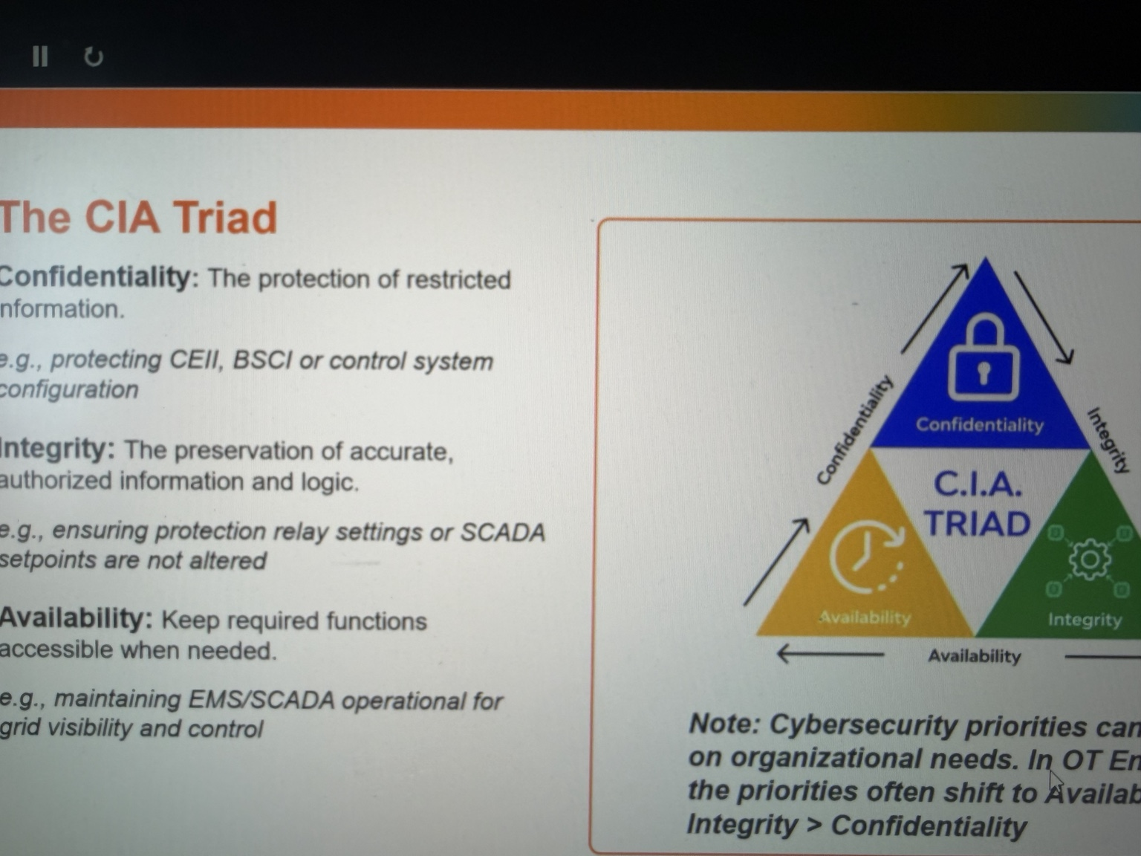

GENERAL TALKING POINTS
- Confidentiality: prevent unauthorized disclosure of sensitive information.
- Integrity: protect trustworthy measurements, configurations, and control logic.
- Availability: preserve operator access, visibility, and control when required.
- Scenarios: exposed substation drawing; modified relay settings; unavailable SCADA.
- OT priorities must reflect process safety, reliability, and consequence—not a universal CIA ranking.

PRESENTER SCRIPT / NOTES
0:00–0:30 | Three questions for any system
The CIA triad gives us three questions to ask about a system. Confidentiality: who is allowed to see the information? Integrity: can we trust the information and settings? Availability: can authorized people use the system when they need it? The three work together. The answer to which matters most depends on the asset, its role, and the consequences of failure.
0:30–1:40 | Confidentiality: a diagram is not just a file
Imagine an electrical substation. The organization stores network drawings, relay configuration files, credentials, and sensitive infrastructure information. If an outsider obtains these records, no breaker necessarily opens at that moment. However, the attacker may gain a clearer picture of device types, communications paths, and locations of high-value equipment. That knowledge could make a later attempt easier. Confidentiality controls include access restrictions, approved data handling, strong authentication, and limiting unnecessary sharing. The same principle protects customer and employee records on the IT side. For an electric utility, consider documents that identify which devices communicate with particular sites and how they are configured. Whether records are regulated as BES Cyber System Information or designated critical energy infrastructure information depends on the information and applicable rules. The general principle is straightforward: engineering documents can have operational significance even when they look like ordinary PDFs or spreadsheets. Limit disclosure to approved recipients and store them using the required protections.
1:40–3:10 | Integrity: the value displayed must be the value intended
Now consider a protective relay. It monitors electrical conditions and may trip a breaker when configured thresholds and logic indicate a fault. An engineer establishes settings through an authorized process. Suppose someone changes those settings without approval. Even if the device still powers on and communicates, it may not behave as engineering intended. An incorrect setting could cause unnecessary trips or undermine protection, depending on the system and safeguards. The integrity issue is not only whether a file was changed; it is whether control logic, measurements, and configurations can be trusted. The same concern applies to a PLC that runs a pump or fan. Configuration management, approved changes, controlled access, and independent validation help protect integrity. Take integrity one step further: suppose an operator sees a measurement of normal temperature, but the underlying process has overheated because the reading is stale or incorrectly represented. The operator may make a perfectly reasonable decision from untrustworthy information. That is why verifying alarms, time stamps, data sources, and changes matters. Integrity can apply to the signal shown on an HMI as much as to the configuration stored in a relay.
3:10–4:00 | Availability: what if the operator loses visibility?
Finally, imagine a control-room operator who relies on SCADA screens to see equipment status and issue authorized commands. If SCADA communications fail or servers become unavailable, the operator may lose supervisory visibility or remote control even though field equipment continues operating locally. Staff may need to use alternate procedures, local indications, and established contingency plans. In OT, availability matters because operations must often continue safely, and integrity matters because wrong information or control can be dangerous. Do not treat the triad as a fixed ranking: safety and the operational process determine the priority. Ask: what happens if this data leaks, changes, or disappears?

Slide 3 | Threat Actors, Techniques, and Tooling
TARGET: 4:30 | SCENARIO-LED PRESENTER NOTES
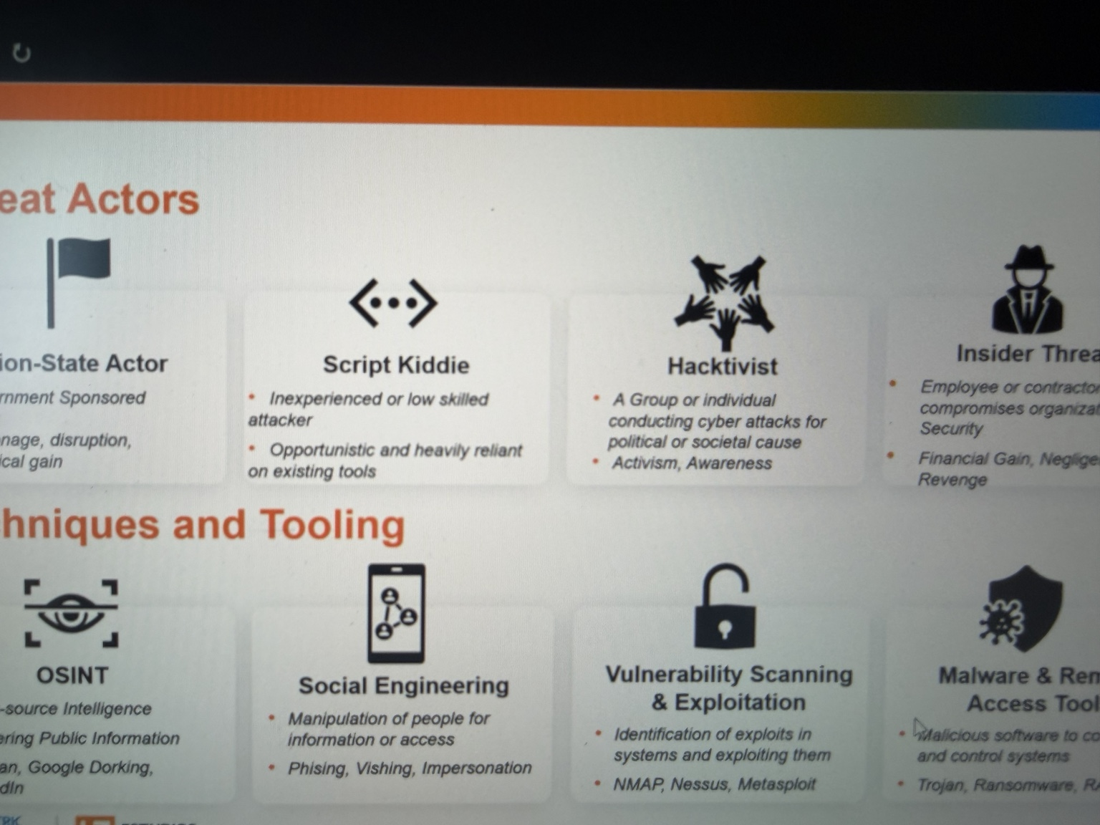

GENERAL TALKING POINTS
- Threat actors differ by motive, access, resources, and industrial expertise.
- OSINT can reveal people, equipment, and vendor relationships.
- Phishing or impersonation may target people before systems.
- Compromised access may lead to discovery, malware, or attempted lateral movement.
- Defensive tools require authorization and OT-aware testing practices.

PRESENTER SCRIPT / NOTES
0:00–1:15 | Who would attack, and why?
Threat actors are people or groups whose activity could compromise a system. A financially motivated criminal may seek payment through ransomware or data theft. A nation-state-linked actor may conduct espionage, establish access for future use, or pursue disruption. Hacktivists may act for an ideological cause, while an insider may misuse legitimate access or accidentally expose a system. Some attackers have specialized industrial knowledge; others simply discover a weak password or exposed service. Motivation and capability are not the same thing, and neither guarantees success. Do not assume that more sophisticated actors are the only serious threat. A basic exposed account can be damaging if it has powerful privileges, while a technically advanced attacker may be stopped by limited permissions and strong network boundaries. Insider risk also requires nuance: a contractor who plugs an unauthorized personal computer into a control network may create exposure without intending harm. The security response is to control access, define safe work practices, and investigate unusual behavior based on evidence.
1:15–1:50 | Scenario, step 1: reconnaissance
Consider a fictional contractor that provides remote support to a generation site. Before trying to break into anything, an attacker researches public information: staff roles on professional websites, facility vendor announcements, and published technology documentation. That is open-source intelligence, or OSINT. The research may tell the attacker whom to impersonate and which services the contractor likely supports. This is why seemingly harmless pieces of public information can become useful when combined.
1:50–2:30 | Scenario, step 2: initial access
The attacker then sends a realistic email posing as the contractor's internal support team and requests a password reset. This is social engineering: manipulating a person rather than directly breaking a machine. If the recipient enters credentials into a fake portal, the attacker may try them against a real account. Multifactor authentication, phishing-resistant methods where available, and clear verification procedures reduce the chance that stolen credentials alone will provide access. Even after one account is compromised, the attacker still needs a route to other systems; access is not automatic.
2:30–3:15 | Scenario, step 3: discovery and attempted expansion
Once an unauthorized foothold exists, an attacker might try to learn which computers and services are reachable, identify weaknesses, or deploy malware. Defenders use similar categories of tooling for legitimate work. Nmap can identify network services; vulnerability-assessment platforms can help identify known weaknesses; security testing frameworks can validate a finding when properly authorized. In OT, active scanning and testing must be assessed with engineering because fragile or time-sensitive devices may not tolerate ordinary IT methods. A tool is not inherently malicious; authorization, target, and method determine the context.
3:15–4:30 | Scenario outcome and interruption points
If that contractor account has broad access into the control environment, it could become a serious risk. If access is limited to a designated gateway, requires approval, and reaches only one authorized device, the opportunity is much narrower. Logging and monitoring may show suspicious activity early. The point is to recognize the chain: research, deception, initial access, attempted movement, and impact. Security controls can interrupt the chain at multiple stages rather than depending on one perfect defense. Give the audience one concrete way to interrupt each stage. Limit what is published and train staff to verify unusual requests before answering. Protect accounts with strong authentication and promptly remove unused vendor access. Segment the network so the compromise of one user does not automatically permit controller access. Monitor connections to detect unexpected patterns. Finally, maintain incident response procedures so someone knows whom to call before an operational issue escalates. No single layer has to be flawless if the other layers continue to work.

Slide 4 | Information Technology vs. Operational Technology
TARGET: 3:00 | SCENARIO-LED PRESENTER NOTES
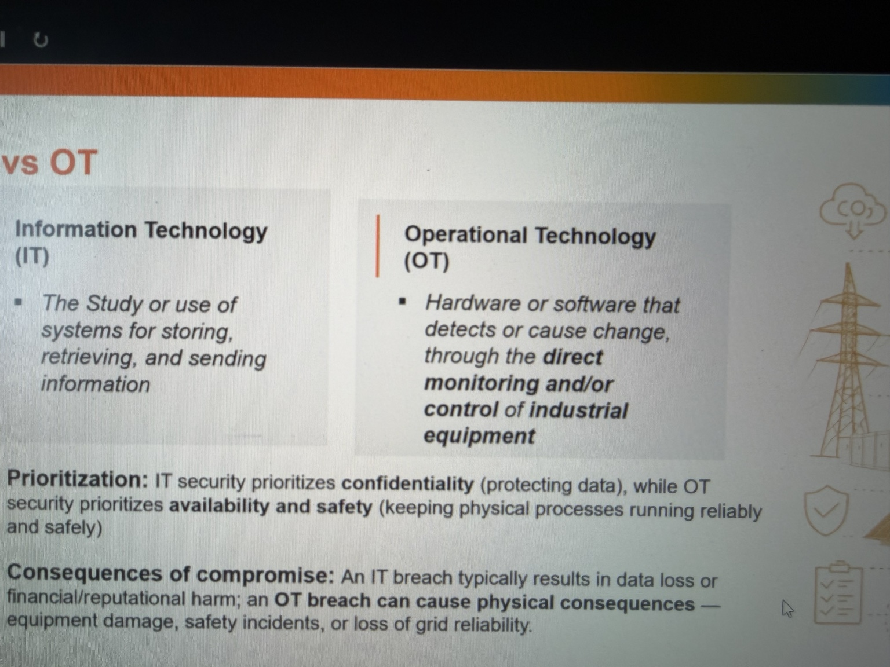

GENERAL TALKING POINTS
- IT manages business information; OT monitors and controls physical processes.
- Sensor → controller/PLC → actuator; HMI presents the operator view.
- SCADA supervises systems; RTUs interface with remote field equipment.
- Protective relays support electrical protection; DCS is another control architecture.
- The correct security approach depends on physical process consequences.

PRESENTER SCRIPT / NOTES
0:00–0:30 | The essential difference
Information Technology, or IT, supports communication, data processing, storage, and business work: email, finance systems, databases, and user workstations. Operational Technology, or OT, monitors and controls physical processes: generation equipment, pumps, valves, breakers, and industrial machinery. Both depend on computing. The distinction is what the technology is being used to do and what happens when it fails.
0:30–2:15 | Walk through a physical control loop
Picture a cooling-water pump at a generating facility. A sensor measures a process condition, such as pressure or temperature. A controller receives that signal, evaluates programmed logic, and sends an output to start equipment, change a valve position, or trigger an alarm. A PLC is one kind of controller that executes such logic. An HMI is the screen an operator uses to view process values, alarms, and controls; the HMI is not the pump itself. SCADA systems gather information and support supervisory monitoring and control, sometimes across distant sites. RTUs are commonly used at remote locations to collect field signals and communicate with supervisory systems. A protective relay has a distinct job: detect electrical conditions and operate protection functions. Different facilities also use DCS architectures rather than stand-alone PLC arrangements. These systems form a chain from measurement, to decision, to physical action. Notice the separation of duties. If an HMI freezes, the underlying PLC may continue executing its programmed control logic, and local protection may still operate. Conversely, a beautifully rendered HMI display does not prove that a field signal or controller setting is correct. An HMI shows information and sends authorized operator requests; it is not the same as the actual physical equipment. Understanding that distinction helps teams diagnose failures and place monitoring at the right points in the process.
2:15–3:00 | Why the difference matters for security
In a corporate environment, if someone locks a file server, the immediate problem may be lost productivity and inaccessible data. In the plant, an unexpected controller output could affect a physical process, while a lost operator screen could reduce visibility. That does not mean every OT cyber event damages equipment, or that IT has no physical consequences. It means cybersecurity decisions in OT must account for safety, timing, engineering constraints, and local fail-safe behavior. Before assessing an OT device, first understand what that device does in the process.

Slide 5 | IT and OT Integration
TARGET: 2:30 | SCENARIO-LED PRESENTER NOTES
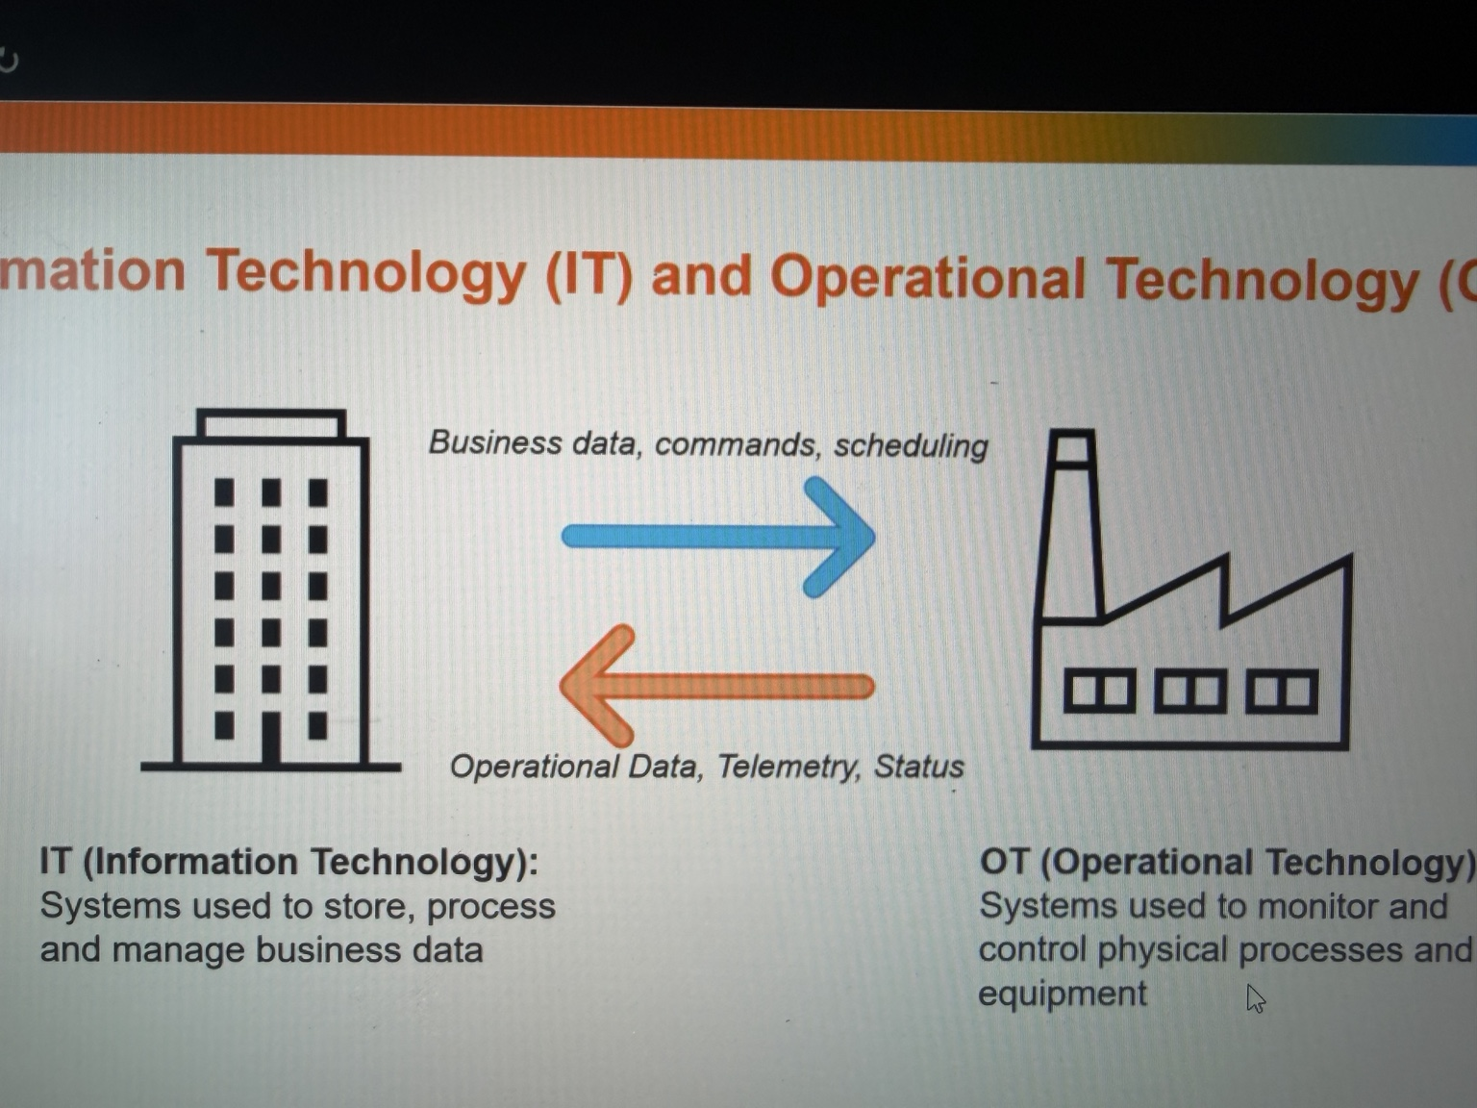

GENERAL TALKING POINTS
- Operations share data with engineering, analytics, maintenance, and business teams.
- Example: OT measurements → historian → approved reporting path.
- The Purdue Model is a useful conceptual guide, not a substitute for a site architecture.
- Use an industrial DMZ and purpose-specific, restricted communications.
- Reporting needs rarely justify unrestricted direct access to controllers.

PRESENTER SCRIPT / NOTES
0:00–0:30 | Why connect these environments?
Plants need information beyond the control room. Engineering wants performance trends, maintenance wants equipment health, and management wants generation reports. A historian can collect process data so teams can study temperature changes, downtime, or equipment performance without querying every controller directly. These business benefits explain why OT and IT exchange information. Connectivity is useful, but the direction and permissions of each connection matter.
0:30–2:00 | Scenario: a historian publishes generation data
Imagine a generator reporting operating measurements to an OT historian. An approved transfer method shares selected data with a service in an industrial demilitarized zone, or DMZ, and then with a reporting system used by the business. The business needs to read a report; it does not need the ability to change a turbine's control logic. Design should therefore distinguish read-only reporting from privileged maintenance or control paths. The Purdue Model provides a useful way to discuss enterprise, supervisory, control, and field functions, although real plant networks do not always map perfectly onto the model. A DMZ and carefully configured firewall rules help mediate traffic between zones. Consider the trust boundary. A maintenance analyst may need to view a month's worth of vibration and temperature history, but should not be able to send commands to a motor starter merely because both systems are on a network. Some architectures use intermediaries, replicated data, or one-way transfer mechanisms where appropriate. The direction of data flow, the access rights, and the protections at each boundary should be based on the actual business requirement, not the easiest available network path.
2:00–2:30 | What to validate
For every IT/OT connection, identify the business purpose, data direction, systems involved, owner, authentication, logging, and failure behavior. Ask whether the data could be shared without giving a corporate workstation direct controller access. Ask what happens if the business network goes down: should the control process continue locally? The design objective is not to eliminate data exchange. It is to make each connection deliberate, bounded, and supportable.

Slide 6 | IT and OT Connectivity Risks
TARGET: 3:30 | SCENARIO-LED PRESENTER NOTES
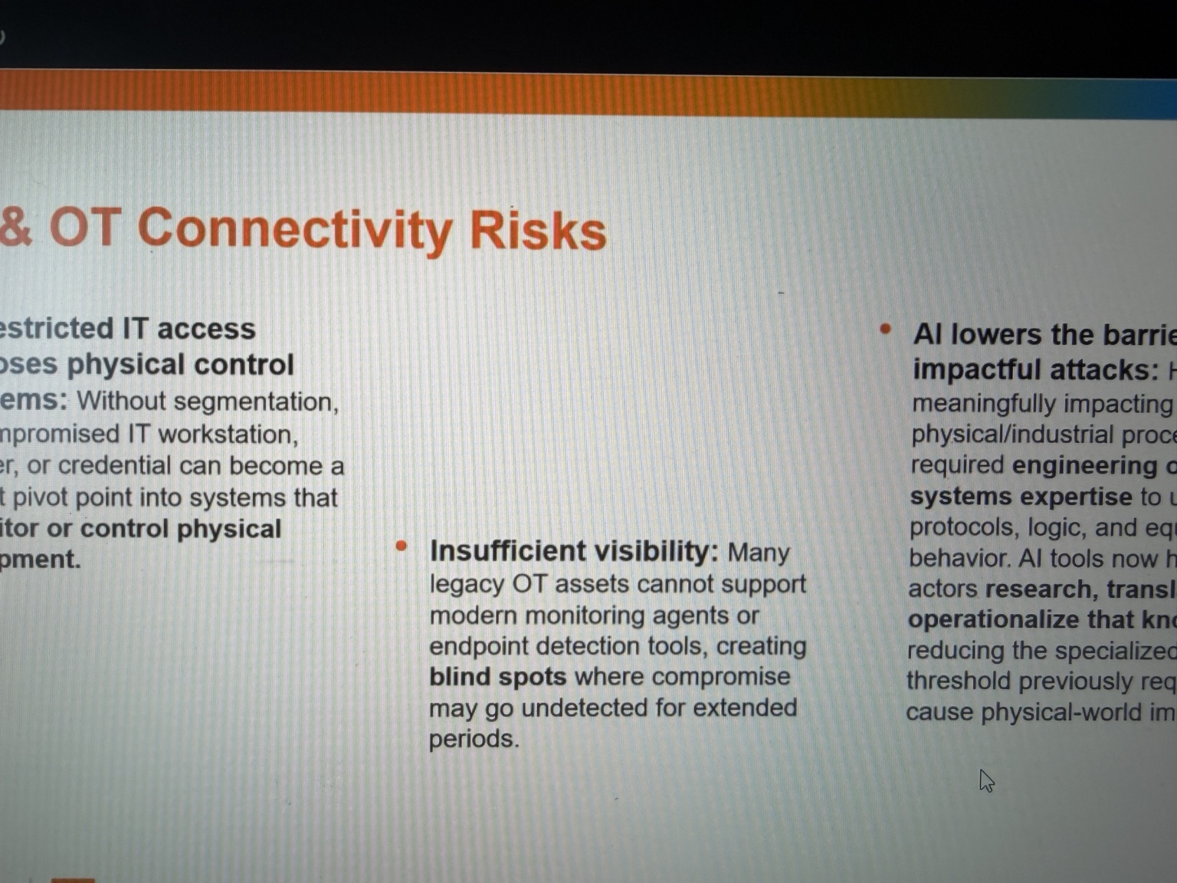

GENERAL TALKING POINTS
- Remote access and IT/OT interconnections increase potential attack paths.
- Trace the chain: phishing → compromised vendor identity → attempted OT access.
- Limit access by person, system, purpose, time, and approval.
- Use segmentation, MFA, controlled gateways, and appropriate monitoring.
- OT scanning and endpoint tooling require engineering and safety review.

PRESENTER SCRIPT / NOTES
0:00–0:35 | A pathway can become an attack path
Every approved connection creates a route for some type of communication. A vendor needs remote access to diagnose a controller; an engineer needs access to settings; a reporting application needs measurements. Those purposes are legitimate. Problems arise when access is always enabled, credentials are shared, accounts remain active after a contract ends, or a firewall permits more than the task requires. The attack surface is the set of opportunities an adversary might attempt to reach.
0:35–1:55 | Scenario: phishing to vendor access
Suppose a vendor technician receives a convincing phishing message and their workstation is compromised. The attacker explores what the technician can reach. If the vendor has an unrestricted VPN into a plant network, the compromised identity or device could provide a route toward operational assets. That is a possible route, not an inevitable compromise of OT. Compare a more controlled design: the vendor first authenticates with MFA, receives time-limited approval, connects to a monitored access gateway, and is permitted to reach only the specific maintenance system. An attacker who steals one password then faces additional controls, and the organization has a clear way to revoke access. Another route sometimes overlooked is an out-of-band remote connection maintained by an integrator for convenience. If it is undocumented, the utility might have excellent firewall rules on its main corporate boundary while an alternate path bypasses those rules. Inventorying remote-access methods, including third-party paths, is therefore as important as reviewing the named VPN. The organization needs to know who can approve access, who can disable it, and how that process works outside normal business hours.
1:55–3:00 | OT monitoring is different
In an office, security teams may install endpoint agents or run routine authenticated scans. Some industrial endpoints do not support these tools or cannot be taken offline easily. Passive monitoring can observe network traffic without actively probing devices; any active scan should be reviewed and tested with operations and the vendor as appropriate. The goal is to learn which devices communicate, whether that pattern changes, and whether a new or unauthorized connection appears. A baseline of known communication patterns can make an alert meaningful. For example, an engineering workstation may normally contact a controller only during approved maintenance. If that workstation begins communicating at midnight or a new host attempts to connect, the change deserves review. The alert alone does not prove malicious activity, but it gives operators and security staff a place to investigate without guessing what normal plant traffic looks like.
3:00–3:30 | Where AI fits
Generative AI can make phishing messages more convincing and help summarize publicly available documentation. It does not automatically give an attacker access to a plant or teach a tool to bypass every safety control. The practical response is the same: reduce exposed pathways, verify remote identities, use least privilege, monitor what is actually happening, and make it possible to disable access quickly without disrupting the process.

Slide 7 | Legacy OT Environments
TARGET: 3:00 | SCENARIO-LED PRESENTER NOTES
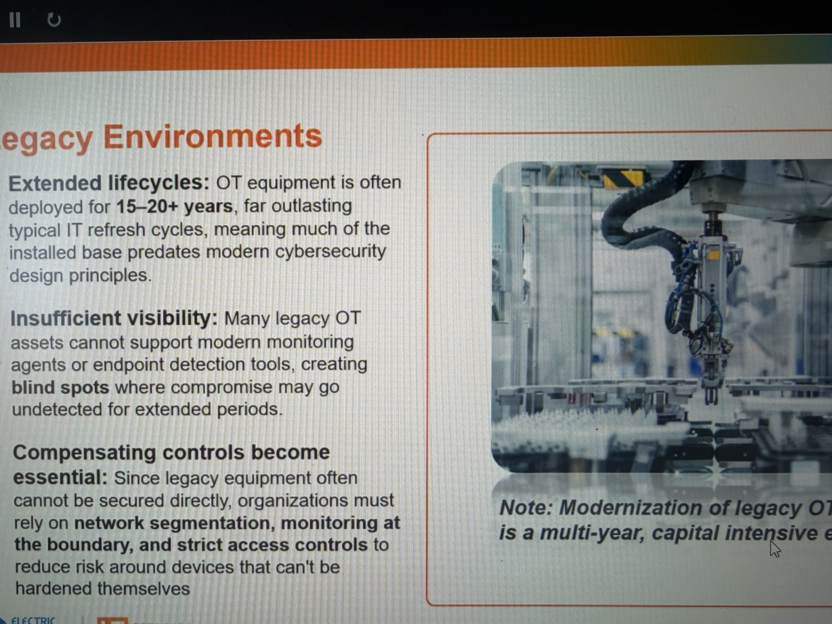

GENERAL TALKING POINTS
- OT equipment may operate for decades and be costly to replace.
- Legacy devices may lack modern authentication, encryption, or vendor support.
- Routine IT patching and active scanning may be unsafe for some OT devices.
- Use engineered compensating controls, documented access, and tested backups.
- Modernization is a risk-based lifecycle and outage-planning decision.

PRESENTER SCRIPT / NOTES
0:00–0:35 | Why older systems remain in service
An industrial controller may perform a stable, essential job for decades. Replacing it can mean redesigning interfaces, checking compatibility, revalidating logic, scheduling an outage, and conducting commissioning tests. A corporate laptop might be replaced every few years; a controller or relay may remain in operation for fifteen, twenty, or more. The age itself is not a vulnerability. The concern is that some older equipment was built without modern authentication, encryption, logging, or supported patching.
0:35–1:55 | Scenario: the unpatchable controller
Imagine a legacy PLC supporting an auxiliary pump. The vendor no longer provides security updates for the controller, but the equipment is reliable and replacement requires a plant outage. A normal IT instinct might be to scan the device aggressively and patch immediately. That could be unsuitable: the controller's protocol stack may be fragile, the patch might not exist, and even a planned restart could affect operations. The right next step is engineering-led assessment. Identify exactly what the controller controls, which hosts communicate with it, and whether it can be separated from less-trusted systems. A practical assessment starts with an inventory and a maintenance conversation. Confirm the exact controller model and firmware, the latest supported configuration, available backups, communication partners, and whether redundancy or manual procedures exist. Operations should identify the consequence of a restart or lost command. Security can then propose controls that do not change the logic in the middle of a production run. The engineers who own the process need to approve the test method and maintenance window.
1:55–3:00 | Compensating controls and lifecycle planning
If the device cannot authenticate remote users directly, put authenticated access controls on the path to it. Restrict network traffic to approved engineering workstations and necessary protocols; log remote sessions; limit physical access; maintain tested backups of configurations; and develop an upgrade plan for a suitable outage window. These are compensating controls: safeguards placed around a system whose own features cannot be quickly changed. The objective is to reduce likelihood and impact while preserving safe, reliable operation. Also plan for recovery rather than only prevention. If a controller fails, can the team obtain a replacement, restore known-good logic, and validate that alarms and interlocks behave correctly? Are configuration files backed up and protected against unauthorized changes? Are current vendor contacts available? Documentation, spare parts, and tested procedures may reduce operational impact even when the underlying older device cannot be updated immediately.

Slide 8 | Security by Design: Brownfield vs. Greenfield
TARGET: 3:00 | SCENARIO-LED PRESENTER NOTES
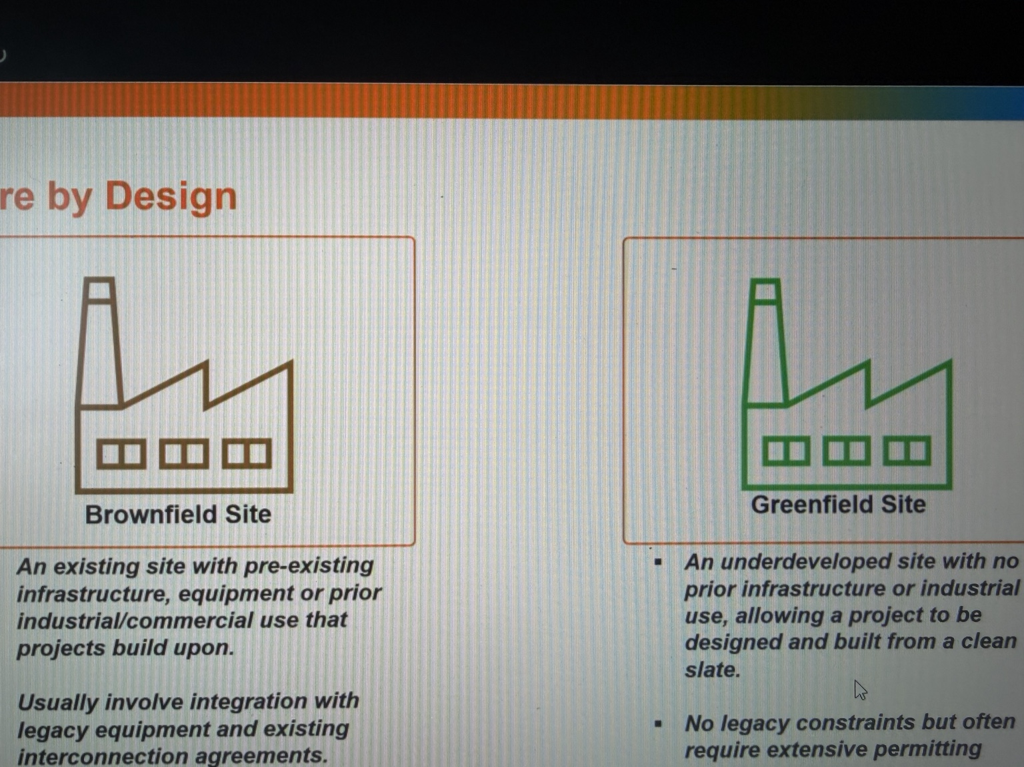

GENERAL TALKING POINTS
- Security by design begins at requirements, procurement, and architecture.
- Brownfield: improve a working facility without disrupting existing processes.
- Greenfield: define access, monitoring, segmentation, and support requirements early.
- Use engineering reviews plus FAT/SAT to validate appropriate security requirements.
- New does not automatically mean secure; existing does not mean unprotectable.

PRESENTER SCRIPT / NOTES
0:00–0:30 | Put security into the engineering process
Security by design means deciding how systems will be protected while they are being specified, purchased, built, and tested. If security is discussed only after commissioning, the facility may already depend on vendor remote access, shared accounts, or equipment that cannot log important events. Fixing those decisions afterward is harder and sometimes requires downtime.
0:30–1:10 | Brownfield: modernize an operating facility
A brownfield project modifies an existing site. Imagine upgrading the control network in a plant that operates every day. The team must preserve connections to existing relays, controllers, displays, and field wiring. Some devices cannot support current protocols or authentication methods. The practical path may be to document existing communications, design new segmentation around legacy components, test changes in stages, and schedule cutovers during approved windows. The security architecture has to respect the facility that already exists.
1:10–2:40 | Greenfield: build requirements before buying equipment
A greenfield project is a new facility or installation. Before a PLC, HMI, switch, or remote-access platform is procured, the project can require supported software, role-based access, network logging, controlled vendor connectivity, and recovery capabilities. Engineering drawings and network diagrams can identify trust boundaries from the beginning. During factory acceptance testing, or FAT, teams can verify selected functionality before delivery; during site acceptance testing, or SAT, they can verify implementation and integration at the site. Cybersecurity checks should be planned and coordinated with the engineering test process rather than assumed to happen automatically. For procurement, a useful test is to turn vague goals into evidence. Instead of writing only 'secure remote access required,' define who approves a session, how authentication works, how permissions are restricted, and what logs must be available. Ask the vendor to demonstrate those functions during an agreed test. Confirm whether insecure default services can be disabled and whether the vendor has a supported method for firmware updates and recovery. A requirement that cannot be verified may not survive commissioning.
2:40–3:00 | Do not confuse new with secure
A brand-new facility can still ship with default passwords or excessive remote access. A brownfield facility can have strong controls through careful upgrades. The advantage of early design is that security requirements become testable engineering requirements instead of an expensive surprise.

Slide 9 | Managing Cybersecurity Risk
TARGET: 3:30 | SCENARIO-LED PRESENTER NOTES
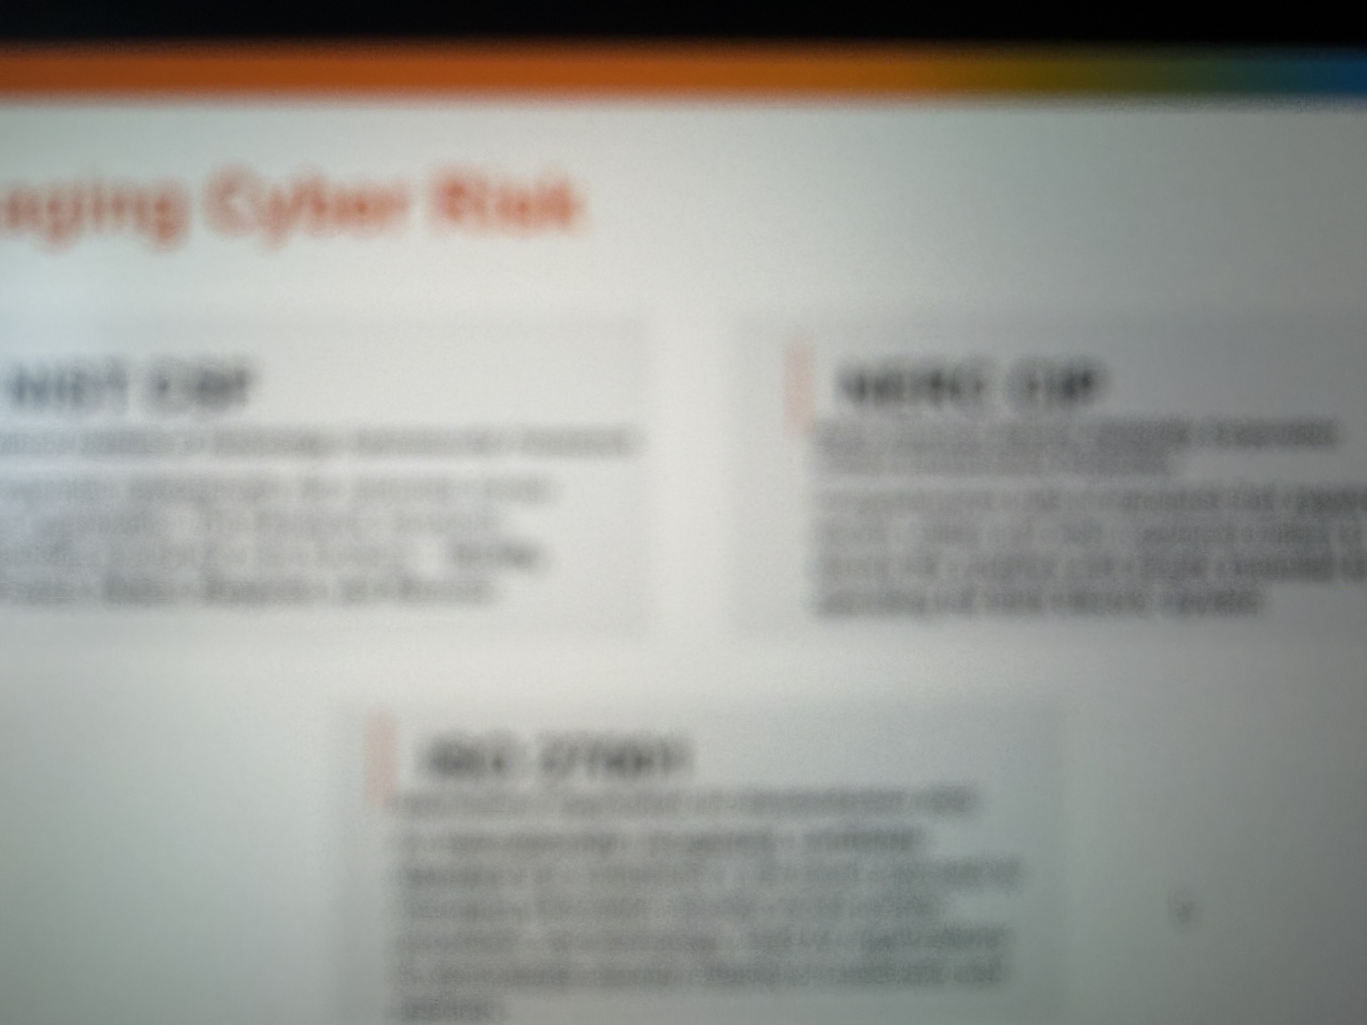

GENERAL TALKING POINTS
- Inventory assets and relate them to actual operational functions.
- Evaluate exposure, threat, vulnerability, existing controls, and consequences.
- Walk through a vendor remote-access request as a real risk decision.
- Choose technical, procedural, and physical controls with clear ownership.
- Use NIST CSF, NIST SP 800-82, and applicable NERC CIP; compliance is not zero risk.

PRESENTER SCRIPT / NOTES
0:00–1:10 | Start with the asset and its consequence
Risk management begins with knowing which assets support which functions. An inventory should do more than name an IP address: identify the system owner, device role, location, communication dependencies, software or firmware information as appropriate, and the process it supports. Consider two computers with the same outdated software. If one produces a low-priority report and the other is necessary for a critical operator function, the consequences of compromise are different. Security priorities should reflect the consequence, the feasible attack pathways, and existing safeguards. To describe risk consistently, separate a threat from a vulnerability and an impact. A stolen credential is one possible attack method. Excessive permission is a weakness that can make it useful. The impact depends on the systems reachable through that permission. A simple risk record should name the owner, affected assets, scenario, controls already present, actions to reduce exposure, and when the organization will review the decision again. That turns an abstract concern into trackable work.
1:10–2:05 | Scenario: vendor access risk assessment
A generator's maintenance vendor requests remote access to troubleshoot equipment. First define the business need: what device requires support, and why can the work not be performed through a lower-privilege method? Next identify exposure: is access permanent or approved per session; are personal accounts and MFA required; can the vendor reach the entire OT network or only one maintenance host? Then consider the threat: an attacker could steal credentials or compromise the vendor's workstation. Finally, estimate impact: what functions could the account reach, and would unauthorized actions affect equipment availability, integrity, or safety? Mitigations might include time-bound approvals, an access gateway, segmented destinations, session recording where suitable, periodic account review, and a procedure to revoke access. The remaining risk is then documented and assigned to an accountable owner.
2:05–3:30 | Frameworks, responsibilities, and close
Frameworks help organize the work. The NIST Cybersecurity Framework gives organizations a common structure for governing, identifying, protecting, detecting, responding, and recovering. NIST SP 800-82 provides OT-specific security guidance. Applicable NERC Critical Infrastructure Protection requirements establish mandatory obligations for certain electric-sector entities and systems; scope must be determined rather than assumed for every OT asset. Compliance evidence is important, but a compliant checklist does not prove that every attack path is closed. The operating habit to carry forward is simple: for a new asset, connection, vendor, or change, ask what it does, who can access it, what could go wrong, and how the organization would detect and respond. Cybersecurity risk is managed through those practical decisions, made repeatedly. Incident preparation should connect security procedures with plant operations. If a suspicious connection appears during generation, cybersecurity staff cannot simply disconnect equipment without understanding the process. Operations and engineering should know how to assess safe isolation, preserve logs, use alternate communications, and return systems to service. The most effective plan identifies decision-makers before a crisis. That collaboration is the same theme running through every slide: understand the process first, then select the controls that protect it.

Presenter reference material
Mike Holcomb, Getting Started in OT/ICS Cybersecurity 2026 (Module 3): PLCs, HMIs, and Others Explained, YouTube (July 2026). https://www.youtube.com/watch?v=UJntDz98u3w
NIST SP 800-82 Rev. 3, Guide to Operational Technology (OT) Security. https://csrc.nist.gov/pubs/sp/800/82/r3/final
NIST Cybersecurity Framework 2.0. https://www.nist.gov/cyberframework
Presenter caution: All scenarios are illustrative, not claims that one weakness automatically causes a real-world outage. NERC CIP applicability must be assessed case by case.

