StatSkill AI — Team Presentation & Concept Guide
Complete Team Reference Document with Embedded Architecture Diagrams
───────────────────────────────────────────────────────

Page 1: The Hook & Introduction
Purpose: Our opening pitch to the evaluators. It identifies our team, the ministry problem statement, and gives a clear one-sentence summary of our tool.
Slide Title: StatSkill AI
One-Sentence Tagline: An offline-ready AI training assistant that tests government statistical officers on official manuals and points them to the exact courses they need.
Competition Details:
• Hackathon: Smart India Hackathon (SIH) 2026
• Partner Ministry: Ministry of Statistics and Programme Implementation (MoSPI)
• Commission: Capacity Building Commission (CBC) & Mission Karmayogi
• Track: AI Software Innovations for the Official Statistical System
Team Members & Roles:
• Eshaan Sunthankar — Team Lead & Full-Stack Architecture
• Teammate 1 — AI Pipeline, RAG & Question Generation
• Teammate 2 — Frontend UI & User Experience
• Teammate 3 — FRAC Framework Research & Ministry Metrics
• Teammate 4 — Offline Edge Caching & Device Testing
• Teammate 5 — Presentation, Pitch & Demo Coordinator
System Overview Diagram:
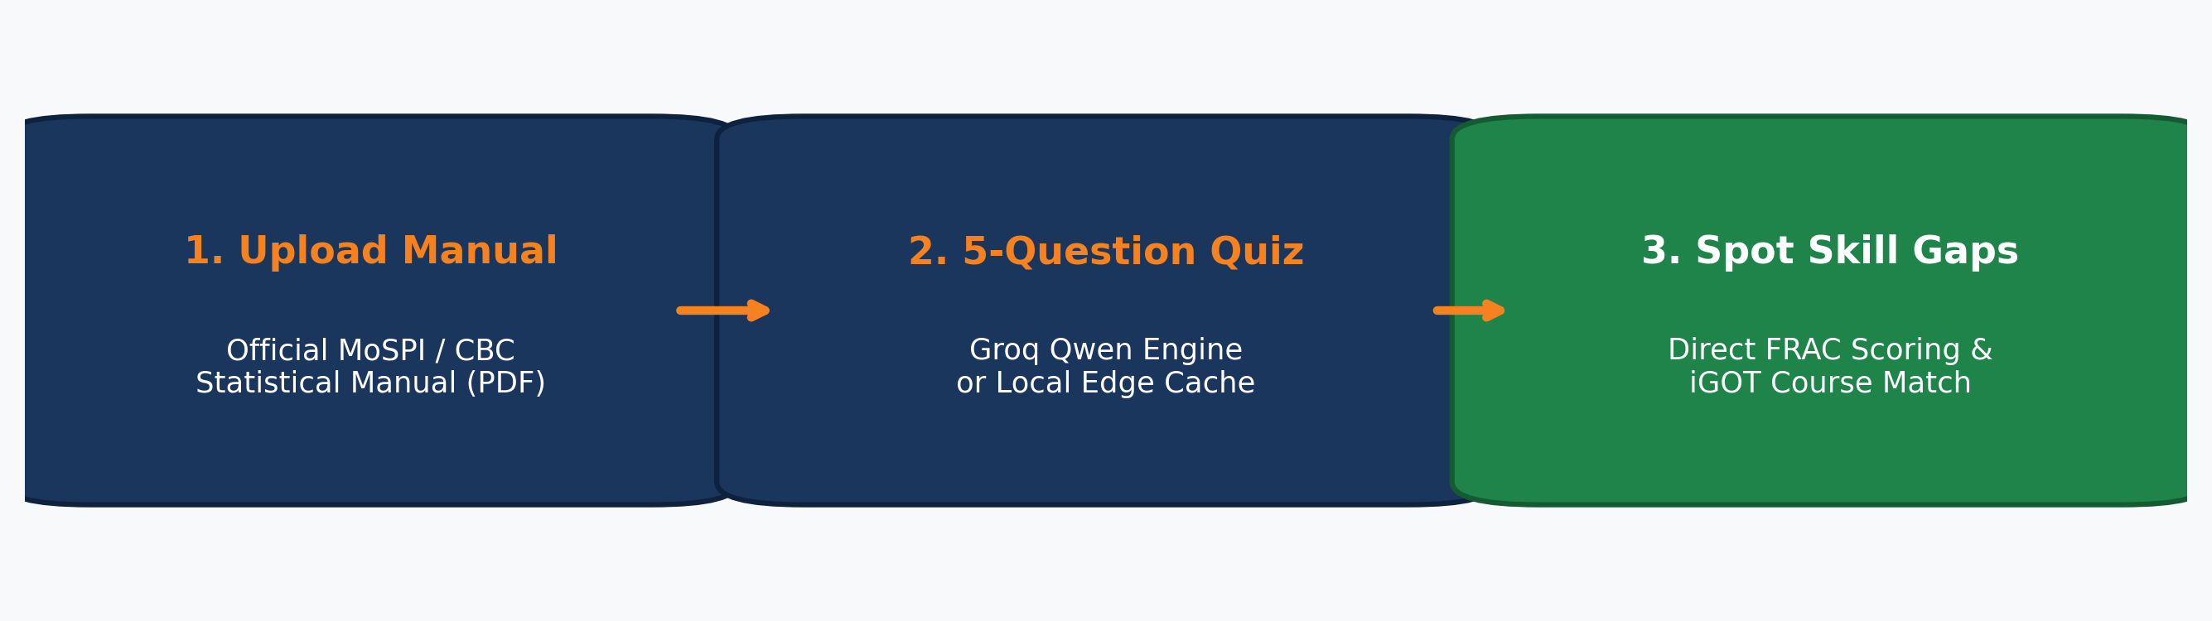

Page 2: The Problem (Why Training in MoSPI Is Stuck)
Purpose: Prove that the problem is real, painful, and experienced daily by thousands of officers in district field offices.
The Core Point: Statistical officers across India receive massive manuals on survey methods and national accounts, but they have no practical way to test their knowledge, diagnose their weak spots, or know which training courses to open next.
Current Reality in the Field:
1. Passive Skimming Fails: Reading 200-page dense PDFs leads to very low knowledge retention, while manually creating exam questions takes months for human committees.
2. Catalog Paralysis: The government iGOT Karmayogi portal hosts over 700 courses, but officers have no diagnosis tool to direct them to the single course that addresses their personal deficiency.
3. Weak Field Office Infrastructure: Many rural offices rely on low-memory computers and unstable 2G/3G internet connections where heavy cloud-based AI applications freeze or fail completely.
The Missing Gap: Prior solutions were either passive video libraries or heavy cloud tools. There was no tool capable of reading official manuals, generating instant active-recall tests, and running completely offline on low-end machines.
Problem vs Solution Comparison:
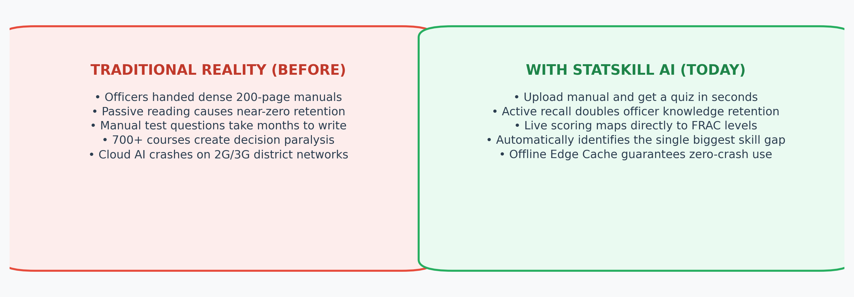

Page 3: The Solution (What We Built & Verified)
Purpose: Present our working prototype. Every feature listed on this page is fully implemented and provable in our code.
The Core Point: StatSkill AI converts dense, unread government manuals into personalized micro-assessments. It accurately maps knowledge gaps against official FRAC standards and matches officers with targeted training courses.
Verified Live Features in Code:
1. Automated Manual-to-Quiz Generator (Live RAG): Officers upload any official PDF manual. The backend parses the text buffer and generates five active-recall questions in seconds via Groq Qwen.
2. Automated Hardware & Bandwidth Detection: detectPerformance.ts profiles device memory, CPU execution speed, and network speed on load, automatically switching to low-spec mode if needed.
3. Zero-Latency Local Edge Database: A local persistent JSON cache (question_bank.json) serves verified quizzes instantly (0ms latency), allowing seamless offline learning in low-bandwidth offices.
4. Live Dynamic Competency Dashboard: The Analytics Dashboard is wired directly into live React state, calculating assessments logged, average FRAC competency level, and the current top skill gap in real time.
Verified Technical Architecture:
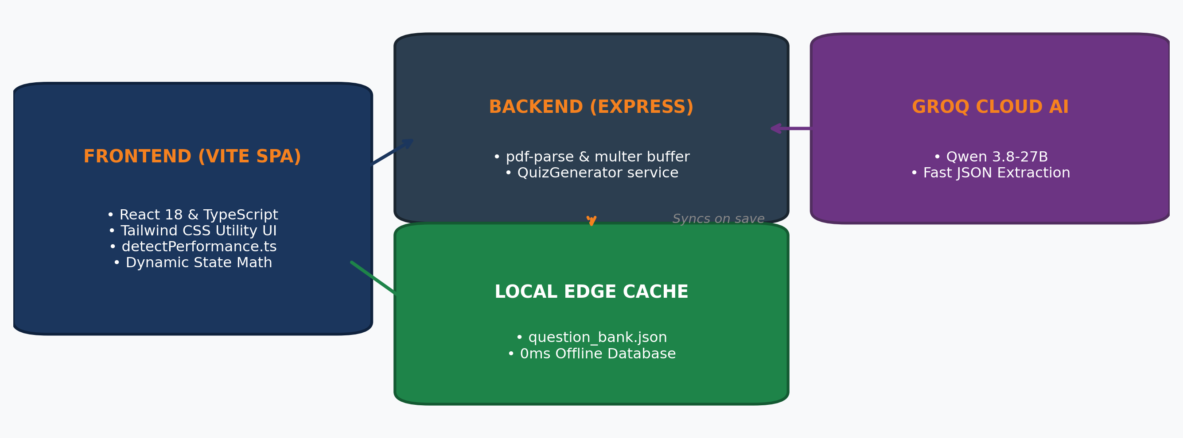

Page 4: The Honest Roadmap (Live vs In Progress)
Purpose: Maintain strict technical integrity for the evaluators by clearly distinguishing between what is 100% operational in code and what is actively in progress.
Status Breakdown:
• 100% Operational Today: PDF file upload, Groq Qwen RAG quiz extraction, hardware/network detection, local edge cache storage, live dynamic FRAC score calculations, and mobile-responsive layout.
• Actively In Progress: Transitioning the realistic Jan Parichay SSO UI simulation to a production JWT authentication system; expanding the 700+ course catalog search into direct automated course enrollment.
• Planned Future Vision: Interactive Radar/Spider charts, learning velocity tracking, Bhashini regional language translation, and native tablet packaging for field staff.
Implementation Roadmap Matrix:
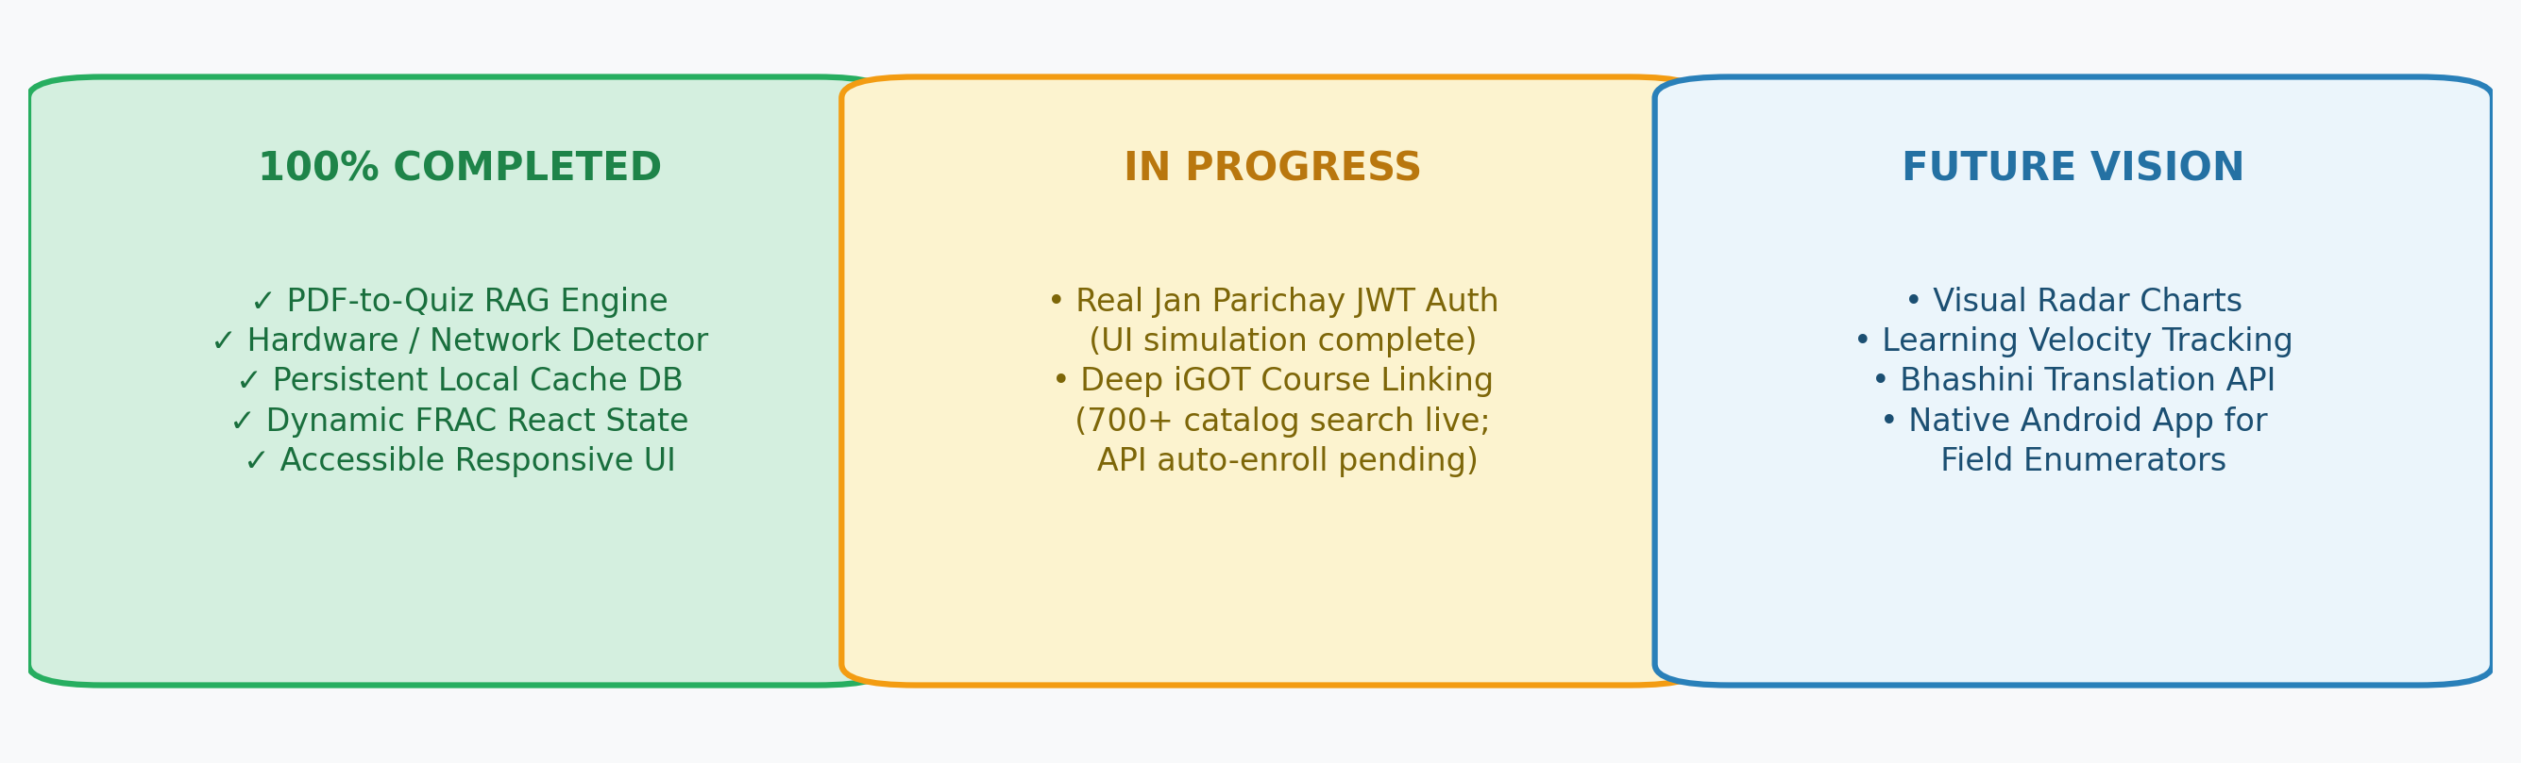

Page 5: Tech Stack & The "Potato Device" Innovation
Purpose: Demonstrate our engineering resilience and how we adapted our software specifically for real-world government field conditions.
Our Tech Stack:
• Frontend: React 18 with TypeScript and Vite; utility-first Tailwind CSS for accessible, mobile-first design.
• Backend: Node.js with Express, pdf-parse, and multer for secure file buffer processing.
• AI Engine: Groq Cloud running Qwen 3.8-27B for sub-second structured JSON question extraction.
• Local Storage: Persistent file-based edge cache (question_bank.json) acting as an instant offline database.
• Profiling: Browser Network Information API and JavaScript hardware benchmarking via detectPerformance.ts.
The Engineering Hurdle & Pivot:
Relying solely on cloud AI in remote district offices caused frequent timeouts and app freezes during 2G/3G connection drops. We pivoted by creating a dual-mode routing engine: the app measures hardware capabilities and network quality on startup. If the machine is low-spec or connection is weak, it bypasses the cloud entirely and serves quizzes from the local edge cache with zero latency.
Dual-Mode Routing Flowchart:
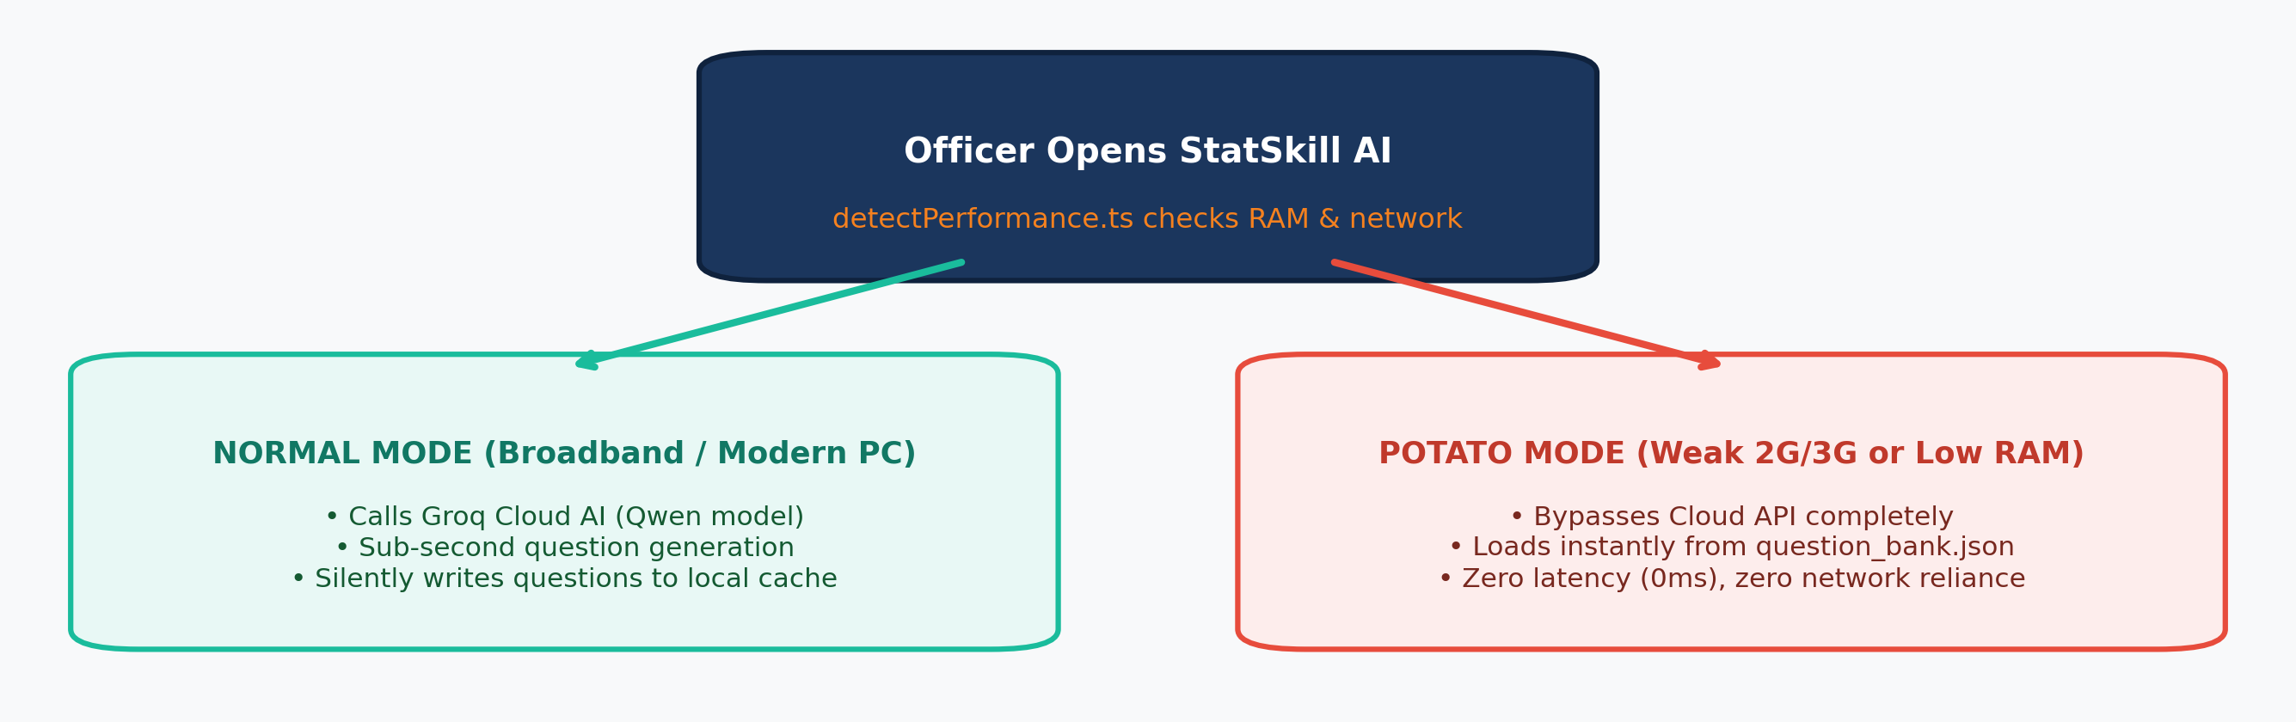

Page 6: Future Scope & Conclusion (What's Next?)
Purpose: Conclude the presentation by demonstrating how StatSkill AI scales to all 28 states and union territories.
Future Scope (Upcoming Enhancements):
1. Native Tablet App for Surveyors: Packaging the app as an offline PWA or Android application for government tablets, allowing enumerators to complete two-minute refreshers before conducting rural household surveys.
2. Statistical Formula & Chart Parsing: Expanding the RAG parser to interpret complex mathematical formulas, sampling tables, and census charts directly from manuals.
3. Ministry Leadership Cockpit: Creating high-level administrative views for MoSPI Joint Directors to monitor regional competency indexes and allocate training workshops effectively.
Closing & Acknowledgements:
Thank you to the Ministry of Statistics and Programme Implementation (MoSPI) and the Capacity Building Commission.
Presented with pride by Eshaan Sunthankar and Team.
Project Repository: github.com/DgrnBoi/statskill-ai
Team Contact: Eshaan Sunthankar (Team Lead)
Nationwide Rollout Architecture:
