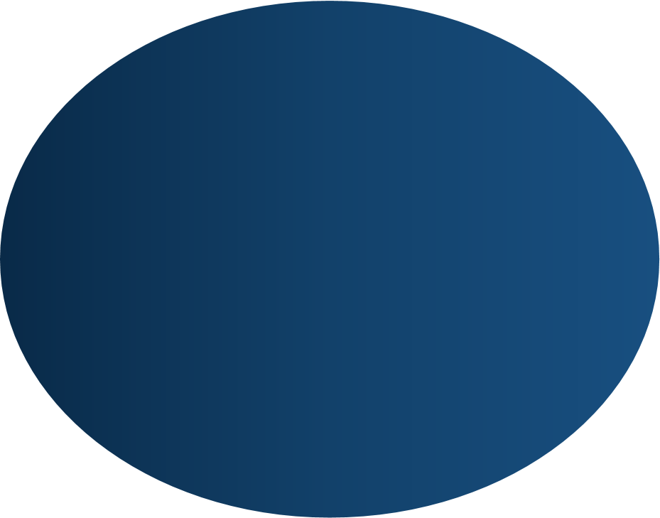

**VINOD DESHAN**



**CONTACTS**

**0789256018**

**Vinodboy864@gmail.com**

**/Opatha , Ganegoda**

**355**

**LANGUAGES**

**SINHALA**

**\* * * * * * * * * * * \***

**ENGLISH**

**\* * * * * * \***

**SKILLS**

W

eb design Besics

P

rogramming language

Microsoft

Office

**HOBBIES**



Vinod deshan

**Vin**

**od deshan deshan**

I am a school dropout with a friendly hard working character. Presently passed advanced level in technology stream. It also supports social and environmental causes

.



**EDUCATION**

2022/23

-

-

Advanced levels with 2C and 1S passes

*Kolvin R The Silva*

*-*

*Iththapana*

2019

-

Ordinary Level

Examination

three A passes

and 3B

P

asses

And 2C passes and 1S passes

2023

-

Completed a certificate course for language &

Skill Green language Academy

**EXTRA CURRICULAR**

•

Member

of School

Art

Team

.

•

Member of Buddhist society

•

.

•

**STRATEGIC DIRECTION**

Mission

to

:

To use opportunities while working hard

make a batter place.

Objectives :

To become expect in the field that the

organization offers.