PHASE 1: FOUNDATION
TASK 1.1 APACHE KAFKA
Apache Kafka is an open-source distributed event streaming platform used to collect, store, and process large amounts of real-time data. It enables applications to publish and consume messages efficiently, making it suitable for building scalable and reliable data pipelines and streaming applications. Kafka is widely used for real-time analytics, log aggregation, monitoring, and communication between distributed systems.
CORE CONCEPTS:
Topic
A topic is a logical channel where messages are stored and organized. Producers send messages to topics, and consumers read messages from them.
Partition
A topic is divided into partitions. Partitions allow Kafka to store data in parallel and improve scalability.
Offset
An offset is the unique, sequential ID of a message within a partition. Offsets start at 0 and always increase. Consumers use offsets to track which messages they have already read.
Broker
A broker is a Kafka server. It stores messages, handles read/write requests from clients, and manages partitions. A Kafka cluster is made up of one or more brokers.
Replication Factor
The replication factor defines how many copies of each partition exist across the cluster. A replication factor of 3 means every partition has 1 leader and 2 follower replicas, providing fault tolerance.
ISR (In-Sync Replicas)
ISR is the set of replicas that are fully caught up with the leader's latest messages. If a replica falls too far behind (due to lag or failure), it is removed from the ISR. Only ISR replicas are eligible to become the new leader.

Producer
A producer is the entry point into Kafka — it's any application that sends messages to a topic, and it controls which partition those messages land in, either by letting Kafka decide or by supplying a key to ensure related messages always go to the same partition.
Consumer
A consumer is a client application that reads (subscribes to) messages from a Kafka topic. Consumers track their own offset, so they can resume from where they left off even after a restart.
Consumer Group
A consumer group is a set of consumers that work together to consume a topic. Each partition is assigned to exactly one consumer in the group at a time, enabling parallel processing, and different groups can each read the full topic independently.
ZooKeeper and KRaft
ZooKeeper was used in older Kafka versions for cluster coordination, metadata management, and leader election. It helped Kafka maintain information about brokers and partitions. However, managing ZooKeeper added complexity to Kafka deployments.
In this project, Kafka is configured and running in ZooKeeper mode, where ZooKeeper is used to manage broker metadata, leader election, and cluster coordination.
KRaft (Kafka Raft Metadata Mode) is the modern replacement for ZooKeeper. It allows Kafka to manage cluster metadata internally without requiring an external service. KRaft simplifies deployment and improves scalability by removing the dependency on an external coordination system entirely.
Conclusion
Apache Kafka is a powerful and scalable event streaming platform that enables efficient communication between applications through real-time data exchange. By understanding its core components such as topics, partitions, brokers, producers, and consumers, we can see how Kafka manages and processes large volumes of data reliably. Its distributed architecture, fault tolerance, and high performance make it a popular choice for building modern data pipelines and streaming applications.

TASK 1.2 – KAFKA CLUSTER SETUP
A single-node Apache Kafka environment was set up using Docker Compose. The setup demonstrated the basic Kafka workflow, including broker startup, topic creation, message production, and message consumption. A topic named orders was created to observe how Kafka stores and distributes messages across partitions.
docker compose up -d
starts all services defined in the Docker Compose file and runs them in the background (detached mode).
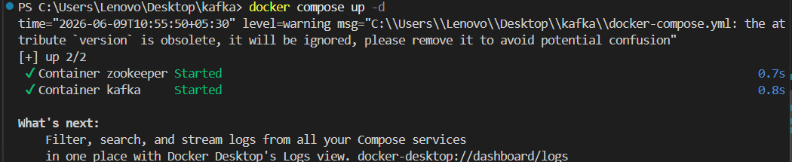

KAFKA BROKER STATUS CHECK
docker ps
The status of the Kafka broker and ZooKeeper services was verified using Docker. The output confirmed that both containers were running successfully, with Kafka listening on port 9092.
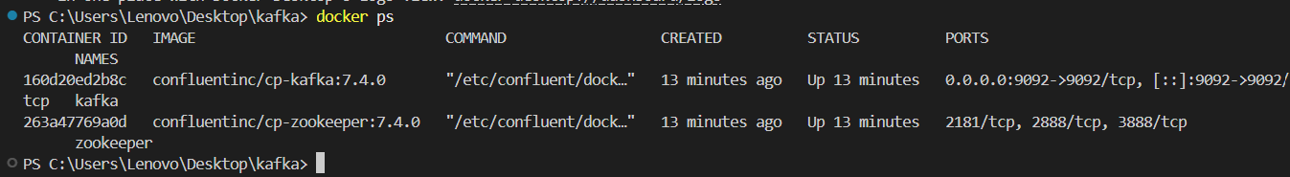
docker exec -it kafka bash
The Kafka container was accessed to perform topic management and messaging operations.

CREATING A TOPIC
A Kafka topic named orders was created with 3 partitions and a replication factor of 1. The output message "Created topic orders." confirmed the successful creation of the topic.
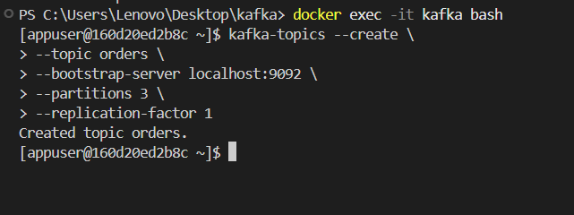
MESSAGE PRODUCTION
Messages were published to the orders topic using the Kafka console producer. Ten messages with different keys were sent successfully to demonstrate message production and partition-based distribution.
MESSAGE CONSUMPTION
Messages were successfully consumed from the orders topic using the Kafka console consumer. The output displayed all produced messages, confirming that the messages were stored correctly in Kafka and could be retrieved by a consumer.

TASK 1.3
Create a topic orders with 3 partitions and replication factor 1 (local). Produce at least 10 messages with different keys. Consume from partition 0 only and document what you observe.

Adding 10 message from producer to kafka:
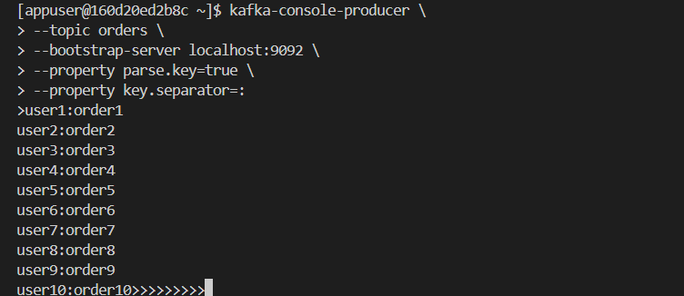

Then read from kafka by consumer, it list out all the message from the kafka with respect to partitions and key-value.
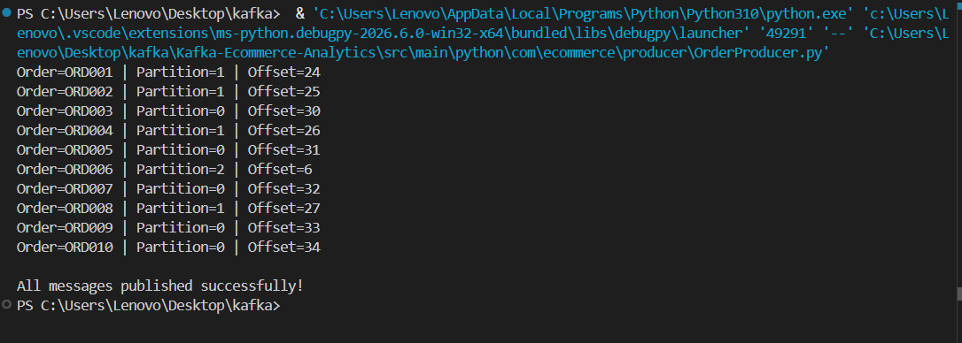

Consume from Partition 0:
