**KPI**

**1. Revenue Growth Rate**

* Formula: ((Current Period Revenue - Previous Period Revenue) / Previous Period Revenue) * 100
* Explanation: Measures the increase or decrease in revenue over a specific period, indicating overall sales growth.

**2. Customer Retention Rate**

* Formula: (Number of Returning Customers / Total Unique Customers) * 100
* Explanation: Shows the percentage of customers who make repeat purchases, reflecting customer loyalty.

**3. Average Order Value (AOV)**

* Formula: Total Revenue / Total Number of Orders
* Explanation: Tracks the average revenue per order, highlighting customer spending patterns.

**4. Average Pizzas per Order**

* Formula: Total Pizzas Sold / Total Orders
* Explanation: Indicates the average number of pizzas ordered per transaction, useful for inventory planning.

**5. Order Frequency Rate**

* Formula: Total Orders / Total Unique Customers
* Explanation: Measures the average number of orders placed by each customer, helpful for understanding purchasing habits.

**6. Sales by Pizza Category Percentage**

* Formula: (Revenue from Each Category / Total Revenue) * 100
* Explanation: Shows the share of revenue each pizza category contributes, helping identify popular products.

**7. Peak Order Hours**

* Formula: Highest Count of Orders by Hour
* Explanation: Identifies the time periods with the highest order frequency, useful for staffing and marketing efforts.

**8. Monthly Sales Growth Rate**

* Formula: ((Current Month Sales - Previous Month Sales) / Previous Month Sales) * 100
* Explanation: Tracks month-over-month growth in sales, showing seasonal or monthly demand trends.

**9. Top-Selling Pizza Variety**

* Formula: Pizza with Highest Quantity Sold
* Explanation: Identifies the most popular pizza by quantity sold, useful for promotions and menu decisions.

**10. Bottom-Selling Pizza Variety**

* Formula: Pizza with Lowest Quantity Sold
* Explanation: Identifies the least popular pizza, which may need adjustments or promotions.

[here is the dataset PIZZA sale docment!](https://docs.google.com/spreadsheets/d/e/2PACX-1vSuXkC3cOLDucfN7jL9rCE-JRjJ7UbbOHMR4nUrCV23y2Gsi-moY2CniC8ah6lcSw/pubhtml)  
[A Video of how we did!](https://www.linkedin.com/posts/dharani-pulipaka-46ab57264_datavisualization-exceldashboard-sql-activity-7258217493033291776-rilC?utm_source=share&utm_medium=member_desktop)  
  
  
--SELECT * FROM pizza_sales  
 **1-Total revenue**

SELECT SUM(total_price) AS Total_Revenu from pizza_sales  
***output***   
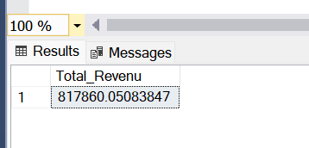**Explanation:**

* This query calculates the total revenue by summing up all values in the total_price column of the pizza_sales table.
* SUM(total_price) adds up the cost of each sale.
* We use AS Total_Revenue to label the output as Total_Revenue. **2- Average order value**

SELECT SUM(total_price) / COUNT(DISTINCT order_id) AS Avg_Order_value FROM pizza_sales  
***Output***  
  
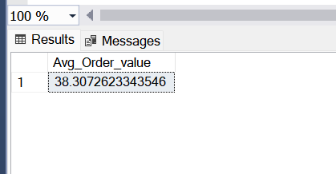

**Explanation:**

* Here, we calculate the average value per order.
* SUM(total_price) gives the total revenue, while COUNT(DISTINCT order_id) counts unique orders.
* Dividing these two gives the average revenue per order.
* AS Avg_Order_value names this calculated value Avg_Order_value. **3- Total PIZZAS sold**  
    
  SELECT SUM(quantity) As Total_Pizza_Sold FROM pizza_sales  
  ***Output***

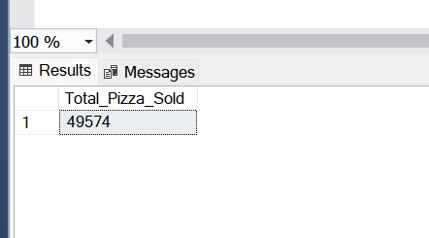

**Explanation:**

* This query gives the total number of pizzas sold by summing up all values in the quantity column.
* SUM(quantity) totals the pizza quantities across all sales records.
* AS Total_Pizza_Sold labels the output as Total_Pizza_Sold.

**4-Total Orders**SELECT COUNT(DISTINCT order_id) AS Total_Order FROM pizza_sales  
  
**Output  
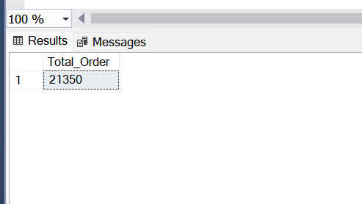  
  
Explanation:**

* Here, we find the total number of unique orders.
* COUNT(DISTINCT order_id) counts the unique order IDs, showing the total orders placed.
* AS Total_Order names this count as Total_Order.

**5-Average pizzas per order**SELECT CAST (CAST (SUM(quantity) AS DECIMAL(10,2)) /

CAST(COUNT(DISTINCT order_id) AS DECIMAL(10,2)) AS DECIMAL(10,2)) AS Avg_Pizza_per_Order FROM pizza_sales  
 **Output**

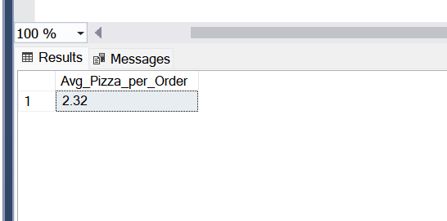

**Explanation:**

* This query calculates the average number of pizzas per order.
* SUM (quantity) gets the total pizzas sold, while COUNT(DISTINCT order_id) finds the total orders.
* Dividing these gives the average, and CAST(... AS DECIMAL(10,2)) ensures it’s formatted to two decimal places.
* AS Avg_Pizza_per_Order labels the output.

-1-daily trend for total orders  
SELECT DATENAME(DW, order_date) AS order_day, COUNT(DISTINCT order_id) AS Total_Order

FROM pizza_sales

GROUP BY DATENAME(DW, order_date)  
  
  
output  
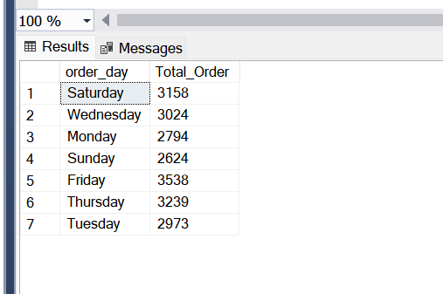

**Explanation**:

* This query finds the **total orders per day of the week**.
* DATENAME(DW, order_date) extracts the weekday name (e.g., "Monday") from order_date.
* COUNT(DISTINCT order_id) gives the unique orders per day.
* GROUP BY DATENAME(DW, order_date) groups results by day of the week.

-2-Hourly trend for total orders  
SELECT DATEPART(HOUR, order_TIME) AS Order_hours, COUNT(DISTINCT order_id) AS Total_Order

FROM pizza_sales

GROUP BY DATEPART(HOUR, order_TIME)

ORDER BY DATEPART(HOUR, order_TIME)

Output  
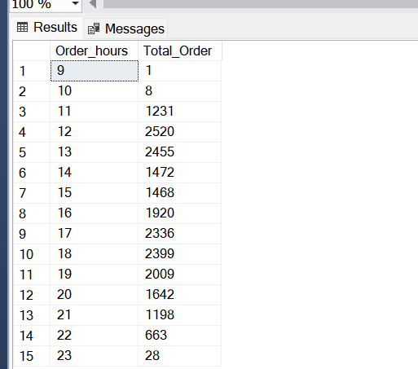  
**Explanation**:

* This query finds the **total orders placed each hour**.
* DATEPART(HOUR, order_TIME) extracts the hour from order_TIME.
* COUNT(DISTINCT order_id) counts the unique orders per hour.
* GROUP BY DATEPART(HOUR, order_TIME) groups results by hour, while ORDER BY DATEPART(HOUR, order_TIME) sorts them chronologically.

8. **Percentage of Sales by Pizza Category**

SELECT

pizza_category,

SUM(total_price) AS Total_sales,

SUM(total_price) * 100 / (SELECT SUM(total_price) FROM pizza_sales WHERE MONTH(order_date) = 1) AS PTC

FROM

pizza_sales

WHERE

MONTH(order_date) = 1  
GROUP BY pizza_Category

Output  
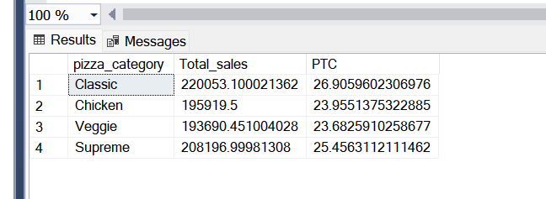

**Explanation**:

* This query shows **sales percentage by pizza category for January**.
* SUM(total_price) gets total sales for each pizza_category.
* (SUM(total_price) * 100 / (SELECT SUM(total_price) FROM pizza_sales WHERE MONTH(order_date) = 1)) calculates each category's percentage of the total January sales.
* GROUP BY pizza_category groups results by pizza category.

9. **Total Pizzas Sold by Size**   
SELECT

pizza_size,

SUM(total_price) AS Total_sales,

CAST(SUM(total_price) * 100.0 / (SELECT SUM(total_price) FROM pizza_sales) AS DECIMAL(10,2)) AS PCT

FROM

pizza_sales

GROUP BY

pizza_size

ORDER BY

PCT DESC;  
-Output  
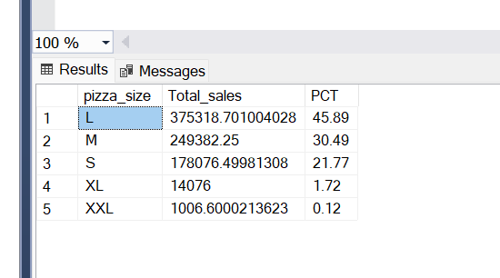

**Explanation**:

* This query calculates **total sales and percentage for each pizza size**.
* SUM(total_price) totals sales for each size, while PCT shows each size's share of total sales.
* ORDER BY PCT DESC sorts sizes by percentage in descending order.

10. **Total Pizzas Sold by Category** 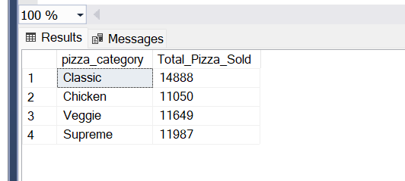  
SELECT pizza_category,

SUM(quantity) as Total_Pizza_Sold

FROM pizza_sales

GROUP BY pizza_category  
output  
  
11. **Top-5 Best Sellers by Total Pizzas Sold**

SELECT TOP 5 pizza_name,

SUM(quantity) AS Total_Pizza_Sold

FROM pizza_sales

GROUP BY pizza_name

ORDER BY Total_Pizza_Sold DESC  
Output  
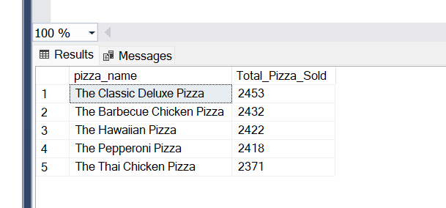  
**Explanation**:

* This query finds the **top 5 best-selling pizzas**.
* SUM(quantity) totals sales for each pizza, and ORDER BY Total_Pizza_Sold DESC ranks them from highest to lowest.
* TOP 5 limits results to the five best sellers.

12. **Bottom-5 Pizzas Sold**  
SELECT TOP 5 pizza_name,

SUM(quantity) AS Total_Pizza_Sold

FROM pizza_sales

GROUP BY pizza_name

ORDER BY Total_Pizza_Sold  
output  
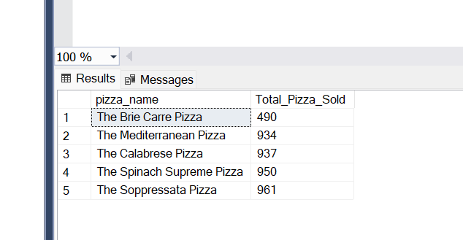

**Explanation**:

* This query finds the **bottom 5 pizzas in terms of sales**.
* SUM(quantity) totals sales for each pizza, and ORDER BY Total_Pizza_Sold ranks them from lowest to highest.
* TOP 5 limits results to the five lowest-selling pizzas.