# Detailed Project Report (DPR)

## iNeuron

## 1. Project Overview

**Project Name:** Funku Online Store  
**Developed By:** [Dharam Chopda]  
**GitHub Repository:** https://github.com/Dhach123/ai_ecommerce_project  
**Certification:** iNeuron Certified Project

The Funku Online Store is an AI-powered e-commerce platform that integrates advanced AI-driven recommendations, a bargaining system, and a chatbot to enhance user shopping experiences.

## 2. Project Objectives

• Develop an AI-based recommendation system to enhance user experience.  
• Implement an AI-driven chatbot for bargaining and customer support.  
• Utilize Firebase Firestore for real-time chat storage.  
• Design an intuitive and user-friendly interface using React.js.  
• Deploy a robust backend using Flask with RESTful APIs.

## 3. System Architecture

The Funku Online Store follows a **client-server architecture**, with a React.js frontend communicating with a Flask backend. The backend handles API requests, integrates AI modules, and interacts with Firebase Firestore for data storage.

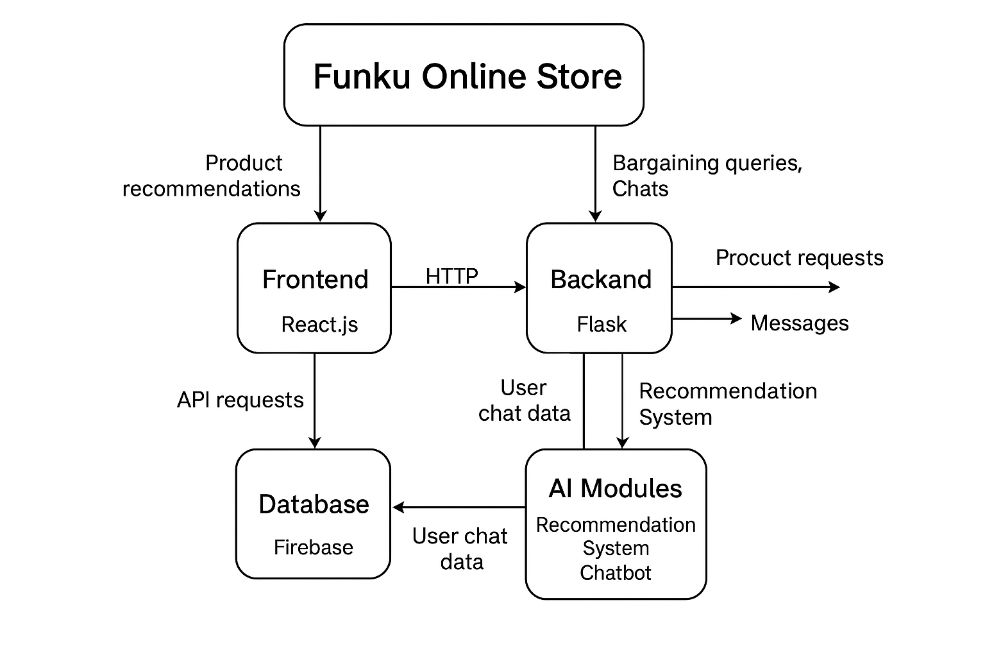

## 4. Key Features

• **AI-Powered Recommendation System:** Suggests products based on user behavior.  
• **AI Chatbot:** Provides customer support and enables price negotiation.  
• **Bargaining System:** Users can negotiate prices in real-time.  
• **Firebase Integration:** Stores chat data securely.  
• **RESTful API:** Facilitates seamless interaction between frontend and backend.  
• **Scalability:** Designed to handle multiple users efficiently.

## 5. Technologies Used

• **Frontend:** React.js, Bootstrap  
• **Backend:** Flask, Flask-CORS, Flask-RESTful  
• **Database:** Firebase Firestore  
• **AI Models:** NLP-based chatbot, recommendation system  
• **Deployment:** Localhost (development), Firebase Hosting (optional)

## 6. Development Process

• **Phase 1:** Requirement Analysis and System Design.  
• **Phase 2:** Frontend and Backend Development.  
• **Phase 3:** AI Model Integration for Chatbot and Recommendations.  
• **Phase 4:** Database Setup and Testing.  
• **Phase 5:** Deployment and Future Enhancements.

## 7. API Endpoints

**Backend API Endpoints:**  
• `/chat?message=your_message` → Handles chatbot queries.  
• `/recommendations?user_id=123` → Fetches personalized product recommendations.  
• `/cart` → Manages shopping cart actions.  
• `/checkout` → Handles the order confirmation process.

## 8. Future Enhancements

• Deploy the backend on Google Cloud Run or AWS Lambda.  
• Improve chatbot AI using GPT-4.  
• Implement Firebase Authentication for secure user login.  
• Introduce an AI-driven voice assistant for a more interactive experience.

## 9. Conclusion

The Funku Online Store successfully integrates AI-powered recommendations, bargaining capabilities, and chatbot features to enhance the online shopping experience. Future improvements will focus on deployability, security, and enhanced AI functionalities.

## 10. Contributors

[Dharam Chopda] ([Dhach123/ai_ecommerce_project](https://github.com/Dhach123/ai_ecommerce_project))

iNeuron Certified Project