# High-Level Design (HLD) Document

## iNeuron

## 1. Introduction

Funku Online Store is an AI-powered e-commerce platform designed to enhance the online shopping experience by integrating an AI-driven recommendation system, a bargaining system, and a chatbot. The system enables users to receive personalized product recommendations, negotiate prices with an AI chatbot, and get customer support in real-time.

## 2. System Overview

The system consists of the following major components:

• **Frontend:** Built with React.js for a seamless and interactive UI.  
• **Backend:** Developed using Flask, providing RESTful APIs for client-server communication.  
• **Database:** Firebase Firestore is used for real-time chat storage and transaction logging.  
• **AI Components:**  
 - **Recommendation System:** Uses collaborative and content-based filtering.  
 - **Bargaining System:** AI chatbot assists users in negotiating prices.  
 - **Chatbot:** Provides customer support and guides users in making purchases.  
• **Hosting:** The system runs locally during development, with potential deployment on Firebase Hosting or Google Cloud Run.

## 3. Architecture Diagram

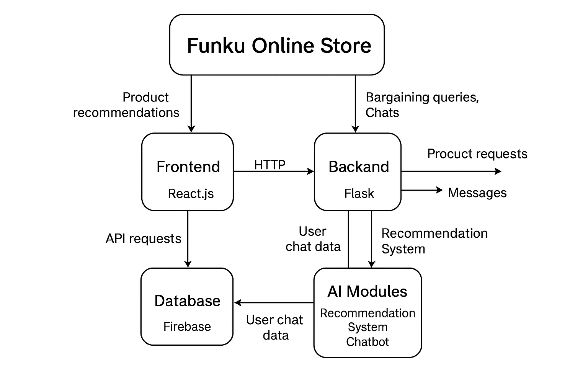

## 4. Module Breakdown

The system is divided into multiple modules:

### 4.1 Frontend (React.js)

• **Components:**  
 - ProductList: Displays recommended products.  
 - Chatbot: Manages user interactions.  
 - BargainSystem: Enables AI-driven price negotiation.  
 - FirebaseConfig: Connects to Firebase Firestore.  
• **State Management:** React Context API is used to manage global states.

### 4.2 Backend (Flask)

• **Endpoints:**  
 - `/chat?message=your_message`: Handles chatbot queries.  
 - `/recommendations?user_id=123`: Returns personalized recommendations.  
• **Core Services:**  
 - Chatbot Service: Processes user messages.  
 - Recommendation Engine: Suggests products based on user behavior.  
• **Security Measures:** Implements CORS and authentication mechanisms.

### 4.3 Database (Firebase Firestore)

• **Collections:**  
 - Users: Stores user data and preferences.  
 - Products: Stores product details and metadata.  
 - Chats: Stores chatbot interactions.

## 5. Data Flow

1. The user interacts with the frontend (React.js).  
2. The frontend sends API requests to the Flask backend.  
3. The backend processes the requests, fetching or storing data in Firebase Firestore.  
4. AI models analyze user preferences and generate responses.  
5. The backend sends the response back to the frontend.  
6. The frontend updates the UI accordingly.

## 6. Technologies Used

• Frontend: React.js, Bootstrap, React-Toastify  
• Backend: Flask, Flask-CORS, Flask-RESTful  
• Database: Firebase Firestore  
• AI Models: NLP-based chatbot, recommendation algorithms  
• Deployment: Localhost (development), Firebase Hosting (optional)

## 7. Future Enhancements

• Deploy backend on Google Cloud Run or AWS Lambda.  
• Enhance chatbot AI with GPT-4.  
• Implement Firebase Authentication for secure user login.

## 8. Contributors

[Dharam Chopda] [Dhach123/ai_ecommerce_project](https://github.com/Dhach123/ai_ecommerce_project)

iNeuron Certified Project