Team Project

Bike Gates

Manual – Claeys Robin, D’Haese Thibault & Walraeve Laurens

To get started, you need to start by connecting the cones to

the internet. Enter the SSID and password in Arduino code. If successful the LEDs will turn white.

Geen beschrijving beschikbaar.

After that you are going to set up the cones for the parkour. Follow the diagram to set them up. If you want it more difficult, the obstacles between the cones can be made more difficult.

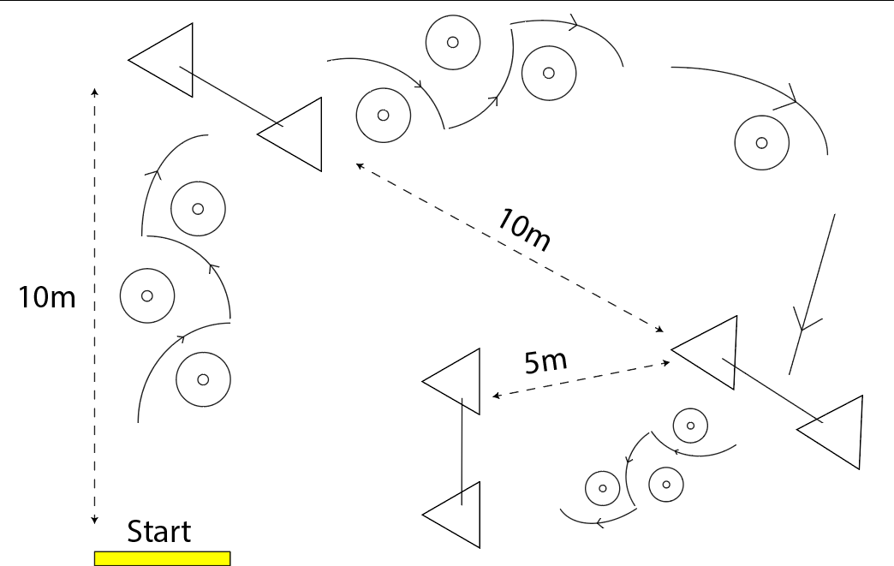

When everything is prepared. Then you can open the app and get started.