M. Dhafa Adjie Saputra (2327250081)

TUGAS 2

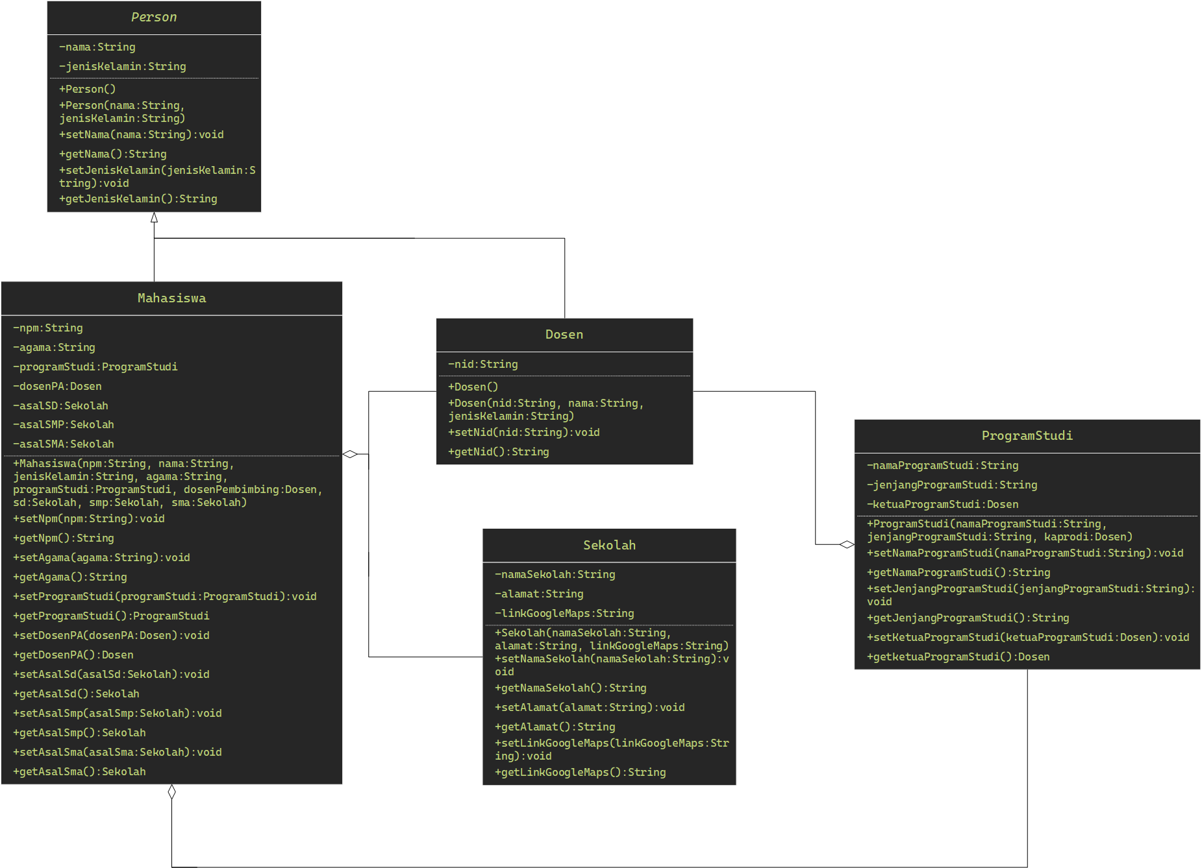

* **Kode Program dalam bentuk Screenshot**

Dosen

package com.mdp.model;

public class Dosen extends Person{

private String nid;

public Dosen() {

super();

}

public Dosen(String nama, String jenisKelamin, String nid) {

super(nama, jenisKelamin);

this.nid = nid;

}

public String getNid() {

return nid;

}

public void setNid(String nid) {

this.nid = nid;

}

}

Sekolah

package com.mdp.model;

public class Sekolah {

private String namaSekolah;

private String alamat;

private String linkGoogleMaps;

public Sekolah() {

super();

}

public Sekolah(String namaSekolah, String alamat, String linkGoogleMaps) {

super();

this.namaSekolah = namaSekolah;

this.alamat = alamat;

this.linkGoogleMaps = linkGoogleMaps;

}

public String getNamaSekolah() {

return namaSekolah;

}

public void setNamaSekolah(String namaSekolah) {

this.namaSekolah = namaSekolah;

}

public String getAlamat() {

return alamat;

}

public void setAlamat(String alamat) {

this.alamat = alamat;

}

public String getLinkGoogleMaps() {

return linkGoogleMaps;

}

public void setLinkGoogleMaps(String linkGoogleMaps) {

this.linkGoogleMaps = linkGoogleMaps;

}

}

ProgramStudi

package com.mdp.model;

public class ProgramStudi {

private String namaProgramStudi;

private String jenjangProgramStudi;

private Dosen ketuaProgramStudi;

public ProgramStudi() {

super();

}

public ProgramStudi(String namaProgramStudi, String jenjangProgramStudi, Dosen ketuaProgramStudi) {

super();

this.namaProgramStudi = namaProgramStudi;

this.jenjangProgramStudi = jenjangProgramStudi;

this.ketuaProgramStudi = ketuaProgramStudi;

}

public String getNamaProgramStudi() {

return namaProgramStudi;

}

public void setNamaProgramStudi(String namaProgramStudi) {

this.namaProgramStudi = namaProgramStudi;

}

public String getJenjangProgramStudi() {

return jenjangProgramStudi;

}

public void setJenjangProgramStudi(String jenjangProgramStudi) {

this.jenjangProgramStudi = jenjangProgramStudi;

}

public Dosen getKetuaProgramStudi() {

return ketuaProgramStudi;

}

public void setKetuaProgramStudi(Dosen ketuaProgramStudi) {

this.ketuaProgramStudi = ketuaProgramStudi;

}

}

Mahasiswa

package com.mdp.model;

public class Mahasiswa extends Person{

private String npm;

private String agama;

private ProgramStudi programStudi;

private Dosen dosenPA;

private Sekolah asalSD;

private Sekolah asalSMP;

private Sekolah asalSMA;

public Mahasiswa() {

super();

}

public Mahasiswa(String nama, String jenisKelamin, String npm, String agama, ProgramStudi programStudi,

Dosen dosenPA, Sekolah asalSD, Sekolah asalSMP, Sekolah asalSMA) {

super(nama, jenisKelamin);

this.npm = npm;

this.agama = agama;

this.programStudi = programStudi;

this.dosenPA = dosenPA;

this.asalSD = asalSD;

this.asalSMP = asalSMP;

this.asalSMA = asalSMA;

}

public String getNpm() {

return npm;

}

public void setNpm(String npm) {

this.npm = npm;

}

public String getAgama() {

return agama;

}

public void setAgama(String agama) {

this.agama = agama;

}

public ProgramStudi getProgramStudi() {

return programStudi;

}

public void setProgramStudi(ProgramStudi programStudi) {

this.programStudi = programStudi;

}

public Dosen getDosenPA() {

return dosenPA;

}

public void setDosenPA(Dosen dosenPA) {

this.dosenPA = dosenPA;

}

public Sekolah getAsalSD() {

return asalSD;

}

public void setAsalSD(Sekolah asalSD) {

this.asalSD = asalSD;

}

public Sekolah getAsalSMP() {

return asalSMP;

}

public void setAsalSMP(Sekolah asalSMP) {

this.asalSMP = asalSMP;

}

public Sekolah getAsalSMA() {

return asalSMA;

}

public void setAsalSMA(Sekolah asalSMA) {

this.asalSMA = asalSMA;

}

public void tampil() {

System.out.println("-------------------------------------------------------Biodata-----------------------------------------------");

System.out.println("Nama \t\t\t: " + getNama() + "\n"

+ "NPM \t\t\t: " + getNpm() + "\n"

+ "Agama \t\t\t: " + getAgama() + "\n"

+ "Program Studi \t\t: " + getProgramStudi().getNamaProgramStudi() + "\n"

+ "Jenjang Prodi \t\t: " + getProgramStudi().getJenjangProgramStudi() + "\n"

+ "Ketua Prodi \t\t: " + getProgramStudi().getKetuaProgramStudi().getNama() + "\n"

+ "Dosen Pembimbing \t: " + getDosenPA().getNama() + "(" + getDosenPA().getNid() + ")" + "\n" + "\n"

+ "Asal SD \t\t: " + getAsalSD().getNamaSekolah() + "\n"

+ "Alamat \t\t\t: " + getAsalSD().getAlamat() + "\n"

+ "Link Google Maps \t: " + getAsalSD().getLinkGoogleMaps() + "\n" + "\n"

+ "Asal SMP \t\t: " + getAsalSMP().getNamaSekolah() + "\n"

+ "Alamat \t\t\t: " + getAsalSMP().getAlamat() + "\n"

+ "Link Google Maps \t: " + getAsalSMP().getLinkGoogleMaps() + "\n"+ "\n"

+ "Asal SMA \t\t: " + getAsalSMA().getNamaSekolah() + "\n"

+ "Alamat \t\t\t: " + getAsalSMA().getAlamat() + "\n"

+ "Link Google Maps \t: " + getAsalSMA().getLinkGoogleMaps() + "\n");

}

}

package com.mdp.if2a;

import java.util.ArrayList;

import com.mdp.model.*;

public class Tugas_2 {

public static void main(String[] args) {

Sekolah sklsd = new Sekolah("SD Negeri 2 Palembang", "Jalan Garuda Putra No.1, 20 Ilir D. IV, Ilir Timur I, Palembang City, South Sumatra 30151", "https://maps.app.goo.gl/FmGuc1UmnLH5fxuBA");

Sekolah sklsmp = new Sekolah("SMP Negeri 3 Palembang", "Jl. Ariodillah No.2280, 20 Ilir D. III, Kec. Ilir Tim. I, Kota Palembang, Sumatera Selatan 30128", "https://maps.app.goo.gl/MBcbRstNfAEEES2o7");

Sekolah sklsma = new Sekolah("SMK Negeri 2 Palembang", "Jl. Demang Lebar Daun, 20 Ilir D. III, Kec. Ilir Tim. I, Kota Palembang, Sumatera Selatan 30151", "https://maps.app.goo.gl/ajWzqkXS8t8Awjz47");

Sekolah [] skl = new Sekolah[4];

skl[0] = new Sekolah("MAN 3 Palembang", "Jl. Inspektur Marzuki No.1, Siring Agung, Kec. Ilir Bar. I, Kota Palembang, Sumatera Selatan 30151", "https://maps.app.goo.gl/2SP8bFxue5HmktHJA");

skl[1] = new Sekolah("SD Muhammadiyyah 14 Palembang", "Jl. Kolonel H. Barlian No.1466, Ario Kemuning, Sukmajaya, Kota Palembang, Sumatera Selatan 30151", "https://maps.app.goo.gl/xNaS8g5jx6f44UaS7");

skl[2] = new Sekolah("SMP Negeri 19 Palembang", "Jl. Srijaya No.628, Srijaya, Kec. Alang-Alang Lebar, Kota Palembang, Sumatera Selatan 30151", "https://maps.app.goo.gl/udopNsRMeHqA1EfNA");

skl[3] = new Sekolah("SMA Negeri 17 Plus Palembang", "3P5X+93G, Jalan Mayor Zurbi Bustan Pipa Jaya Kecamatan Kemuning, Kelurahan:, Sukajaya, Kec. Sukarami, Kota Palembang, Sumatera Selatan 30961", "https://maps.app.goo.gl/RN7RENjC8rtCs5Yt7");

Dosen [] dos = new Dosen[5];

dos[0] = new Dosen("Mike Tyson", "Pria", "19230091");

dos[1] = new Dosen("Arnold Schwarznegger", "Pria", "19240071");

dos[2] = new Dosen("Emma Watson", "Wanita", "20050190");

dos[3] = new Dosen("Mary Jane", "Wanita", "21040091");

dos[4] = new Dosen("LeBron James", "Wanita", "20081210");

ProgramStudi [] prodi = new ProgramStudi[3];

prodi[0] = new ProgramStudi("Informatika", "S1", dos[2]);

prodi[1] = new ProgramStudi("Teknik Komputer", "D3", dos[1]);

prodi[2] = new ProgramStudi("Biofarma", "S1", dos[0]);

ArrayList<Mahasiswa> mhs = new ArrayList<>();

mhs.add(new Mahasiswa("M. Dhafa Adjie Saputra", "Pria", "2327250081", "Islam", prodi[0], dos[4], sklsd, sklsmp, sklsma));

mhs.add(new Mahasiswa("Peter Walemark", "Pria", "149082001", "Atheist", prodi[2], dos[0], skl[1], skl[2], skl[0]));

mhs.add(new Mahasiswa("Alejandro Garnacho", "Pria", "23090012", "Katolik", prodi[1], dos[3], sklsd, sklsmp, skl[3]));

for (Mahasiswa i : mhs) {

i.tampil();

}

}

}

* **Kode Program dalam bentuk Screenshot**

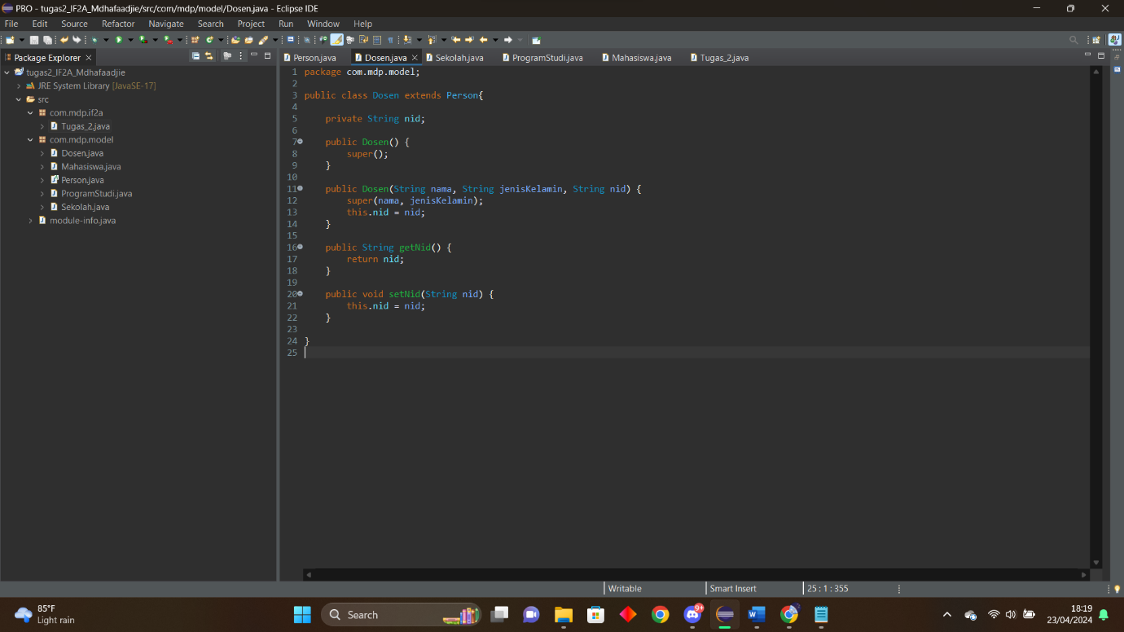

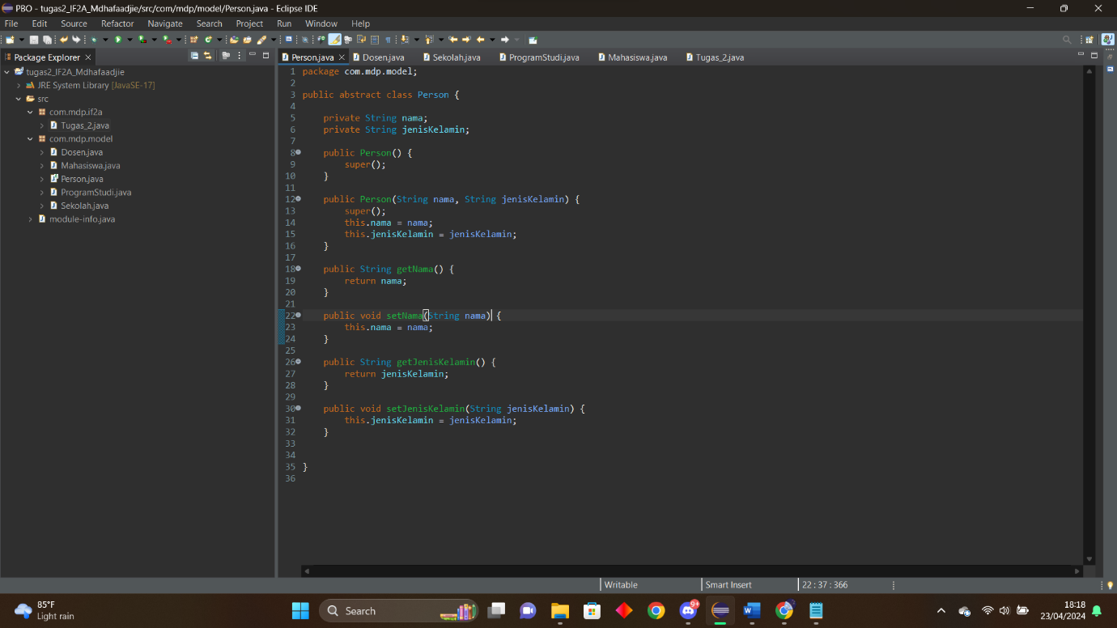

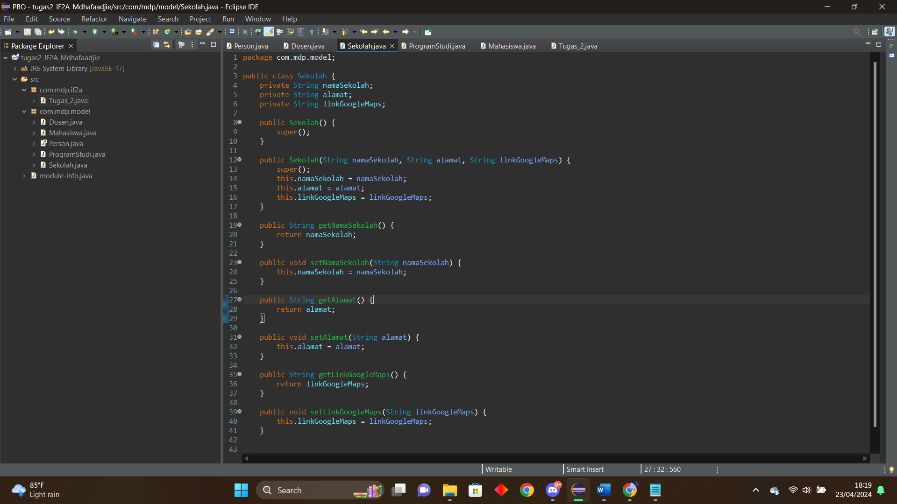

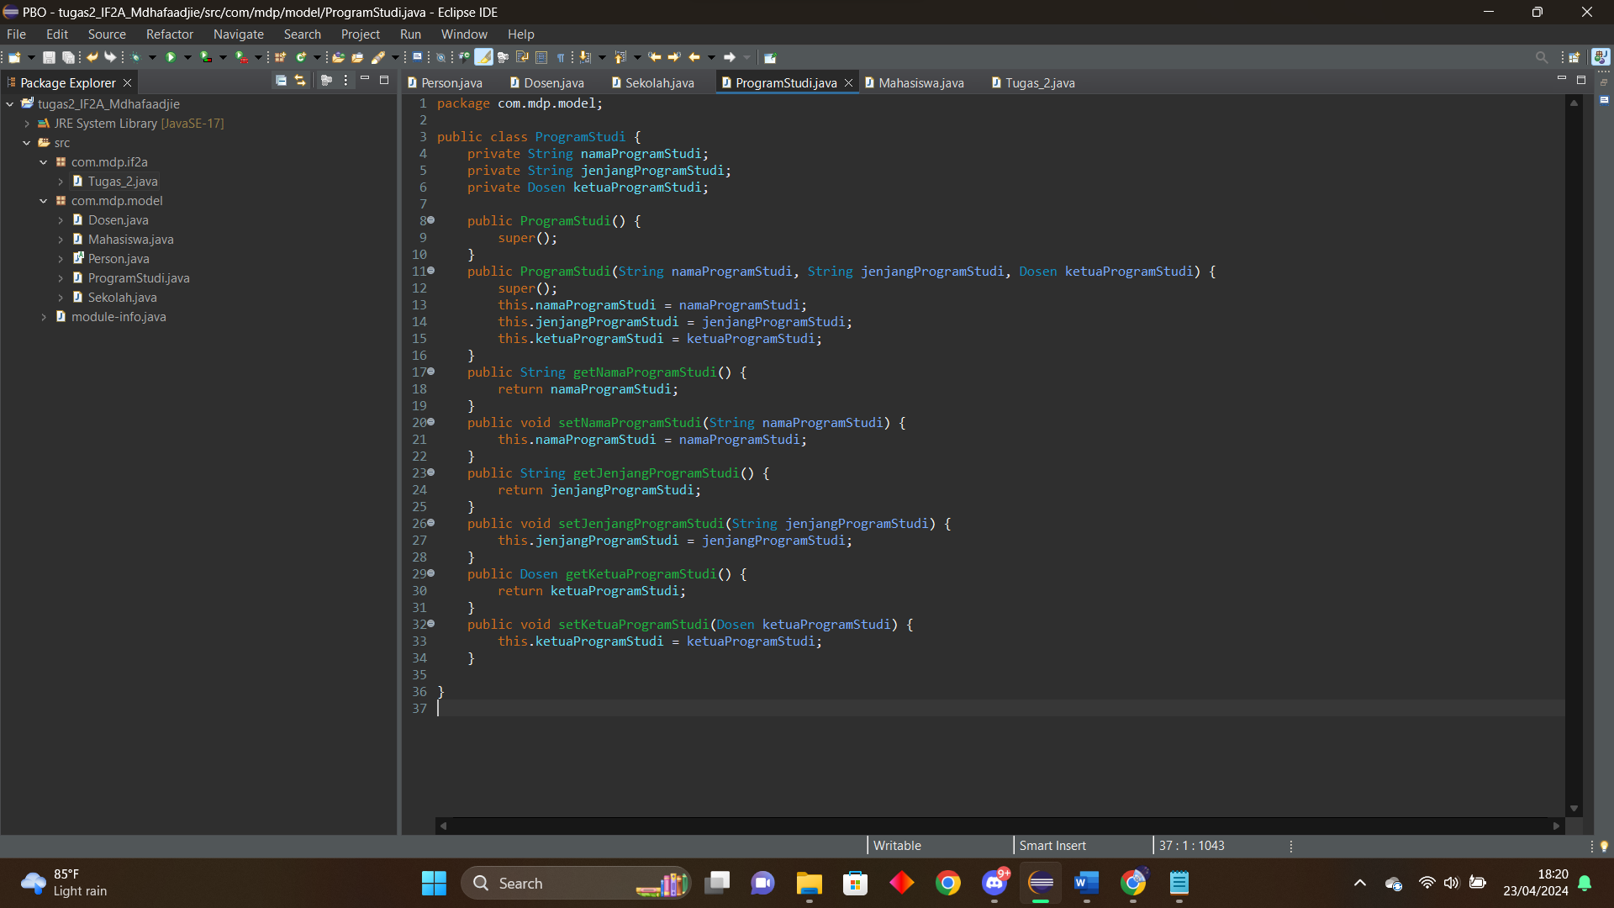

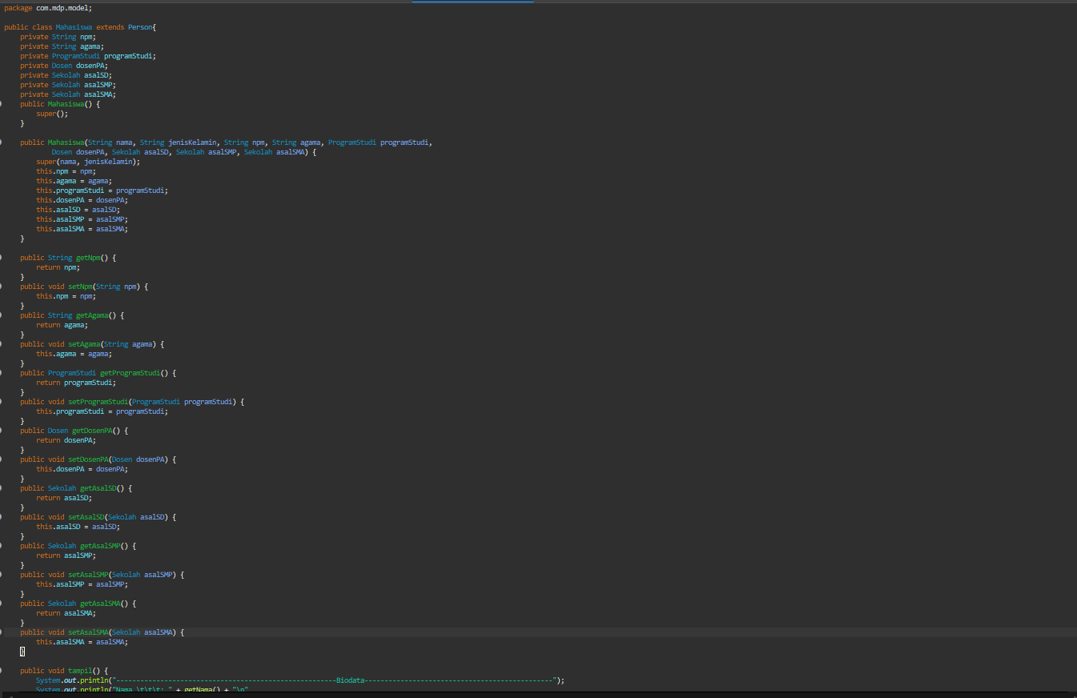

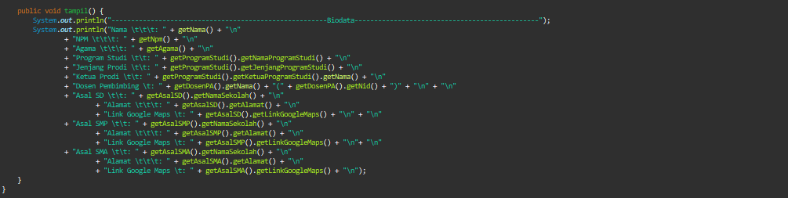

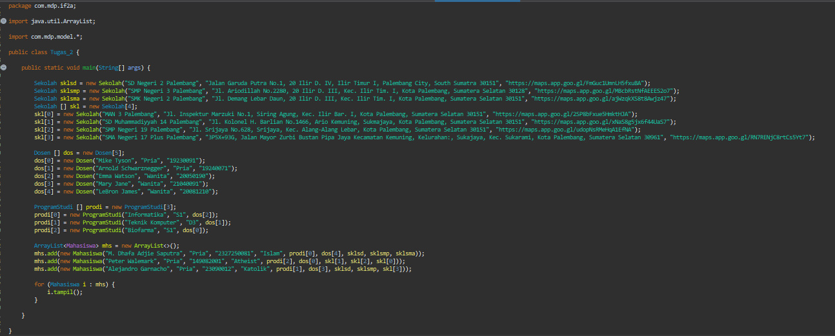

* **Screenshot Hasil eksekusi**

