[Recursive query using CTEs](https://www.postgresqltutorial.com/postgresql-tutorial/postgresql-recursive-query/)

Upsert

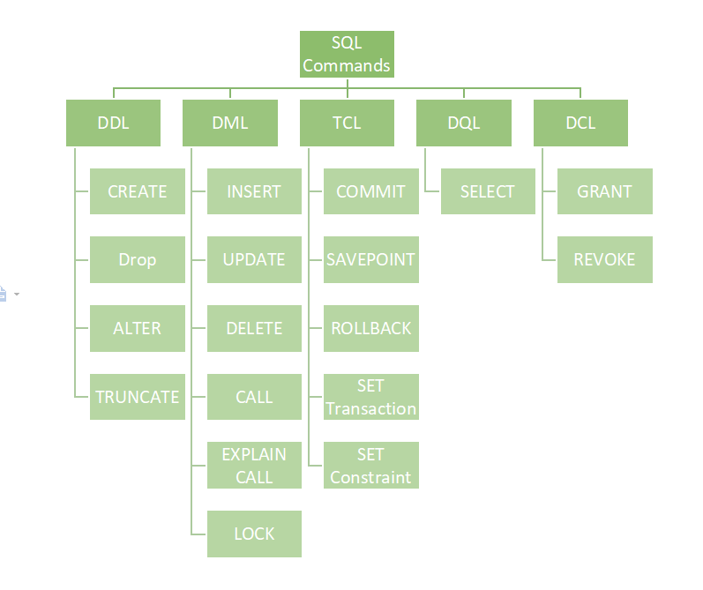

**Fetch:**

SELECT film_id, title FROM film ORDER BY title FETCH FIRST 5 ROW ONLY;

**Natural Join:**

If you use the asterisk (*) in the select list, the result will contain the following columns:

* All the common columns, which are the columns from both tables that have the same name.
* Every column from both tables, which is not a common column.

**HAVING vs. WHERE**

The [WHERE](https://www.postgresqltutorial.com/postgresql-tutorial/postgresql-where/) clause allows you to filter rows based on a specified condition. However, the HAVING clause allows you to filter groups of rows according to a specified condition.

In other words, the WHERE clause is applied to rows while the HAVING clause is applied to groups of rows.

**Brouping Set:** https://www.postgresqltutorial.com/postgresql-tutorial/postgresql-grouping-sets/

SELECT brand, segment, SUM (quantity) FROM sales GROUP BY GROUPING SETS ( (brand, segment), (brand), (segment), () );

SELECT GROUPING(brand) grouping_brand, GROUPING(segment) grouping_segment, brand, segment, SUM (quantity) FROM sales GROUP BY GROUPING SETS ( (brand), (segment), () ) ORDER BY brand, segment;

**Order**

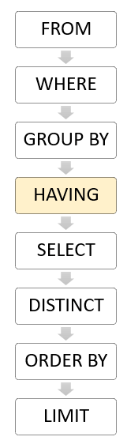

### Postgres Command

sudo apt install postgresql

sudo -u postgres psql

ALTER USER postgres PASSWORD 'root' // Reset password to root

psql -U postgres -h localhost // Login to postgres user

\l // List all databases

e

\du // List of all users

CREATE USER Dhainik WITH CREATEDB LOGIN ENCRYPTED PASSWORD 'admin'; // Create new user

CREATE DATABASE dhainik; // Create database

DROP DATABASE cb; // Drop cb database

sudo /usr/pgadmin4/bin/setup-web.sh

Any

All

Upsert

**Postgres Commands**

psql : to start psql server

\l : List all databases

\c database_name : To connect with database

\dt : list all tables in database

\c : To check connected database and user

SHOW default_transaction_isolation; : to check isolation level(read committed)

start transaction isolation level repeatable read; : set isolation level as repeatable read

**Copy csv file data in sql table**

CREATE TABLE persons ( id SERIAL, first_name VARCHAR(50), last_name VARCHAR(50), dob DATE, email VARCHAR(255), PRIMARY KEY (id) )

\COPY persons(first_name, last_name, dob, email)

FROM '/home/dhainik/Downloads/persons.csv'

DELIMITER ','

CSV HEADER;