

**Appendix-A**

**Publication Details**

**School of Engineering and Technology / School of Computer Engg & Technology  
M. Tech. Dissertation, Viva-Voce, AY 2024-25**

|  |  |  |  |
| --- | --- | --- | --- |
| Full Name of Student | **Dhairvi Shah** | | |
| Department | **School of Computer Engineering & Technology (M.TECH)** | | |
| Branch Specialization | **Data Science and Analytics** | | |
| Roll No | **PA10** | PRN | **1032230299** |
| Mob | **9824488826** |  |  |
| Email | **dhairvi.shah@mitwpu.edu.in** | | |
| Name of PG Guide | **Dr. Preeti Kale** | | |
| Mob of PG Guide | **9850843165** |  |  |
| Name of Company Guide | **NA** | | |
| Designation of Company Guide | **NA** | Mob of Company Guide | **NA** |
| Company Address | **NA** | | |
| Permission received for publishing a paper from company | | Yes / No : **Not Applicable** | |
| PG College Guide remarks on above point (if No) | |  | |

**PG Student have to complete either Sr.1, Sr.2 OR Sr.3 below and attach all necessary proofs/evidences mentioned**

|  |  |  |  |
| --- | --- | --- | --- |
| **1.Conference Publication *(Fill the details if applicable)*** | | | |
| Name of National/ International Conference | **Soft Computing and Signal Processing: Proceedings of 8th ICSCSP 2025** | | |
| Date of submission of paper | **14th May 2025** | Date of Conference: | **20th -21st June 2025** |
| Acceptance of Abstract/Paper | Yes / No : **Yes** | Date of Acceptance: *(Attach paper acceptance mail)* | **7th June 2025 (Proof 1)** |
| Indexing of Conference  *(Attach proof)* | **Scopus Indexed (Proof 2)** |  |  |
| **2.Journal Publication *(Fill the details if applicable)*** | | | |
| Name of National/ International Journal | **International Journal of Data Science and Analytics** | | |
| Date of submission of paper | **23rd March 2025** | Date of Acceptance of Paper | **With Editor** |
| Indexing of Journal *(Tick mark and Attach proof)* | SCOPUS  **Yes**  (Proof 3) | Web of Science  **No** | Q1 / Q2 / Q3 / Q4 /  **Q2**  ABDC |
| Frequency of publication of Journal | **Monthly** | Minimum duration required for publication in Journal | In months : **7 to 8 months** |
| **3.Journal Publication *(Fill the details if applicable)*** | | | |
| Name of National/ International Journal | **Indian Council of Historical Research (Review Paper)** | | |
| Date of submission of paper | **28th February 2025** | Date of Acceptance of Paper | **With Editor** |
| Indexing of Journal *(Tick mark and Attach proof)* | SCOPUS  **Yes**  (Proof 4) | Web of Science  **No** | Q1 / Q2 / Q3 / Q4 /  **Q4**  ABDC |
| Frequency of publication of Journal | **Yearly** | Minimum duration required for publication in Journal | In months : **11 to 15** |
| **Dhairvi Shah**  Name & Sign of Student | | **Dr. Preeti Kale**  Name & Sign of PG Guide | |

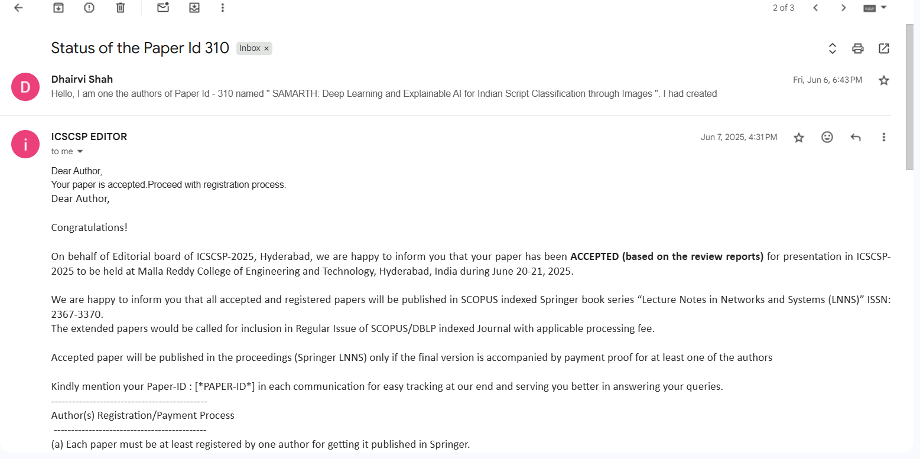

Proof 1 Acceptance Mail

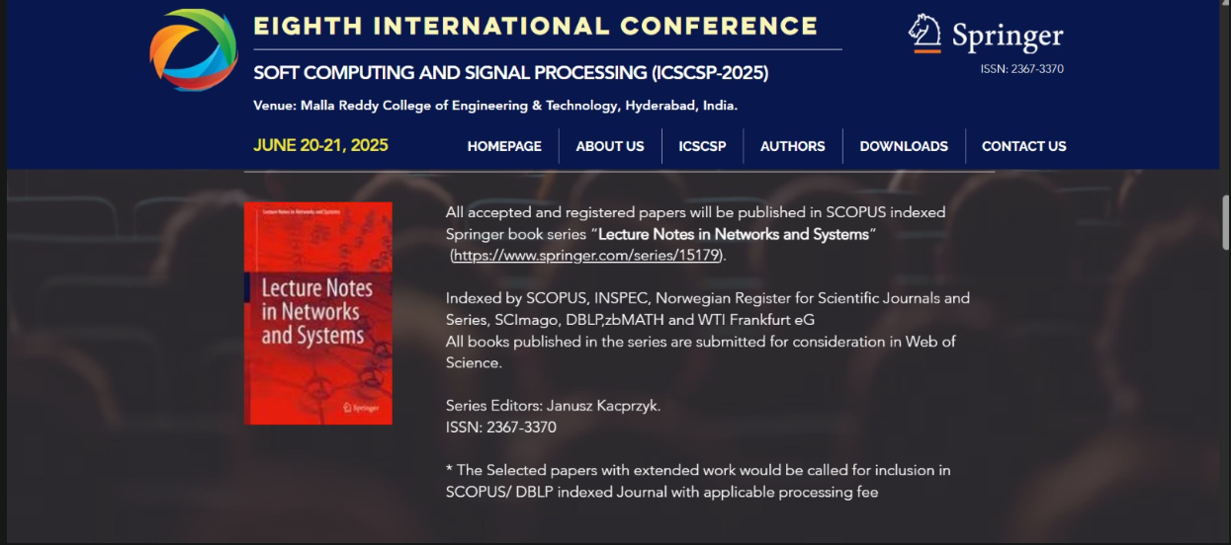

Proof 2 Conference Scopus Index

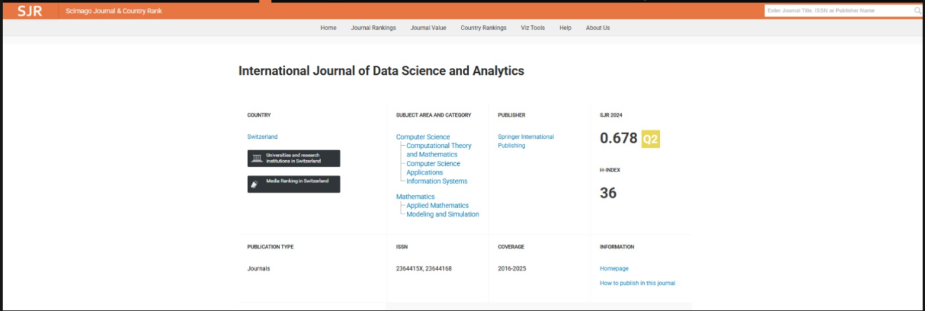

Proof 3 Journal Proof

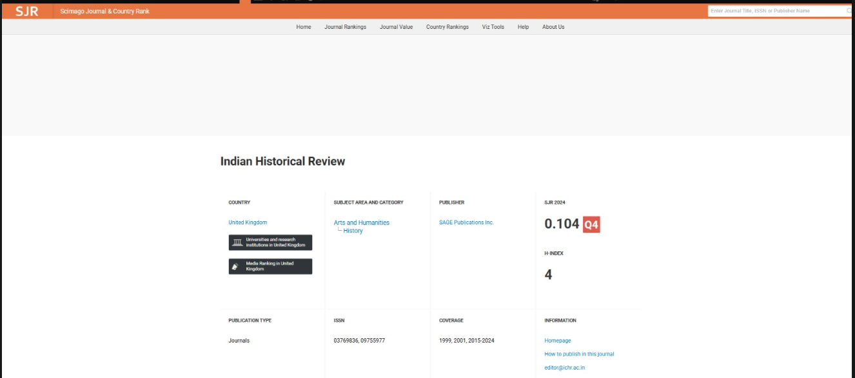

Proof 4 Review Paper Journal Proof