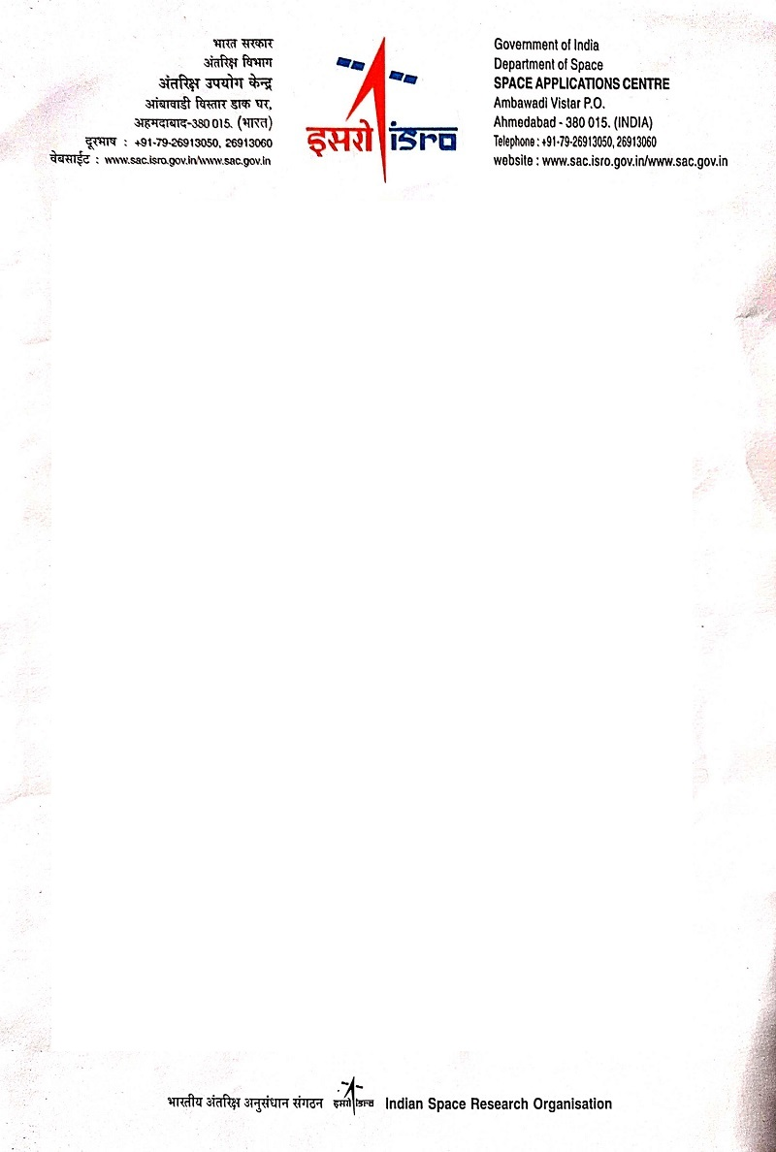

Mrs. Anuja Sharma

Scientist Engineer

ISRO – SAC

[ANUJASHARMA@isro.sac.gov.in](mailto:ANUJASHARMA@isro.sac.gov.in)

21st November 2023

To whom it may concern

CERN institute Geneva, Switzerland

Summer Student Program - 2024

Respected Sir/Ma’am,

I am writing to enthusiastically endorse Dhairvi Shah for any future academic or professional endeavors. She did her Bachelor's last-year internship at ISRO-SAC under my supervision, and I am confidence in her ability and dedication.

Dhairvi Shah demonstrated an amazing work ethic and a genuine drive to learn throughout her internship. She eagerly sought out new challenges and consistently displayed a high level of professionalism. She was in charge of **creating a machine learning model to identify significant flag values using historic data from a calibrated ScatSat-1 Scatterometer, as well as automating the database system**, and I was pleased with her ability to handle complex jobs with quickness and precision. Her attention to detail, problem-solving abilities, and optimistic attitude towards continuous learning and never giving up are some of her outstanding talents. She tackled jobs with a rigorous exceptional collaborator, collaborating with team members and positively contributing to the general work environment. She did, however, require some assistance with written communication skills when she first joined us, but by the conclusion of her time with us, she had significantly enhanced her abilities.

Dhairvi Shah offered a cheerful and energetic attitude to the office, in addition to her technical capabilities such as Machine Learning, Deep Learning, Data Analysis, Artificial Intelligence, SQL, PostgreSQL, handling databases, advanced mathematics, and data visualization. She was always willing to take on new duties and displayed a dedication to excellence that went above and beyond expectations.

In conclusion, I have no doubt that Dhairvi Shah will achieve in any academic or professional pursuit she chooses. She is a motivated and talented individual with a promising future. If you require any additional information or have any questions, please do not hesitate to contact me.

Sincerely,

IMP.PNG

Mrs. Anuja Sharma

Scientist Engineer

ISRO – SAC